# The System Design Primer

[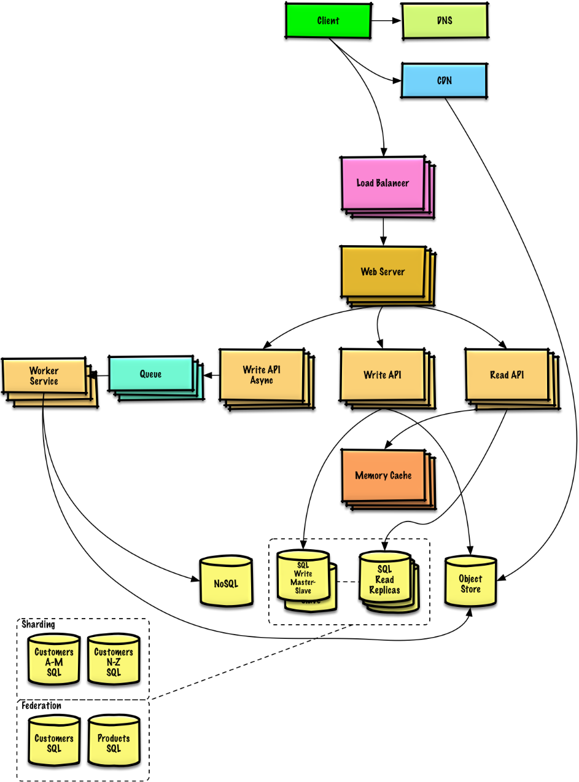](https://github.com/donnemartin/system-design-primer/blob/master/images/jj3A5N8.png)

## Motivation

Learn how to design large-scale systems.

Prep for the system design interview.

### Learn how to design large-scale systems

Learning how to design scalable systems will help you become a better engineer.

System design is a broad topic. There is a **vast amount of resources scattered throughout the web** on system design principles.

This repo is an **organized collection** of resources to help you learn how to build systems at scale.

### Learn from the open source community

This is a continually updated, open source project.

[Contributions](https://github.com/donnemartin/system-design-primer#contributing) are welcome!

### Prep for the system design interview

In addition to coding interviews, system design is a **required component** of the **technical interview process** at many tech companies.

**Practice common system design interview questions** and **compare** your results with **sample solutions**: discussions, code, and diagrams.

Additional topics for interview prep:

* [Study guide](https://github.com/donnemartin/system-design-primer#study-guide)
* [How to approach a system design interview question](https://github.com/donnemartin/system-design-primer#how-to-approach-a-system-design-interview-question)
* [System design interview questions, **with solutions**](https://github.com/donnemartin/system-design-primer#system-design-interview-questions-with-solutions)
* [Object-oriented design interview questions, **with solutions**](https://github.com/donnemartin/system-design-primer#object-oriented-design-interview-questions-with-solutions)
* [Additional system design interview questions](https://github.com/donnemartin/system-design-primer#additional-system-design-interview-questions)

## Anki flashcards

[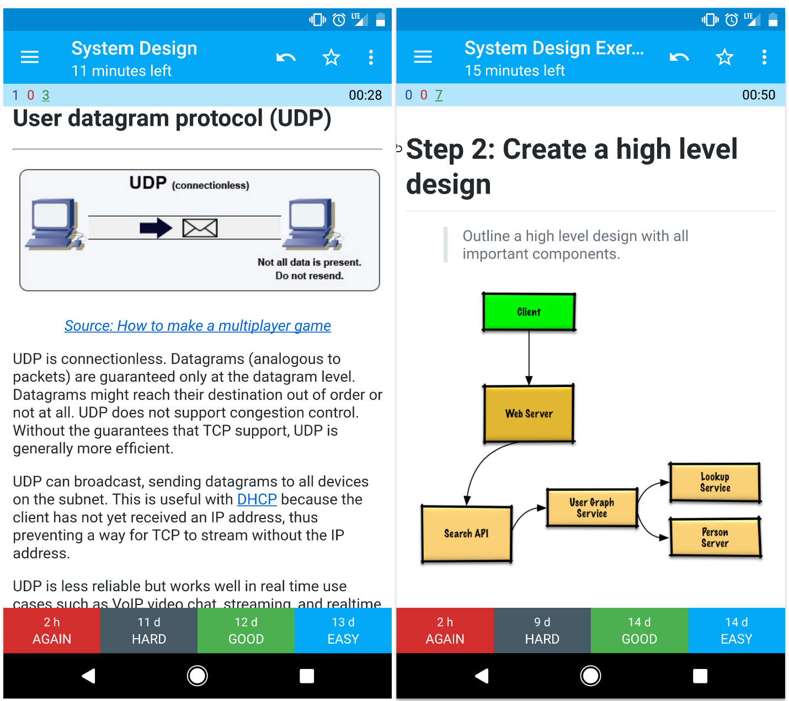](https://github.com/donnemartin/system-design-primer/blob/master/images/zdCAkB3.png)

The provided [Anki flashcard decks](https://apps.ankiweb.net/) use spaced repetition to help you retain key system design concepts.

* [System design deck](https://github.com/donnemartin/system-design-primer/tree/master/resources/flash_cards/System%20Design.apkg)
* [System design exercises deck](https://github.com/donnemartin/system-design-primer/tree/master/resources/flash_cards/System%20Design%20Exercises.apkg)
* [Object oriented design exercises deck](https://github.com/donnemartin/system-design-primer/tree/master/resources/flash_cards/OO%20Design.apkg)

Great for use while on-the-go.

### Coding Resource: Interactive Coding Challenges

Looking for resources to help you prep for the [**Coding Interview**](https://github.com/donnemartin/interactive-coding-challenges)?

[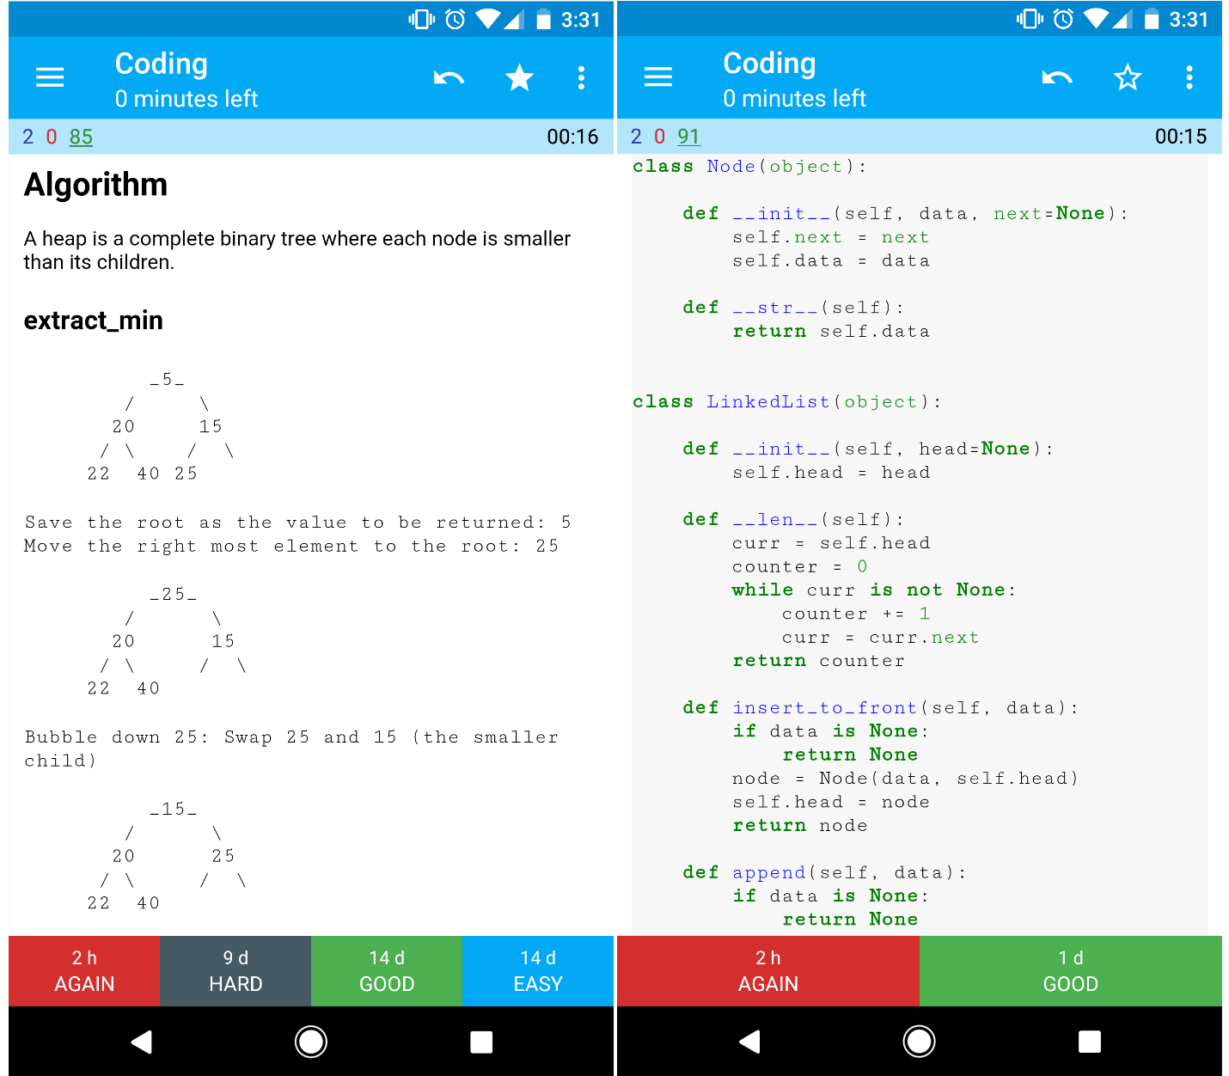](https://github.com/donnemartin/system-design-primer/blob/master/images/b4YtAEN.png)

Check out the sister repo [**Interactive Coding Challenges**](https://github.com/donnemartin/interactive-coding-challenges), which contains an additional Anki deck:

* [Coding deck](https://github.com/donnemartin/interactive-coding-challenges/tree/master/anki_cards/Coding.apkg)

## Contributing

Learn from the community.

Feel free to submit pull requests to help:

* Fix errors
* Improve sections
* Add new sections
* [Translate](https://github.com/donnemartin/system-design-primer/issues/28)

Content that needs some polishing is placed [under development](https://github.com/donnemartin/system-design-primer#under-development).

Review the [Contributing Guidelines](https://github.com/donnemartin/system-design-primer/blob/master/CONTRIBUTING.md).

## Index of system design topics

Summaries of various system design topics, including pros and cons. **Everything is a trade-off**.

Each section contains links to more in-depth resources.

[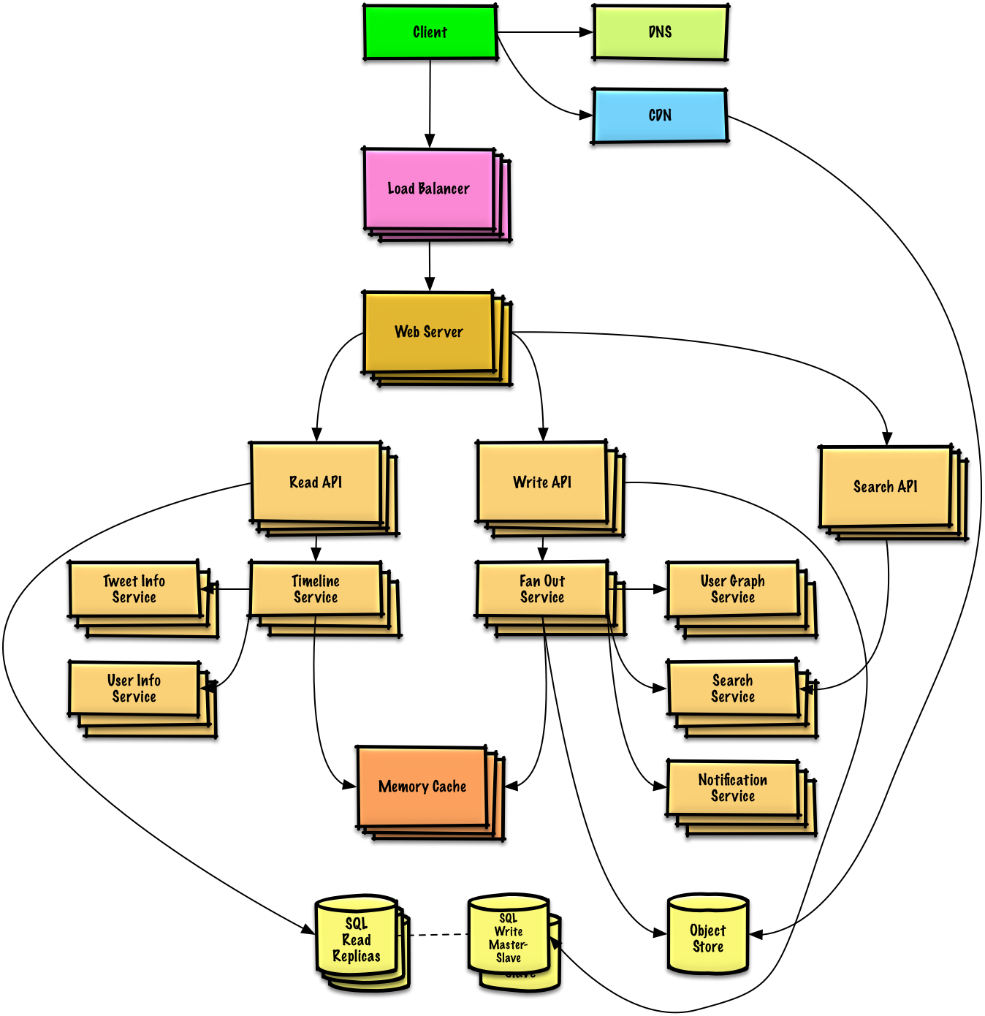](https://github.com/donnemartin/system-design-primer/blob/master/images/jrUBAF7.png)

* [System design topics: start here](https://github.com/donnemartin/system-design-primer#system-design-topics-start-here)
  + [Step 1: Review the scalability video lecture](https://github.com/donnemartin/system-design-primer#step-1-review-the-scalability-video-lecture)
  + [Step 2: Review the scalability article](https://github.com/donnemartin/system-design-primer#step-2-review-the-scalability-article)
  + [Next steps](https://github.com/donnemartin/system-design-primer#next-steps)
* [Performance vs scalability](https://github.com/donnemartin/system-design-primer#performance-vs-scalability)
* [Latency vs throughput](https://github.com/donnemartin/system-design-primer#latency-vs-throughput)
* [Availability vs consistency](https://github.com/donnemartin/system-design-primer#availability-vs-consistency)
  + [CAP theorem](https://github.com/donnemartin/system-design-primer#cap-theorem)
    - [CP - consistency and partition tolerance](https://github.com/donnemartin/system-design-primer#cp---consistency-and-partition-tolerance)
    - [AP - availability and partition tolerance](https://github.com/donnemartin/system-design-primer#ap---availability-and-partition-tolerance)
* [Consistency patterns](https://github.com/donnemartin/system-design-primer#consistency-patterns)
  + [Weak consistency](https://github.com/donnemartin/system-design-primer#weak-consistency)
  + [Eventual consistency](https://github.com/donnemartin/system-design-primer#eventual-consistency)
  + [Strong consistency](https://github.com/donnemartin/system-design-primer#strong-consistency)
* [Availability patterns](https://github.com/donnemartin/system-design-primer#availability-patterns)
  + [Fail-over](https://github.com/donnemartin/system-design-primer#fail-over)
  + [Replication](https://github.com/donnemartin/system-design-primer#replication)
  + [Availability in numbers](https://github.com/donnemartin/system-design-primer#availability-in-numbers)
* [Domain name system](https://github.com/donnemartin/system-design-primer#domain-name-system)
* [Content delivery network](https://github.com/donnemartin/system-design-primer#content-delivery-network)
  + [Push CDNs](https://github.com/donnemartin/system-design-primer#push-cdns)
  + [Pull CDNs](https://github.com/donnemartin/system-design-primer#pull-cdns)
* [Load balancer](https://github.com/donnemartin/system-design-primer#load-balancer)
  + [Active-passive](https://github.com/donnemartin/system-design-primer#active-passive)
  + [Active-active](https://github.com/donnemartin/system-design-primer#active-active)
  + [Layer 4 load balancing](https://github.com/donnemartin/system-design-primer#layer-4-load-balancing)
  + [Layer 7 load balancing](https://github.com/donnemartin/system-design-primer#layer-7-load-balancing)
  + [Horizontal scaling](https://github.com/donnemartin/system-design-primer#horizontal-scaling)
* [Reverse proxy (web server)](https://github.com/donnemartin/system-design-primer#reverse-proxy-web-server)
  + [Load balancer vs reverse proxy](https://github.com/donnemartin/system-design-primer#load-balancer-vs-reverse-proxy)
* [Application layer](https://github.com/donnemartin/system-design-primer#application-layer)
  + [Microservices](https://github.com/donnemartin/system-design-primer#microservices)
  + [Service discovery](https://github.com/donnemartin/system-design-primer#service-discovery)
* [Database](https://github.com/donnemartin/system-design-primer#database)
  + [Relational database management system (RDBMS)](https://github.com/donnemartin/system-design-primer#relational-database-management-system-rdbms)
    - [Master-slave replication](https://github.com/donnemartin/system-design-primer#master-slave-replication)
    - [Master-master replication](https://github.com/donnemartin/system-design-primer#master-master-replication)
    - [Federation](https://github.com/donnemartin/system-design-primer#federation)
    - [Sharding](https://github.com/donnemartin/system-design-primer#sharding)
    - [Denormalization](https://github.com/donnemartin/system-design-primer#denormalization)
    - [SQL tuning](https://github.com/donnemartin/system-design-primer#sql-tuning)
  + [NoSQL](https://github.com/donnemartin/system-design-primer#nosql)
    - [Key-value store](https://github.com/donnemartin/system-design-primer#key-value-store)
    - [Document store](https://github.com/donnemartin/system-design-primer#document-store)
    - [Wide column store](https://github.com/donnemartin/system-design-primer#wide-column-store)
    - [Graph Database](https://github.com/donnemartin/system-design-primer#graph-database)
  + [SQL or NoSQL](https://github.com/donnemartin/system-design-primer#sql-or-nosql)
* [Cache](https://github.com/donnemartin/system-design-primer#cache)
  + [Client caching](https://github.com/donnemartin/system-design-primer#client-caching)
  + [CDN caching](https://github.com/donnemartin/system-design-primer#cdn-caching)
  + [Web server caching](https://github.com/donnemartin/system-design-primer#web-server-caching)
  + [Database caching](https://github.com/donnemartin/system-design-primer#database-caching)
  + [Application caching](https://github.com/donnemartin/system-design-primer#application-caching)
  + [Caching at the database query level](https://github.com/donnemartin/system-design-primer#caching-at-the-database-query-level)
  + [Caching at the object level](https://github.com/donnemartin/system-design-primer#caching-at-the-object-level)
  + [When to update the cache](https://github.com/donnemartin/system-design-primer#when-to-update-the-cache)
    - [Cache-aside](https://github.com/donnemartin/system-design-primer#cache-aside)
    - [Write-through](https://github.com/donnemartin/system-design-primer#write-through)
    - [Write-behind (write-back)](https://github.com/donnemartin/system-design-primer#write-behind-write-back)
    - [Refresh-ahead](https://github.com/donnemartin/system-design-primer#refresh-ahead)
* [Asynchronism](https://github.com/donnemartin/system-design-primer#asynchronism)
  + [Message queues](https://github.com/donnemartin/system-design-primer#message-queues)
  + [Task queues](https://github.com/donnemartin/system-design-primer#task-queues)
  + [Back pressure](https://github.com/donnemartin/system-design-primer#back-pressure)
* [Communication](https://github.com/donnemartin/system-design-primer#communication)
  + [Transmission control protocol (TCP)](https://github.com/donnemartin/system-design-primer#transmission-control-protocol-tcp)
  + [User datagram protocol (UDP)](https://github.com/donnemartin/system-design-primer#user-datagram-protocol-udp)
  + [Remote procedure call (RPC)](https://github.com/donnemartin/system-design-primer#remote-procedure-call-rpc)
  + [Representational state transfer (REST)](https://github.com/donnemartin/system-design-primer#representational-state-transfer-rest)
* [Security](https://github.com/donnemartin/system-design-primer#security)
* [Appendix](https://github.com/donnemartin/system-design-primer#appendix)
  + [Powers of two table](https://github.com/donnemartin/system-design-primer#powers-of-two-table)
  + [Latency numbers every programmer should know](https://github.com/donnemartin/system-design-primer#latency-numbers-every-programmer-should-know)
  + [Additional system design interview questions](https://github.com/donnemartin/system-design-primer#additional-system-design-interview-questions)
  + [Real world architectures](https://github.com/donnemartin/system-design-primer#real-world-architectures)
  + [Company architectures](https://github.com/donnemartin/system-design-primer#company-architectures)
  + [Company engineering blogs](https://github.com/donnemartin/system-design-primer#company-engineering-blogs)
* [Under development](https://github.com/donnemartin/system-design-primer#under-development)
* [Credits](https://github.com/donnemartin/system-design-primer#credits)
* [Contact info](https://github.com/donnemartin/system-design-primer#contact-info)
* [License](https://github.com/donnemartin/system-design-primer#license)

## Study guide

Suggested topics to review based on your interview timeline (short, medium, long).

[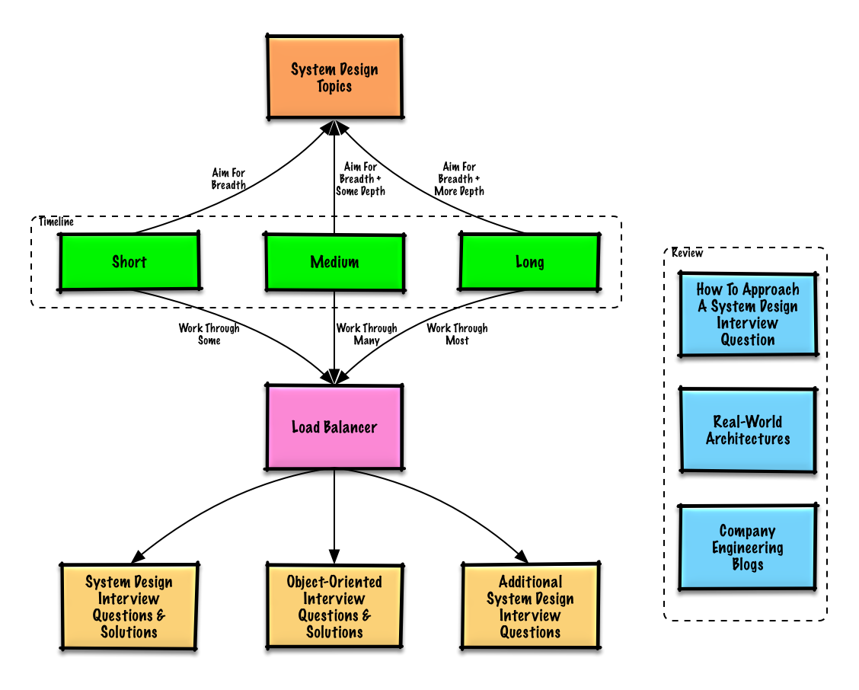](https://github.com/donnemartin/system-design-primer/blob/master/images/OfVllex.png)

**Q: For interviews, do I need to know everything here?**

**A: No, you don't need to know everything here to prepare for the interview**.

What you are asked in an interview depends on variables such as:

* How much experience you have
* What your technical background is
* What positions you are interviewing for
* Which companies you are interviewing with
* Luck

More experienced candidates are generally expected to know more about system design. Architects or team leads might be expected to know more than individual contributors. Top tech companies are likely to have one or more design interview rounds.

Start broad and go deeper in a few areas. It helps to know a little about various key system design topics. Adjust the following guide based on your timeline, experience, what positions you are interviewing for, and which companies you are interviewing with.

* **Short timeline** - Aim for **breadth** with system design topics. Practice by solving **some** interview questions.
* **Medium timeline** - Aim for **breadth** and **some depth** with system design topics. Practice by solving **many** interview questions.
* **Long timeline** - Aim for **breadth** and **more depth** with system design topics. Practice by solving **most** interview questions.

|  | **Short** | **Medium** | **Long** |
| --- | --- | --- | --- |
| Read through the [System design topics](https://github.com/donnemartin/system-design-primer#index-of-system-design-topics) to get a broad understanding of how systems work | 👍 | 👍 | 👍 |
| Read through a few articles in the [Company engineering blogs](https://github.com/donnemartin/system-design-primer#company-engineering-blogs) for the companies you are interviewing with | 👍 | 👍 | 👍 |
| Read through a few [Real world architectures](https://github.com/donnemartin/system-design-primer#real-world-architectures) | 👍 | 👍 | 👍 |
| Review [How to approach a system design interview question](https://github.com/donnemartin/system-design-primer#how-to-approach-a-system-design-interview-question) | 👍 | 👍 | 👍 |
| Work through [System design interview questions with solutions](https://github.com/donnemartin/system-design-primer#system-design-interview-questions-with-solutions) | Some | Many | Most |
| Work through [Object-oriented design interview questions with solutions](https://github.com/donnemartin/system-design-primer#object-oriented-design-interview-questions-with-solutions) | Some | Many | Most |
| Review [Additional system design interview questions](https://github.com/donnemartin/system-design-primer#additional-system-design-interview-questions) | Some | Many | Most |

## How to approach a system design interview question

How to tackle a system design interview question.

The system design interview is an **open-ended conversation**. You are expected to lead it.

You can use the following steps to guide the discussion. To help solidify this process, work through the [System design interview questions with solutions](https://github.com/donnemartin/system-design-primer#system-design-interview-questions-with-solutions) section using the following steps.

### Step 1: Outline use cases, constraints, and assumptions

Gather requirements and scope the problem. Ask questions to clarify use cases and constraints. Discuss assumptions.

* Who is going to use it?
* How are they going to use it?
* How many users are there?
* What does the system do?
* What are the inputs and outputs of the system?
* How much data do we expect to handle?
* How many requests per second do we expect?
* What is the expected read to write ratio?

### Step 2: Create a high level design

Outline a high level design with all important components.

* Sketch the main components and connections
* Justify your ideas

### Step 3: Design core components

Dive into details for each core component. For example, if you were asked to [design a url shortening service](https://github.com/donnemartin/system-design-primer/blob/master/solutions/system_design/pastebin/README.md), discuss:

* Generating and storing a hash of the full url
  + [MD5](https://github.com/donnemartin/system-design-primer/blob/master/solutions/system_design/pastebin/README.md) and [Base62](https://github.com/donnemartin/system-design-primer/blob/master/solutions/system_design/pastebin/README.md)
  + Hash collisions
  + SQL or NoSQL
  + Database schema
* Translating a hashed url to the full url
  + Database lookup
* API and object-oriented design

### Step 4: Scale the design

Identify and address bottlenecks, given the constraints. For example, do you need the following to address scalability issues?

* Load balancer
* Horizontal scaling
* Caching
* Database sharding

Discuss potential solutions and trade-offs. Everything is a trade-off. Address bottlenecks using [principles of scalable system design](https://github.com/donnemartin/system-design-primer#index-of-system-design-topics).

### Back-of-the-envelope calculations

You might be asked to do some estimates by hand. Refer to the [Appendix](https://github.com/donnemartin/system-design-primer#appendix) for the following resources:

* [Use back of the envelope calculations](http://highscalability.com/blog/2011/1/26/google-pro-tip-use-back-of-the-envelope-calculations-to-choo.html)
* [Powers of two table](https://github.com/donnemartin/system-design-primer#powers-of-two-table)
* [Latency numbers every programmer should know](https://github.com/donnemartin/system-design-primer#latency-numbers-every-programmer-should-know)

### Source(s) and further reading

Check out the following links to get a better idea of what to expect:

* [How to ace a systems design interview](https://www.palantir.com/2011/10/how-to-rock-a-systems-design-interview/)
* [The system design interview](http://www.hiredintech.com/system-design)
* [Intro to Architecture and Systems Design Interviews](https://www.youtube.com/watch?v=ZgdS0EUmn70)
* [System design template](https://leetcode.com/discuss/career/229177/My-System-Design-Template)

## System design interview questions with solutions

Common system design interview questions with sample discussions, code, and diagrams.

Solutions linked to content in the solutions/ folder.

| **Question** |  |
| --- | --- |
| Design Pastebin.com (or Bit.ly) | [Solution](https://github.com/donnemartin/system-design-primer/blob/master/solutions/system_design/pastebin/README.md) |
| Design the Twitter timeline and search (or Facebook feed and search) | [Solution](https://github.com/donnemartin/system-design-primer/blob/master/solutions/system_design/twitter/README.md) |
| Design a web crawler | [Solution](https://github.com/donnemartin/system-design-primer/blob/master/solutions/system_design/web_crawler/README.md) |
| Design Mint.com | [Solution](https://github.com/donnemartin/system-design-primer/blob/master/solutions/system_design/mint/README.md) |
| Design the data structures for a social network | [Solution](https://github.com/donnemartin/system-design-primer/blob/master/solutions/system_design/social_graph/README.md) |
| Design a key-value store for a search engine | [Solution](https://github.com/donnemartin/system-design-primer/blob/master/solutions/system_design/query_cache/README.md) |
| Design Amazon's sales ranking by category feature | [Solution](https://github.com/donnemartin/system-design-primer/blob/master/solutions/system_design/sales_rank/README.md) |
| Design a system that scales to millions of users on AWS | [Solution](https://github.com/donnemartin/system-design-primer/blob/master/solutions/system_design/scaling_aws/README.md) |
| Add a system design question | [Contribute](https://github.com/donnemartin/system-design-primer#contributing) |

### Design Pastebin.com (or Bit.ly)

[View exercise and solution](https://github.com/donnemartin/system-design-primer/blob/master/solutions/system_design/pastebin/README.md)

[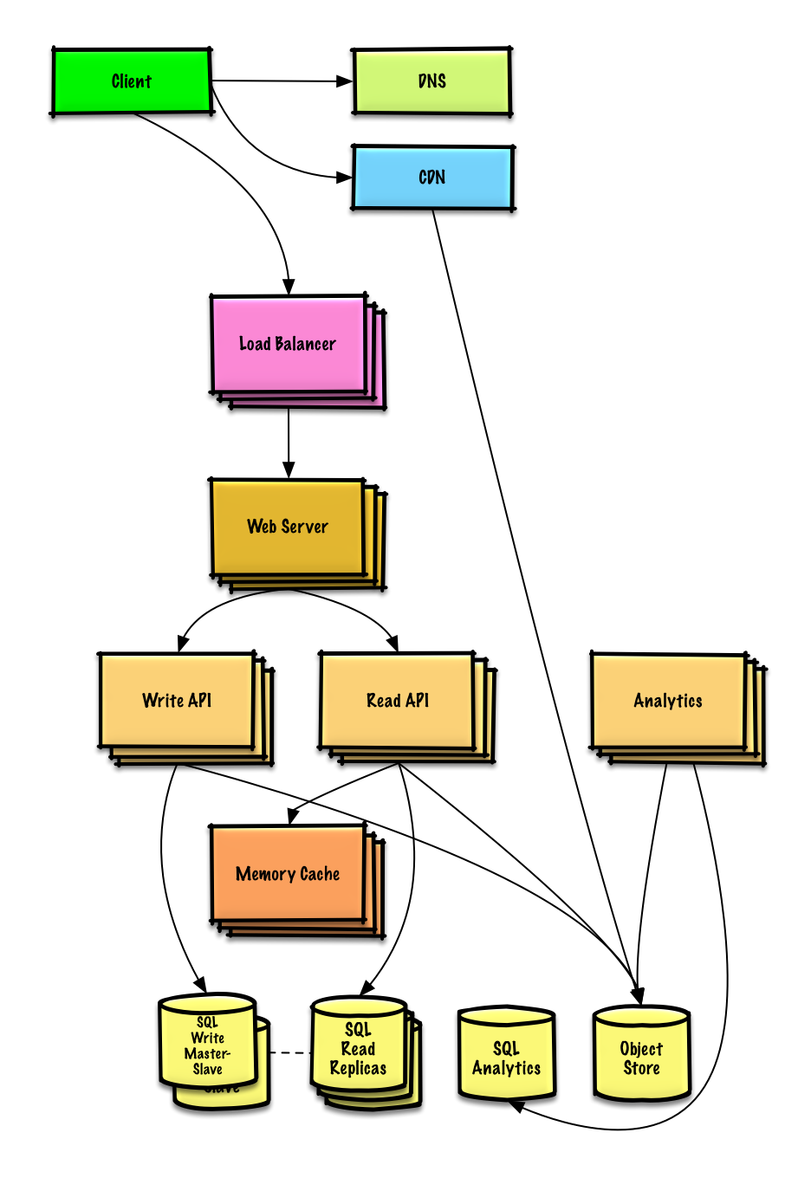](https://github.com/donnemartin/system-design-primer/blob/master/images/4edXG0T.png)

### Design the Twitter timeline and search (or Facebook feed and search)

[View exercise and solution](https://github.com/donnemartin/system-design-primer/blob/master/solutions/system_design/twitter/README.md)

[](https://github.com/donnemartin/system-design-primer/blob/master/images/jrUBAF7.png)

### Design a web crawler

[View exercise and solution](https://github.com/donnemartin/system-design-primer/blob/master/solutions/system_design/web_crawler/README.md)

[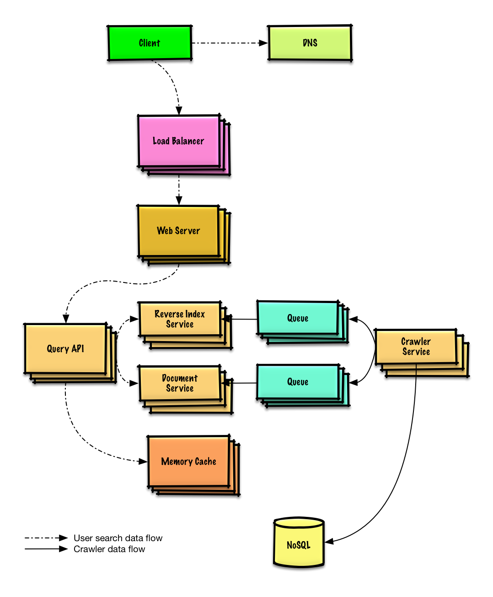](https://github.com/donnemartin/system-design-primer/blob/master/images/bWxPtQA.png)

### Design Mint.com

[View exercise and solution](https://github.com/donnemartin/system-design-primer/blob/master/solutions/system_design/mint/README.md)

[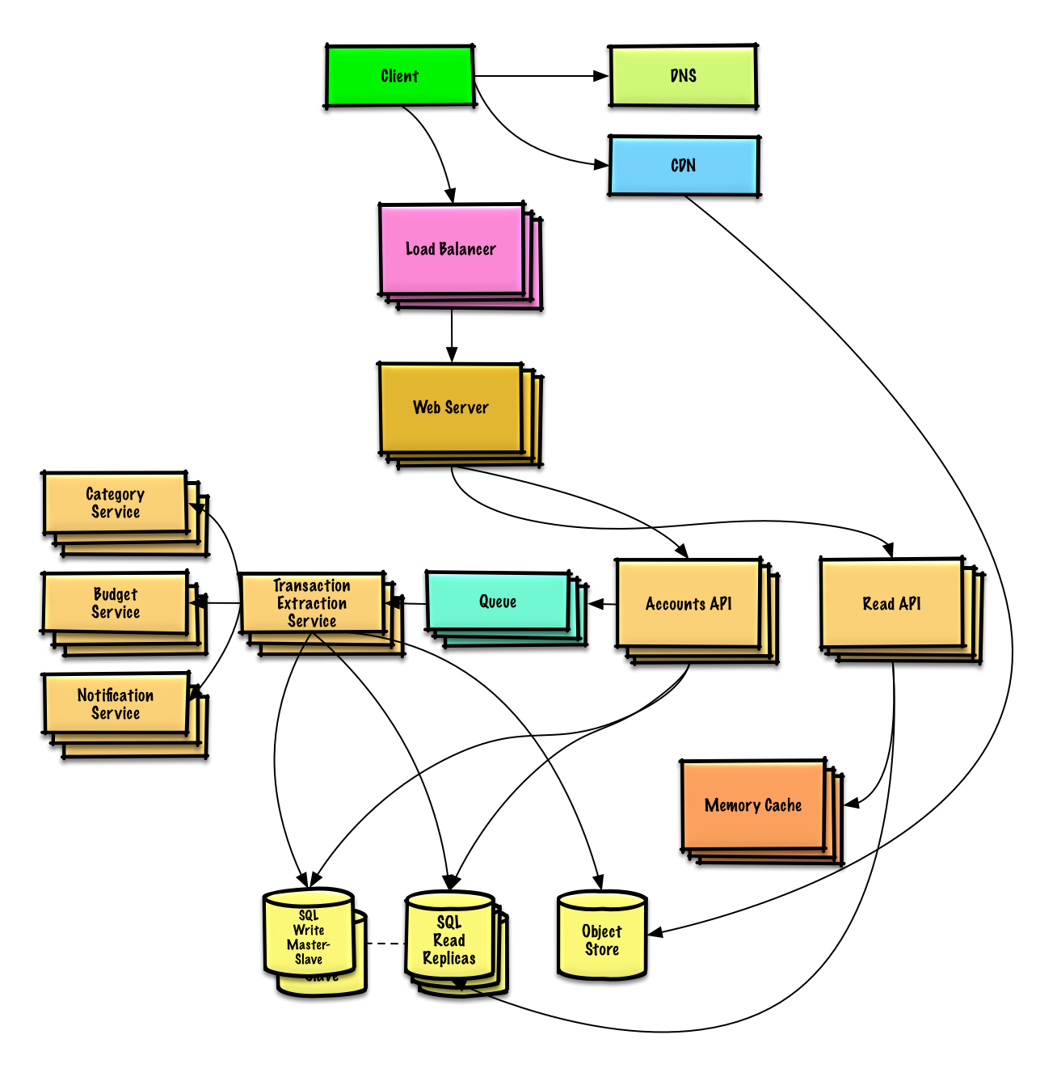](https://github.com/donnemartin/system-design-primer/blob/master/images/V5q57vU.png)

### Design the data structures for a social network

[View exercise and solution](https://github.com/donnemartin/system-design-primer/blob/master/solutions/system_design/social_graph/README.md)

[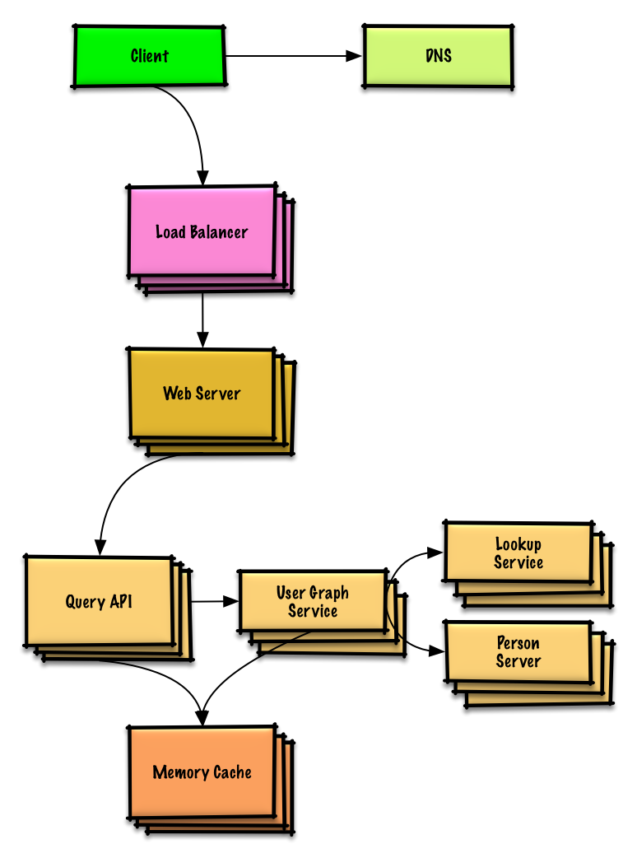](https://github.com/donnemartin/system-design-primer/blob/master/images/cdCv5g7.png)

### Design a key-value store for a search engine

[View exercise and solution](https://github.com/donnemartin/system-design-primer/blob/master/solutions/system_design/query_cache/README.md)

[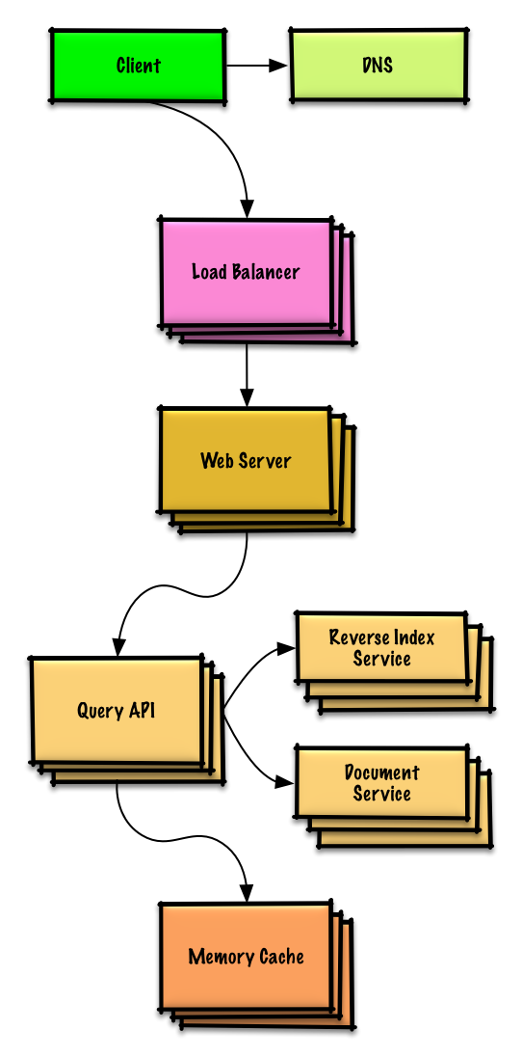](https://github.com/donnemartin/system-design-primer/blob/master/images/4j99mhe.png)

### Design Amazon's sales ranking by category feature

[View exercise and solution](https://github.com/donnemartin/system-design-primer/blob/master/solutions/system_design/sales_rank/README.md)

[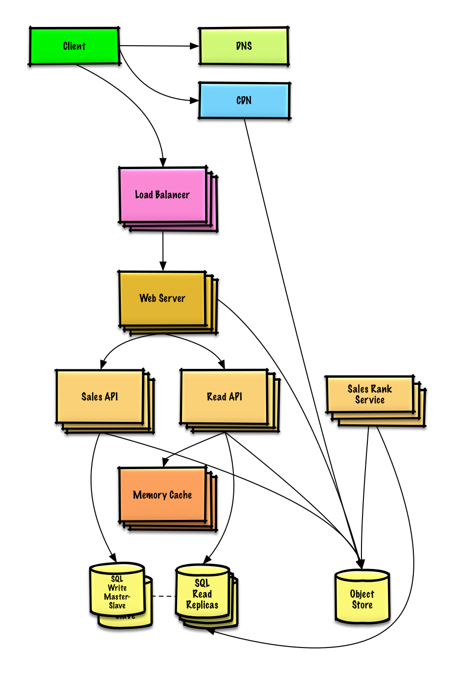](https://github.com/donnemartin/system-design-primer/blob/master/images/MzExP06.png)

### Design a system that scales to millions of users on AWS

[View exercise and solution](https://github.com/donnemartin/system-design-primer/blob/master/solutions/system_design/scaling_aws/README.md)

[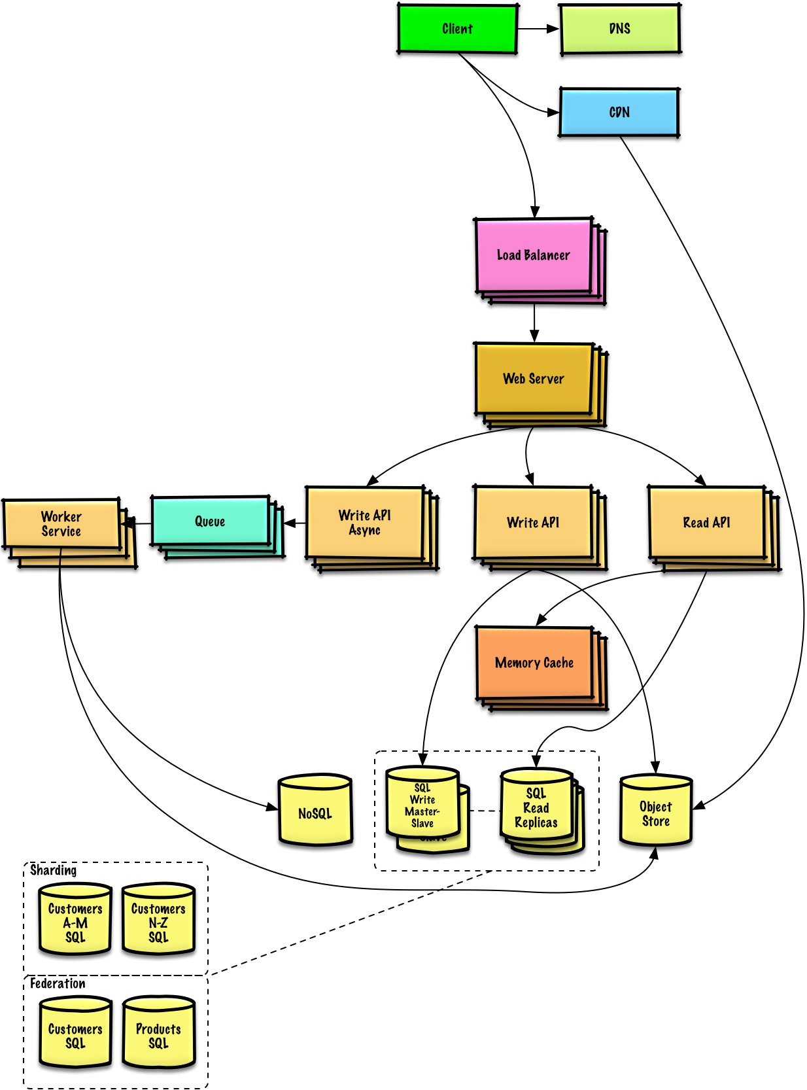](https://github.com/donnemartin/system-design-primer/blob/master/images/jj3A5N8.png)

## Object-oriented design interview questions with solutions

Common object-oriented design interview questions with sample discussions, code, and diagrams.

Solutions linked to content in the solutions/ folder.

**Note: This section is under development**

| **Question** |  |
| --- | --- |
| Design a hash map | [Solution](https://github.com/donnemartin/system-design-primer/blob/master/solutions/object_oriented_design/hash_table/hash_map.ipynb) |
| Design a least recently used cache | [Solution](https://github.com/donnemartin/system-design-primer/blob/master/solutions/object_oriented_design/lru_cache/lru_cache.ipynb) |
| Design a call center | [Solution](https://github.com/donnemartin/system-design-primer/blob/master/solutions/object_oriented_design/call_center/call_center.ipynb) |
| Design a deck of cards | [Solution](https://github.com/donnemartin/system-design-primer/blob/master/solutions/object_oriented_design/deck_of_cards/deck_of_cards.ipynb) |
| Design a parking lot | [Solution](https://github.com/donnemartin/system-design-primer/blob/master/solutions/object_oriented_design/parking_lot/parking_lot.ipynb) |
| Design a chat server | [Solution](https://github.com/donnemartin/system-design-primer/blob/master/solutions/object_oriented_design/online_chat/online_chat.ipynb) |
| Design a circular array | [Contribute](https://github.com/donnemartin/system-design-primer#contributing) |
| Add an object-oriented design question | [Contribute](https://github.com/donnemartin/system-design-primer#contributing) |

## System design topics: start here

New to system design?

First, you'll need a basic understanding of common principles, learning about what they are, how they are used, and their pros and cons.

### Step 1: Review the scalability video lecture

[Scalability Lecture at Harvard](https://www.youtube.com/watch?v=-W9F__D3oY4)

* Topics covered:
  + Vertical scaling
  + Horizontal scaling
  + Caching
  + Load balancing
  + Database replication
  + Database partitioning

### Step 2: Review the scalability article

[Scalability](http://www.lecloud.net/tagged/scalability/chrono)

* Topics covered:
  + [Clones](http://www.lecloud.net/post/7295452622/scalability-for-dummies-part-1-clones)
  + [Databases](http://www.lecloud.net/post/7994751381/scalability-for-dummies-part-2-database)
  + [Caches](http://www.lecloud.net/post/9246290032/scalability-for-dummies-part-3-cache)
  + [Asynchronism](http://www.lecloud.net/post/9699762917/scalability-for-dummies-part-4-asynchronism)

### Next steps

Next, we'll look at high-level trade-offs:

* **Performance** vs **scalability**
* **Latency** vs **throughput**
* **Availability** vs **consistency**

Keep in mind that **everything is a trade-off**.

Then we'll dive into more specific topics such as DNS, CDNs, and load balancers.

## Performance vs scalability

A service is **scalable** if it results in increased **performance** in a manner proportional to resources added. Generally, increasing performance means serving more units of work, but it can also be to handle larger units of work, such as when datasets grow.[1](http://www.allthingsdistributed.com/2006/03/a_word_on_scalability.html)

Another way to look at performance vs scalability:

* If you have a **performance** problem, your system is slow for a single user.
* If you have a **scalability** problem, your system is fast for a single user but slow under heavy load.

### Source(s) and further reading

* [A word on scalability](http://www.allthingsdistributed.com/2006/03/a_word_on_scalability.html)
* [Scalability, availability, stability, patterns](http://www.slideshare.net/jboner/scalability-availability-stability-patterns/)

## Latency vs throughput

**Latency** is the time to perform some action or to produce some result.

**Throughput** is the number of such actions or results per unit of time.

Generally, you should aim for **maximal throughput** with **acceptable latency**.

### Source(s) and further reading

* [Understanding latency vs throughput](https://community.cadence.com/cadence_blogs_8/b/sd/archive/2010/09/13/understanding-latency-vs-throughput)

## Availability vs consistency

### CAP theorem

[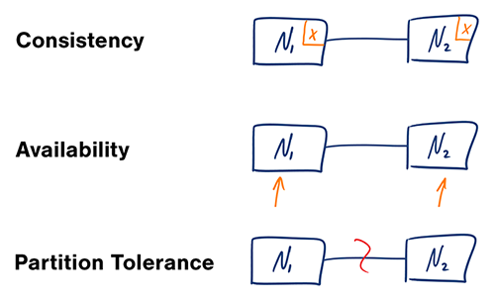](https://github.com/donnemartin/system-design-primer/blob/master/images/bgLMI2u.png)  
[*Source: CAP theorem revisited*](http://robertgreiner.com/2014/08/cap-theorem-revisited)

In a distributed computer system, you can only support two of the following guarantees:

* **Consistency** - Every read receives the most recent write or an error
* **Availability** - Every request receives a response, without guarantee that it contains the most recent version of the information
* **Partition Tolerance** - The system continues to operate despite arbitrary partitioning due to network failures

Networks aren't reliable, so you'll need to support partition tolerance. You'll need to make a software tradeoff between consistency and availability.

#### CP - consistency and partition tolerance

Waiting for a response from the partitioned node might result in a timeout error. CP is a good choice if your business needs require atomic reads and writes.

#### AP - availability and partition tolerance

Responses return the most readily available version of the data available on any node, which might not be the latest. Writes might take some time to propagate when the partition is resolved.

AP is a good choice if the business needs allow for [eventual consistency](https://github.com/donnemartin/system-design-primer#eventual-consistency) or when the system needs to continue working despite external errors.

### Source(s) and further reading

* [CAP theorem revisited](http://robertgreiner.com/2014/08/cap-theorem-revisited/)
* [A plain english introduction to CAP theorem](http://ksat.me/a-plain-english-introduction-to-cap-theorem)
* [CAP FAQ](https://github.com/henryr/cap-faq)
* [The CAP theorem](https://www.youtube.com/watch?v=k-Yaq8AHlFA)

## Consistency patterns

With multiple copies of the same data, we are faced with options on how to synchronize them so clients have a consistent view of the data. Recall the definition of consistency from the [CAP theorem](https://github.com/donnemartin/system-design-primer#cap-theorem) - Every read receives the most recent write or an error.

### Weak consistency

After a write, reads may or may not see it. A best effort approach is taken.

This approach is seen in systems such as memcached. Weak consistency works well in real time use cases such as VoIP, video chat, and realtime multiplayer games. For example, if you are on a phone call and lose reception for a few seconds, when you regain connection you do not hear what was spoken during connection loss.

### Eventual consistency

After a write, reads will eventually see it (typically within milliseconds). Data is replicated asynchronously.

This approach is seen in systems such as DNS and email. Eventual consistency works well in highly available systems.

### Strong consistency

After a write, reads will see it. Data is replicated synchronously.

This approach is seen in file systems and RDBMSes. Strong consistency works well in systems that need transactions.

### Source(s) and further reading

* [Transactions across data centers](http://snarfed.org/transactions_across_datacenters_io.html)

## Availability patterns

There are two complementary patterns to support high availability: **fail-over** and **replication**.

### Fail-over

#### Active-passive

With active-passive fail-over, heartbeats are sent between the active and the passive server on standby. If the heartbeat is interrupted, the passive server takes over the active's IP address and resumes service.

The length of downtime is determined by whether the passive server is already running in 'hot' standby or whether it needs to start up from 'cold' standby. Only the active server handles traffic.

Active-passive failover can also be referred to as master-slave failover.

#### Active-active

In active-active, both servers are managing traffic, spreading the load between them.

If the servers are public-facing, the DNS would need to know about the public IPs of both servers. If the servers are internal-facing, application logic would need to know about both servers.

Active-active failover can also be referred to as master-master failover.

### Disadvantage(s): failover

* Fail-over adds more hardware and additional complexity.
* There is a potential for loss of data if the active system fails before any newly written data can be replicated to the passive.

### Replication

#### Master-slave and master-master

This topic is further discussed in the [Database](https://github.com/donnemartin/system-design-primer#database) section:

* [Master-slave replication](https://github.com/donnemartin/system-design-primer#master-slave-replication)
* [Master-master replication](https://github.com/donnemartin/system-design-primer#master-master-replication)

### Availability in numbers

Availability is often quantified by uptime (or downtime) as a percentage of time the service is available. Availability is generally measured in number of 9s--a service with 99.99% availability is described as having four 9s.

#### 99.9% availability - three 9s

| **Duration** | **Acceptable downtime** |
| --- | --- |
| Downtime per year | 8h 45min 57s |
| Downtime per month | 43m 49.7s |
| Downtime per week | 10m 4.8s |
| Downtime per day | 1m 26.4s |

#### 99.99% availability - four 9s

| **Duration** | **Acceptable downtime** |
| --- | --- |
| Downtime per year | 52min 35.7s |
| Downtime per month | 4m 23s |
| Downtime per week | 1m 5s |
| Downtime per day | 8.6s |

#### Availability in parallel vs in sequence

If a service consists of multiple components prone to failure, the service's overall availability depends on whether the components are in sequence or in parallel.

###### In sequence

Overall availability decreases when two components with availability < 100% are in sequence:

Availability (Total) = Availability (Foo) \* Availability (Bar)

If both Foo and Bar each had 99.9% availability, their total availability in sequence would be 99.8%.

###### In parallel

Overall availability increases when two components with availability < 100% are in parallel:

Availability (Total) = 1 - (1 - Availability (Foo)) \* (1 - Availability (Bar))

If both Foo and Bar each had 99.9% availability, their total availability in parallel would be 99.9999%.

## Domain name system

[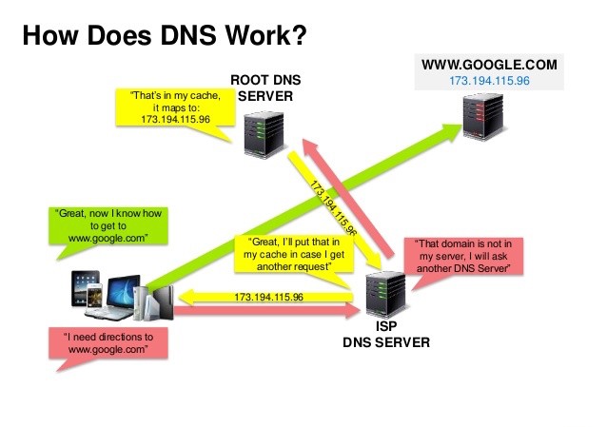](https://github.com/donnemartin/system-design-primer/blob/master/images/IOyLj4i.jpg)  
[*Source: DNS security presentation*](http://www.slideshare.net/srikrupa5/dns-security-presentation-issa)

A Domain Name System (DNS) translates a domain name such as [www.example.com](http://www.example.com/) to an IP address.

DNS is hierarchical, with a few authoritative servers at the top level. Your router or ISP provides information about which DNS server(s) to contact when doing a lookup. Lower level DNS servers cache mappings, which could become stale due to DNS propagation delays. DNS results can also be cached by your browser or OS for a certain period of time, determined by the [time to live (TTL)](https://en.wikipedia.org/wiki/Time_to_live).

* **NS record (name server)** - Specifies the DNS servers for your domain/subdomain.
* **MX record (mail exchange)** - Specifies the mail servers for accepting messages.
* **A record (address)** - Points a name to an IP address.
* **CNAME (canonical)** - Points a name to another name or CNAME (example.com to [www.example.com](http://www.example.com/)) or to an A record.

Services such as [CloudFlare](https://www.cloudflare.com/dns/) and [Route 53](https://aws.amazon.com/route53/) provide managed DNS services. Some DNS services can route traffic through various methods:

* [Weighted round robin](https://www.jscape.com/blog/load-balancing-algorithms)
  + Prevent traffic from going to servers under maintenance
  + Balance between varying cluster sizes
  + A/B testing
* [Latency-based](https://docs.aws.amazon.com/Route53/latest/DeveloperGuide/routing-policy.html#routing-policy-latency)
* [Geolocation-based](https://docs.aws.amazon.com/Route53/latest/DeveloperGuide/routing-policy.html#routing-policy-geo)

### Disadvantage(s): DNS

* Accessing a DNS server introduces a slight delay, although mitigated by caching described above.
* DNS server management could be complex and is generally managed by [governments, ISPs, and large companies](http://superuser.com/questions/472695/who-controls-the-dns-servers/472729).
* DNS services have recently come under [DDoS attack](http://dyn.com/blog/dyn-analysis-summary-of-friday-october-21-attack/), preventing users from accessing websites such as Twitter without knowing Twitter's IP address(es).

### Source(s) and further reading

* [DNS architecture](https://technet.microsoft.com/en-us/library/dd197427(v=ws.10).aspx)
* [Wikipedia](https://en.wikipedia.org/wiki/Domain_Name_System)
* [DNS articles](https://support.dnsimple.com/categories/dns/)

## Content delivery network

[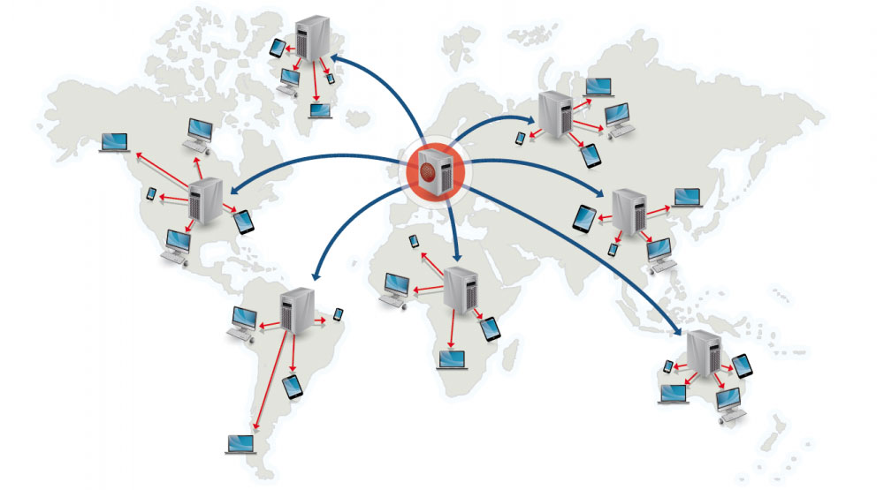](https://github.com/donnemartin/system-design-primer/blob/master/images/h9TAuGI.jpg)  
[*Source: Why use a CDN*](https://www.creative-artworks.eu/why-use-a-content-delivery-network-cdn/)

A content delivery network (CDN) is a globally distributed network of proxy servers, serving content from locations closer to the user. Generally, static files such as HTML/CSS/JS, photos, and videos are served from CDN, although some CDNs such as Amazon's CloudFront support dynamic content. The site's DNS resolution will tell clients which server to contact.

Serving content from CDNs can significantly improve performance in two ways:

* Users receive content from data centers close to them
* Your servers do not have to serve requests that the CDN fulfills

### Push CDNs

Push CDNs receive new content whenever changes occur on your server. You take full responsibility for providing content, uploading directly to the CDN and rewriting URLs to point to the CDN. You can configure when content expires and when it is updated. Content is uploaded only when it is new or changed, minimizing traffic, but maximizing storage.

Sites with a small amount of traffic or sites with content that isn't often updated work well with push CDNs. Content is placed on the CDNs once, instead of being re-pulled at regular intervals.

### Pull CDNs

Pull CDNs grab new content from your server when the first user requests the content. You leave the content on your server and rewrite URLs to point to the CDN. This results in a slower request until the content is cached on the CDN.

A [time-to-live (TTL)](https://en.wikipedia.org/wiki/Time_to_live) determines how long content is cached. Pull CDNs minimize storage space on the CDN, but can create redundant traffic if files expire and are pulled before they have actually changed.

Sites with heavy traffic work well with pull CDNs, as traffic is spread out more evenly with only recently-requested content remaining on the CDN.

### Disadvantage(s): CDN

* CDN costs could be significant depending on traffic, although this should be weighed with additional costs you would incur not using a CDN.
* Content might be stale if it is updated before the TTL expires it.
* CDNs require changing URLs for static content to point to the CDN.

### Source(s) and further reading

* [Globally distributed content delivery](https://figshare.com/articles/Globally_distributed_content_delivery/6605972)
* [The differences between push and pull CDNs](http://www.travelblogadvice.com/technical/the-differences-between-push-and-pull-cdns/)
* [Wikipedia](https://en.wikipedia.org/wiki/Content_delivery_network)

## Load balancer

[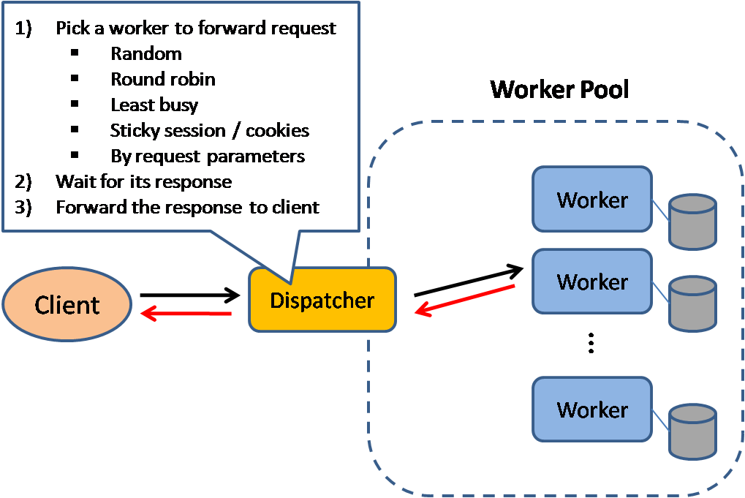](https://github.com/donnemartin/system-design-primer/blob/master/images/h81n9iK.png)  
[*Source: Scalable system design patterns*](http://horicky.blogspot.com/2010/10/scalable-system-design-patterns.html)

Load balancers distribute incoming client requests to computing resources such as application servers and databases. In each case, the load balancer returns the response from the computing resource to the appropriate client. Load balancers are effective at:

* Preventing requests from going to unhealthy servers
* Preventing overloading resources
* Helping to eliminate a single point of failure

Load balancers can be implemented with hardware (expensive) or with software such as HAProxy.

Additional benefits include:

* **SSL termination** - Decrypt incoming requests and encrypt server responses so backend servers do not have to perform these potentially expensive operations
  + Removes the need to install [X.509 certificates](https://en.wikipedia.org/wiki/X.509) on each server
* **Session persistence** - Issue cookies and route a specific client's requests to same instance if the web apps do not keep track of sessions

To protect against failures, it's common to set up multiple load balancers, either in [active-passive](https://github.com/donnemartin/system-design-primer#active-passive) or [active-active](https://github.com/donnemartin/system-design-primer#active-active) mode.

Load balancers can route traffic based on various metrics, including:

* Random
* Least loaded
* Session/cookies
* [Round robin or weighted round robin](https://www.g33kinfo.com/info/round-robin-vs-weighted-round-robin-lb)
* [Layer 4](https://github.com/donnemartin/system-design-primer#layer-4-load-balancing)
* [Layer 7](https://github.com/donnemartin/system-design-primer#layer-7-load-balancing)

### Layer 4 load balancing

Layer 4 load balancers look at info at the [transport layer](https://github.com/donnemartin/system-design-primer#communication) to decide how to distribute requests. Generally, this involves the source, destination IP addresses, and ports in the header, but not the contents of the packet. Layer 4 load balancers forward network packets to and from the upstream server, performing [Network Address Translation (NAT)](https://www.nginx.com/resources/glossary/layer-4-load-balancing/).

### Layer 7 load balancing

Layer 7 load balancers look at the [application layer](https://github.com/donnemartin/system-design-primer#communication) to decide how to distribute requests. This can involve contents of the header, message, and cookies. Layer 7 load balancers terminate network traffic, reads the message, makes a load-balancing decision, then opens a connection to the selected server. For example, a layer 7 load balancer can direct video traffic to servers that host videos while directing more sensitive user billing traffic to security-hardened servers.

At the cost of flexibility, layer 4 load balancing requires less time and computing resources than Layer 7, although the performance impact can be minimal on modern commodity hardware.

### Horizontal scaling

Load balancers can also help with horizontal scaling, improving performance and availability. Scaling out using commodity machines is more cost efficient and results in higher availability than scaling up a single server on more expensive hardware, called **Vertical Scaling**. It is also easier to hire for talent working on commodity hardware than it is for specialized enterprise systems.

#### Disadvantage(s): horizontal scaling

* Scaling horizontally introduces complexity and involves cloning servers
  + Servers should be stateless: they should not contain any user-related data like sessions or profile pictures
  + Sessions can be stored in a centralized data store such as a [database](https://github.com/donnemartin/system-design-primer#database) (SQL, NoSQL) or a persistent [cache](https://github.com/donnemartin/system-design-primer#cache) (Redis, Memcached)
* Downstream servers such as caches and databases need to handle more simultaneous connections as upstream servers scale out

### Disadvantage(s): load balancer

* The load balancer can become a performance bottleneck if it does not have enough resources or if it is not configured properly.
* Introducing a load balancer to help eliminate a single point of failure results in increased complexity.
* A single load balancer is a single point of failure, configuring multiple load balancers further increases complexity.

### Source(s) and further reading

* [NGINX architecture](https://www.nginx.com/blog/inside-nginx-how-we-designed-for-performance-scale/)
* [HAProxy architecture guide](http://www.haproxy.org/download/1.2/doc/architecture.txt)
* [Scalability](http://www.lecloud.net/post/7295452622/scalability-for-dummies-part-1-clones)
* [Wikipedia](https://en.wikipedia.org/wiki/Load_balancing_(computing))
* [Layer 4 load balancing](https://www.nginx.com/resources/glossary/layer-4-load-balancing/)
* [Layer 7 load balancing](https://www.nginx.com/resources/glossary/layer-7-load-balancing/)
* [ELB listener config](http://docs.aws.amazon.com/elasticloadbalancing/latest/classic/elb-listener-config.html)

## Reverse proxy (web server)

[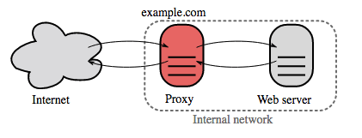](https://github.com/donnemartin/system-design-primer/blob/master/images/n41Azff.png)  
[*Source: Wikipedia*](https://upload.wikimedia.org/wikipedia/commons/6/67/Reverse_proxy_h2g2bob.svg)

A reverse proxy is a web server that centralizes internal services and provides unified interfaces to the public. Requests from clients are forwarded to a server that can fulfill it before the reverse proxy returns the server's response to the client.

Additional benefits include:

* **Increased security** - Hide information about backend servers, blacklist IPs, limit number of connections per client
* **Increased scalability and flexibility** - Clients only see the reverse proxy's IP, allowing you to scale servers or change their configuration
* **SSL termination** - Decrypt incoming requests and encrypt server responses so backend servers do not have to perform these potentially expensive operations
  + Removes the need to install [X.509 certificates](https://en.wikipedia.org/wiki/X.509) on each server
* **Compression** - Compress server responses
* **Caching** - Return the response for cached requests
* **Static content** - Serve static content directly
  + HTML/CSS/JS
  + Photos
  + Videos
  + Etc

### Load balancer vs reverse proxy

* Deploying a load balancer is useful when you have multiple servers. Often, load balancers route traffic to a set of servers serving the same function.
* Reverse proxies can be useful even with just one web server or application server, opening up the benefits described in the previous section.
* Solutions such as NGINX and HAProxy can support both layer 7 reverse proxying and load balancing.

### Disadvantage(s): reverse proxy

* Introducing a reverse proxy results in increased complexity.
* A single reverse proxy is a single point of failure, configuring multiple reverse proxies (ie a [failover](https://en.wikipedia.org/wiki/Failover)) further increases complexity.

### Source(s) and further reading

* [Reverse proxy vs load balancer](https://www.nginx.com/resources/glossary/reverse-proxy-vs-load-balancer/)
* [NGINX architecture](https://www.nginx.com/blog/inside-nginx-how-we-designed-for-performance-scale/)
* [HAProxy architecture guide](http://www.haproxy.org/download/1.2/doc/architecture.txt)
* [Wikipedia](https://en.wikipedia.org/wiki/Reverse_proxy)

## Application layer

[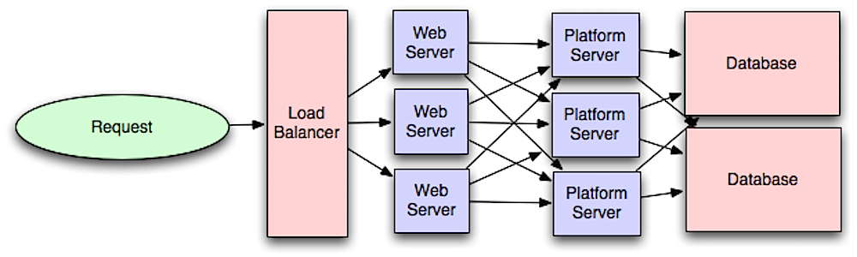](https://github.com/donnemartin/system-design-primer/blob/master/images/yB5SYwm.png)  
[*Source: Intro to architecting systems for scale*](http://lethain.com/introduction-to-architecting-systems-for-scale/#platform_layer)

Separating out the web layer from the application layer (also known as platform layer) allows you to scale and configure both layers independently. Adding a new API results in adding application servers without necessarily adding additional web servers. The **single responsibility principle** advocates for small and autonomous services that work together. Small teams with small services can plan more aggressively for rapid growth.

Workers in the application layer also help enable [asynchronism](https://github.com/donnemartin/system-design-primer#asynchronism).

### Microservices

Related to this discussion are [microservices](https://en.wikipedia.org/wiki/Microservices), which can be described as a suite of independently deployable, small, modular services. Each service runs a unique process and communicates through a well-defined, lightweight mechanism to serve a business goal. [1](https://smartbear.com/learn/api-design/what-are-microservices)

Pinterest, for example, could have the following microservices: user profile, follower, feed, search, photo upload, etc.

### Service Discovery

Systems such as [Consul](https://www.consul.io/docs/index.html), [Etcd](https://coreos.com/etcd/docs/latest), and [Zookeeper](http://www.slideshare.net/sauravhaloi/introduction-to-apache-zookeeper) can help services find each other by keeping track of registered names, addresses, and ports. [Health checks](https://www.consul.io/intro/getting-started/checks.html) help verify service integrity and are often done using an [HTTP](https://github.com/donnemartin/system-design-primer#hypertext-transfer-protocol-http) endpoint. Both Consul and Etcd have a built in [key-value store](https://github.com/donnemartin/system-design-primer#key-value-store) that can be useful for storing config values and other shared data.

### Disadvantage(s): application layer

* Adding an application layer with loosely coupled services requires a different approach from an architectural, operations, and process viewpoint (vs a monolithic system).
* Microservices can add complexity in terms of deployments and operations.

### Source(s) and further reading

* [Intro to architecting systems for scale](http://lethain.com/introduction-to-architecting-systems-for-scale)
* [Crack the system design interview](http://www.puncsky.com/blog/2016-02-13-crack-the-system-design-interview)
* [Service oriented architecture](https://en.wikipedia.org/wiki/Service-oriented_architecture)
* [Introduction to Zookeeper](http://www.slideshare.net/sauravhaloi/introduction-to-apache-zookeeper)
* [Here's what you need to know about building microservices](https://cloudncode.wordpress.com/2016/07/22/msa-getting-started/)

## Database

[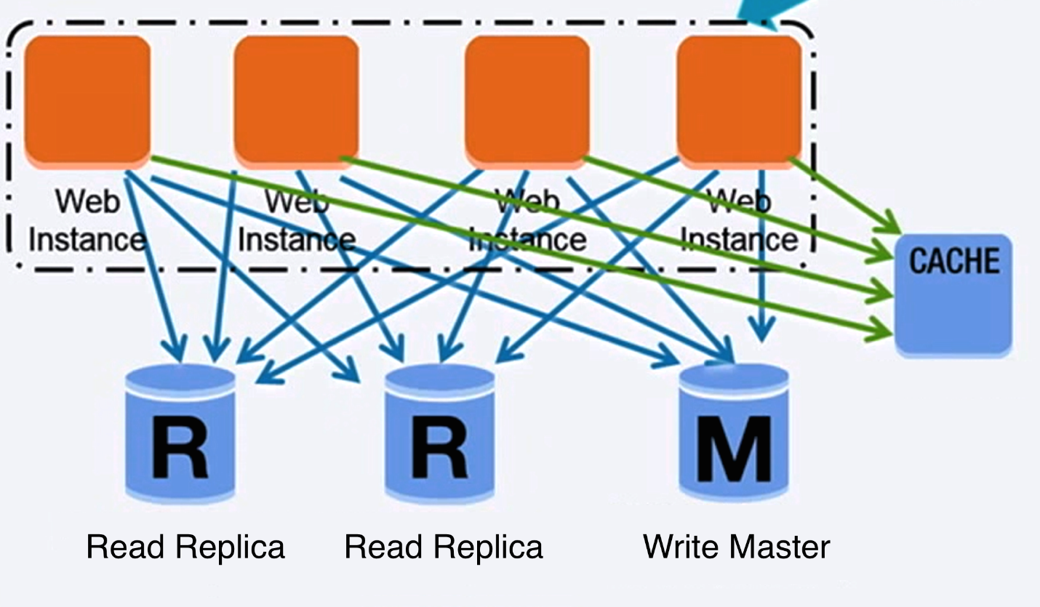](https://github.com/donnemartin/system-design-primer/blob/master/images/Xkm5CXz.png)  
[*Source: Scaling up to your first 10 million users*](https://www.youtube.com/watch?v=kKjm4ehYiMs)

### Relational database management system (RDBMS)

A relational database like SQL is a collection of data items organized in tables.

**ACID** is a set of properties of relational database [transactions](https://en.wikipedia.org/wiki/Database_transaction).

* **Atomicity** - Each transaction is all or nothing
* **Consistency** - Any transaction will bring the database from one valid state to another
* **Isolation** - Executing transactions concurrently has the same results as if the transactions were executed serially
* **Durability** - Once a transaction has been committed, it will remain so

There are many techniques to scale a relational database: **master-slave replication**, **master-master replication**, **federation**, **sharding**, **denormalization**, and **SQL tuning**.

#### Master-slave replication

The master serves reads and writes, replicating writes to one or more slaves, which serve only reads. Slaves can also replicate to additional slaves in a tree-like fashion. If the master goes offline, the system can continue to operate in read-only mode until a slave is promoted to a master or a new master is provisioned.

[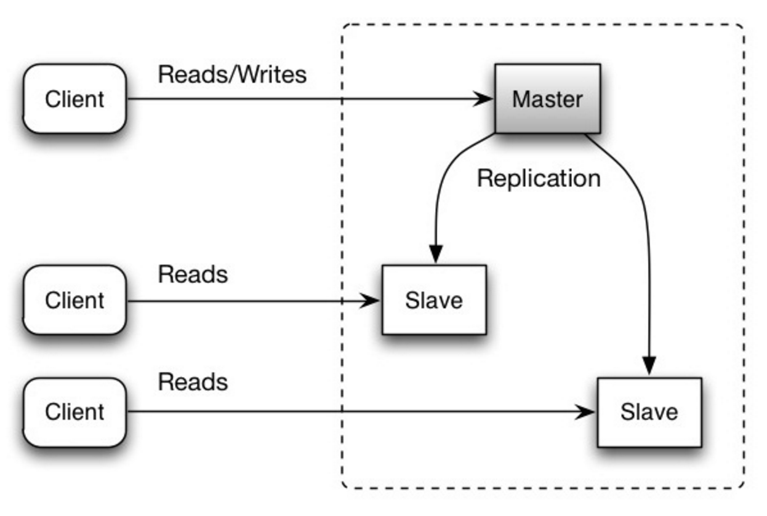](https://github.com/donnemartin/system-design-primer/blob/master/images/C9ioGtn.png)  
[*Source: Scalability, availability, stability, patterns*](http://www.slideshare.net/jboner/scalability-availability-stability-patterns/)

##### Disadvantage(s): master-slave replication

* Additional logic is needed to promote a slave to a master.
* See [Disadvantage(s): replication](https://github.com/donnemartin/system-design-primer#disadvantages-replication) for points related to **both** master-slave and master-master.

#### Master-master replication

Both masters serve reads and writes and coordinate with each other on writes. If either master goes down, the system can continue to operate with both reads and writes.

[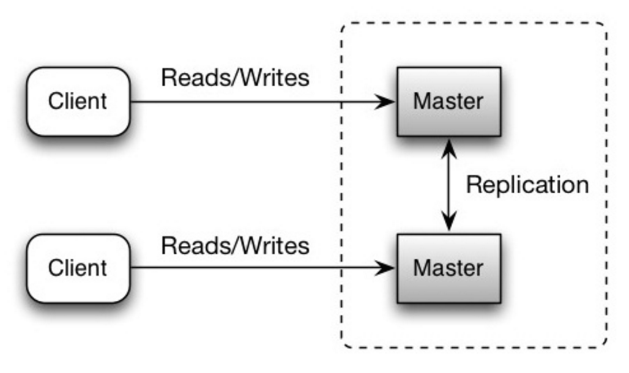](https://github.com/donnemartin/system-design-primer/blob/master/images/krAHLGg.png)  
[*Source: Scalability, availability, stability, patterns*](http://www.slideshare.net/jboner/scalability-availability-stability-patterns/)

##### Disadvantage(s): master-master replication

* You'll need a load balancer or you'll need to make changes to your application logic to determine where to write.
* Most master-master systems are either loosely consistent (violating ACID) or have increased write latency due to synchronization.
* Conflict resolution comes more into play as more write nodes are added and as latency increases.
* See [Disadvantage(s): replication](https://github.com/donnemartin/system-design-primer#disadvantages-replication) for points related to **both** master-slave and master-master.

##### Disadvantage(s): replication

* There is a potential for loss of data if the master fails before any newly written data can be replicated to other nodes.
* Writes are replayed to the read replicas. If there are a lot of writes, the read replicas can get bogged down with replaying writes and can't do as many reads.
* The more read slaves, the more you have to replicate, which leads to greater replication lag.
* On some systems, writing to the master can spawn multiple threads to write in parallel, whereas read replicas only support writing sequentially with a single thread.
* Replication adds more hardware and additional complexity.

##### Source(s) and further reading: replication

* [Scalability, availability, stability, patterns](http://www.slideshare.net/jboner/scalability-availability-stability-patterns/)
* [Multi-master replication](https://en.wikipedia.org/wiki/Multi-master_replication)

#### Federation

[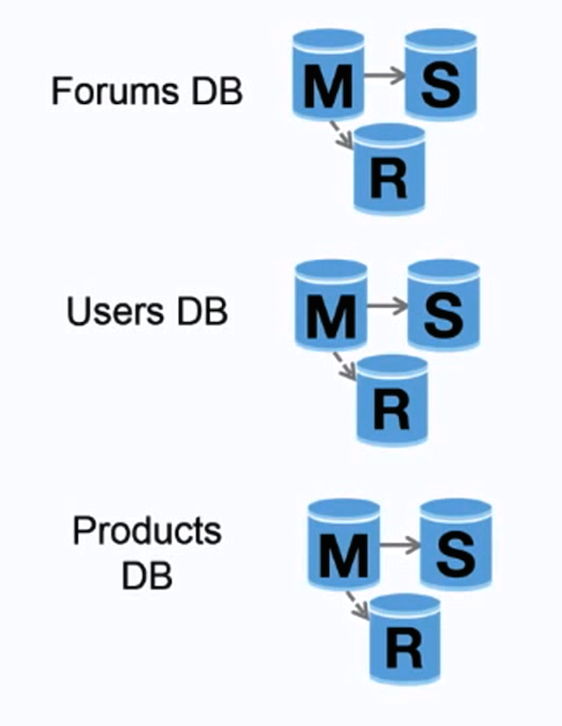](https://github.com/donnemartin/system-design-primer/blob/master/images/U3qV33e.png)  
[*Source: Scaling up to your first 10 million users*](https://www.youtube.com/watch?v=kKjm4ehYiMs)

Federation (or functional partitioning) splits up databases by function. For example, instead of a single, monolithic database, you could have three databases: **forums**, **users**, and **products**, resulting in less read and write traffic to each database and therefore less replication lag. Smaller databases result in more data that can fit in memory, which in turn results in more cache hits due to improved cache locality. With no single central master serializing writes you can write in parallel, increasing throughput.

##### Disadvantage(s): federation

* Federation is not effective if your schema requires huge functions or tables.
* You'll need to update your application logic to determine which database to read and write.
* Joining data from two databases is more complex with a [server link](http://stackoverflow.com/questions/5145637/querying-data-by-joining-two-tables-in-two-database-on-different-servers).
* Federation adds more hardware and additional complexity.

##### Source(s) and further reading: federation

* [Scaling up to your first 10 million users](https://www.youtube.com/watch?v=kKjm4ehYiMs)

#### Sharding

[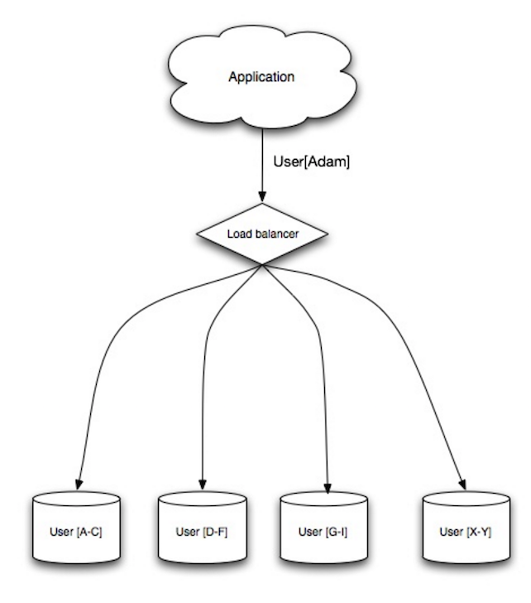](https://github.com/donnemartin/system-design-primer/blob/master/images/wU8x5Id.png)  
[*Source: Scalability, availability, stability, patterns*](http://www.slideshare.net/jboner/scalability-availability-stability-patterns/)

Sharding distributes data across different databases such that each database can only manage a subset of the data. Taking a users database as an example, as the number of users increases, more shards are added to the cluster.

Similar to the advantages of [federation](https://github.com/donnemartin/system-design-primer#federation), sharding results in less read and write traffic, less replication, and more cache hits. Index size is also reduced, which generally improves performance with faster queries. If one shard goes down, the other shards are still operational, although you'll want to add some form of replication to avoid data loss. Like federation, there is no single central master serializing writes, allowing you to write in parallel with increased throughput.

Common ways to shard a table of users is either through the user's last name initial or the user's geographic location.

##### Disadvantage(s): sharding

* You'll need to update your application logic to work with shards, which could result in complex SQL queries.
* Data distribution can become lopsided in a shard. For example, a set of power users on a shard could result in increased load to that shard compared to others.
  + Rebalancing adds additional complexity. A sharding function based on [consistent hashing](http://www.paperplanes.de/2011/12/9/the-magic-of-consistent-hashing.html) can reduce the amount of transferred data.
* Joining data from multiple shards is more complex.
* Sharding adds more hardware and additional complexity.

##### Source(s) and further reading: sharding

* [The coming of the shard](http://highscalability.com/blog/2009/8/6/an-unorthodox-approach-to-database-design-the-coming-of-the.html)
* [Shard database architecture](https://en.wikipedia.org/wiki/Shard_(database_architecture))
* [Consistent hashing](http://www.paperplanes.de/2011/12/9/the-magic-of-consistent-hashing.html)

#### Denormalization

Denormalization attempts to improve read performance at the expense of some write performance. Redundant copies of the data are written in multiple tables to avoid expensive joins. Some RDBMS such as [PostgreSQL](https://en.wikipedia.org/wiki/PostgreSQL) and Oracle support [materialized views](https://en.wikipedia.org/wiki/Materialized_view) which handle the work of storing redundant information and keeping redundant copies consistent.

Once data becomes distributed with techniques such as [federation](https://github.com/donnemartin/system-design-primer#federation) and [sharding](https://github.com/donnemartin/system-design-primer" \l "sharding), managing joins across data centers further increases complexity. Denormalization might circumvent the need for such complex joins.

In most systems, reads can heavily outnumber writes 100:1 or even 1000:1. A read resulting in a complex database join can be very expensive, spending a significant amount of time on disk operations.

##### Disadvantage(s): denormalization

* Data is duplicated.
* Constraints can help redundant copies of information stay in sync, which increases complexity of the database design.
* A denormalized database under heavy write load might perform worse than its normalized counterpart.

###### Source(s) and further reading: denormalization

* [Denormalization](https://en.wikipedia.org/wiki/Denormalization)

#### SQL tuning

SQL tuning is a broad topic and many [books](https://www.amazon.com/s/ref=nb_sb_noss_2?url=search-alias%3Daps&field-keywords=sql+tuning) have been written as reference.

It's important to **benchmark** and **profile** to simulate and uncover bottlenecks.

* **Benchmark** - Simulate high-load situations with tools such as [ab](http://httpd.apache.org/docs/2.2/programs/ab.html).
* **Profile** - Enable tools such as the [slow query log](http://dev.mysql.com/doc/refman/5.7/en/slow-query-log.html) to help track performance issues.

Benchmarking and profiling might point you to the following optimizations.

##### Tighten up the schema

* MySQL dumps to disk in contiguous blocks for fast access.
* Use CHAR instead of VARCHAR for fixed-length fields.
  + CHAR effectively allows for fast, random access, whereas with VARCHAR, you must find the end of a string before moving onto the next one.
* Use TEXT for large blocks of text such as blog posts. TEXT also allows for boolean searches. Using a TEXT field results in storing a pointer on disk that is used to locate the text block.
* Use INT for larger numbers up to 2^32 or 4 billion.
* Use DECIMAL for currency to avoid floating point representation errors.
* Avoid storing large BLOBS, store the location of where to get the object instead.
* VARCHAR(255) is the largest number of characters that can be counted in an 8 bit number, often maximizing the use of a byte in some RDBMS.
* Set the NOT NULL constraint where applicable to [improve search performance](http://stackoverflow.com/questions/1017239/how-do-null-values-affect-performance-in-a-database-search).

##### Use good indices

* Columns that you are querying (SELECT, GROUP BY, ORDER BY, JOIN) could be faster with indices.
* Indices are usually represented as self-balancing [B-tree](https://en.wikipedia.org/wiki/B-tree) that keeps data sorted and allows searches, sequential access, insertions, and deletions in logarithmic time.
* Placing an index can keep the data in memory, requiring more space.
* Writes could also be slower since the index also needs to be updated.
* When loading large amounts of data, it might be faster to disable indices, load the data, then rebuild the indices.

##### Avoid expensive joins

* [Denormalize](https://github.com/donnemartin/system-design-primer#denormalization) where performance demands it.

##### Partition tables

* Break up a table by putting hot spots in a separate table to help keep it in memory.

##### Tune the query cache

* In some cases, the [query cache](https://dev.mysql.com/doc/refman/5.7/en/query-cache.html) could lead to [performance issues](https://www.percona.com/blog/2016/10/12/mysql-5-7-performance-tuning-immediately-after-installation/).

##### Source(s) and further reading: SQL tuning

* [Tips for optimizing MySQL queries](http://aiddroid.com/10-tips-optimizing-mysql-queries-dont-suck/)
* [Is there a good reason i see VARCHAR(255) used so often?](http://stackoverflow.com/questions/1217466/is-there-a-good-reason-i-see-varchar255-used-so-often-as-opposed-to-another-l)
* [How do null values affect performance?](http://stackoverflow.com/questions/1017239/how-do-null-values-affect-performance-in-a-database-search)
* [Slow query log](http://dev.mysql.com/doc/refman/5.7/en/slow-query-log.html)

### NoSQL

NoSQL is a collection of data items represented in a **key-value store**, **document store**, **wide column store**, or a **graph database**. Data is denormalized, and joins are generally done in the application code. Most NoSQL stores lack true ACID transactions and favor [eventual consistency](https://github.com/donnemartin/system-design-primer#eventual-consistency).

**BASE** is often used to describe the properties of NoSQL databases. In comparison with the [CAP Theorem](https://github.com/donnemartin/system-design-primer#cap-theorem), BASE chooses availability over consistency.

* **Basically available** - the system guarantees availability.
* **Soft state** - the state of the system may change over time, even without input.
* **Eventual consistency** - the system will become consistent over a period of time, given that the system doesn't receive input during that period.

In addition to choosing between [SQL or NoSQL](https://github.com/donnemartin/system-design-primer#sql-or-nosql), it is helpful to understand which type of NoSQL database best fits your use case(s). We'll review **key-value stores**, **document stores**, **wide column stores**, and **graph databases** in the next section.

#### Key-value store

Abstraction: hash table

A key-value store generally allows for O(1) reads and writes and is often backed by memory or SSD. Data stores can maintain keys in [lexicographic order](https://en.wikipedia.org/wiki/Lexicographical_order), allowing efficient retrieval of key ranges. Key-value stores can allow for storing of metadata with a value.

Key-value stores provide high performance and are often used for simple data models or for rapidly-changing data, such as an in-memory cache layer. Since they offer only a limited set of operations, complexity is shifted to the application layer if additional operations are needed.

A key-value store is the basis for more complex systems such as a document store, and in some cases, a graph database.

##### Source(s) and further reading: key-value store

* [Key-value database](https://en.wikipedia.org/wiki/Key-value_database)
* [Disadvantages of key-value stores](http://stackoverflow.com/questions/4056093/what-are-the-disadvantages-of-using-a-key-value-table-over-nullable-columns-or)
* [Redis architecture](http://qnimate.com/overview-of-redis-architecture/)
* [Memcached architecture](https://adayinthelifeof.nl/2011/02/06/memcache-internals/)

#### Document store

Abstraction: key-value store with documents stored as values

A document store is centered around documents (XML, JSON, binary, etc), where a document stores all information for a given object. Document stores provide APIs or a query language to query based on the internal structure of the document itself. Note, many key-value stores include features for working with a value's metadata, blurring the lines between these two storage types.

Based on the underlying implementation, documents are organized by collections, tags, metadata, or directories. Although documents can be organized or grouped together, documents may have fields that are completely different from each other.

Some document stores like [MongoDB](https://www.mongodb.com/mongodb-architecture) and [CouchDB](https://blog.couchdb.org/2016/08/01/couchdb-2-0-architecture/) also provide a SQL-like language to perform complex queries. [DynamoDB](http://www.read.seas.harvard.edu/~kohler/class/cs239-w08/decandia07dynamo.pdf) supports both key-values and documents.

Document stores provide high flexibility and are often used for working with occasionally changing data.

##### Source(s) and further reading: document store

* [Document-oriented database](https://en.wikipedia.org/wiki/Document-oriented_database)
* [MongoDB architecture](https://www.mongodb.com/mongodb-architecture)
* [CouchDB architecture](https://blog.couchdb.org/2016/08/01/couchdb-2-0-architecture/)
* [Elasticsearch architecture](https://www.elastic.co/blog/found-elasticsearch-from-the-bottom-up)

#### Wide column store

[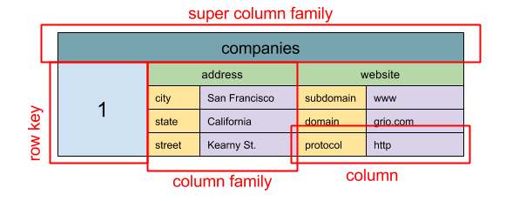](https://github.com/donnemartin/system-design-primer/blob/master/images/n16iOGk.png)  
[*Source: SQL & NoSQL, a brief history*](http://blog.grio.com/2015/11/sql-nosql-a-brief-history.html)

Abstraction: nested map ColumnFamily<RowKey, Columns<ColKey, Value, Timestamp>>

A wide column store's basic unit of data is a column (name/value pair). A column can be grouped in column families (analogous to a SQL table). Super column families further group column families. You can access each column independently with a row key, and columns with the same row key form a row. Each value contains a timestamp for versioning and for conflict resolution.

Google introduced [Bigtable](http://www.read.seas.harvard.edu/~kohler/class/cs239-w08/chang06bigtable.pdf) as the first wide column store, which influenced the open-source [HBase](https://www.edureka.co/blog/hbase-architecture/) often-used in the Hadoop ecosystem, and [Cassandra](http://docs.datastax.com/en/cassandra/3.0/cassandra/architecture/archIntro.html) from Facebook. Stores such as BigTable, HBase, and Cassandra maintain keys in lexicographic order, allowing efficient retrieval of selective key ranges.

Wide column stores offer high availability and high scalability. They are often used for very large data sets.

##### Source(s) and further reading: wide column store

* [SQL & NoSQL, a brief history](http://blog.grio.com/2015/11/sql-nosql-a-brief-history.html)
* [Bigtable architecture](http://www.read.seas.harvard.edu/~kohler/class/cs239-w08/chang06bigtable.pdf)
* [HBase architecture](https://www.edureka.co/blog/hbase-architecture/)
* [Cassandra architecture](http://docs.datastax.com/en/cassandra/3.0/cassandra/architecture/archIntro.html)

#### Graph database

[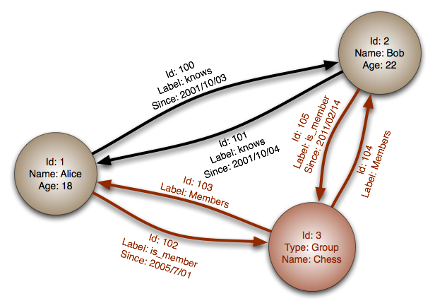](https://github.com/donnemartin/system-design-primer/blob/master/images/fNcl65g.png)  
[*Source: Graph database*](https://en.wikipedia.org/wiki/File:GraphDatabase_PropertyGraph.png)

Abstraction: graph

In a graph database, each node is a record and each arc is a relationship between two nodes. Graph databases are optimized to represent complex relationships with many foreign keys or many-to-many relationships.

Graphs databases offer high performance for data models with complex relationships, such as a social network. They are relatively new and are not yet widely-used; it might be more difficult to find development tools and resources. Many graphs can only be accessed with [REST APIs](https://github.com/donnemartin/system-design-primer#representational-state-transfer-rest).

##### Source(s) and further reading: graph

* [Graph database](https://en.wikipedia.org/wiki/Graph_database)
* [Neo4j](https://neo4j.com/)
* [FlockDB](https://blog.twitter.com/2010/introducing-flockdb)

#### Source(s) and further reading: NoSQL

* [Explanation of base terminology](http://stackoverflow.com/questions/3342497/explanation-of-base-terminology)
* [NoSQL databases a survey and decision guidance](https://medium.com/baqend-blog/nosql-databases-a-survey-and-decision-guidance-ea7823a822d#.wskogqenq)
* [Scalability](http://www.lecloud.net/post/7994751381/scalability-for-dummies-part-2-database)
* [Introduction to NoSQL](https://www.youtube.com/watch?v=qI_g07C_Q5I)
* [NoSQL patterns](http://horicky.blogspot.com/2009/11/nosql-patterns.html)

### SQL or NoSQL

[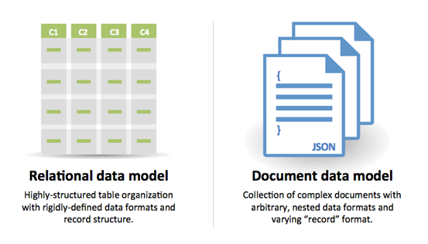](https://github.com/donnemartin/system-design-primer/blob/master/images/wXGqG5f.png)  
[*Source: Transitioning from RDBMS to NoSQL*](https://www.infoq.com/articles/Transition-RDBMS-NoSQL/)

Reasons for **SQL**:

* Structured data
* Strict schema
* Relational data
* Need for complex joins
* Transactions
* Clear patterns for scaling
* More established: developers, community, code, tools, etc
* Lookups by index are very fast

Reasons for **NoSQL**:

* Semi-structured data
* Dynamic or flexible schema
* Non-relational data
* No need for complex joins
* Store many TB (or PB) of data
* Very data intensive workload
* Very high throughput for IOPS

Sample data well-suited for NoSQL:

* Rapid ingest of clickstream and log data
* Leaderboard or scoring data
* Temporary data, such as a shopping cart
* Frequently accessed ('hot') tables
* Metadata/lookup tables

##### Source(s) and further reading: SQL or NoSQL

* [Scaling up to your first 10 million users](https://www.youtube.com/watch?v=kKjm4ehYiMs)
* [SQL vs NoSQL differences](https://www.sitepoint.com/sql-vs-nosql-differences/)

## Cache

[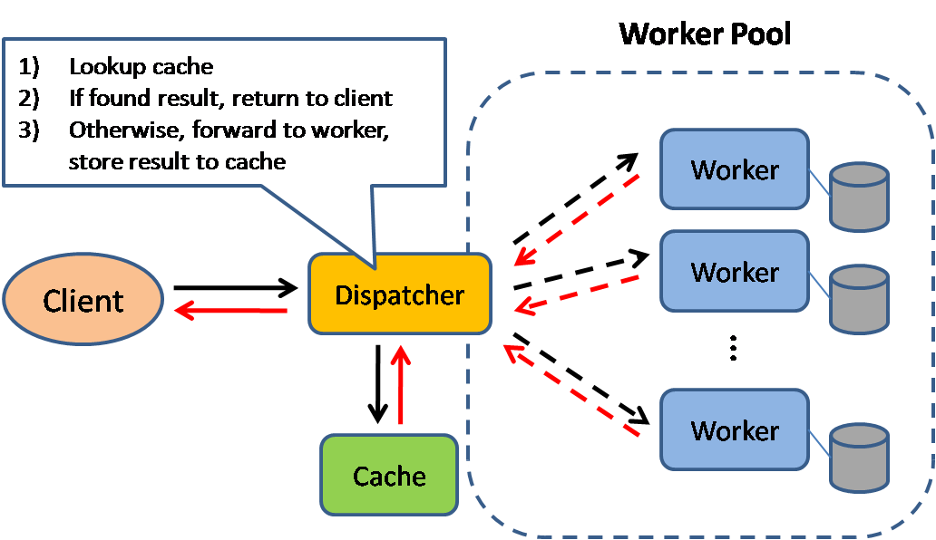](https://github.com/donnemartin/system-design-primer/blob/master/images/Q6z24La.png)  
[*Source: Scalable system design patterns*](http://horicky.blogspot.com/2010/10/scalable-system-design-patterns.html)

Caching improves page load times and can reduce the load on your servers and databases. In this model, the dispatcher will first lookup if the request has been made before and try to find the previous result to return, in order to save the actual execution.

Databases often benefit from a uniform distribution of reads and writes across its partitions. Popular items can skew the distribution, causing bottlenecks. Putting a cache in front of a database can help absorb uneven loads and spikes in traffic.

### Client caching

Caches can be located on the client side (OS or browser), [server side](https://github.com/donnemartin/system-design-primer#reverse-proxy-web-server), or in a distinct cache layer.

### CDN caching

[CDNs](https://github.com/donnemartin/system-design-primer#content-delivery-network) are considered a type of cache.

### Web server caching

[Reverse proxies](https://github.com/donnemartin/system-design-primer#reverse-proxy-web-server) and caches such as [Varnish](https://www.varnish-cache.org/) can serve static and dynamic content directly. Web servers can also cache requests, returning responses without having to contact application servers.

### Database caching

Your database usually includes some level of caching in a default configuration, optimized for a generic use case. Tweaking these settings for specific usage patterns can further boost performance.

### Application caching

In-memory caches such as Memcached and Redis are key-value stores between your application and your data storage. Since the data is held in RAM, it is much faster than typical databases where data is stored on disk. RAM is more limited than disk, so [cache invalidation](https://en.wikipedia.org/wiki/Cache_algorithms) algorithms such as [least recently used (LRU)](https://en.wikipedia.org/wiki/Cache_replacement_policies#Least_recently_used_(LRU)) can help invalidate 'cold' entries and keep 'hot' data in RAM.

Redis has the following additional features:

* Persistence option
* Built-in data structures such as sorted sets and lists

There are multiple levels you can cache that fall into two general categories: **database queries** and **objects**:

* Row level
* Query-level
* Fully-formed serializable objects
* Fully-rendered HTML

Generally, you should try to avoid file-based caching, as it makes cloning and auto-scaling more difficult.

### Caching at the database query level

Whenever you query the database, hash the query as a key and store the result to the cache. This approach suffers from expiration issues:

* Hard to delete a cached result with complex queries
* If one piece of data changes such as a table cell, you need to delete all cached queries that might include the changed cell

### Caching at the object level

See your data as an object, similar to what you do with your application code. Have your application assemble the dataset from the database into a class instance or a data structure(s):

* Remove the object from cache if its underlying data has changed
* Allows for asynchronous processing: workers assemble objects by consuming the latest cached object

Suggestions of what to cache:

* User sessions
* Fully rendered web pages
* Activity streams
* User graph data

### When to update the cache

Since you can only store a limited amount of data in cache, you'll need to determine which cache update strategy works best for your use case.

#### Cache-aside

[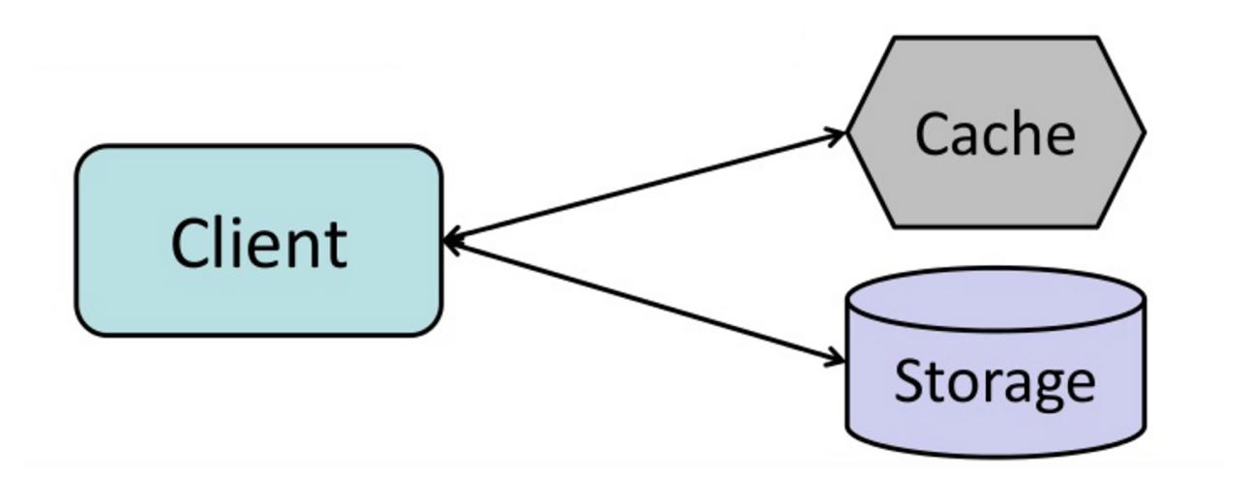](https://github.com/donnemartin/system-design-primer/blob/master/images/ONjORqk.png)  
[*Source: From cache to in-memory data grid*](http://www.slideshare.net/tmatyashovsky/from-cache-to-in-memory-data-grid-introduction-to-hazelcast)

The application is responsible for reading and writing from storage. The cache does not interact with storage directly. The application does the following:

* Look for entry in cache, resulting in a cache miss
* Load entry from the database
* Add entry to cache
* Return entry

def get\_user(self, user\_id):

user = cache.get("user.{0}", user\_id)

if user is None:

user = db.query("SELECT \* FROM users WHERE user\_id = {0}", user\_id)

if user is not None:

key = "user.{0}".format(user\_id)

cache.set(key, json.dumps(user))

return user

[Memcached](https://memcached.org/) is generally used in this manner.

Subsequent reads of data added to cache are fast. Cache-aside is also referred to as lazy loading. Only requested data is cached, which avoids filling up the cache with data that isn't requested.

##### Disadvantage(s): cache-aside

* Each cache miss results in three trips, which can cause a noticeable delay.
* Data can become stale if it is updated in the database. This issue is mitigated by setting a time-to-live (TTL) which forces an update of the cache entry, or by using write-through.
* When a node fails, it is replaced by a new, empty node, increasing latency.

#### Write-through

[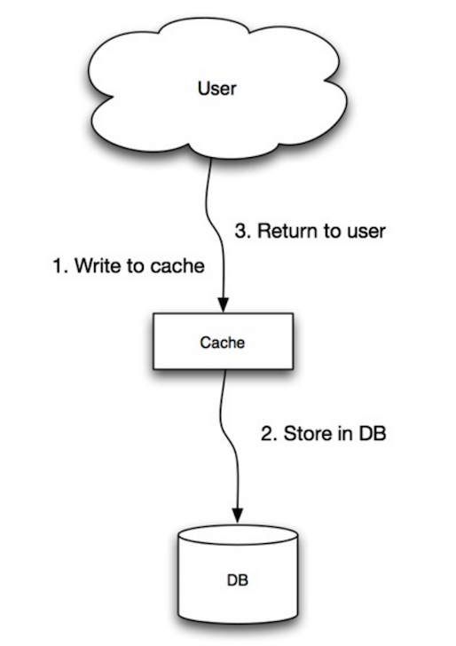](https://github.com/donnemartin/system-design-primer/blob/master/images/0vBc0hN.png)  
[*Source: Scalability, availability, stability, patterns*](http://www.slideshare.net/jboner/scalability-availability-stability-patterns/)

The application uses the cache as the main data store, reading and writing data to it, while the cache is responsible for reading and writing to the database:

* Application adds/updates entry in cache
* Cache synchronously writes entry to data store
* Return

Application code:

set\_user(12345, {"foo":"bar"})

Cache code:

def set\_user(user\_id, values):

user = db.query("UPDATE Users WHERE id = {0}", user\_id, values)

cache.set(user\_id, user)

Write-through is a slow overall operation due to the write operation, but subsequent reads of just written data are fast. Users are generally more tolerant of latency when updating data than reading data. Data in the cache is not stale.

##### Disadvantage(s): write through

* When a new node is created due to failure or scaling, the new node will not cache entries until the entry is updated in the database. Cache-aside in conjunction with write through can mitigate this issue.
* Most data written might never be read, which can be minimized with a TTL.

#### Write-behind (write-back)

[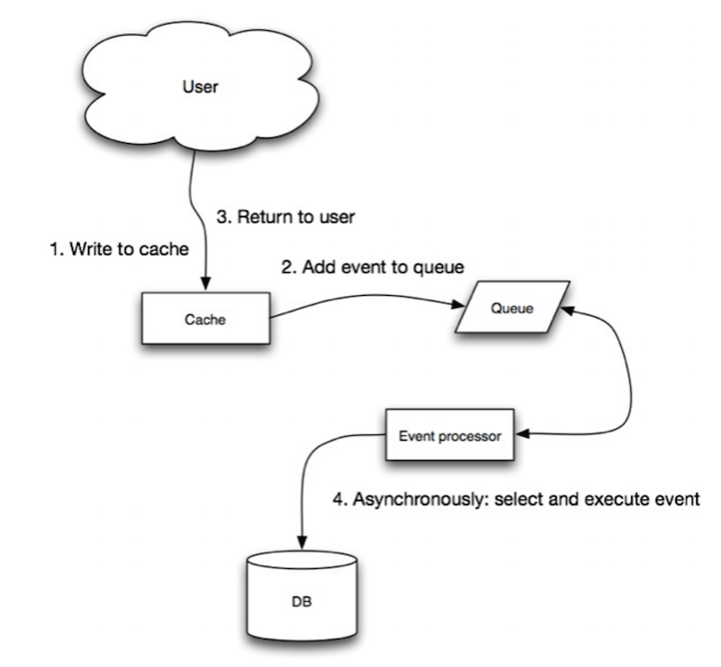](https://github.com/donnemartin/system-design-primer/blob/master/images/rgSrvjG.png)  
[*Source: Scalability, availability, stability, patterns*](http://www.slideshare.net/jboner/scalability-availability-stability-patterns/)

In write-behind, the application does the following:

* Add/update entry in cache
* Asynchronously write entry to the data store, improving write performance

##### Disadvantage(s): write-behind

* There could be data loss if the cache goes down prior to its contents hitting the data store.
* It is more complex to implement write-behind than it is to implement cache-aside or write-through.

#### Refresh-ahead

[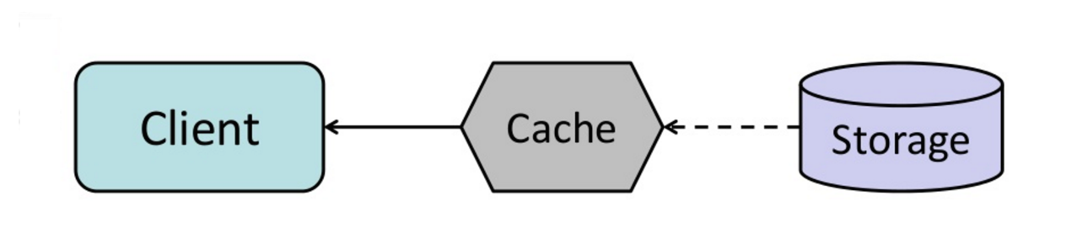](https://github.com/donnemartin/system-design-primer/blob/master/images/kxtjqgE.png)  
[*Source: From cache to in-memory data grid*](http://www.slideshare.net/tmatyashovsky/from-cache-to-in-memory-data-grid-introduction-to-hazelcast)

You can configure the cache to automatically refresh any recently accessed cache entry prior to its expiration.

Refresh-ahead can result in reduced latency vs read-through if the cache can accurately predict which items are likely to be needed in the future.

##### Disadvantage(s): refresh-ahead

* Not accurately predicting which items are likely to be needed in the future can result in reduced performance than without refresh-ahead.

### Disadvantage(s): cache

* Need to maintain consistency between caches and the source of truth such as the database through [cache invalidation](https://en.wikipedia.org/wiki/Cache_algorithms).
* Cache invalidation is a difficult problem, there is additional complexity associated with when to update the cache.
* Need to make application changes such as adding Redis or memcached.

### Source(s) and further reading

* [From cache to in-memory data grid](http://www.slideshare.net/tmatyashovsky/from-cache-to-in-memory-data-grid-introduction-to-hazelcast)
* [Scalable system design patterns](http://horicky.blogspot.com/2010/10/scalable-system-design-patterns.html)
* [Introduction to architecting systems for scale](http://lethain.com/introduction-to-architecting-systems-for-scale/)
* [Scalability, availability, stability, patterns](http://www.slideshare.net/jboner/scalability-availability-stability-patterns/)
* [Scalability](http://www.lecloud.net/post/9246290032/scalability-for-dummies-part-3-cache)
* [AWS ElastiCache strategies](http://docs.aws.amazon.com/AmazonElastiCache/latest/UserGuide/Strategies.html)
* [Wikipedia](https://en.wikipedia.org/wiki/Cache_(computing))

## Asynchronism

[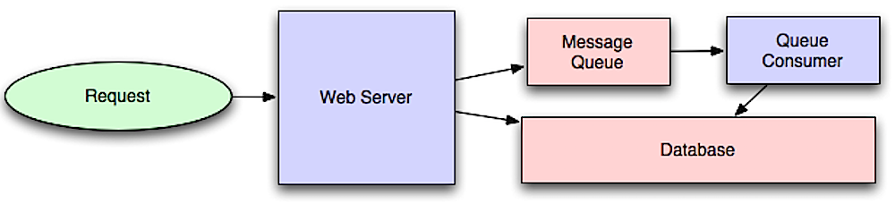](https://github.com/donnemartin/system-design-primer/blob/master/images/54GYsSx.png)  
[*Source: Intro to architecting systems for scale*](http://lethain.com/introduction-to-architecting-systems-for-scale/#platform_layer)

Asynchronous workflows help reduce request times for expensive operations that would otherwise be performed in-line. They can also help by doing time-consuming work in advance, such as periodic aggregation of data.

### Message queues

Message queues receive, hold, and deliver messages. If an operation is too slow to perform inline, you can use a message queue with the following workflow:

* An application publishes a job to the queue, then notifies the user of job status
* A worker picks up the job from the queue, processes it, then signals the job is complete

The user is not blocked and the job is processed in the background. During this time, the client might optionally do a small amount of processing to make it seem like the task has completed. For example, if posting a tweet, the tweet could be instantly posted to your timeline, but it could take some time before your tweet is actually delivered to all of your followers.

[**Redis**](https://redis.io/) is useful as a simple message broker but messages can be lost.

[**RabbitMQ**](https://www.rabbitmq.com/) is popular but requires you to adapt to the 'AMQP' protocol and manage your own nodes.

[**Amazon SQS**](https://aws.amazon.com/sqs/) is hosted but can have high latency and has the possibility of messages being delivered twice.

### Task queues

Tasks queues receive tasks and their related data, runs them, then delivers their results. They can support scheduling and can be used to run computationally-intensive jobs in the background.

[**Celery**](https://docs.celeryproject.org/en/stable/) has support for scheduling and primarily has python support.

### Back pressure

If queues start to grow significantly, the queue size can become larger than memory, resulting in cache misses, disk reads, and even slower performance. [Back pressure](http://mechanical-sympathy.blogspot.com/2012/05/apply-back-pressure-when-overloaded.html) can help by limiting the queue size, thereby maintaining a high throughput rate and good response times for jobs already in the queue. Once the queue fills up, clients get a server busy or HTTP 503 status code to try again later. Clients can retry the request at a later time, perhaps with [exponential backoff](https://en.wikipedia.org/wiki/Exponential_backoff).

### Disadvantage(s): asynchronism

* Use cases such as inexpensive calculations and realtime workflows might be better suited for synchronous operations, as introducing queues can add delays and complexity.

### Source(s) and further reading

* [It's all a numbers game](https://www.youtube.com/watch?v=1KRYH75wgy4)
* [Applying back pressure when overloaded](http://mechanical-sympathy.blogspot.com/2012/05/apply-back-pressure-when-overloaded.html)
* [Little's law](https://en.wikipedia.org/wiki/Little%27s_law)
* [What is the difference between a message queue and a task queue?](https://www.quora.com/What-is-the-difference-between-a-message-queue-and-a-task-queue-Why-would-a-task-queue-require-a-message-broker-like-RabbitMQ-Redis-Celery-or-IronMQ-to-function)

## Communication

[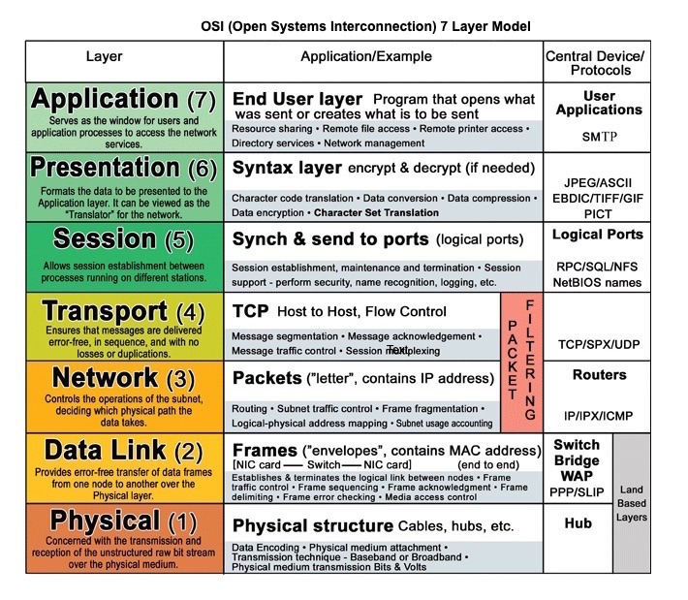](https://github.com/donnemartin/system-design-primer/blob/master/images/5KeocQs.jpg)  
[*Source: OSI 7 layer model*](http://www.escotal.com/osilayer.html)

### Hypertext transfer protocol (HTTP)

HTTP is a method for encoding and transporting data between a client and a server. It is a request/response protocol: clients issue requests and servers issue responses with relevant content and completion status info about the request. HTTP is self-contained, allowing requests and responses to flow through many intermediate routers and servers that perform load balancing, caching, encryption, and compression.

A basic HTTP request consists of a verb (method) and a resource (endpoint). Below are common HTTP verbs:

| **Verb** | **Description** | **Idempotent\*** | **Safe** | **Cacheable** |
| --- | --- | --- | --- | --- |
| GET | Reads a resource | Yes | Yes | Yes |
| POST | Creates a resource or trigger a process that handles data | No | No | Yes if response contains freshness info |
| PUT | Creates or replace a resource | Yes | No | No |
| PATCH | Partially updates a resource | No | No | Yes if response contains freshness info |
| DELETE | Deletes a resource | Yes | No | No |

\*Can be called many times without different outcomes.

HTTP is an application layer protocol relying on lower-level protocols such as **TCP** and **UDP**.

#### Source(s) and further reading: HTTP

* [What is HTTP?](https://www.nginx.com/resources/glossary/http/)
* [Difference between HTTP and TCP](https://www.quora.com/What-is-the-difference-between-HTTP-protocol-and-TCP-protocol)
* [Difference between PUT and PATCH](https://laracasts.com/discuss/channels/general-discussion/whats-the-differences-between-put-and-patch?page=1)

### Transmission control protocol (TCP)

[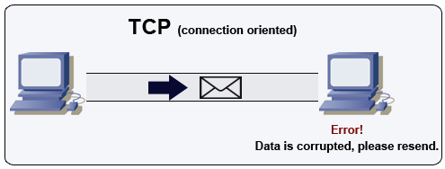](https://github.com/donnemartin/system-design-primer/blob/master/images/JdAsdvG.jpg)  
[*Source: How to make a multiplayer game*](http://www.wildbunny.co.uk/blog/2012/10/09/how-to-make-a-multi-player-game-part-1/)

TCP is a connection-oriented protocol over an [IP network](https://en.wikipedia.org/wiki/Internet_Protocol). Connection is established and terminated using a [handshake](https://en.wikipedia.org/wiki/Handshaking). All packets sent are guaranteed to reach the destination in the original order and without corruption through:

* Sequence numbers and [checksum fields](https://en.wikipedia.org/wiki/Transmission_Control_Protocol#Checksum_computation) for each packet
* [Acknowledgement](https://en.wikipedia.org/wiki/Acknowledgement_(data_networks)) packets and automatic retransmission

If the sender does not receive a correct response, it will resend the packets. If there are multiple timeouts, the connection is dropped. TCP also implements [flow control](https://en.wikipedia.org/wiki/Flow_control_(data)) and [congestion control](https://en.wikipedia.org/wiki/Network_congestion#Congestion_control). These guarantees cause delays and generally result in less efficient transmission than UDP.

To ensure high throughput, web servers can keep a large number of TCP connections open, resulting in high memory usage. It can be expensive to have a large number of open connections between web server threads and say, a [memcached](https://memcached.org/) server. [Connection pooling](https://en.wikipedia.org/wiki/Connection_pool) can help in addition to switching to UDP where applicable.

TCP is useful for applications that require high reliability but are less time critical. Some examples include web servers, database info, SMTP, FTP, and SSH.

Use TCP over UDP when:

* You need all of the data to arrive intact
* You want to automatically make a best estimate use of the network throughput

### User datagram protocol (UDP)

[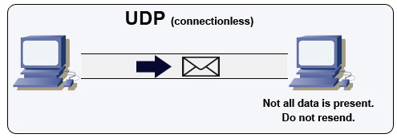](https://github.com/donnemartin/system-design-primer/blob/master/images/yzDrJtA.jpg)  
[*Source: How to make a multiplayer game*](http://www.wildbunny.co.uk/blog/2012/10/09/how-to-make-a-multi-player-game-part-1/)

UDP is connectionless. Datagrams (analogous to packets) are guaranteed only at the datagram level. Datagrams might reach their destination out of order or not at all. UDP does not support congestion control. Without the guarantees that TCP support, UDP is generally more efficient.

UDP can broadcast, sending datagrams to all devices on the subnet. This is useful with [DHCP](https://en.wikipedia.org/wiki/Dynamic_Host_Configuration_Protocol) because the client has not yet received an IP address, thus preventing a way for TCP to stream without the IP address.

UDP is less reliable but works well in real time use cases such as VoIP, video chat, streaming, and realtime multiplayer games.

Use UDP over TCP when:

* You need the lowest latency
* Late data is worse than loss of data
* You want to implement your own error correction

#### Source(s) and further reading: TCP and UDP

* [Networking for game programming](http://gafferongames.com/networking-for-game-programmers/udp-vs-tcp/)
* [Key differences between TCP and UDP protocols](http://www.cyberciti.biz/faq/key-differences-between-tcp-and-udp-protocols/)
* [Difference between TCP and UDP](http://stackoverflow.com/questions/5970383/difference-between-tcp-and-udp)
* [Transmission control protocol](https://en.wikipedia.org/wiki/Transmission_Control_Protocol)
* [User datagram protocol](https://en.wikipedia.org/wiki/User_Datagram_Protocol)
* [Scaling memcache at Facebook](http://www.cs.bu.edu/~jappavoo/jappavoo.github.com/451/papers/memcache-fb.pdf)

### Remote procedure call (RPC)

[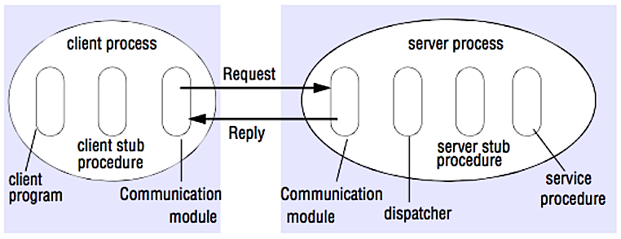](https://github.com/donnemartin/system-design-primer/blob/master/images/iF4Mkb5.png)  
[*Source: Crack the system design interview*](http://www.puncsky.com/blog/2016-02-13-crack-the-system-design-interview)

In an RPC, a client causes a procedure to execute on a different address space, usually a remote server. The procedure is coded as if it were a local procedure call, abstracting away the details of how to communicate with the server from the client program. Remote calls are usually slower and less reliable than local calls so it is helpful to distinguish RPC calls from local calls. Popular RPC frameworks include [Protobuf](https://developers.google.com/protocol-buffers/), [Thrift](https://thrift.apache.org/), and [Avro](https://avro.apache.org/docs/current/).

RPC is a request-response protocol:

* **Client program** - Calls the client stub procedure. The parameters are pushed onto the stack like a local procedure call.
* **Client stub procedure** - Marshals (packs) procedure id and arguments into a request message.
* **Client communication module** - OS sends the message from the client to the server.
* **Server communication module** - OS passes the incoming packets to the server stub procedure.
* **Server stub procedure** - Unmarshalls the results, calls the server procedure matching the procedure id and passes the given arguments.
* The server response repeats the steps above in reverse order.

Sample RPC calls:

GET /someoperation?data=anId

POST /anotheroperation

{

"data":"anId";

"anotherdata": "another value"

}

RPC is focused on exposing behaviors. RPCs are often used for performance reasons with internal communications, as you can hand-craft native calls to better fit your use cases.

Choose a native library (aka SDK) when:

* You know your target platform.
* You want to control how your "logic" is accessed.
* You want to control how error control happens off your library.
* Performance and end user experience is your primary concern.

HTTP APIs following **REST** tend to be used more often for public APIs.

#### Disadvantage(s): RPC

* RPC clients become tightly coupled to the service implementation.
* A new API must be defined for every new operation or use case.
* It can be difficult to debug RPC.
* You might not be able to leverage existing technologies out of the box. For example, it might require additional effort to ensure [RPC calls are properly cached](http://etherealbits.com/2012/12/debunking-the-myths-of-rpc-rest/) on caching servers such as [Squid](http://www.squid-cache.org/).

### Representational state transfer (REST)

REST is an architectural style enforcing a client/server model where the client acts on a set of resources managed by the server. The server provides a representation of resources and actions that can either manipulate or get a new representation of resources. All communication must be stateless and cacheable.

There are four qualities of a RESTful interface:

* **Identify resources (URI in HTTP)** - use the same URI regardless of any operation.
* **Change with representations (Verbs in HTTP)** - use verbs, headers, and body.
* **Self-descriptive error message (status response in HTTP)** - Use status codes, don't reinvent the wheel.
* [**HATEOAS**](http://restcookbook.com/Basics/hateoas/)**(HTML interface for HTTP)** - your web service should be fully accessible in a browser.

Sample REST calls:

GET /someresources/anId

PUT /someresources/anId

{"anotherdata": "another value"}

REST is focused on exposing data. It minimizes the coupling between client/server and is often used for public HTTP APIs. REST uses a more generic and uniform method of exposing resources through URIs, [representation through headers](https://github.com/for-GET/know-your-http-well/blob/master/headers.md), and actions through verbs such as GET, POST, PUT, DELETE, and PATCH. Being stateless, REST is great for horizontal scaling and partitioning.

#### Disadvantage(s): REST

* With REST being focused on exposing data, it might not be a good fit if resources are not naturally organized or accessed in a simple hierarchy. For example, returning all updated records from the past hour matching a particular set of events is not easily expressed as a path. With REST, it is likely to be implemented with a combination of URI path, query parameters, and possibly the request body.
* REST typically relies on a few verbs (GET, POST, PUT, DELETE, and PATCH) which sometimes doesn't fit your use case. For example, moving expired documents to the archive folder might not cleanly fit within these verbs.
* Fetching complicated resources with nested hierarchies requires multiple round trips between the client and server to render single views, e.g. fetching content of a blog entry and the comments on that entry. For mobile applications operating in variable network conditions, these multiple roundtrips are highly undesirable.
* Over time, more fields might be added to an API response and older clients will receive all new data fields, even those that they do not need, as a result, it bloats the payload size and leads to larger latencies.

### RPC and REST calls comparison

| **Operation** | **RPC** | **REST** |
| --- | --- | --- |
| Signup | **POST** /signup | **POST** /persons |
| Resign | **POST** /resign { "personid": "1234" } | **DELETE** /persons/1234 |
| Read a person | **GET** /readPerson?personid=1234 | **GET** /persons/1234 |
| Read a person’s items list | **GET** /readUsersItemsList?personid=1234 | **GET** /persons/1234/items |
| Add an item to a person’s items | **POST** /addItemToUsersItemsList { "personid": "1234"; "itemid": "456" } | **POST** /persons/1234/items { "itemid": "456" } |
| Update an item | **POST** /modifyItem { "itemid": "456"; "key": "value" } | **PUT** /items/456 { "key": "value" } |
| Delete an item | **POST** /removeItem { "itemid": "456" } | **DELETE** /items/456 |

[*Source: Do you really know why you prefer REST over RPC*](https://apihandyman.io/do-you-really-know-why-you-prefer-rest-over-rpc/)

#### Source(s) and further reading: REST and RPC

* [Do you really know why you prefer REST over RPC](https://apihandyman.io/do-you-really-know-why-you-prefer-rest-over-rpc/)
* [When are RPC-ish approaches more appropriate than REST?](http://programmers.stackexchange.com/a/181186)
* [REST vs JSON-RPC](http://stackoverflow.com/questions/15056878/rest-vs-json-rpc)
* [Debunking the myths of RPC and REST](http://etherealbits.com/2012/12/debunking-the-myths-of-rpc-rest/)
* [What are the drawbacks of using REST](https://www.quora.com/What-are-the-drawbacks-of-using-RESTful-APIs)
* [Crack the system design interview](http://www.puncsky.com/blog/2016-02-13-crack-the-system-design-interview)
* [Thrift](https://code.facebook.com/posts/1468950976659943/)
* [Why REST for internal use and not RPC](http://arstechnica.com/civis/viewtopic.php?t=1190508)

## Security

This section could use some updates. Consider [contributing](https://github.com/donnemartin/system-design-primer#contributing)!

Security is a broad topic. Unless you have considerable experience, a security background, or are applying for a position that requires knowledge of security, you probably won't need to know more than the basics:

* Encrypt in transit and at rest.
* Sanitize all user inputs or any input parameters exposed to user to prevent [XSS](https://en.wikipedia.org/wiki/Cross-site_scripting) and [SQL injection](https://en.wikipedia.org/wiki/SQL_injection).
* Use parameterized queries to prevent SQL injection.
* Use the principle of [least privilege](https://en.wikipedia.org/wiki/Principle_of_least_privilege).

### Source(s) and further reading

* [API security checklist](https://github.com/shieldfy/API-Security-Checklist)
* [Security guide for developers](https://github.com/FallibleInc/security-guide-for-developers)
* [OWASP top ten](https://www.owasp.org/index.php/OWASP_Top_Ten_Cheat_Sheet)

## Appendix

You'll sometimes be asked to do 'back-of-the-envelope' estimates. For example, you might need to determine how long it will take to generate 100 image thumbnails from disk or how much memory a data structure will take. The **Powers of two table** and **Latency numbers every programmer should know** are handy references.

### Powers of two table

Power Exact Value Approx Value Bytes

---------------------------------------------------------------

7 128

8 256

10 1024 1 thousand 1 KB

16 65,536 64 KB

20 1,048,576 1 million 1 MB

30 1,073,741,824 1 billion 1 GB

32 4,294,967,296 4 GB

40 1,099,511,627,776 1 trillion 1 TB

#### Source(s) and further reading

* [Powers of two](https://en.wikipedia.org/wiki/Power_of_two)

### Latency numbers every programmer should know

Latency Comparison Numbers

--------------------------

L1 cache reference 0.5 ns

Branch mispredict 5 ns

L2 cache reference 7 ns 14x L1 cache

Mutex lock/unlock 25 ns

Main memory reference 100 ns 20x L2 cache, 200x L1 cache

Compress 1K bytes with Zippy 10,000 ns 10 us

Send 1 KB bytes over 1 Gbps network 10,000 ns 10 us

Read 4 KB randomly from SSD\* 150,000 ns 150 us ~1GB/sec SSD

Read 1 MB sequentially from memory 250,000 ns 250 us

Round trip within same datacenter 500,000 ns 500 us

Read 1 MB sequentially from SSD\* 1,000,000 ns 1,000 us 1 ms ~1GB/sec SSD, 4X memory

HDD seek 10,000,000 ns 10,000 us 10 ms 20x datacenter roundtrip

Read 1 MB sequentially from 1 Gbps 10,000,000 ns 10,000 us 10 ms 40x memory, 10X SSD

Read 1 MB sequentially from HDD 30,000,000 ns 30,000 us 30 ms 120x memory, 30X SSD

Send packet CA->Netherlands->CA 150,000,000 ns 150,000 us 150 ms

Notes

-----

1 ns = 10^-9 seconds

1 us = 10^-6 seconds = 1,000 ns

1 ms = 10^-3 seconds = 1,000 us = 1,000,000 ns

Handy metrics based on numbers above:

* Read sequentially from HDD at 30 MB/s
* Read sequentially from 1 Gbps Ethernet at 100 MB/s
* Read sequentially from SSD at 1 GB/s
* Read sequentially from main memory at 4 GB/s
* 6-7 world-wide round trips per second
* 2,000 round trips per second within a data center

#### Latency numbers visualized

[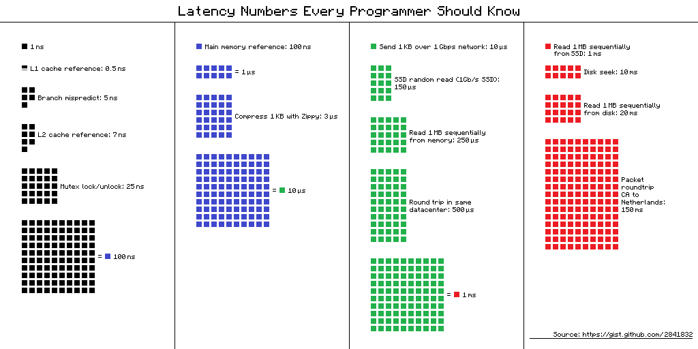](https://camo.githubusercontent.com/77f72259e1eb58596b564d1ad823af1853bc60a3/687474703a2f2f692e696d6775722e636f6d2f6b307431652e706e67)

#### Source(s) and further reading

* [Latency numbers every programmer should know - 1](https://gist.github.com/jboner/2841832)
* [Latency numbers every programmer should know - 2](https://gist.github.com/hellerbarde/2843375)
* [Designs, lessons, and advice from building large distributed systems](http://www.cs.cornell.edu/projects/ladis2009/talks/dean-keynote-ladis2009.pdf)
* [Software Engineering Advice from Building Large-Scale Distributed Systems](https://static.googleusercontent.com/media/research.google.com/en/people/jeff/stanford-295-talk.pdf)

### Additional system design interview questions

Common system design interview questions, with links to resources on how to solve each.

| **Question** | **Reference(s)** |
| --- | --- |
| Design a file sync service like Dropbox | [youtube.com](https://www.youtube.com/watch?v=PE4gwstWhmc) |
| Design a search engine like Google | [queue.acm.org](http://queue.acm.org/detail.cfm?id=988407) [stackexchange.com](http://programmers.stackexchange.com/questions/38324/interview-question-how-would-you-implement-google-search) [ardendertat.com](http://www.ardendertat.com/2012/01/11/implementing-search-engines/) [stanford.edu](http://infolab.stanford.edu/~backrub/google.html) |
| Design a scalable web crawler like Google | [quora.com](https://www.quora.com/How-can-I-build-a-web-crawler-from-scratch) |
| Design Google docs | [code.google.com](https://code.google.com/p/google-mobwrite/) [neil.fraser.name](https://neil.fraser.name/writing/sync/) |
| Design a key-value store like Redis | [slideshare.net](http://www.slideshare.net/dvirsky/introduction-to-redis) |
| Design a cache system like Memcached | [slideshare.net](http://www.slideshare.net/oemebamo/introduction-to-memcached) |
| Design a recommendation system like Amazon's | [hulu.com](https://web.archive.org/web/20170406065247/http:/tech.hulu.com/blog/2011/09/19/recommendation-system.html) [ijcai13.org](http://ijcai13.org/files/tutorial_slides/td3.pdf) |
| Design a tinyurl system like Bitly | [n00tc0d3r.blogspot.com](http://n00tc0d3r.blogspot.com/) |
| Design a chat app like WhatsApp | [highscalability.com](http://highscalability.com/blog/2014/2/26/the-whatsapp-architecture-facebook-bought-for-19-billion.html) |
| Design a picture sharing system like Instagram | [highscalability.com](http://highscalability.com/flickr-architecture) [highscalability.com](http://highscalability.com/blog/2011/12/6/instagram-architecture-14-million-users-terabytes-of-photos.html) |
| Design the Facebook news feed function | [quora.com](http://www.quora.com/What-are-best-practices-for-building-something-like-a-News-Feed) [quora.com](http://www.quora.com/Activity-Streams/What-are-the-scaling-issues-to-keep-in-mind-while-developing-a-social-network-feed) [slideshare.net](http://www.slideshare.net/danmckinley/etsy-activity-feeds-architecture) |
| Design the Facebook timeline function | [facebook.com](https://www.facebook.com/note.php?note_id=10150468255628920) [highscalability.com](http://highscalability.com/blog/2012/1/23/facebook-timeline-brought-to-you-by-the-power-of-denormaliza.html) |
| Design the Facebook chat function | [erlang-factory.com](http://www.erlang-factory.com/upload/presentations/31/EugeneLetuchy-ErlangatFacebook.pdf) [facebook.com](https://www.facebook.com/note.php?note_id=14218138919&id=9445547199&index=0) |
| Design a graph search function like Facebook's | [facebook.com](https://www.facebook.com/notes/facebook-engineering/under-the-hood-building-out-the-infrastructure-for-graph-search/10151347573598920) [facebook.com](https://www.facebook.com/notes/facebook-engineering/under-the-hood-indexing-and-ranking-in-graph-search/10151361720763920) [facebook.com](https://www.facebook.com/notes/facebook-engineering/under-the-hood-the-natural-language-interface-of-graph-search/10151432733048920) |
| Design a content delivery network like CloudFlare | [figshare.com](https://figshare.com/articles/Globally_distributed_content_delivery/6605972) |
| Design a trending topic system like Twitter's | [michael-noll.com](http://www.michael-noll.com/blog/2013/01/18/implementing-real-time-trending-topics-in-storm/) [snikolov .wordpress.com](http://snikolov.wordpress.com/2012/11/14/early-detection-of-twitter-trends/) |
| Design a random ID generation system | [blog.twitter.com](https://blog.twitter.com/2010/announcing-snowflake) [github.com](https://github.com/twitter/snowflake/) |
| Return the top k requests during a time interval | [cs.ucsb.edu](https://www.cs.ucsb.edu/sites/cs.ucsb.edu/files/docs/reports/2005-23.pdf) [wpi.edu](http://davis.wpi.edu/xmdv/docs/EDBT11-diyang.pdf) |
| Design a system that serves data from multiple data centers | [highscalability.com](http://highscalability.com/blog/2009/8/24/how-google-serves-data-from-multiple-datacenters.html) |
| Design an online multiplayer card game | [indieflashblog.com](https://web.archive.org/web/20180929181117/http:/www.indieflashblog.com/how-to-create-an-asynchronous-multiplayer-game.html) [buildnewgames.com](http://buildnewgames.com/real-time-multiplayer/) |
| Design a garbage collection system | [stuffwithstuff.com](http://journal.stuffwithstuff.com/2013/12/08/babys-first-garbage-collector/) [washington.edu](http://courses.cs.washington.edu/courses/csep521/07wi/prj/rick.pdf) |
| Design an API rate limiter | [https://stripe.com/blog/](https://stripe.com/blog/rate-limiters) |
| Design a Stock Exchange (like NASDAQ or Binance) | [Jane Street](https://youtu.be/b1e4t2k2KJY) [Golang Implementation](https://around25.com/blog/building-a-trading-engine-for-a-crypto-exchange/) [Go Implementation](http://bhomnick.net/building-a-simple-limit-order-in-go/) |
| Add a system design question | [Contribute](https://github.com/donnemartin/system-design-primer#contributing) |

### Real world architectures

Articles on how real world systems are designed.

[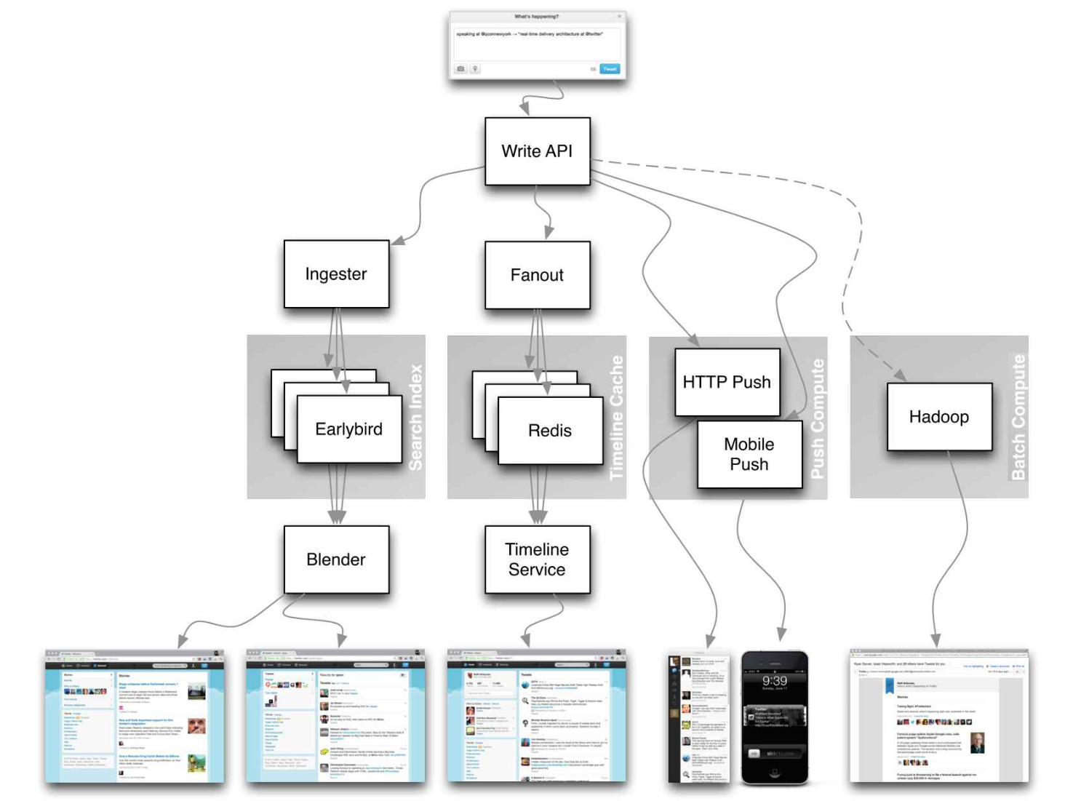](https://github.com/donnemartin/system-design-primer/blob/master/images/TcUo2fw.png)  
[*Source: Twitter timelines at scale*](https://www.infoq.com/presentations/Twitter-Timeline-Scalability)

**Don't focus on nitty gritty details for the following articles, instead:**

* Identify shared principles, common technologies, and patterns within these articles
* Study what problems are solved by each component, where it works, where it doesn't
* Review the lessons learned

| **Type** | **System** | **Reference(s)** |
| --- | --- | --- |
| Data processing | **MapReduce** - Distributed data processing from Google | [research.google.com](http://static.googleusercontent.com/media/research.google.com/zh-CN/us/archive/mapreduce-osdi04.pdf) |
| Data processing | **Spark** - Distributed data processing from Databricks | [slideshare.net](http://www.slideshare.net/AGrishchenko/apache-spark-architecture) |
| Data processing | **Storm** - Distributed data processing from Twitter | [slideshare.net](http://www.slideshare.net/previa/storm-16094009) |
|  |  |  |
| Data store | **Bigtable** - Distributed column-oriented database from Google | [harvard.edu](http://www.read.seas.harvard.edu/~kohler/class/cs239-w08/chang06bigtable.pdf) |
| Data store | **HBase** - Open source implementation of Bigtable | [slideshare.net](http://www.slideshare.net/alexbaranau/intro-to-hbase) |
| Data store | **Cassandra** - Distributed column-oriented database from Facebook | [slideshare.net](http://www.slideshare.net/planetcassandra/cassandra-introduction-features-30103666) |
| Data store | **DynamoDB** - Document-oriented database from Amazon | [harvard.edu](http://www.read.seas.harvard.edu/~kohler/class/cs239-w08/decandia07dynamo.pdf) |
| Data store | **MongoDB** - Document-oriented database | [slideshare.net](http://www.slideshare.net/mdirolf/introduction-to-mongodb) |
| Data store | **Spanner** - Globally-distributed database from Google | [research.google.com](http://research.google.com/archive/spanner-osdi2012.pdf) |
| Data store | **Memcached** - Distributed memory caching system | [slideshare.net](http://www.slideshare.net/oemebamo/introduction-to-memcached) |
| Data store | **Redis** - Distributed memory caching system with persistence and value types | [slideshare.net](http://www.slideshare.net/dvirsky/introduction-to-redis) |
|  |  |  |
| File system | **Google File System (GFS)** - Distributed file system | [research.google.com](http://static.googleusercontent.com/media/research.google.com/zh-CN/us/archive/gfs-sosp2003.pdf) |
| File system | **Hadoop File System (HDFS)** - Open source implementation of GFS | [apache.org](http://hadoop.apache.org/docs/stable/hadoop-project-dist/hadoop-hdfs/HdfsDesign.html) |
|  |  |  |
| Misc | **Chubby** - Lock service for loosely-coupled distributed systems from Google | [research.google.com](http://static.googleusercontent.com/external_content/untrusted_dlcp/research.google.com/en/us/archive/chubby-osdi06.pdf) |
| Misc | **Dapper** - Distributed systems tracing infrastructure | [research.google.com](http://static.googleusercontent.com/media/research.google.com/en/pubs/archive/36356.pdf) |
| Misc | **Kafka** - Pub/sub message queue from LinkedIn | [slideshare.net](http://www.slideshare.net/mumrah/kafka-talk-tri-hug) |
| Misc | **Zookeeper** - Centralized infrastructure and services enabling synchronization | [slideshare.net](http://www.slideshare.net/sauravhaloi/introduction-to-apache-zookeeper) |
|  | Add an architecture | [Contribute](https://github.com/donnemartin/system-design-primer#contributing) |

### Company architectures

| **Company** | **Reference(s)** |
| --- | --- |
| Amazon | [Amazon architecture](http://highscalability.com/amazon-architecture) |
| Cinchcast | [Producing 1,500 hours of audio every day](http://highscalability.com/blog/2012/7/16/cinchcast-architecture-producing-1500-hours-of-audio-every-d.html) |
| DataSift | [Realtime datamining At 120,000 tweets per second](http://highscalability.com/blog/2011/11/29/datasift-architecture-realtime-datamining-at-120000-tweets-p.html) |
| Dropbox | [How we've scaled Dropbox](https://www.youtube.com/watch?v=PE4gwstWhmc) |
| ESPN | [Operating At 100,000 duh nuh nuhs per second](http://highscalability.com/blog/2013/11/4/espns-architecture-at-scale-operating-at-100000-duh-nuh-nuhs.html) |
| Google | [Google architecture](http://highscalability.com/google-architecture) |
| Instagram | [14 million users, terabytes of photos](http://highscalability.com/blog/2011/12/6/instagram-architecture-14-million-users-terabytes-of-photos.html) [What powers Instagram](http://instagram-engineering.tumblr.com/post/13649370142/what-powers-instagram-hundreds-of-instances) |
| Justin.tv | [Justin.Tv's live video broadcasting architecture](http://highscalability.com/blog/2010/3/16/justintvs-live-video-broadcasting-architecture.html) |
| Facebook | [Scaling memcached at Facebook](https://cs.uwaterloo.ca/~brecht/courses/854-Emerging-2014/readings/key-value/fb-memcached-nsdi-2013.pdf) [TAO: Facebook’s distributed data store for the social graph](https://cs.uwaterloo.ca/~brecht/courses/854-Emerging-2014/readings/data-store/tao-facebook-distributed-datastore-atc-2013.pdf) [Facebook’s photo storage](https://www.usenix.org/legacy/event/osdi10/tech/full_papers/Beaver.pdf) [How Facebook Live Streams To 800,000 Simultaneous Viewers](http://highscalability.com/blog/2016/6/27/how-facebook-live-streams-to-800000-simultaneous-viewers.html) |
| Flickr | [Flickr architecture](http://highscalability.com/flickr-architecture) |
| Mailbox | [From 0 to one million users in 6 weeks](http://highscalability.com/blog/2013/6/18/scaling-mailbox-from-0-to-one-million-users-in-6-weeks-and-1.html) |
| Netflix | [A 360 Degree View Of The Entire Netflix Stack](http://highscalability.com/blog/2015/11/9/a-360-degree-view-of-the-entire-netflix-stack.html) [Netflix: What Happens When You Press Play?](http://highscalability.com/blog/2017/12/11/netflix-what-happens-when-you-press-play.html) |
| Pinterest | [From 0 To 10s of billions of page views a month](http://highscalability.com/blog/2013/4/15/scaling-pinterest-from-0-to-10s-of-billions-of-page-views-a.html) [18 million visitors, 10x growth, 12 employees](http://highscalability.com/blog/2012/5/21/pinterest-architecture-update-18-million-visitors-10x-growth.html) |
| Playfish | [50 million monthly users and growing](http://highscalability.com/blog/2010/9/21/playfishs-social-gaming-architecture-50-million-monthly-user.html) |
| PlentyOfFish | [PlentyOfFish architecture](http://highscalability.com/plentyoffish-architecture) |
| Salesforce | [How they handle 1.3 billion transactions a day](http://highscalability.com/blog/2013/9/23/salesforce-architecture-how-they-handle-13-billion-transacti.html) |
| Stack Overflow | [Stack Overflow architecture](http://highscalability.com/blog/2009/8/5/stack-overflow-architecture.html) |
| TripAdvisor | [40M visitors, 200M dynamic page views, 30TB data](http://highscalability.com/blog/2011/6/27/tripadvisor-architecture-40m-visitors-200m-dynamic-page-view.html) |
| Tumblr | [15 billion page views a month](http://highscalability.com/blog/2012/2/13/tumblr-architecture-15-billion-page-views-a-month-and-harder.html) |
| Twitter | [Making Twitter 10000 percent faster](http://highscalability.com/scaling-twitter-making-twitter-10000-percent-faster) [Storing 250 million tweets a day using MySQL](http://highscalability.com/blog/2011/12/19/how-twitter-stores-250-million-tweets-a-day-using-mysql.html) [150M active users, 300K QPS, a 22 MB/S firehose](http://highscalability.com/blog/2013/7/8/the-architecture-twitter-uses-to-deal-with-150m-active-users.html) [Timelines at scale](https://www.infoq.com/presentations/Twitter-Timeline-Scalability) [Big and small data at Twitter](https://www.youtube.com/watch?v=5cKTP36HVgI) [Operations at Twitter: scaling beyond 100 million users](https://www.youtube.com/watch?v=z8LU0Cj6BOU) [How Twitter Handles 3,000 Images Per Second](http://highscalability.com/blog/2016/4/20/how-twitter-handles-3000-images-per-second.html) |
| Uber | [How Uber scales their real-time market platform](http://highscalability.com/blog/2015/9/14/how-uber-scales-their-real-time-market-platform.html) [Lessons Learned From Scaling Uber To 2000 Engineers, 1000 Services, And 8000 Git Repositories](http://highscalability.com/blog/2016/10/12/lessons-learned-from-scaling-uber-to-2000-engineers-1000-ser.html) |
| WhatsApp | [The WhatsApp architecture Facebook bought for $19 billion](http://highscalability.com/blog/2014/2/26/the-whatsapp-architecture-facebook-bought-for-19-billion.html) |
| YouTube | [YouTube scalability](https://www.youtube.com/watch?v=w5WVu624fY8) [YouTube architecture](http://highscalability.com/youtube-architecture) |

### Company engineering blogs

Architectures for companies you are interviewing with.

Questions you encounter might be from the same domain.

* [Airbnb Engineering](http://nerds.airbnb.com/)
* [Atlassian Developers](https://developer.atlassian.com/blog/)
* [AWS Blog](https://aws.amazon.com/blogs/aws/)
* [Bitly Engineering Blog](http://word.bitly.com/)
* [Box Blogs](https://blog.box.com/blog/category/engineering)
* [Cloudera Developer Blog](http://blog.cloudera.com/)
* [Dropbox Tech Blog](https://tech.dropbox.com/)
* [Engineering at Quora](https://www.quora.com/q/quoraengineering)
* [Ebay Tech Blog](http://www.ebaytechblog.com/)
* [Evernote Tech Blog](https://blog.evernote.com/tech/)
* [Etsy Code as Craft](http://codeascraft.com/)
* [Facebook Engineering](https://www.facebook.com/Engineering)
* [Flickr Code](http://code.flickr.net/)
* [Foursquare Engineering Blog](http://engineering.foursquare.com/)
* [GitHub Engineering Blog](https://github.blog/category/engineering)
* [Google Research Blog](http://googleresearch.blogspot.com/)
* [Groupon Engineering Blog](https://engineering.groupon.com/)
* [Heroku Engineering Blog](https://engineering.heroku.com/)
* [Hubspot Engineering Blog](http://product.hubspot.com/blog/topic/engineering)
* [High Scalability](http://highscalability.com/)
* [Instagram Engineering](http://instagram-engineering.tumblr.com/)
* [Intel Software Blog](https://software.intel.com/en-us/blogs/)
* [Jane Street Tech Blog](https://blogs.janestreet.com/category/ocaml/)
* [LinkedIn Engineering](http://engineering.linkedin.com/blog)
* [Microsoft Engineering](https://engineering.microsoft.com/)
* [Microsoft Python Engineering](https://blogs.msdn.microsoft.com/pythonengineering/)
* [Netflix Tech Blog](http://techblog.netflix.com/)
* [Paypal Developer Blog](https://medium.com/paypal-engineering)
* [Pinterest Engineering Blog](https://medium.com/@Pinterest_Engineering)
* [Reddit Blog](http://www.redditblog.com/)
* [Salesforce Engineering Blog](https://developer.salesforce.com/blogs/engineering/)
* [Slack Engineering Blog](https://slack.engineering/)
* [Spotify Labs](https://labs.spotify.com/)
* [Twilio Engineering Blog](http://www.twilio.com/engineering)
* [Twitter Engineering](https://blog.twitter.com/engineering/)
* [Uber Engineering Blog](http://eng.uber.com/)
* [Yahoo Engineering Blog](http://yahooeng.tumblr.com/)
* [Yelp Engineering Blog](http://engineeringblog.yelp.com/)
* [Zynga Engineering Blog](https://www.zynga.com/blogs/engineering)

#### Source(s) and further reading

Looking to add a blog? To avoid duplicating work, consider adding your company blog to the following repo:

* [kilimchoi/engineering-blogs](https://github.com/kilimchoi/engineering-blogs)

## Under development

Interested in adding a section or helping complete one in-progress? [Contribute](https://github.com/donnemartin/system-design-primer#contributing)!

* Distributed computing with MapReduce
* Consistent hashing
* Scatter gather
* [Contribute](https://github.com/donnemartin/system-design-primer#contributing)

## Credits

Credits and sources are provided throughout this repo.

Special thanks to:

* [Hired in tech](http://www.hiredintech.com/system-design/the-system-design-process/)
* [Cracking the coding interview](https://www.amazon.com/dp/0984782850/)
* [High scalability](http://highscalability.com/)
* [checkcheckzz/system-design-interview](https://github.com/checkcheckzz/system-design-interview)
* [shashank88/system\_design](https://github.com/shashank88/system_design)
* [mmcgrana/services-engineering](https://github.com/mmcgrana/services-engineering)
* [System design cheat sheet](https://gist.github.com/vasanthk/485d1c25737e8e72759f)
* [A distributed systems reading list](http://dancres.github.io/Pages/)
* [Cracking the system design interview](http://www.puncsky.com/blog/2016-02-13-crack-the-system-design-interview)

# Design Mint.com

Note: This document links directly to relevant areas found in the [*system design topics*](https://github.com/donnemartin/system-design-primer#index-of-system-design-topics) to avoid duplication. Refer to the linked content for general talking points, tradeoffs, and alternatives.

## Step 1: Outline use cases and constraints

Gather requirements and scope the problem. Ask questions to clarify use cases and constraints. Discuss assumptions.

Without an interviewer to address clarifying questions, we'll define some use cases and constraints.

### Use cases

#### We'll scope the problem to handle only the following use cases

* **User** connects to a financial account
* **Service** extracts transactions from the account
  + Updates daily
  + Categorizes transactions
    - Allows manual category override by the user
    - No automatic re-categorization
  + Analyzes monthly spending, by category
* **Service** recommends a budget
  + Allows users to manually set a budget
  + Sends notifications when approaching or exceeding budget
* **Service** has high availability

#### Out of scope

* **Service** performs additional logging and analytics

### Constraints and assumptions

#### State assumptions

* Traffic is not evenly distributed
* Automatic daily update of accounts applies only to users active in the past 30 days
* Adding or removing financial accounts is relatively rare
* Budget notifications don't need to be instant
* 10 million users
  + 10 budget categories per user = 100 million budget items
  + Example categories:
    - Housing = $1,000
    - Food = $200
    - Gas = $100
  + Sellers are used to determine transaction category
    - 50,000 sellers
* 30 million financial accounts
* 5 billion transactions per month
* 500 million read requests per month
* 10:1 write to read ratio
  + Write-heavy, users make transactions daily, but few visit the site daily

#### Calculate usage

**Clarify with your interviewer if you should run back-of-the-envelope usage calculations.**

* Size per transaction:
  + user\_id - 8 bytes
  + created\_at - 5 bytes
  + seller - 32 bytes
  + amount - 5 bytes
  + Total: ~50 bytes
* 250 GB of new transaction content per month
  + 50 bytes per transaction \* 5 billion transactions per month
  + 9 TB of new transaction content in 3 years
  + Assume most are new transactions instead of updates to existing ones
* 2,000 transactions per second on average
* 200 read requests per second on average

Handy conversion guide:

* 2.5 million seconds per month
* 1 request per second = 2.5 million requests per month
* 40 requests per second = 100 million requests per month
* 400 requests per second = 1 billion requests per month

## Step 2: Create a high level design

Outline a high level design with all important components.

[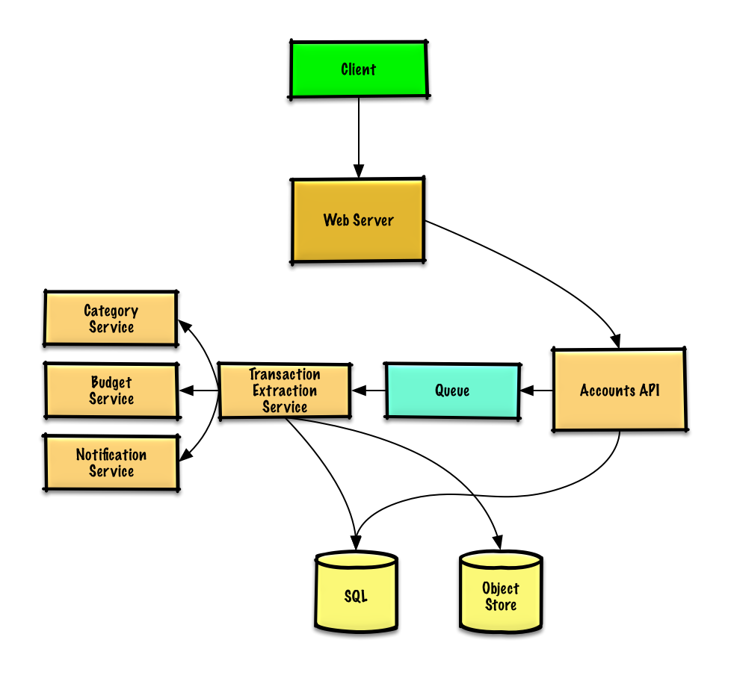](https://camo.githubusercontent.com/666f6457fc3b9aed4f88bbc4f5465b539839d5c775b8014eb4e7963daca43a44/687474703a2f2f692e696d6775722e636f6d2f45386b6c7242682e706e67)

## Step 3: Design core components

Dive into details for each core component.

### Use case: User connects to a financial account

We could store info on the 10 million users in a [relational database](https://github.com/donnemartin/system-design-primer#relational-database-management-system-rdbms). We should discuss the [use cases and tradeoffs between choosing SQL or NoSQL](https://github.com/donnemartin/system-design-primer#sql-or-nosql).

* The **Client** sends a request to the **Web Server**, running as a [reverse proxy](https://github.com/donnemartin/system-design-primer#reverse-proxy-web-server)
* The **Web Server** forwards the request to the **Accounts API** server
* The **Accounts API** server updates the **SQL Database** accounts table with the newly entered account info

**Clarify with your interviewer how much code you are expected to write**.

The accounts table could have the following structure:

id int NOT NULL AUTO\_INCREMENT

created\_at datetime NOT NULL

last\_update datetime NOT NULL

account\_url varchar(255) NOT NULL

account\_login varchar(32) NOT NULL

account\_password\_hash char(64) NOT NULL

user\_id int NOT NULL

PRIMARY KEY(id)

FOREIGN KEY(user\_id) REFERENCES users(id)

We'll create an [index](https://github.com/donnemartin/system-design-primer#use-good-indices) on id, user\_id , and created\_at to speed up lookups (log-time instead of scanning the entire table) and to keep the data in memory. Reading 1 MB sequentially from memory takes about 250 microseconds, while reading from SSD takes 4x and from disk takes 80x longer.[1](https://github.com/donnemartin/system-design-primer#latency-numbers-every-programmer-should-know)

We'll use a public [**REST API**](https://github.com/donnemartin/system-design-primer#representational-state-transfer-rest):

$ curl -X POST --data '{ "user\_id": "foo", "account\_url": "bar", \

"account\_login": "baz", "account\_password": "qux" }' \

https://mint.com/api/v1/account

For internal communications, we could use [Remote Procedure Calls](https://github.com/donnemartin/system-design-primer#remote-procedure-call-rpc).

Next, the service extracts transactions from the account.

### Use case: Service extracts transactions from the account

We'll want to extract information from an account in these cases:

* The user first links the account
* The user manually refreshes the account
* Automatically each day for users who have been active in the past 30 days

Data flow:

* The **Client** sends a request to the **Web Server**
* The **Web Server** forwards the request to the **Accounts API** server
* The **Accounts API** server places a job on a **Queue** such as [Amazon SQS](https://aws.amazon.com/sqs/) or [RabbitMQ](https://www.rabbitmq.com/)
  + Extracting transactions could take awhile, we'd probably want to do this [asynchronously with a queue](https://github.com/donnemartin/system-design-primer#asynchronism), although this introduces additional complexity
* The **Transaction Extraction Service** does the following:
  + Pulls from the **Queue** and extracts transactions for the given account from the financial institution, storing the results as raw log files in the **Object Store**
  + Uses the **Category Service** to categorize each transaction
  + Uses the **Budget Service** to calculate aggregate monthly spending by category
    - The **Budget Service** uses the **Notification Service** to let users know if they are nearing or have exceeded their budget
  + Updates the **SQL Database** transactions table with categorized transactions
  + Updates the **SQL Database** monthly\_spending table with aggregate monthly spending by category
  + Notifies the user the transactions have completed through the **Notification Service**:
    - Uses a **Queue** (not pictured) to asynchronously send out notifications

The transactions table could have the following structure:

id int NOT NULL AUTO\_INCREMENT

created\_at datetime NOT NULL

seller varchar(32) NOT NULL

amount decimal NOT NULL

user\_id int NOT NULL

PRIMARY KEY(id)

FOREIGN KEY(user\_id) REFERENCES users(id)

We'll create an [index](https://github.com/donnemartin/system-design-primer#use-good-indices) on id, user\_id , and created\_at.

The monthly\_spending table could have the following structure:

id int NOT NULL AUTO\_INCREMENT

month\_year date NOT NULL

category varchar(32)

amount decimal NOT NULL

user\_id int NOT NULL

PRIMARY KEY(id)

FOREIGN KEY(user\_id) REFERENCES users(id)

We'll create an [index](https://github.com/donnemartin/system-design-primer#use-good-indices) on id and user\_id .

#### Category service

For the **Category Service**, we can seed a seller-to-category dictionary with the most popular sellers. If we estimate 50,000 sellers and estimate each entry to take less than 255 bytes, the dictionary would only take about 12 MB of memory.

**Clarify with your interviewer how much code you are expected to write**.

class DefaultCategories(Enum):

HOUSING = 0

FOOD = 1

GAS = 2

SHOPPING = 3

...

seller\_category\_map = {}

seller\_category\_map['Exxon'] = DefaultCategories.GAS

seller\_category\_map['Target'] = DefaultCategories.SHOPPING

...

For sellers not initially seeded in the map, we could use a crowdsourcing effort by evaluating the manual category overrides our users provide. We could use a heap to quickly lookup the top manual override per seller in O(1) time.

class Categorizer(object):

def \_\_init\_\_(self, seller\_category\_map, seller\_category\_crowd\_overrides\_map):

self.seller\_category\_map = seller\_category\_map

self.seller\_category\_crowd\_overrides\_map = \

seller\_category\_crowd\_overrides\_map

def categorize(self, transaction):

if transaction.seller in self.seller\_category\_map:

return self.seller\_category\_map[transaction.seller]

elif transaction.seller in self.seller\_category\_crowd\_overrides\_map:

self.seller\_category\_map[transaction.seller] = \

self.seller\_category\_crowd\_overrides\_map[transaction.seller].peek\_min()

return self.seller\_category\_map[transaction.seller]

return None

Transaction implementation:

class Transaction(object):

def \_\_init\_\_(self, created\_at, seller, amount):

self.created\_at = created\_at

self.seller = seller

self.amount = amount

### Use case: Service recommends a budget

To start, we could use a generic budget template that allocates category amounts based on income tiers. Using this approach, we would not have to store the 100 million budget items identified in the constraints, only those that the user overrides. If a user overrides a budget category, which we could store the override in the TABLE budget\_overrides.

class Budget(object):

def \_\_init\_\_(self, income):

self.income = income

self.categories\_to\_budget\_map = self.create\_budget\_template()

def create\_budget\_template(self):

return {

DefaultCategories.HOUSING: self.income \* .4,

DefaultCategories.FOOD: self.income \* .2,

DefaultCategories.GAS: self.income \* .1,

DefaultCategories.SHOPPING: self.income \* .2,

...

}

def override\_category\_budget(self, category, amount):

self.categories\_to\_budget\_map[category] = amount

For the **Budget Service**, we can potentially run SQL queries on the transactions table to generate the monthly\_spending aggregate table. The monthly\_spending table would likely have much fewer rows than the total 5 billion transactions, since users typically have many transactions per month.

As an alternative, we can run **MapReduce** jobs on the raw transaction files to:

* Categorize each transaction
* Generate aggregate monthly spending by category

Running analyses on the transaction files could significantly reduce the load on the database.

We could call the **Budget Service** to re-run the analysis if the user updates a category.

**Clarify with your interviewer how much code you are expected to write**.

Sample log file format, tab delimited:

user\_id timestamp seller amount

**MapReduce** implementation:

class SpendingByCategory(MRJob):

def \_\_init\_\_(self, categorizer):

self.categorizer = categorizer

self.current\_year\_month = calc\_current\_year\_month()

...

def calc\_current\_year\_month(self):

"""Return the current year and month."""

...

def extract\_year\_month(self, timestamp):

"""Return the year and month portions of the timestamp."""

...

def handle\_budget\_notifications(self, key, total):

"""Call notification API if nearing or exceeded budget."""

...

def mapper(self, \_, line):

"""Parse each log line, extract and transform relevant lines.

Argument line will be of the form:

user\_id timestamp seller amount

Using the categorizer to convert seller to category,

emit key value pairs of the form:

(user\_id, 2016-01, shopping), 25

(user\_id, 2016-01, shopping), 100

(user\_id, 2016-01, gas), 50

"""

user\_id, timestamp, seller, amount = line.split('\t')

category = self.categorizer.categorize(seller)

period = self.extract\_year\_month(timestamp)

if period == self.current\_year\_month:

yield (user\_id, period, category), amount

def reducer(self, key, value):

"""Sum values for each key.

(user\_id, 2016-01, shopping), 125

(user\_id, 2016-01, gas), 50

"""

total = sum(values)

yield key, sum(values)

## Step 4: Scale the design

Identify and address bottlenecks, given the constraints.

[](https://camo.githubusercontent.com/88a01f869dcc15fde13d0ff961a5c708cc51052e6136e7eab851c9792ad32f96/687474703a2f2f692e696d6775722e636f6d2f563571353776552e706e67)

**Important: Do not simply jump right into the final design from the initial design!**

State you would 1) **Benchmark/Load Test**, 2) **Profile** for bottlenecks 3) address bottlenecks while evaluating alternatives and trade-offs, and 4) repeat. See [Design a system that scales to millions of users on AWS](https://github.com/donnemartin/system-design-primer/blob/master/solutions/system_design/scaling_aws/README.md) as a sample on how to iteratively scale the initial design.

It's important to discuss what bottlenecks you might encounter with the initial design and how you might address each of them. For example, what issues are addressed by adding a **Load Balancer** with multiple **Web Servers**? **CDN**? **Master-Slave Replicas**? What are the alternatives and **Trade-Offs** for each?

We'll introduce some components to complete the design and to address scalability issues. Internal load balancers are not shown to reduce clutter.

To avoid repeating discussions, refer to the following [system design topics](https://github.com/donnemartin/system-design-primer#index-of-system-design-topics) for main talking points, tradeoffs, and alternatives:

* [DNS](https://github.com/donnemartin/system-design-primer#domain-name-system)
* [CDN](https://github.com/donnemartin/system-design-primer#content-delivery-network)
* [Load balancer](https://github.com/donnemartin/system-design-primer#load-balancer)
* [Horizontal scaling](https://github.com/donnemartin/system-design-primer#horizontal-scaling)
* [Web server (reverse proxy)](https://github.com/donnemartin/system-design-primer#reverse-proxy-web-server)
* [API server (application layer)](https://github.com/donnemartin/system-design-primer#application-layer)
* [Cache](https://github.com/donnemartin/system-design-primer#cache)
* [Relational database management system (RDBMS)](https://github.com/donnemartin/system-design-primer#relational-database-management-system-rdbms)
* [SQL write master-slave failover](https://github.com/donnemartin/system-design-primer#fail-over)
* [Master-slave replication](https://github.com/donnemartin/system-design-primer#master-slave-replication)
* [Asynchronism](https://github.com/donnemartin/system-design-primer#asynchronism)
* [Consistency patterns](https://github.com/donnemartin/system-design-primer#consistency-patterns)
* [Availability patterns](https://github.com/donnemartin/system-design-primer#availability-patterns)

We'll add an additional use case: **User** accesses summaries and transactions.

User sessions, aggregate stats by category, and recent transactions could be placed in a **Memory Cache** such as Redis or Memcached.

* The **Client** sends a read request to the **Web Server**
* The **Web Server** forwards the request to the **Read API** server
  + Static content can be served from the **Object Store** such as S3, which is cached on the **CDN**
* The **Read API** server does the following:
  + Checks the **Memory Cache** for the content
    - If the url is in the **Memory Cache**, returns the cached contents
    - Else
      * If the url is in the **SQL Database**, fetches the contents
        + Updates the **Memory Cache** with the contents

Refer to [When to update the cache](https://github.com/donnemartin/system-design-primer#when-to-update-the-cache) for tradeoffs and alternatives. The approach above describes [cache-aside](https://github.com/donnemartin/system-design-primer#cache-aside).

Instead of keeping the monthly\_spending aggregate table in the **SQL Database**, we could create a separate **Analytics Database** using a data warehousing solution such as Amazon Redshift or Google BigQuery.

We might only want to store a month of transactions data in the database, while storing the rest in a data warehouse or in an **Object Store**. An **Object Store** such as Amazon S3 can comfortably handle the constraint of 250 GB of new content per month.

To address the 200 average read requests per second (higher at peak), traffic for popular content should be handled by the **Memory Cache** instead of the database. The **Memory Cache** is also useful for handling the unevenly distributed traffic and traffic spikes. The **SQL Read Replicas** should be able to handle the cache misses, as long as the replicas are not bogged down with replicating writes.

2,000 average transaction writes per second (higher at peak) might be tough for a single **SQL Write Master-Slave**. We might need to employ additional SQL scaling patterns:

* [Federation](https://github.com/donnemartin/system-design-primer#federation)
* [Sharding](https://github.com/donnemartin/system-design-primer#sharding)
* [Denormalization](https://github.com/donnemartin/system-design-primer#denormalization)
* [SQL Tuning](https://github.com/donnemartin/system-design-primer#sql-tuning)

We should also consider moving some data to a **NoSQL Database**.

## Additional talking points

Additional topics to dive into, depending on the problem scope and time remaining.

#### NoSQL

* [Key-value store](https://github.com/donnemartin/system-design-primer#key-value-store)
* [Document store](https://github.com/donnemartin/system-design-primer#document-store)
* [Wide column store](https://github.com/donnemartin/system-design-primer#wide-column-store)
* [Graph database](https://github.com/donnemartin/system-design-primer#graph-database)
* [SQL vs NoSQL](https://github.com/donnemartin/system-design-primer#sql-or-nosql)

### Caching

* Where to cache
  + [Client caching](https://github.com/donnemartin/system-design-primer#client-caching)
  + [CDN caching](https://github.com/donnemartin/system-design-primer#cdn-caching)
  + [Web server caching](https://github.com/donnemartin/system-design-primer#web-server-caching)
  + [Database caching](https://github.com/donnemartin/system-design-primer#database-caching)
  + [Application caching](https://github.com/donnemartin/system-design-primer#application-caching)
* What to cache
  + [Caching at the database query level](https://github.com/donnemartin/system-design-primer#caching-at-the-database-query-level)
  + [Caching at the object level](https://github.com/donnemartin/system-design-primer#caching-at-the-object-level)
* When to update the cache
  + [Cache-aside](https://github.com/donnemartin/system-design-primer#cache-aside)
  + [Write-through](https://github.com/donnemartin/system-design-primer#write-through)
  + [Write-behind (write-back)](https://github.com/donnemartin/system-design-primer#write-behind-write-back)
  + [Refresh ahead](https://github.com/donnemartin/system-design-primer#refresh-ahead)

### Asynchronism and microservices

* [Message queues](https://github.com/donnemartin/system-design-primer#message-queues)
* [Task queues](https://github.com/donnemartin/system-design-primer#task-queues)
* [Back pressure](https://github.com/donnemartin/system-design-primer#back-pressure)
* [Microservices](https://github.com/donnemartin/system-design-primer#microservices)

### Communications

* Discuss tradeoffs:
  + External communication with clients - [HTTP APIs following REST](https://github.com/donnemartin/system-design-primer#representational-state-transfer-rest)
  + Internal communications - [RPC](https://github.com/donnemartin/system-design-primer#remote-procedure-call-rpc)
* [Service discovery](https://github.com/donnemartin/system-design-primer#service-discovery)

### Security

Refer to the [security section](https://github.com/donnemartin/system-design-primer#security).

### Latency numbers

See [Latency numbers every programmer should know](https://github.com/donnemartin/system-design-primer#latency-numbers-every-programmer-should-know).

### Ongoing

* Continue benchmarking and monitoring your system to address bottlenecks as they come up
* Scaling is an iterative process

# Design Pastebin.com (or Bit.ly)

Note: This document links directly to relevant areas found in the [*system design topics*](https://github.com/donnemartin/system-design-primer#index-of-system-design-topics) to avoid duplication. Refer to the linked content for general talking points, tradeoffs, and alternatives.

**Design Bit.ly** - is a similar question, except pastebin requires storing the paste contents instead of the original unshortened url.

## Step 1: Outline use cases and constraints

Gather requirements and scope the problem. Ask questions to clarify use cases and constraints. Discuss assumptions.

Without an interviewer to address clarifying questions, we'll define some use cases and constraints.

### Use cases

#### We'll scope the problem to handle only the following use cases

* **User** enters a block of text and gets a randomly generated link
  + Expiration
    - Default setting does not expire
    - Can optionally set a timed expiration
* **User** enters a paste's url and views the contents
* **User** is anonymous
* **Service** tracks analytics of pages
  + Monthly visit stats
* **Service** deletes expired pastes
* **Service** has high availability

#### Out of scope

* **User** registers for an account
  + **User** verifies email
* **User** logs into a registered account
  + **User** edits the document
* **User** can set visibility
* **User** can set the shortlink

### Constraints and assumptions

#### State assumptions

* Traffic is not evenly distributed
* Following a short link should be fast
* Pastes are text only
* Page view analytics do not need to be realtime
* 10 million users
* 10 million paste writes per month
* 100 million paste reads per month
* 10:1 read to write ratio

#### Calculate usage

**Clarify with your interviewer if you should run back-of-the-envelope usage calculations.**

* Size per paste
  + 1 KB content per paste
  + shortlink - 7 bytes
  + expiration\_length\_in\_minutes - 4 bytes
  + created\_at - 5 bytes
  + paste\_path - 255 bytes
  + total = ~1.27 KB
* 12.7 GB of new paste content per month
  + 1.27 KB per paste \* 10 million pastes per month
  + ~450 GB of new paste content in 3 years
  + 360 million shortlinks in 3 years
  + Assume most are new pastes instead of updates to existing ones
* 4 paste writes per second on average
* 40 read requests per second on average

Handy conversion guide:

* 2.5 million seconds per month
* 1 request per second = 2.5 million requests per month
* 40 requests per second = 100 million requests per month
* 400 requests per second = 1 billion requests per month

## Step 2: Create a high level design

Outline a high level design with all important components.

[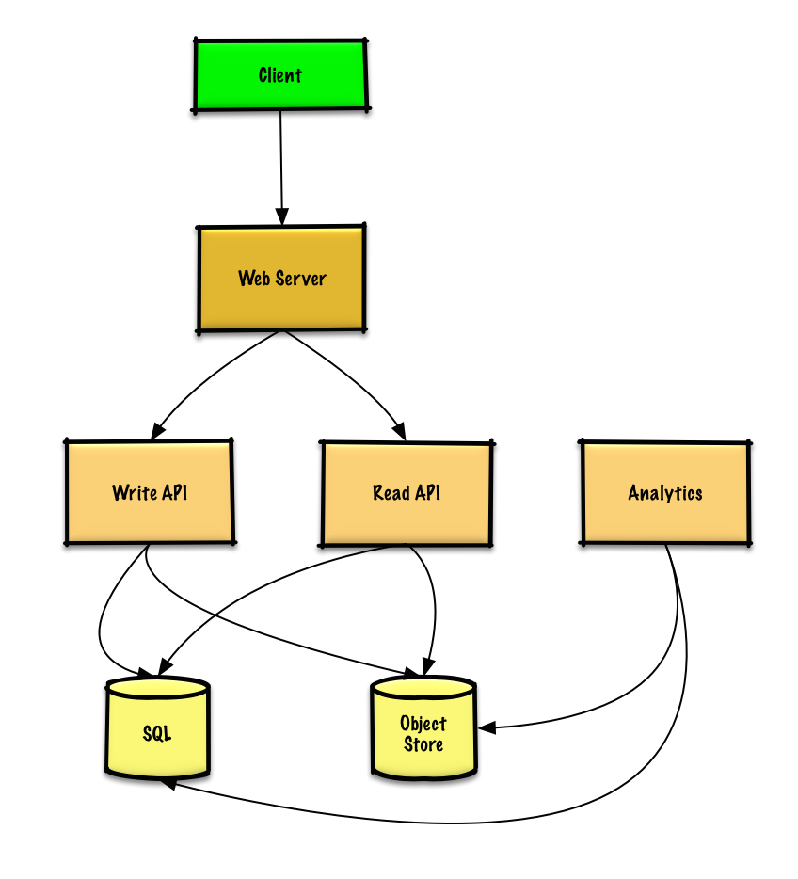](https://camo.githubusercontent.com/3cb97853adab74ef0abfe733685aab2a224702191cb696560be2b48a0d6c1d08/687474703a2f2f692e696d6775722e636f6d2f424b73426e6d472e706e67)

## Step 3: Design core components

Dive into details for each core component.

### Use case: User enters a block of text and gets a randomly generated link

We could use a [relational database](https://github.com/donnemartin/system-design-primer#relational-database-management-system-rdbms) as a large hash table, mapping the generated url to a file server and path containing the paste file.

Instead of managing a file server, we could use a managed **Object Store** such as Amazon S3 or a [NoSQL document store](https://github.com/donnemartin/system-design-primer#document-store).

An alternative to a relational database acting as a large hash table, we could use a [NoSQL key-value store](https://github.com/donnemartin/system-design-primer#key-value-store). We should discuss the [tradeoffs between choosing SQL or NoSQL](https://github.com/donnemartin/system-design-primer#sql-or-nosql). The following discussion uses the relational database approach.

* The **Client** sends a create paste request to the **Web Server**, running as a [reverse proxy](https://github.com/donnemartin/system-design-primer#reverse-proxy-web-server)
* The **Web Server** forwards the request to the **Write API** server
* The **Write API** server does the following:
  + Generates a unique url
    - Checks if the url is unique by looking at the **SQL Database** for a duplicate
    - If the url is not unique, it generates another url
    - If we supported a custom url, we could use the user-supplied (also check for a duplicate)
  + Saves to the **SQL Database** pastes table
  + Saves the paste data to the **Object Store**
  + Returns the url

**Clarify with your interviewer how much code you are expected to write**.

The pastes table could have the following structure:

shortlink char(7) NOT NULL

expiration\_length\_in\_minutes int NOT NULL

created\_at datetime NOT NULL

paste\_path varchar(255) NOT NULL

PRIMARY KEY(shortlink)

Setting the primary key to be based on the shortlink column creates an [index](https://github.com/donnemartin/system-design-primer#use-good-indices) that the database uses to enforce uniqueness. We'll create an additional index on created\_at to speed up lookups (log-time instead of scanning the entire table) and to keep the data in memory. Reading 1 MB sequentially from memory takes about 250 microseconds, while reading from SSD takes 4x and from disk takes 80x longer.[1](https://github.com/donnemartin/system-design-primer#latency-numbers-every-programmer-should-know)

To generate the unique url, we could:

* Take the [**MD5**](https://en.wikipedia.org/wiki/MD5) hash of the user's ip\_address + timestamp
  + MD5 is a widely used hashing function that produces a 128-bit hash value
  + MD5 is uniformly distributed
  + Alternatively, we could also take the MD5 hash of randomly-generated data
* [**Base 62**](https://www.kerstner.at/2012/07/shortening-strings-using-base-62-encoding/) encode the MD5 hash
  + Base 62 encodes to [a-zA-Z0-9] which works well for urls, eliminating the need for escaping special characters
  + There is only one hash result for the original input and Base 62 is deterministic (no randomness involved)
  + Base 64 is another popular encoding but provides issues for urls because of the additional + and / characters
  + The following [Base 62 pseudocode](http://stackoverflow.com/questions/742013/how-to-code-a-url-shortener) runs in O(k) time where k is the number of digits = 7:

def base\_encode(num, base=62):

digits = []

while num > 0

remainder = modulo(num, base)

digits.push(remainder)

num = divide(num, base)

digits = digits.reverse

* Take the first 7 characters of the output, which results in 62^7 possible values and should be sufficient to handle our constraint of 360 million shortlinks in 3 years:

url = base\_encode(md5(ip\_address+timestamp))[:URL\_LENGTH]

We'll use a public [**REST API**](https://github.com/donnemartin/system-design-primer#representational-state-transfer-rest):

$ curl -X POST --data '{ "expiration\_length\_in\_minutes": "60", \

"paste\_contents": "Hello World!" }' https://pastebin.com/api/v1/paste

Response:

{

"shortlink": "foobar"

}

For internal communications, we could use [Remote Procedure Calls](https://github.com/donnemartin/system-design-primer#remote-procedure-call-rpc).

### Use case: User enters a paste's url and views the contents

* The **Client** sends a get paste request to the **Web Server**
* The **Web Server** forwards the request to the **Read API** server
* The **Read API** server does the following:
  + Checks the **SQL Database** for the generated url
    - If the url is in the **SQL Database**, fetch the paste contents from the **Object Store**
    - Else, return an error message for the user

REST API:

$ curl https://pastebin.com/api/v1/paste?shortlink=foobar

Response:

{

"paste\_contents": "Hello World"

"created\_at": "YYYY-MM-DD HH:MM:SS"

"expiration\_length\_in\_minutes": "60"

}

### Use case: Service tracks analytics of pages

Since realtime analytics are not a requirement, we could simply **MapReduce** the **Web Server** logs to generate hit counts.

**Clarify with your interviewer how much code you are expected to write**.

class HitCounts(MRJob):

def extract\_url(self, line):

"""Extract the generated url from the log line."""

...

def extract\_year\_month(self, line):

"""Return the year and month portions of the timestamp."""

...

def mapper(self, \_, line):

"""Parse each log line, extract and transform relevant lines.

Emit key value pairs of the form:

(2016-01, url0), 1

(2016-01, url0), 1

(2016-01, url1), 1

"""

url = self.extract\_url(line)

period = self.extract\_year\_month(line)

yield (period, url), 1

def reducer(self, key, values):

"""Sum values for each key.

(2016-01, url0), 2

(2016-01, url1), 1

"""

yield key, sum(values)

### Use case: Service deletes expired pastes

To delete expired pastes, we could just scan the **SQL Database** for all entries whose expiration timestamp are older than the current timestamp. All expired entries would then be deleted (or marked as expired) from the table.

## Step 4: Scale the design

Identify and address bottlenecks, given the constraints.

[](https://camo.githubusercontent.com/018f5e8780f65abf18eee58d0dfe8a0501213be42829a3da0d4d94118a5979c9/687474703a2f2f692e696d6775722e636f6d2f346564584730542e706e67)

**Important: Do not simply jump right into the final design from the initial design!**

State you would do this iteratively: 1) **Benchmark/Load Test**, 2) **Profile** for bottlenecks 3) address bottlenecks while evaluating alternatives and trade-offs, and 4) repeat. See [Design a system that scales to millions of users on AWS](https://github.com/donnemartin/system-design-primer/blob/master/solutions/system_design/scaling_aws/README.md) as a sample on how to iteratively scale the initial design.

It's important to discuss what bottlenecks you might encounter with the initial design and how you might address each of them. For example, what issues are addressed by adding a **Load Balancer** with multiple **Web Servers**? **CDN**? **Master-Slave Replicas**? What are the alternatives and **Trade-Offs** for each?

We'll introduce some components to complete the design and to address scalability issues. Internal load balancers are not shown to reduce clutter.

To avoid repeating discussions, refer to the following [system design topics](https://github.com/donnemartin/system-design-primer#index-of-system-design-topics) for main talking points, tradeoffs, and alternatives:

* [DNS](https://github.com/donnemartin/system-design-primer#domain-name-system)
* [CDN](https://github.com/donnemartin/system-design-primer#content-delivery-network)
* [Load balancer](https://github.com/donnemartin/system-design-primer#load-balancer)
* [Horizontal scaling](https://github.com/donnemartin/system-design-primer#horizontal-scaling)
* [Web server (reverse proxy)](https://github.com/donnemartin/system-design-primer#reverse-proxy-web-server)
* [API server (application layer)](https://github.com/donnemartin/system-design-primer#application-layer)
* [Cache](https://github.com/donnemartin/system-design-primer#cache)
* [Relational database management system (RDBMS)](https://github.com/donnemartin/system-design-primer#relational-database-management-system-rdbms)
* [SQL write master-slave failover](https://github.com/donnemartin/system-design-primer#fail-over)
* [Master-slave replication](https://github.com/donnemartin/system-design-primer#master-slave-replication)
* [Consistency patterns](https://github.com/donnemartin/system-design-primer#consistency-patterns)
* [Availability patterns](https://github.com/donnemartin/system-design-primer#availability-patterns)

The **Analytics Database** could use a data warehousing solution such as Amazon Redshift or Google BigQuery.

An **Object Store** such as Amazon S3 can comfortably handle the constraint of 12.7 GB of new content per month.

To address the 40 average read requests per second (higher at peak), traffic for popular content should be handled by the **Memory Cache** instead of the database. The **Memory Cache** is also useful for handling the unevenly distributed traffic and traffic spikes. The **SQL Read Replicas** should be able to handle the cache misses, as long as the replicas are not bogged down with replicating writes.

4 average paste writes per second (with higher at peak) should be do-able for a single **SQL Write Master-Slave**. Otherwise, we'll need to employ additional SQL scaling patterns:

* [Federation](https://github.com/donnemartin/system-design-primer#federation)
* [Sharding](https://github.com/donnemartin/system-design-primer#sharding)
* [Denormalization](https://github.com/donnemartin/system-design-primer#denormalization)
* [SQL Tuning](https://github.com/donnemartin/system-design-primer#sql-tuning)

We should also consider moving some data to a **NoSQL Database**.

## Additional talking points

Additional topics to dive into, depending on the problem scope and time remaining.

#### NoSQL

* [Key-value store](https://github.com/donnemartin/system-design-primer#key-value-store)
* [Document store](https://github.com/donnemartin/system-design-primer#document-store)
* [Wide column store](https://github.com/donnemartin/system-design-primer#wide-column-store)
* [Graph database](https://github.com/donnemartin/system-design-primer#graph-database)
* [SQL vs NoSQL](https://github.com/donnemartin/system-design-primer#sql-or-nosql)

### Caching

* Where to cache
  + [Client caching](https://github.com/donnemartin/system-design-primer#client-caching)
  + [CDN caching](https://github.com/donnemartin/system-design-primer#cdn-caching)
  + [Web server caching](https://github.com/donnemartin/system-design-primer#web-server-caching)
  + [Database caching](https://github.com/donnemartin/system-design-primer#database-caching)
  + [Application caching](https://github.com/donnemartin/system-design-primer#application-caching)
* What to cache
  + [Caching at the database query level](https://github.com/donnemartin/system-design-primer#caching-at-the-database-query-level)
  + [Caching at the object level](https://github.com/donnemartin/system-design-primer#caching-at-the-object-level)
* When to update the cache
  + [Cache-aside](https://github.com/donnemartin/system-design-primer#cache-aside)
  + [Write-through](https://github.com/donnemartin/system-design-primer#write-through)
  + [Write-behind (write-back)](https://github.com/donnemartin/system-design-primer#write-behind-write-back)
  + [Refresh ahead](https://github.com/donnemartin/system-design-primer#refresh-ahead)

### Asynchronism and microservices

* [Message queues](https://github.com/donnemartin/system-design-primer#message-queues)
* [Task queues](https://github.com/donnemartin/system-design-primer#task-queues)
* [Back pressure](https://github.com/donnemartin/system-design-primer#back-pressure)
* [Microservices](https://github.com/donnemartin/system-design-primer#microservices)

### Communications

* Discuss tradeoffs:
  + External communication with clients - [HTTP APIs following REST](https://github.com/donnemartin/system-design-primer#representational-state-transfer-rest)
  + Internal communications - [RPC](https://github.com/donnemartin/system-design-primer#remote-procedure-call-rpc)
* [Service discovery](https://github.com/donnemartin/system-design-primer#service-discovery)

### Security

Refer to the [security section](https://github.com/donnemartin/system-design-primer#security).

### Latency numbers

See [Latency numbers every programmer should know](https://github.com/donnemartin/system-design-primer#latency-numbers-every-programmer-should-know).

### Ongoing

* Continue benchmarking and monitoring your system to address bottlenecks as they come up
* Scaling is an iterative process

# Design the Twitter timeline and search

Note: This document links directly to relevant areas found in the [*system design topics*](https://github.com/donnemartin/system-design-primer#index-of-system-design-topics) to avoid duplication. Refer to the linked content for general talking points, tradeoffs, and alternatives.

**Design the Facebook feed** and **Design Facebook search** are similar questions.

## Step 1: Outline use cases and constraints

Gather requirements and scope the problem. Ask questions to clarify use cases and constraints. Discuss assumptions.

Without an interviewer to address clarifying questions, we'll define some use cases and constraints.

### Use cases

#### We'll scope the problem to handle only the following use cases

* **User** posts a tweet
  + **Service** pushes tweets to followers, sending push notifications and emails
* **User** views the user timeline (activity from the user)
* **User** views the home timeline (activity from people the user is following)
* **User** searches keywords
* **Service** has high availability

#### Out of scope

* **Service** pushes tweets to the Twitter Firehose and other streams
* **Service** strips out tweets based on users' visibility settings
  + Hide @reply if the user is not also following the person being replied to
  + Respect 'hide retweets' setting
* Analytics

### Constraints and assumptions

#### State assumptions

General

* Traffic is not evenly distributed
* Posting a tweet should be fast
  + Fanning out a tweet to all of your followers should be fast, unless you have millions of followers
* 100 million active users
* 500 million tweets per day or 15 billion tweets per month
  + Each tweet averages a fanout of 10 deliveries
  + 5 billion total tweets delivered on fanout per day
  + 150 billion tweets delivered on fanout per month
* 250 billion read requests per month
* 10 billion searches per month

Timeline

* Viewing the timeline should be fast
* Twitter is more read heavy than write heavy
  + Optimize for fast reads of tweets
* Ingesting tweets is write heavy

Search

* Searching should be fast
* Search is read-heavy

#### Calculate usage

**Clarify with your interviewer if you should run back-of-the-envelope usage calculations.**

* Size per tweet:
  + tweet\_id - 8 bytes
  + user\_id - 32 bytes
  + text - 140 bytes
  + media - 10 KB average
  + Total: ~10 KB
* 150 TB of new tweet content per month
  + 10 KB per tweet \* 500 million tweets per day \* 30 days per month
  + 5.4 PB of new tweet content in 3 years
* 100 thousand read requests per second
  + 250 billion read requests per month \* (400 requests per second / 1 billion requests per month)
* 6,000 tweets per second
  + 15 billion tweets per month \* (400 requests per second / 1 billion requests per month)
* 60 thousand tweets delivered on fanout per second
  + 150 billion tweets delivered on fanout per month \* (400 requests per second / 1 billion requests per month)
* 4,000 search requests per second
  + 10 billion searches per month \* (400 requests per second / 1 billion requests per month)

Handy conversion guide:

* 2.5 million seconds per month
* 1 request per second = 2.5 million requests per month
* 40 requests per second = 100 million requests per month
* 400 requests per second = 1 billion requests per month

## Step 2: Create a high level design

Outline a high level design with all important components.

[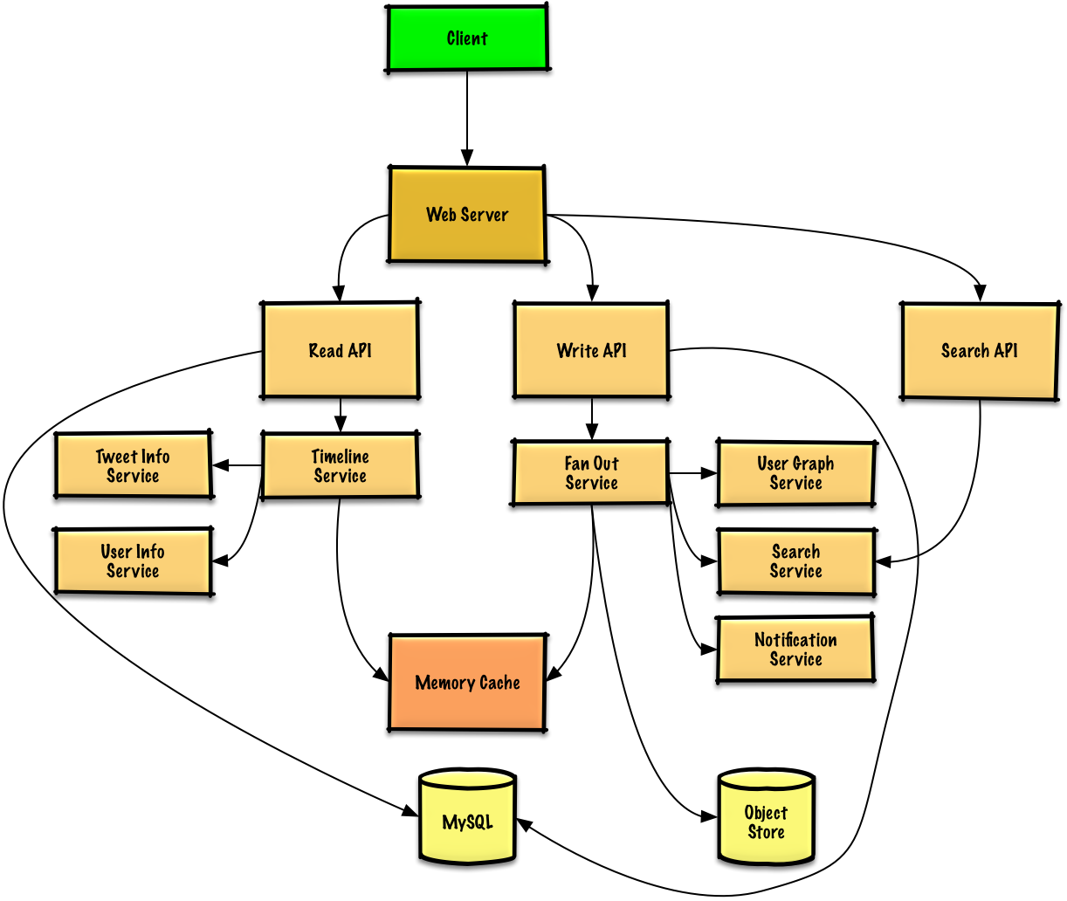](https://camo.githubusercontent.com/50cbbc6a5ca2edf3f549ee5d1bad0816320862edcd16a66533670b95d6ad77b9/687474703a2f2f692e696d6775722e636f6d2f3438744541326a2e706e67)

## Step 3: Design core components

Dive into details for each core component.

### Use case: User posts a tweet

We could store the user's own tweets to populate the user timeline (activity from the user) in a [relational database](https://github.com/donnemartin/system-design-primer#relational-database-management-system-rdbms). We should discuss the [use cases and tradeoffs between choosing SQL or NoSQL](https://github.com/donnemartin/system-design-primer#sql-or-nosql).

Delivering tweets and building the home timeline (activity from people the user is following) is trickier. Fanning out tweets to all followers (60 thousand tweets delivered on fanout per second) will overload a traditional [relational database](https://github.com/donnemartin/system-design-primer#relational-database-management-system-rdbms). We'll probably want to choose a data store with fast writes such as a **NoSQL database** or **Memory Cache**. Reading 1 MB sequentially from memory takes about 250 microseconds, while reading from SSD takes 4x and from disk takes 80x longer.[1](https://github.com/donnemartin/system-design-primer#latency-numbers-every-programmer-should-know)

We could store media such as photos or videos on an **Object Store**.

* The **Client** posts a tweet to the **Web Server**, running as a [reverse proxy](https://github.com/donnemartin/system-design-primer#reverse-proxy-web-server)
* The **Web Server** forwards the request to the **Write API** server
* The **Write API** stores the tweet in the user's timeline on a **SQL database**
* The **Write API** contacts the **Fan Out Service**, which does the following:
  + Queries the **User Graph Service** to find the user's followers stored in the **Memory Cache**
  + Stores the tweet in the home timeline of the user's followers in a **Memory Cache**
    - O(n) operation: 1,000 followers = 1,000 lookups and inserts
  + Stores the tweet in the **Search Index Service** to enable fast searching
  + Stores media in the **Object Store**
  + Uses the **Notification Service** to send out push notifications to followers:
    - Uses a **Queue** (not pictured) to asynchronously send out notifications

**Clarify with your interviewer how much code you are expected to write**.

If our **Memory Cache** is Redis, we could use a native Redis list with the following structure:

tweet n+2 tweet n+1 tweet n

| 8 bytes 8 bytes 1 byte | 8 bytes 8 bytes 1 byte | 8 bytes 8 bytes 1 byte |

| tweet\_id user\_id meta | tweet\_id user\_id meta | tweet\_id user\_id meta |

The new tweet would be placed in the **Memory Cache**, which populates the user's home timeline (activity from people the user is following).

We'll use a public [**REST API**](https://github.com/donnemartin/system-design-primer#representational-state-transfer-rest):

$ curl -X POST --data '{ "user\_id": "123", "auth\_token": "ABC123", \

"status": "hello world!", "media\_ids": "ABC987" }' \

https://twitter.com/api/v1/tweet

Response:

{

"created\_at": "Wed Sep 05 00:37:15 +0000 2012",

"status": "hello world!",

"tweet\_id": "987",

"user\_id": "123",

...

}

For internal communications, we could use [Remote Procedure Calls](https://github.com/donnemartin/system-design-primer#remote-procedure-call-rpc).

### Use case: User views the home timeline

* The **Client** posts a home timeline request to the **Web Server**
* The **Web Server** forwards the request to the **Read API** server
* The **Read API** server contacts the **Timeline Service**, which does the following:
  + Gets the timeline data stored in the **Memory Cache**, containing tweet ids and user ids - O(1)
  + Queries the **Tweet Info Service** with a [multiget](http://redis.io/commands/mget) to obtain additional info about the tweet ids - O(n)
  + Queries the **User Info Service** with a multiget to obtain additional info about the user ids - O(n)

REST API:

$ curl https://twitter.com/api/v1/home\_timeline?user\_id=123

Response:

{

"user\_id": "456",

"tweet\_id": "123",

"status": "foo"

},

{

"user\_id": "789",

"tweet\_id": "456",

"status": "bar"

},

{

"user\_id": "789",

"tweet\_id": "579",

"status": "baz"

},

### Use case: User views the user timeline

* The **Client** posts a user timeline request to the **Web Server**
* The **Web Server** forwards the request to the **Read API** server
* The **Read API** retrieves the user timeline from the **SQL Database**

The REST API would be similar to the home timeline, except all tweets would come from the user as opposed to the people the user is following.

### Use case: User searches keywords

* The **Client** sends a search request to the **Web Server**
* The **Web Server** forwards the request to the **Search API** server
* The **Search API** contacts the **Search Service**, which does the following:
  + Parses/tokenizes the input query, determining what needs to be searched
    - Removes markup
    - Breaks up the text into terms
    - Fixes typos
    - Normalizes capitalization
    - Converts the query to use boolean operations
  + Queries the **Search Cluster** (ie [Lucene](https://lucene.apache.org/)) for the results:
    - [Scatter gathers](https://github.com/donnemartin/system-design-primer#under-development) each server in the cluster to determine if there are any results for the query
    - Merges, ranks, sorts, and returns the results

REST API:

$ curl https://twitter.com/api/v1/search?query=hello+world

The response would be similar to that of the home timeline, except for tweets matching the given query.

## Step 4: Scale the design

Identify and address bottlenecks, given the constraints.

[](https://camo.githubusercontent.com/9e39348f2f5859e053bf6e394dc0f114d93f199f31418cfb58b7e89e1cc40fa0/687474703a2f2f692e696d6775722e636f6d2f6a7255424146372e706e67)

**Important: Do not simply jump right into the final design from the initial design!**

State you would 1) **Benchmark/Load Test**, 2) **Profile** for bottlenecks 3) address bottlenecks while evaluating alternatives and trade-offs, and 4) repeat. See [Design a system that scales to millions of users on AWS](https://github.com/donnemartin/system-design-primer/blob/master/solutions/system_design/scaling_aws/README.md) as a sample on how to iteratively scale the initial design.

It's important to discuss what bottlenecks you might encounter with the initial design and how you might address each of them. For example, what issues are addressed by adding a **Load Balancer** with multiple **Web Servers**? **CDN**? **Master-Slave Replicas**? What are the alternatives and **Trade-Offs** for each?

We'll introduce some components to complete the design and to address scalability issues. Internal load balancers are not shown to reduce clutter.

To avoid repeating discussions, refer to the following [system design topics](https://github.com/donnemartin/system-design-primer#index-of-system-design-topics) for main talking points, tradeoffs, and alternatives:

* [DNS](https://github.com/donnemartin/system-design-primer#domain-name-system)
* [CDN](https://github.com/donnemartin/system-design-primer#content-delivery-network)
* [Load balancer](https://github.com/donnemartin/system-design-primer#load-balancer)
* [Horizontal scaling](https://github.com/donnemartin/system-design-primer#horizontal-scaling)
* [Web server (reverse proxy)](https://github.com/donnemartin/system-design-primer#reverse-proxy-web-server)
* [API server (application layer)](https://github.com/donnemartin/system-design-primer#application-layer)
* [Cache](https://github.com/donnemartin/system-design-primer#cache)
* [Relational database management system (RDBMS)](https://github.com/donnemartin/system-design-primer#relational-database-management-system-rdbms)
* [SQL write master-slave failover](https://github.com/donnemartin/system-design-primer#fail-over)
* [Master-slave replication](https://github.com/donnemartin/system-design-primer#master-slave-replication)
* [Consistency patterns](https://github.com/donnemartin/system-design-primer#consistency-patterns)
* [Availability patterns](https://github.com/donnemartin/system-design-primer#availability-patterns)

The **Fanout Service** is a potential bottleneck. Twitter users with millions of followers could take several minutes to have their tweets go through the fanout process. This could lead to race conditions with @replies to the tweet, which we could mitigate by re-ordering the tweets at serve time.

We could also avoid fanning out tweets from highly-followed users. Instead, we could search to find tweets for highly-followed users, merge the search results with the user's home timeline results, then re-order the tweets at serve time.

Additional optimizations include:

* Keep only several hundred tweets for each home timeline in the **Memory Cache**
* Keep only active users' home timeline info in the **Memory Cache**
  + If a user was not previously active in the past 30 days, we could rebuild the timeline from the **SQL Database**
    - Query the **User Graph Service** to determine who the user is following
    - Get the tweets from the **SQL Database** and add them to the **Memory Cache**
* Store only a month of tweets in the **Tweet Info Service**
* Store only active users in the **User Info Service**
* The **Search Cluster** would likely need to keep the tweets in memory to keep latency low

We'll also want to address the bottleneck with the **SQL Database**.

Although the **Memory Cache** should reduce the load on the database, it is unlikely the **SQL Read Replicas** alone would be enough to handle the cache misses. We'll probably need to employ additional SQL scaling patterns.

The high volume of writes would overwhelm a single **SQL Write Master-Slave**, also pointing to a need for additional scaling techniques.

* [Federation](https://github.com/donnemartin/system-design-primer#federation)
* [Sharding](https://github.com/donnemartin/system-design-primer#sharding)
* [Denormalization](https://github.com/donnemartin/system-design-primer#denormalization)
* [SQL Tuning](https://github.com/donnemartin/system-design-primer#sql-tuning)

We should also consider moving some data to a **NoSQL Database**.

## Additional talking points

Additional topics to dive into, depending on the problem scope and time remaining.

#### NoSQL

* [Key-value store](https://github.com/donnemartin/system-design-primer#key-value-store)
* [Document store](https://github.com/donnemartin/system-design-primer#document-store)
* [Wide column store](https://github.com/donnemartin/system-design-primer#wide-column-store)
* [Graph database](https://github.com/donnemartin/system-design-primer#graph-database)
* [SQL vs NoSQL](https://github.com/donnemartin/system-design-primer#sql-or-nosql)

### Caching

* Where to cache
  + [Client caching](https://github.com/donnemartin/system-design-primer#client-caching)
  + [CDN caching](https://github.com/donnemartin/system-design-primer#cdn-caching)
  + [Web server caching](https://github.com/donnemartin/system-design-primer#web-server-caching)
  + [Database caching](https://github.com/donnemartin/system-design-primer#database-caching)
  + [Application caching](https://github.com/donnemartin/system-design-primer#application-caching)
* What to cache
  + [Caching at the database query level](https://github.com/donnemartin/system-design-primer#caching-at-the-database-query-level)
  + [Caching at the object level](https://github.com/donnemartin/system-design-primer#caching-at-the-object-level)
* When to update the cache
  + [Cache-aside](https://github.com/donnemartin/system-design-primer#cache-aside)
  + [Write-through](https://github.com/donnemartin/system-design-primer#write-through)
  + [Write-behind (write-back)](https://github.com/donnemartin/system-design-primer#write-behind-write-back)
  + [Refresh ahead](https://github.com/donnemartin/system-design-primer#refresh-ahead)

### Asynchronism and microservices

* [Message queues](https://github.com/donnemartin/system-design-primer#message-queues)
* [Task queues](https://github.com/donnemartin/system-design-primer#task-queues)
* [Back pressure](https://github.com/donnemartin/system-design-primer#back-pressure)
* [Microservices](https://github.com/donnemartin/system-design-primer#microservices)

### Communications

* Discuss tradeoffs:
  + External communication with clients - [HTTP APIs following REST](https://github.com/donnemartin/system-design-primer#representational-state-transfer-rest)
  + Internal communications - [RPC](https://github.com/donnemartin/system-design-primer#remote-procedure-call-rpc)
* [Service discovery](https://github.com/donnemartin/system-design-primer#service-discovery)

### Security

Refer to the [security section](https://github.com/donnemartin/system-design-primer#security).

### Latency numbers

See [Latency numbers every programmer should know](https://github.com/donnemartin/system-design-primer#latency-numbers-every-programmer-should-know).

### Ongoing

* Continue benchmarking and monitoring your system to address bottlenecks as they come up
* Scaling is an iterative process

# Design a key-value cache to save the results of the most recent web server queries

Note: This document links directly to relevant areas found in the [*system design topics*](https://github.com/donnemartin/system-design-primer#index-of-system-design-topics) to avoid duplication. Refer to the linked content for general talking points, tradeoffs, and alternatives.

## Step 1: Outline use cases and constraints

Gather requirements and scope the problem. Ask questions to clarify use cases and constraints. Discuss assumptions.

Without an interviewer to address clarifying questions, we'll define some use cases and constraints.

### Use cases

#### We'll scope the problem to handle only the following use cases

* **User** sends a search request resulting in a cache hit
* **User** sends a search request resulting in a cache miss
* **Service** has high availability

### Constraints and assumptions

#### State assumptions

* Traffic is not evenly distributed
  + Popular queries should almost always be in the cache
  + Need to determine how to expire/refresh
* Serving from cache requires fast lookups
* Low latency between machines
* Limited memory in cache
  + Need to determine what to keep/remove
  + Need to cache millions of queries
* 10 million users
* 10 billion queries per month

#### Calculate usage

**Clarify with your interviewer if you should run back-of-the-envelope usage calculations.**

* Cache stores ordered list of key: query, value: results
  + query - 50 bytes
  + title - 20 bytes
  + snippet - 200 bytes
  + Total: 270 bytes
* 2.7 TB of cache data per month if all 10 billion queries are unique and all are stored
  + 270 bytes per search \* 10 billion searches per month
  + Assumptions state limited memory, need to determine how to expire contents
* 4,000 requests per second

Handy conversion guide:

* 2.5 million seconds per month
* 1 request per second = 2.5 million requests per month
* 40 requests per second = 100 million requests per month
* 400 requests per second = 1 billion requests per month

## Step 2: Create a high level design

Outline a high level design with all important components.

[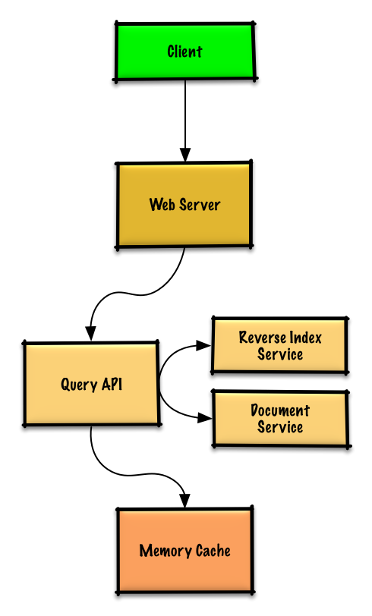](https://camo.githubusercontent.com/ba52ed50e9fcfac793417de73dd49215bb80e84cff86ce6fdcb6cf8ad55a17da/687474703a2f2f692e696d6775722e636f6d2f4b715a336453782e706e67)

## Step 3: Design core components

Dive into details for each core component.

### Use case: User sends a request resulting in a cache hit

Popular queries can be served from a **Memory Cache** such as Redis or Memcached to reduce read latency and to avoid overloading the **Reverse Index Service** and **Document Service**. Reading 1 MB sequentially from memory takes about 250 microseconds, while reading from SSD takes 4x and from disk takes 80x longer.[1](https://github.com/donnemartin/system-design-primer#latency-numbers-every-programmer-should-know)

Since the cache has limited capacity, we'll use a least recently used (LRU) approach to expire older entries.

* The **Client** sends a request to the **Web Server**, running as a [reverse proxy](https://github.com/donnemartin/system-design-primer#reverse-proxy-web-server)
* The **Web Server** forwards the request to the **Query API** server
* The **Query API** server does the following:
  + Parses the query
    - Removes markup
    - Breaks up the text into terms
    - Fixes typos
    - Normalizes capitalization
    - Converts the query to use boolean operations
  + Checks the **Memory Cache** for the content matching the query
    - If there's a hit in the **Memory Cache**, the **Memory Cache** does the following:
      * Updates the cached entry's position to the front of the LRU list
      * Returns the cached contents
    - Else, the **Query API** does the following:
      * Uses the **Reverse Index Service** to find documents matching the query
        + The **Reverse Index Service** ranks the matching results and returns the top ones
      * Uses the **Document Service** to return titles and snippets
      * Updates the **Memory Cache** with the contents, placing the entry at the front of the LRU list

#### Cache implementation

The cache can use a doubly-linked list: new items will be added to the head while items to expire will be removed from the tail. We'll use a hash table for fast lookups to each linked list node.

**Clarify with your interviewer how much code you are expected to write**.

**Query API Server** implementation:

class QueryApi(object):

def \_\_init\_\_(self, memory\_cache, reverse\_index\_service):

self.memory\_cache = memory\_cache

self.reverse\_index\_service = reverse\_index\_service

def parse\_query(self, query):

"""Remove markup, break text into terms, deal with typos,

normalize capitalization, convert to use boolean operations.

"""

...

def process\_query(self, query):

query = self.parse\_query(query)

results = self.memory\_cache.get(query)

if results is None:

results = self.reverse\_index\_service.process\_search(query)

self.memory\_cache.set(query, results)

return results

**Node** implementation:

class Node(object):

def \_\_init\_\_(self, query, results):

self.query = query

self.results = results

**LinkedList** implementation:

class LinkedList(object):

def \_\_init\_\_(self):

self.head = None

self.tail = None

def move\_to\_front(self, node):

...

def append\_to\_front(self, node):

...

def remove\_from\_tail(self):

...

**Cache** implementation:

class Cache(object):

def \_\_init\_\_(self, MAX\_SIZE):

self.MAX\_SIZE = MAX\_SIZE

self.size = 0

self.lookup = {} # key: query, value: node

self.linked\_list = LinkedList()

def get(self, query)

"""Get the stored query result from the cache.

Accessing a node updates its position to the front of the LRU list.

"""

node = self.lookup[query]

if node is None:

return None

self.linked\_list.move\_to\_front(node)

return node.results

def set(self, results, query):

"""Set the result for the given query key in the cache.

When updating an entry, updates its position to the front of the LRU list.

If the entry is new and the cache is at capacity, removes the oldest entry

before the new entry is added.

"""

node = self.lookup[query]

if node is not None:

# Key exists in cache, update the value

node.results = results

self.linked\_list.move\_to\_front(node)

else:

# Key does not exist in cache

if self.size == self.MAX\_SIZE:

# Remove the oldest entry from the linked list and lookup

self.lookup.pop(self.linked\_list.tail.query, None)

self.linked\_list.remove\_from\_tail()

else:

self.size += 1

# Add the new key and value

new\_node = Node(query, results)

self.linked\_list.append\_to\_front(new\_node)

self.lookup[query] = new\_node

#### When to update the cache

The cache should be updated when:

* The page contents change
* The page is removed or a new page is added
* The page rank changes

The most straightforward way to handle these cases is to simply set a max time that a cached entry can stay in the cache before it is updated, usually referred to as time to live (TTL).

Refer to [When to update the cache](https://github.com/donnemartin/system-design-primer#when-to-update-the-cache) for tradeoffs and alternatives. The approach above describes [cache-aside](https://github.com/donnemartin/system-design-primer#cache-aside).

## Step 4: Scale the design

Identify and address bottlenecks, given the constraints.

[](https://camo.githubusercontent.com/b436ee282f12de304f591a27d51511c2264244ac21b4afa9900c0bfa605f8e31/687474703a2f2f692e696d6775722e636f6d2f346a39396d68652e706e67)

**Important: Do not simply jump right into the final design from the initial design!**

State you would 1) **Benchmark/Load Test**, 2) **Profile** for bottlenecks 3) address bottlenecks while evaluating alternatives and trade-offs, and 4) repeat. See [Design a system that scales to millions of users on AWS](https://github.com/donnemartin/system-design-primer/blob/master/solutions/system_design/scaling_aws/README.md) as a sample on how to iteratively scale the initial design.

It's important to discuss what bottlenecks you might encounter with the initial design and how you might address each of them. For example, what issues are addressed by adding a **Load Balancer** with multiple **Web Servers**? **CDN**? **Master-Slave Replicas**? What are the alternatives and **Trade-Offs** for each?

We'll introduce some components to complete the design and to address scalability issues. Internal load balancers are not shown to reduce clutter.

To avoid repeating discussions, refer to the following [system design topics](https://github.com/donnemartin/system-design-primer#index-of-system-design-topics) for main talking points, tradeoffs, and alternatives:

* [DNS](https://github.com/donnemartin/system-design-primer#domain-name-system)
* [Load balancer](https://github.com/donnemartin/system-design-primer#load-balancer)
* [Horizontal scaling](https://github.com/donnemartin/system-design-primer#horizontal-scaling)
* [Web server (reverse proxy)](https://github.com/donnemartin/system-design-primer#reverse-proxy-web-server)
* [API server (application layer)](https://github.com/donnemartin/system-design-primer#application-layer)
* [Cache](https://github.com/donnemartin/system-design-primer#cache)
* [Consistency patterns](https://github.com/donnemartin/system-design-primer#consistency-patterns)
* [Availability patterns](https://github.com/donnemartin/system-design-primer#availability-patterns)

### Expanding the Memory Cache to many machines

To handle the heavy request load and the large amount of memory needed, we'll scale horizontally. We have three main options on how to store the data on our **Memory Cache** cluster:

* **Each machine in the cache cluster has its own cache** - Simple, although it will likely result in a low cache hit rate.
* **Each machine in the cache cluster has a copy of the cache** - Simple, although it is an inefficient use of memory.
* **The cache is**[**sharded**](https://github.com/donnemartin/system-design-primer#sharding)**across all machines in the cache cluster** - More complex, although it is likely the best option. We could use hashing to determine which machine could have the cached results of a query using machine = hash(query). We'll likely want to use [consistent hashing](https://github.com/donnemartin/system-design-primer#under-development).

## Additional talking points

Additional topics to dive into, depending on the problem scope and time remaining.

### SQL scaling patterns

* [Read replicas](https://github.com/donnemartin/system-design-primer#master-slave-replication)
* [Federation](https://github.com/donnemartin/system-design-primer#federation)
* [Sharding](https://github.com/donnemartin/system-design-primer#sharding)
* [Denormalization](https://github.com/donnemartin/system-design-primer#denormalization)
* [SQL Tuning](https://github.com/donnemartin/system-design-primer#sql-tuning)

#### NoSQL

* [Key-value store](https://github.com/donnemartin/system-design-primer#key-value-store)
* [Document store](https://github.com/donnemartin/system-design-primer#document-store)
* [Wide column store](https://github.com/donnemartin/system-design-primer#wide-column-store)
* [Graph database](https://github.com/donnemartin/system-design-primer#graph-database)
* [SQL vs NoSQL](https://github.com/donnemartin/system-design-primer#sql-or-nosql)

### Caching

* Where to cache
  + [Client caching](https://github.com/donnemartin/system-design-primer#client-caching)
  + [CDN caching](https://github.com/donnemartin/system-design-primer#cdn-caching)
  + [Web server caching](https://github.com/donnemartin/system-design-primer#web-server-caching)
  + [Database caching](https://github.com/donnemartin/system-design-primer#database-caching)
  + [Application caching](https://github.com/donnemartin/system-design-primer#application-caching)
* What to cache
  + [Caching at the database query level](https://github.com/donnemartin/system-design-primer#caching-at-the-database-query-level)
  + [Caching at the object level](https://github.com/donnemartin/system-design-primer#caching-at-the-object-level)
* When to update the cache
  + [Cache-aside](https://github.com/donnemartin/system-design-primer#cache-aside)
  + [Write-through](https://github.com/donnemartin/system-design-primer#write-through)
  + [Write-behind (write-back)](https://github.com/donnemartin/system-design-primer#write-behind-write-back)
  + [Refresh ahead](https://github.com/donnemartin/system-design-primer#refresh-ahead)

### Asynchronism and microservices

* [Message queues](https://github.com/donnemartin/system-design-primer#message-queues)
* [Task queues](https://github.com/donnemartin/system-design-primer#task-queues)
* [Back pressure](https://github.com/donnemartin/system-design-primer#back-pressure)
* [Microservices](https://github.com/donnemartin/system-design-primer#microservices)

### Communications

* Discuss tradeoffs:
  + External communication with clients - [HTTP APIs following REST](https://github.com/donnemartin/system-design-primer#representational-state-transfer-rest)
  + Internal communications - [RPC](https://github.com/donnemartin/system-design-primer#remote-procedure-call-rpc)
* [Service discovery](https://github.com/donnemartin/system-design-primer#service-discovery)

### Security

Refer to the [security section](https://github.com/donnemartin/system-design-primer#security).

### Latency numbers

See [Latency numbers every programmer should know](https://github.com/donnemartin/system-design-primer#latency-numbers-every-programmer-should-know).

### Ongoing

* Continue benchmarking and monitoring your system to address bottlenecks as they come up
* Scaling is an iterative process

# Design Amazon's sales rank by category feature

Note: This document links directly to relevant areas found in the [*system design topics*](https://github.com/donnemartin/system-design-primer#index-of-system-design-topics) to avoid duplication. Refer to the linked content for general talking points, tradeoffs, and alternatives.

## Step 1: Outline use cases and constraints

Gather requirements and scope the problem. Ask questions to clarify use cases and constraints. Discuss assumptions.

Without an interviewer to address clarifying questions, we'll define some use cases and constraints.

### Use cases

#### We'll scope the problem to handle only the following use case

* **Service** calculates the past week's most popular products by category
* **User** views the past week's most popular products by category
* **Service** has high availability

#### Out of scope

* The general e-commerce site
  + Design components only for calculating sales rank

### Constraints and assumptions

#### State assumptions

* Traffic is not evenly distributed
* Items can be in multiple categories
* Items cannot change categories
* There are no subcategories ie foo/bar/baz
* Results must be updated hourly
  + More popular products might need to be updated more frequently
* 10 million products
* 1000 categories
* 1 billion transactions per month
* 100 billion read requests per month
* 100:1 read to write ratio

#### Calculate usage

**Clarify with your interviewer if you should run back-of-the-envelope usage calculations.**

* Size per transaction:
  + created\_at - 5 bytes
  + product\_id - 8 bytes
  + category\_id - 4 bytes
  + seller\_id - 8 bytes
  + buyer\_id - 8 bytes
  + quantity - 4 bytes
  + total\_price - 5 bytes
  + Total: ~40 bytes
* 40 GB of new transaction content per month
  + 40 bytes per transaction \* 1 billion transactions per month
  + 1.44 TB of new transaction content in 3 years
  + Assume most are new transactions instead of updates to existing ones
* 400 transactions per second on average
* 40,000 read requests per second on average

Handy conversion guide:

* 2.5 million seconds per month
* 1 request per second = 2.5 million requests per month
* 40 requests per second = 100 million requests per month
* 400 requests per second = 1 billion requests per month

## Step 2: Create a high level design

Outline a high level design with all important components.

[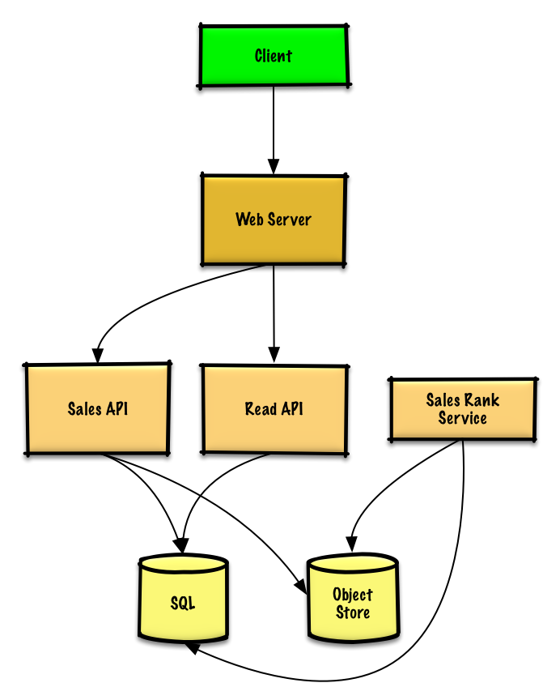](https://camo.githubusercontent.com/824f8dcd754036f3653bb53a8b5412cdf156e9ff1844b224150bf6109a79b6cd/687474703a2f2f692e696d6775722e636f6d2f76774d613151752e706e67)

## Step 3: Design core components

Dive into details for each core component.

### Use case: Service calculates the past week's most popular products by category

We could store the raw **Sales API** server log files on a managed **Object Store** such as Amazon S3, rather than managing our own distributed file system.

**Clarify with your interviewer how much code you are expected to write**.

We'll assume this is a sample log entry, tab delimited:

timestamp product\_id category\_id qty total\_price seller\_id buyer\_id

t1 product1 category1 2 20.00 1 1

t2 product1 category2 2 20.00 2 2

t2 product1 category2 1 10.00 2 3

t3 product2 category1 3 7.00 3 4

t4 product3 category2 7 2.00 4 5

t5 product4 category1 1 5.00 5 6

...

The **Sales Rank Service** could use **MapReduce**, using the **Sales API** server log files as input and writing the results to an aggregate table sales\_rank in a **SQL Database**. We should discuss the [use cases and tradeoffs between choosing SQL or NoSQL](https://github.com/donnemartin/system-design-primer#sql-or-nosql).

We'll use a multi-step **MapReduce**:

* **Step 1** - Transform the data to (category, product\_id), sum(quantity)
* **Step 2** - Perform a distributed sort

class SalesRanker(MRJob):

def within\_past\_week(self, timestamp):

"""Return True if timestamp is within past week, False otherwise."""

...

def mapper(self, \_ line):

"""Parse each log line, extract and transform relevant lines.

Emit key value pairs of the form:

(category1, product1), 2

(category2, product1), 2

(category2, product1), 1

(category1, product2), 3

(category2, product3), 7

(category1, product4), 1

"""

timestamp, product\_id, category\_id, quantity, total\_price, seller\_id, \

buyer\_id = line.split('\t')

if self.within\_past\_week(timestamp):

yield (category\_id, product\_id), quantity

def reducer(self, key, value):

"""Sum values for each key.

(category1, product1), 2

(category2, product1), 3

(category1, product2), 3

(category2, product3), 7

(category1, product4), 1

"""

yield key, sum(values)

def mapper\_sort(self, key, value):

"""Construct key to ensure proper sorting.

Transform key and value to the form:

(category1, 2), product1

(category2, 3), product1

(category1, 3), product2

(category2, 7), product3

(category1, 1), product4

The shuffle/sort step of MapReduce will then do a

distributed sort on the keys, resulting in:

(category1, 1), product4

(category1, 2), product1

(category1, 3), product2

(category2, 3), product1

(category2, 7), product3

"""

category\_id, product\_id = key

quantity = value

yield (category\_id, quantity), product\_id

def reducer\_identity(self, key, value):

yield key, value

def steps(self):

"""Run the map and reduce steps."""

return [

self.mr(mapper=self.mapper,

reducer=self.reducer),

self.mr(mapper=self.mapper\_sort,

reducer=self.reducer\_identity),

]

The result would be the following sorted list, which we could insert into the sales\_rank table:

(category1, 1), product4

(category1, 2), product1

(category1, 3), product2

(category2, 3), product1

(category2, 7), product3

The sales\_rank table could have the following structure:

id int NOT NULL AUTO\_INCREMENT

category\_id int NOT NULL

total\_sold int NOT NULL

product\_id int NOT NULL

PRIMARY KEY(id)

FOREIGN KEY(category\_id) REFERENCES Categories(id)

FOREIGN KEY(product\_id) REFERENCES Products(id)

We'll create an [index](https://github.com/donnemartin/system-design-primer#use-good-indices) on id , category\_id, and product\_id to speed up lookups (log-time instead of scanning the entire table) and to keep the data in memory. Reading 1 MB sequentially from memory takes about 250 microseconds, while reading from SSD takes 4x and from disk takes 80x longer.[1](https://github.com/donnemartin/system-design-primer#latency-numbers-every-programmer-should-know)

### Use case: User views the past week's most popular products by category

* The **Client** sends a request to the **Web Server**, running as a [reverse proxy](https://github.com/donnemartin/system-design-primer#reverse-proxy-web-server)
* The **Web Server** forwards the request to the **Read API** server
* The **Read API** server reads from the **SQL Database** sales\_rank table

We'll use a public [**REST API**](https://github.com/donnemartin/system-design-primer#representational-state-transfer-rest):

$ curl https://amazon.com/api/v1/popular?category\_id=1234

Response:

{

"id": "100",

"category\_id": "1234",

"total\_sold": "100000",

"product\_id": "50",

},

{

"id": "53",

"category\_id": "1234",

"total\_sold": "90000",

"product\_id": "200",

},

{

"id": "75",

"category\_id": "1234",

"total\_sold": "80000",

"product\_id": "3",

},

For internal communications, we could use [Remote Procedure Calls](https://github.com/donnemartin/system-design-primer#remote-procedure-call-rpc).

## Step 4: Scale the design

Identify and address bottlenecks, given the constraints.

[](https://camo.githubusercontent.com/9998bc0bfdd975524dc971f539306dfa53fccd5ae74f2559729bfd8b37cd475e/687474703a2f2f692e696d6775722e636f6d2f4d7a45785030362e706e67)

**Important: Do not simply jump right into the final design from the initial design!**

State you would 1) **Benchmark/Load Test**, 2) **Profile** for bottlenecks 3) address bottlenecks while evaluating alternatives and trade-offs, and 4) repeat. See [Design a system that scales to millions of users on AWS](https://github.com/donnemartin/system-design-primer/blob/master/solutions/system_design/scaling_aws/README.md) as a sample on how to iteratively scale the initial design.

It's important to discuss what bottlenecks you might encounter with the initial design and how you might address each of them. For example, what issues are addressed by adding a **Load Balancer** with multiple **Web Servers**? **CDN**? **Master-Slave Replicas**? What are the alternatives and **Trade-Offs** for each?

We'll introduce some components to complete the design and to address scalability issues. Internal load balancers are not shown to reduce clutter.

To avoid repeating discussions, refer to the following [system design topics](https://github.com/donnemartin/system-design-primer#index-of-system-design-topics) for main talking points, tradeoffs, and alternatives:

* [DNS](https://github.com/donnemartin/system-design-primer#domain-name-system)
* [CDN](https://github.com/donnemartin/system-design-primer#content-delivery-network)
* [Load balancer](https://github.com/donnemartin/system-design-primer#load-balancer)
* [Horizontal scaling](https://github.com/donnemartin/system-design-primer#horizontal-scaling)
* [Web server (reverse proxy)](https://github.com/donnemartin/system-design-primer#reverse-proxy-web-server)
* [API server (application layer)](https://github.com/donnemartin/system-design-primer#application-layer)
* [Cache](https://github.com/donnemartin/system-design-primer#cache)
* [Relational database management system (RDBMS)](https://github.com/donnemartin/system-design-primer#relational-database-management-system-rdbms)
* [SQL write master-slave failover](https://github.com/donnemartin/system-design-primer#fail-over)
* [Master-slave replication](https://github.com/donnemartin/system-design-primer#master-slave-replication)
* [Consistency patterns](https://github.com/donnemartin/system-design-primer#consistency-patterns)
* [Availability patterns](https://github.com/donnemartin/system-design-primer#availability-patterns)

The **Analytics Database** could use a data warehousing solution such as Amazon Redshift or Google BigQuery.

We might only want to store a limited time period of data in the database, while storing the rest in a data warehouse or in an **Object Store**. An **Object Store** such as Amazon S3 can comfortably handle the constraint of 40 GB of new content per month.

To address the 40,000 average read requests per second (higher at peak), traffic for popular content (and their sales rank) should be handled by the **Memory Cache** instead of the database. The **Memory Cache** is also useful for handling the unevenly distributed traffic and traffic spikes. With the large volume of reads, the **SQL Read Replicas** might not be able to handle the cache misses. We'll probably need to employ additional SQL scaling patterns.

400 average writes per second (higher at peak) might be tough for a single **SQL Write Master-Slave**, also pointing to a need for additional scaling techniques.

SQL scaling patterns include:

* [Federation](https://github.com/donnemartin/system-design-primer#federation)
* [Sharding](https://github.com/donnemartin/system-design-primer#sharding)
* [Denormalization](https://github.com/donnemartin/system-design-primer#denormalization)
* [SQL Tuning](https://github.com/donnemartin/system-design-primer#sql-tuning)

We should also consider moving some data to a **NoSQL Database**.

## Additional talking points

Additional topics to dive into, depending on the problem scope and time remaining.

#### NoSQL

* [Key-value store](https://github.com/donnemartin/system-design-primer#key-value-store)
* [Document store](https://github.com/donnemartin/system-design-primer#document-store)
* [Wide column store](https://github.com/donnemartin/system-design-primer#wide-column-store)
* [Graph database](https://github.com/donnemartin/system-design-primer#graph-database)
* [SQL vs NoSQL](https://github.com/donnemartin/system-design-primer#sql-or-nosql)

### Caching

* Where to cache
  + [Client caching](https://github.com/donnemartin/system-design-primer#client-caching)
  + [CDN caching](https://github.com/donnemartin/system-design-primer#cdn-caching)
  + [Web server caching](https://github.com/donnemartin/system-design-primer#web-server-caching)
  + [Database caching](https://github.com/donnemartin/system-design-primer#database-caching)
  + [Application caching](https://github.com/donnemartin/system-design-primer#application-caching)
* What to cache
  + [Caching at the database query level](https://github.com/donnemartin/system-design-primer#caching-at-the-database-query-level)
  + [Caching at the object level](https://github.com/donnemartin/system-design-primer#caching-at-the-object-level)
* When to update the cache
  + [Cache-aside](https://github.com/donnemartin/system-design-primer#cache-aside)
  + [Write-through](https://github.com/donnemartin/system-design-primer#write-through)
  + [Write-behind (write-back)](https://github.com/donnemartin/system-design-primer#write-behind-write-back)
  + [Refresh ahead](https://github.com/donnemartin/system-design-primer#refresh-ahead)

### Asynchronism and microservices

* [Message queues](https://github.com/donnemartin/system-design-primer#message-queues)
* [Task queues](https://github.com/donnemartin/system-design-primer#task-queues)
* [Back pressure](https://github.com/donnemartin/system-design-primer#back-pressure)
* [Microservices](https://github.com/donnemartin/system-design-primer#microservices)

### Communications

* Discuss tradeoffs:
  + External communication with clients - [HTTP APIs following REST](https://github.com/donnemartin/system-design-primer#representational-state-transfer-rest)
  + Internal communications - [RPC](https://github.com/donnemartin/system-design-primer#remote-procedure-call-rpc)
* [Service discovery](https://github.com/donnemartin/system-design-primer#service-discovery)

### Security

Refer to the [security section](https://github.com/donnemartin/system-design-primer#security).

### Latency numbers

See [Latency numbers every programmer should know](https://github.com/donnemartin/system-design-primer#latency-numbers-every-programmer-should-know).

### Ongoing

* Continue benchmarking and monitoring your system to address bottlenecks as they come up
* Scaling is an iterative process

# Design a system that scales to millions of users on AWS

Note: This document links directly to relevant areas found in the [*system design topics*](https://github.com/donnemartin/system-design-primer#index-of-system-design-topics) to avoid duplication. Refer to the linked content for general talking points, tradeoffs, and alternatives.

## Step 1: Outline use cases and constraints

Gather requirements and scope the problem. Ask questions to clarify use cases and constraints. Discuss assumptions.

Without an interviewer to address clarifying questions, we'll define some use cases and constraints.

### Use cases

Solving this problem takes an iterative approach of: 1) **Benchmark/Load Test**, 2) **Profile** for bottlenecks 3) address bottlenecks while evaluating alternatives and trade-offs, and 4) repeat, which is good pattern for evolving basic designs to scalable designs.

Unless you have a background in AWS or are applying for a position that requires AWS knowledge, AWS-specific details are not a requirement. However, **much of the principles discussed in this exercise can apply more generally outside of the AWS ecosystem.**

#### We'll scope the problem to handle only the following use cases

* **User** makes a read or write request
  + **Service** does processing, stores user data, then returns the results
* **Service** needs to evolve from serving a small amount of users to millions of users
  + Discuss general scaling patterns as we evolve an architecture to handle a large number of users and requests
* **Service** has high availability

### Constraints and assumptions

#### State assumptions

* Traffic is not evenly distributed
* Need for relational data
* Scale from 1 user to tens of millions of users
  + Denote increase of users as:
    - Users+
    - Users++
    - Users+++
    - ...
  + 10 million users
  + 1 billion writes per month
  + 100 billion reads per month
  + 100:1 read to write ratio
  + 1 KB content per write

#### Calculate usage

**Clarify with your interviewer if you should run back-of-the-envelope usage calculations.**

* 1 TB of new content per month
  + 1 KB per write \* 1 billion writes per month
  + 36 TB of new content in 3 years
  + Assume most writes are from new content instead of updates to existing ones
* 400 writes per second on average
* 40,000 reads per second on average

Handy conversion guide:

* 2.5 million seconds per month
* 1 request per second = 2.5 million requests per month
* 40 requests per second = 100 million requests per month
* 400 requests per second = 1 billion requests per month

## Step 2: Create a high level design

Outline a high level design with all important components.

[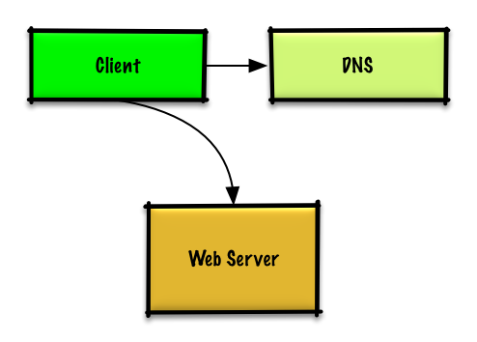](https://camo.githubusercontent.com/87e388aed1c4dc435ec99c200b6294b70ca960d5c3f0fd90beae5366c0cccc2e/687474703a2f2f692e696d6775722e636f6d2f42384c444b44372e706e67)

## Step 3: Design core components

Dive into details for each core component.

### Use case: User makes a read or write request

#### Goals

* With only 1-2 users, you only need a basic setup
  + Single box for simplicity
  + Vertical scaling when needed
  + Monitor to determine bottlenecks

#### Start with a single box

* **Web server** on EC2
  + Storage for user data
  + [**MySQL Database**](https://github.com/donnemartin/system-design-primer#relational-database-management-system-rdbms)

Use **Vertical Scaling**:

* Simply choose a bigger box
* Keep an eye on metrics to determine how to scale up
  + Use basic monitoring to determine bottlenecks: CPU, memory, IO, network, etc
  + CloudWatch, top, nagios, statsd, graphite, etc
* Scaling vertically can get very expensive
* No redundancy/failover

Trade-offs, alternatives, and additional details:

* The alternative to **Vertical Scaling** is [**Horizontal scaling**](https://github.com/donnemartin/system-design-primer#horizontal-scaling)

#### Start with SQL, consider NoSQL

The constraints assume there is a need for relational data. We can start off using a **MySQL Database** on the single box.

Trade-offs, alternatives, and additional details:

* See the [Relational database management system (RDBMS)](https://github.com/donnemartin/system-design-primer#relational-database-management-system-rdbms) section
* Discuss reasons to use [SQL or NoSQL](https://github.com/donnemartin/system-design-primer#sql-or-nosql)

#### Assign a public static IP

* Elastic IPs provide a public endpoint whose IP doesn't change on reboot
* Helps with failover, just point the domain to a new IP

#### Use a DNS

Add a **DNS** such as Route 53 to map the domain to the instance's public IP.

Trade-offs, alternatives, and additional details:

* See the [Domain name system](https://github.com/donnemartin/system-design-primer#domain-name-system) section

#### Secure the web server

* Open up only necessary ports
  + Allow the web server to respond to incoming requests from:
    - 80 for HTTP
    - 443 for HTTPS
    - 22 for SSH to only whitelisted IPs
  + Prevent the web server from initiating outbound connections

Trade-offs, alternatives, and additional details:

* See the [Security](https://github.com/donnemartin/system-design-primer#security) section

## Step 4: Scale the design

Identify and address bottlenecks, given the constraints.

### Users+

[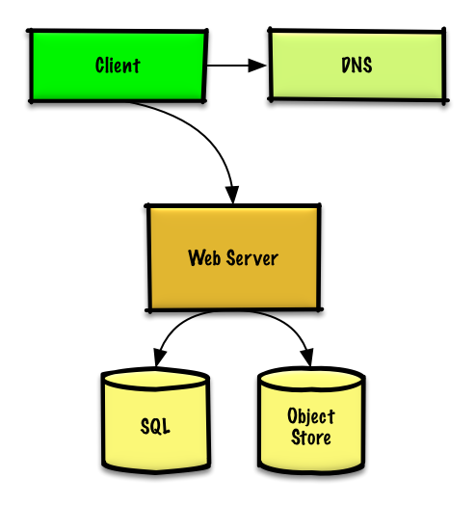](https://camo.githubusercontent.com/4c2d5d5f1032727abb770080009f40e10646dccff49df77be91036b9aac8a516/687474703a2f2f692e696d6775722e636f6d2f7272666a4d58422e706e67)

#### Assumptions

Our user count is starting to pick up and the load is increasing on our single box. Our **Benchmarks/Load Tests** and **Profiling** are pointing to the **MySQL Database** taking up more and more memory and CPU resources, while the user content is filling up disk space.

We've been able to address these issues with **Vertical Scaling** so far. Unfortunately, this has become quite expensive and it doesn't allow for independent scaling of the **MySQL Database** and **Web Server**.

#### Goals

* Lighten load on the single box and allow for independent scaling
  + Store static content separately in an **Object Store**
  + Move the **MySQL Database** to a separate box
* Disadvantages
  + These changes would increase complexity and would require changes to the **Web Server** to point to the **Object Store** and the **MySQL Database**
  + Additional security measures must be taken to secure the new components
  + AWS costs could also increase, but should be weighed with the costs of managing similar systems on your own

#### Store static content separately

* Consider using a managed **Object Store** like S3 to store static content
  + Highly scalable and reliable
  + Server side encryption
* Move static content to S3
  + User files
  + JS
  + CSS
  + Images
  + Videos

#### Move the MySQL database to a separate box

* Consider using a service like RDS to manage the **MySQL Database**
  + Simple to administer, scale
  + Multiple availability zones
  + Encryption at rest

#### Secure the system

* Encrypt data in transit and at rest
* Use a Virtual Private Cloud
  + Create a public subnet for the single **Web Server** so it can send and receive traffic from the internet
  + Create a private subnet for everything else, preventing outside access
  + Only open ports from whitelisted IPs for each component
* These same patterns should be implemented for new components in the remainder of the exercise

Trade-offs, alternatives, and additional details:

* See the [Security](https://github.com/donnemartin/system-design-primer#security) section

### Users++

[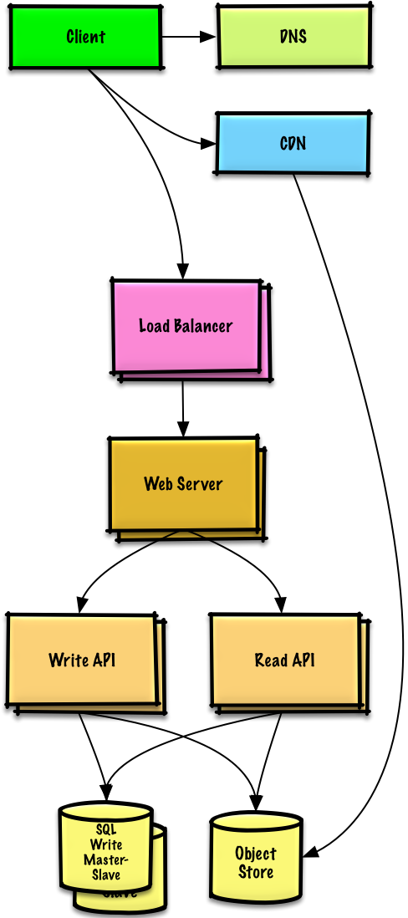](https://camo.githubusercontent.com/7a8932d3fbdc02f24db6008e7c1950deb62397a76136473748003fe2c76b10c8/687474703a2f2f692e696d6775722e636f6d2f72616f4654584d2e706e67)

#### Assumptions

Our **Benchmarks/Load Tests** and **Profiling** show that our single **Web Server** bottlenecks during peak hours, resulting in slow responses and in some cases, downtime. As the service matures, we'd also like to move towards higher availability and redundancy.

#### Goals

* The following goals attempt to address the scaling issues with the **Web Server**
  + Based on the **Benchmarks/Load Tests** and **Profiling**, you might only need to implement one or two of these techniques
* Use [**Horizontal Scaling**](https://github.com/donnemartin/system-design-primer#horizontal-scaling) to handle increasing loads and to address single points of failure
  + Add a [**Load Balancer**](https://github.com/donnemartin/system-design-primer#load-balancer) such as Amazon's ELB or HAProxy
    - ELB is highly available
    - If you are configuring your own **Load Balancer**, setting up multiple servers in [active-active](https://github.com/donnemartin/system-design-primer#active-active) or [active-passive](https://github.com/donnemartin/system-design-primer#active-passive) in multiple availability zones will improve availability
    - Terminate SSL on the **Load Balancer** to reduce computational load on backend servers and to simplify certificate administration
  + Use multiple **Web Servers** spread out over multiple availability zones
  + Use multiple **MySQL** instances in [**Master-Slave Failover**](https://github.com/donnemartin/system-design-primer#master-slave-replication) mode across multiple availability zones to improve redundancy
* Separate out the **Web Servers** from the [**Application Servers**](https://github.com/donnemartin/system-design-primer#application-layer)
  + Scale and configure both layers independently
  + **Web Servers** can run as a [**Reverse Proxy**](https://github.com/donnemartin/system-design-primer#reverse-proxy-web-server)
  + For example, you can add **Application Servers** handling **Read APIs** while others handle **Write APIs**
* Move static (and some dynamic) content to a [**Content Delivery Network (CDN)**](https://github.com/donnemartin/system-design-primer#content-delivery-network) such as CloudFront to reduce load and latency

Trade-offs, alternatives, and additional details:

* See the linked content above for details

### Users+++

[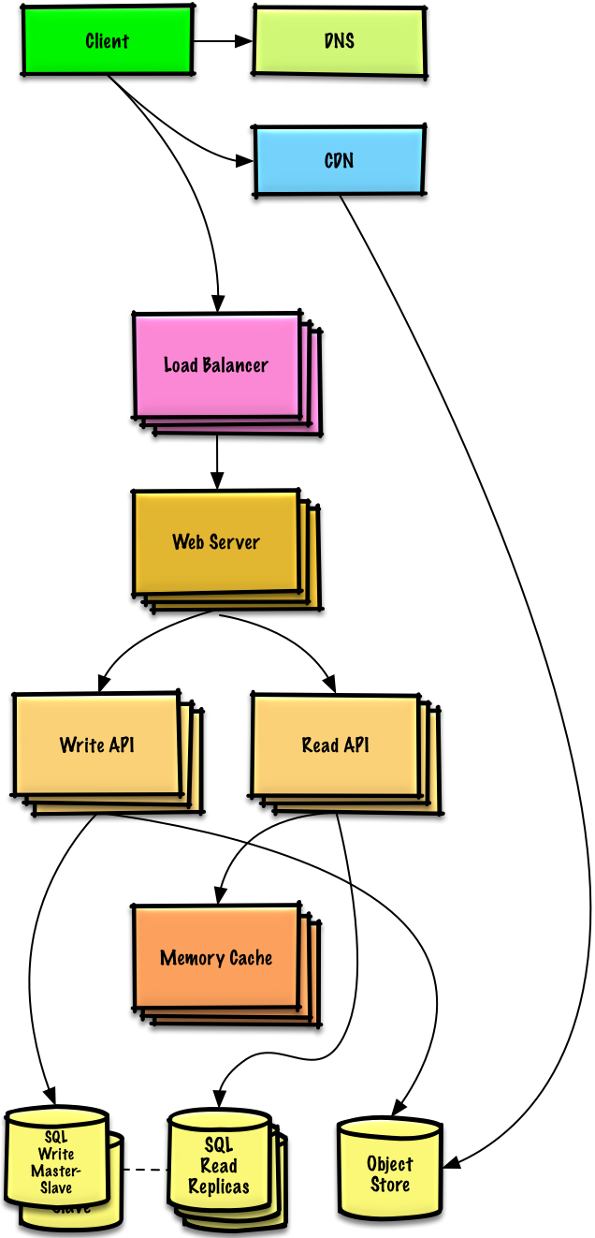](https://camo.githubusercontent.com/08365251aa4acab21a86cada3d89167e50fb5dc85c21aa6275ebbbd976ebaecd/687474703a2f2f692e696d6775722e636f6d2f4f5a43784a72302e706e67)

**Note:** **Internal Load Balancers** not shown to reduce clutter

#### Assumptions

Our **Benchmarks/Load Tests** and **Profiling** show that we are read-heavy (100:1 with writes) and our database is suffering from poor performance from the high read requests.

#### Goals

* The following goals attempt to address the scaling issues with the **MySQL Database**
  + Based on the **Benchmarks/Load Tests** and **Profiling**, you might only need to implement one or two of these techniques
* Move the following data to a [**Memory Cache**](https://github.com/donnemartin/system-design-primer#cache) such as Elasticache to reduce load and latency:
  + Frequently accessed content from **MySQL**
    - First, try to configure the **MySQL Database** cache to see if that is sufficient to relieve the bottleneck before implementing a **Memory Cache**
  + Session data from the **Web Servers**
    - The **Web Servers** become stateless, allowing for **Autoscaling**
  + Reading 1 MB sequentially from memory takes about 250 microseconds, while reading from SSD takes 4x and from disk takes 80x longer.[1](https://github.com/donnemartin/system-design-primer#latency-numbers-every-programmer-should-know)
* Add [**MySQL Read Replicas**](https://github.com/donnemartin/system-design-primer#master-slave-replication) to reduce load on the write master
* Add more **Web Servers** and **Application Servers** to improve responsiveness

Trade-offs, alternatives, and additional details:

* See the linked content above for details

#### Add MySQL read replicas

* In addition to adding and scaling a **Memory Cache**, **MySQL Read Replicas** can also help relieve load on the **MySQL Write Master**
* Add logic to **Web Server** to separate out writes and reads
* Add **Load Balancers** in front of **MySQL Read Replicas** (not pictured to reduce clutter)
* Most services are read-heavy vs write-heavy

Trade-offs, alternatives, and additional details:

* See the [Relational database management system (RDBMS)](https://github.com/donnemartin/system-design-primer#relational-database-management-system-rdbms) section

### Users++++

[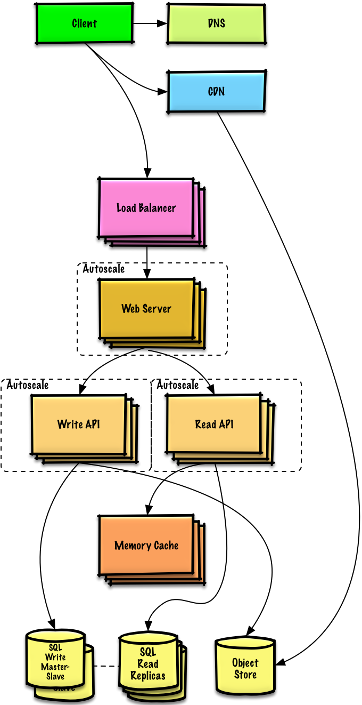](https://camo.githubusercontent.com/e27062086b93c4cac51a643bb250613de2b9454eae651fdf74c0f22f344afd12/687474703a2f2f692e696d6775722e636f6d2f3358386e6d644c2e706e67)

#### Assumptions

Our **Benchmarks/Load Tests** and **Profiling** show that our traffic spikes during regular business hours in the U.S. and drop significantly when users leave the office. We think we can cut costs by automatically spinning up and down servers based on actual load. We're a small shop so we'd like to automate as much of the DevOps as possible for **Autoscaling** and for the general operations.

#### Goals

* Add **Autoscaling** to provision capacity as needed
  + Keep up with traffic spikes
  + Reduce costs by powering down unused instances
* Automate DevOps
  + Chef, Puppet, Ansible, etc
* Continue monitoring metrics to address bottlenecks
  + **Host level** - Review a single EC2 instance
  + **Aggregate level** - Review load balancer stats
  + **Log analysis** - CloudWatch, CloudTrail, Loggly, Splunk, Sumo
  + **External site performance** - Pingdom or New Relic
  + **Handle notifications and incidents** - PagerDuty
  + **Error Reporting** - Sentry

#### Add autoscaling

* Consider a managed service such as AWS **Autoscaling**
  + Create one group for each **Web Server** and one for each **Application Server** type, place each group in multiple availability zones
  + Set a min and max number of instances
  + Trigger to scale up and down through CloudWatch
    - Simple time of day metric for predictable loads or
    - Metrics over a time period:
      * CPU load
      * Latency
      * Network traffic
      * Custom metric
  + Disadvantages
    - Autoscaling can introduce complexity
    - It could take some time before a system appropriately scales up to meet increased demand, or to scale down when demand drops

### Users+++++

[](https://camo.githubusercontent.com/033b69eca98ddb679043146844ff3bcf98888eff49edf4f98f9af68fc13deb20/687474703a2f2f692e696d6775722e636f6d2f6a6a3341354e382e706e67)

**Note:** **Autoscaling** groups not shown to reduce clutter

#### Assumptions

As the service continues to grow towards the figures outlined in the constraints, we iteratively run **Benchmarks/Load Tests** and **Profiling** to uncover and address new bottlenecks.

#### Goals

We'll continue to address scaling issues due to the problem's constraints:

* If our **MySQL Database** starts to grow too large, we might consider only storing a limited time period of data in the database, while storing the rest in a data warehouse such as Redshift
  + A data warehouse such as Redshift can comfortably handle the constraint of 1 TB of new content per month
* With 40,000 average read requests per second, read traffic for popular content can be addressed by scaling the **Memory Cache**, which is also useful for handling the unevenly distributed traffic and traffic spikes
  + The **SQL Read Replicas** might have trouble handling the cache misses, we'll probably need to employ additional SQL scaling patterns
* 400 average writes per second (with presumably significantly higher peaks) might be tough for a single **SQL Write Master-Slave**, also pointing to a need for additional scaling techniques

SQL scaling patterns include:

* [Federation](https://github.com/donnemartin/system-design-primer#federation)
* [Sharding](https://github.com/donnemartin/system-design-primer#sharding)
* [Denormalization](https://github.com/donnemartin/system-design-primer#denormalization)
* [SQL Tuning](https://github.com/donnemartin/system-design-primer#sql-tuning)

To further address the high read and write requests, we should also consider moving appropriate data to a [**NoSQL Database**](https://github.com/donnemartin/system-design-primer#nosql) such as DynamoDB.

We can further separate out our [**Application Servers**](https://github.com/donnemartin/system-design-primer#application-layer) to allow for independent scaling. Batch processes or computations that do not need to be done in real-time can be done [**Asynchronously**](https://github.com/donnemartin/system-design-primer#asynchronism) with **Queues** and **Workers**:

* For example, in a photo service, the photo upload and the thumbnail creation can be separated:
  + **Client** uploads photo
  + **Application Server** puts a job in a **Queue** such as SQS
  + The **Worker Service** on EC2 or Lambda pulls work off the **Queue** then:
    - Creates a thumbnail
    - Updates a **Database**
    - Stores the thumbnail in the **Object Store**

Trade-offs, alternatives, and additional details:

* See the linked content above for details

## Additional talking points

Additional topics to dive into, depending on the problem scope and time remaining.

### SQL scaling patterns

* [Read replicas](https://github.com/donnemartin/system-design-primer#master-slave-replication)
* [Federation](https://github.com/donnemartin/system-design-primer#federation)
* [Sharding](https://github.com/donnemartin/system-design-primer#sharding)
* [Denormalization](https://github.com/donnemartin/system-design-primer#denormalization)
* [SQL Tuning](https://github.com/donnemartin/system-design-primer#sql-tuning)

#### NoSQL

* [Key-value store](https://github.com/donnemartin/system-design-primer#key-value-store)
* [Document store](https://github.com/donnemartin/system-design-primer#document-store)
* [Wide column store](https://github.com/donnemartin/system-design-primer#wide-column-store)
* [Graph database](https://github.com/donnemartin/system-design-primer#graph-database)
* [SQL vs NoSQL](https://github.com/donnemartin/system-design-primer#sql-or-nosql)

### Caching

* Where to cache
  + [Client caching](https://github.com/donnemartin/system-design-primer#client-caching)
  + [CDN caching](https://github.com/donnemartin/system-design-primer#cdn-caching)
  + [Web server caching](https://github.com/donnemartin/system-design-primer#web-server-caching)
  + [Database caching](https://github.com/donnemartin/system-design-primer#database-caching)
  + [Application caching](https://github.com/donnemartin/system-design-primer#application-caching)
* What to cache
  + [Caching at the database query level](https://github.com/donnemartin/system-design-primer#caching-at-the-database-query-level)
  + [Caching at the object level](https://github.com/donnemartin/system-design-primer#caching-at-the-object-level)
* When to update the cache
  + [Cache-aside](https://github.com/donnemartin/system-design-primer#cache-aside)
  + [Write-through](https://github.com/donnemartin/system-design-primer#write-through)
  + [Write-behind (write-back)](https://github.com/donnemartin/system-design-primer#write-behind-write-back)
  + [Refresh ahead](https://github.com/donnemartin/system-design-primer#refresh-ahead)

### Asynchronism and microservices

* [Message queues](https://github.com/donnemartin/system-design-primer#message-queues)
* [Task queues](https://github.com/donnemartin/system-design-primer#task-queues)
* [Back pressure](https://github.com/donnemartin/system-design-primer#back-pressure)
* [Microservices](https://github.com/donnemartin/system-design-primer#microservices)

### Communications

* Discuss tradeoffs:
  + External communication with clients - [HTTP APIs following REST](https://github.com/donnemartin/system-design-primer#representational-state-transfer-rest)
  + Internal communications - [RPC](https://github.com/donnemartin/system-design-primer#remote-procedure-call-rpc)
* [Service discovery](https://github.com/donnemartin/system-design-primer#service-discovery)

### Security

Refer to the [security section](https://github.com/donnemartin/system-design-primer#security).

### Latency numbers

See [Latency numbers every programmer should know](https://github.com/donnemartin/system-design-primer#latency-numbers-every-programmer-should-know).

### Ongoing

* Continue benchmarking and monitoring your system to address bottlenecks as they come up
* Scaling is an iterative process

# Design the data structures for a social network

Note: This document links directly to relevant areas found in the [*system design topics*](https://github.com/donnemartin/system-design-primer#index-of-system-design-topics) to avoid duplication. Refer to the linked content for general talking points, tradeoffs, and alternatives.

## Step 1: Outline use cases and constraints

Gather requirements and scope the problem. Ask questions to clarify use cases and constraints. Discuss assumptions.

Without an interviewer to address clarifying questions, we'll define some use cases and constraints.

### Use cases

#### We'll scope the problem to handle only the following use cases

* **User** searches for someone and sees the shortest path to the searched person
* **Service** has high availability

### Constraints and assumptions

#### State assumptions

* Traffic is not evenly distributed
  + Some searches are more popular than others, while others are only executed once
* Graph data won't fit on a single machine
* Graph edges are unweighted
* 100 million users
* 50 friends per user average
* 1 billion friend searches per month

Exercise the use of more traditional systems - don't use graph-specific solutions such as [GraphQL](http://graphql.org/) or a graph database like [Neo4j](https://neo4j.com/)

#### Calculate usage

**Clarify with your interviewer if you should run back-of-the-envelope usage calculations.**

* 5 billion friend relationships
  + 100 million users \* 50 friends per user average
* 400 search requests per second

Handy conversion guide:

* 2.5 million seconds per month
* 1 request per second = 2.5 million requests per month
* 40 requests per second = 100 million requests per month
* 400 requests per second = 1 billion requests per month

## Step 2: Create a high level design

Outline a high level design with all important components.

[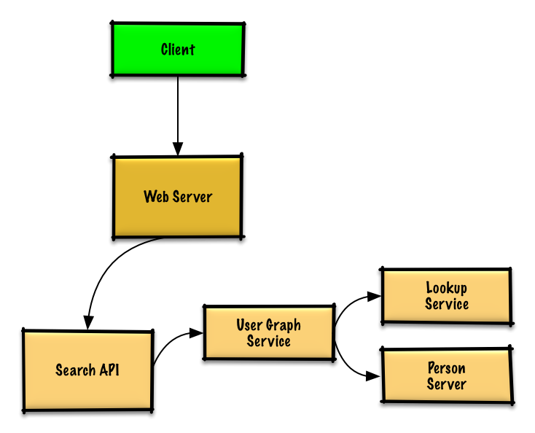](https://camo.githubusercontent.com/77cd62d1b709a77ceaf5543ab06bde1ba684f842e64755c198296ef87a0cd2c5/687474703a2f2f692e696d6775722e636f6d2f7778587971324a2e706e67)

## Step 3: Design core components

Dive into details for each core component.

### Use case: User searches for someone and sees the shortest path to the searched person

**Clarify with your interviewer how much code you are expected to write**.

Without the constraint of millions of users (vertices) and billions of friend relationships (edges), we could solve this unweighted shortest path task with a general BFS approach:

class Graph(Graph):

def shortest\_path(self, source, dest):

if source is None or dest is None:

return None

if source is dest:

return [source.key]

prev\_node\_keys = self.\_shortest\_path(source, dest)

if prev\_node\_keys is None:

return None

else:

path\_ids = [dest.key]

prev\_node\_key = prev\_node\_keys[dest.key]

while prev\_node\_key is not None:

path\_ids.append(prev\_node\_key)

prev\_node\_key = prev\_node\_keys[prev\_node\_key]

return path\_ids[::-1]

def \_shortest\_path(self, source, dest):

queue = deque()

queue.append(source)

prev\_node\_keys = {source.key: None}

source.visit\_state = State.visited

while queue:

node = queue.popleft()

if node is dest:

return prev\_node\_keys

prev\_node = node

for adj\_node in node.adj\_nodes.values():

if adj\_node.visit\_state == State.unvisited:

queue.append(adj\_node)

prev\_node\_keys[adj\_node.key] = prev\_node.key

adj\_node.visit\_state = State.visited

return None

We won't be able to fit all users on the same machine, we'll need to [shard](https://github.com/donnemartin/system-design-primer#sharding) users across **Person Servers** and access them with a **Lookup Service**.

* The **Client** sends a request to the **Web Server**, running as a [reverse proxy](https://github.com/donnemartin/system-design-primer#reverse-proxy-web-server)
* The **Web Server** forwards the request to the **Search API** server
* The **Search API** server forwards the request to the **User Graph Service**
* The **User Graph Service** does the following:
  + Uses the **Lookup Service** to find the **Person Server** where the current user's info is stored
  + Finds the appropriate **Person Server** to retrieve the current user's list of friend\_ids
  + Runs a BFS search using the current user as the source and the current user's friend\_ids as the ids for each adjacent\_node
  + To get the adjacent\_node from a given id:
    - The **User Graph Service** will again need to communicate with the **Lookup Service** to determine which **Person Server** stores theadjacent\_node matching the given id (potential for optimization)

**Clarify with your interviewer how much code you should be writing**.

**Note**: Error handling is excluded below for simplicity. Ask if you should code proper error handing.

**Lookup Service** implementation:

class LookupService(object):

def \_\_init\_\_(self):

self.lookup = self.\_init\_lookup() # key: person\_id, value: person\_server

def \_init\_lookup(self):

...

def lookup\_person\_server(self, person\_id):

return self.lookup[person\_id]

**Person Server** implementation:

class PersonServer(object):

def \_\_init\_\_(self):

self.people = {} # key: person\_id, value: person

def add\_person(self, person):

...

def people(self, ids):

results = []

for id in ids:

if id in self.people:

results.append(self.people[id])

return results

**Person** implementation:

class Person(object):

def \_\_init\_\_(self, id, name, friend\_ids):

self.id = id

self.name = name

self.friend\_ids = friend\_ids

**User Graph Service** implementation:

class UserGraphService(object):

def \_\_init\_\_(self, lookup\_service):

self.lookup\_service = lookup\_service

def person(self, person\_id):

person\_server = self.lookup\_service.lookup\_person\_server(person\_id)

return person\_server.people([person\_id])

def shortest\_path(self, source\_key, dest\_key):

if source\_key is None or dest\_key is None:

return None

if source\_key is dest\_key:

return [source\_key]

prev\_node\_keys = self.\_shortest\_path(source\_key, dest\_key)

if prev\_node\_keys is None:

return None

else:

# Iterate through the path\_ids backwards, starting at dest\_key

path\_ids = [dest\_key]

prev\_node\_key = prev\_node\_keys[dest\_key]

while prev\_node\_key is not None:

path\_ids.append(prev\_node\_key)

prev\_node\_key = prev\_node\_keys[prev\_node\_key]

# Reverse the list since we iterated backwards

return path\_ids[::-1]

def \_shortest\_path(self, source\_key, dest\_key, path):

# Use the id to get the Person

source = self.person(source\_key)

# Update our bfs queue

queue = deque()

queue.append(source)

# prev\_node\_keys keeps track of each hop from

# the source\_key to the dest\_key

prev\_node\_keys = {source\_key: None}

# We'll use visited\_ids to keep track of which nodes we've

# visited, which can be different from a typical bfs where

# this can be stored in the node itself

visited\_ids = set()

visited\_ids.add(source.id)

while queue:

node = queue.popleft()

if node.key is dest\_key:

return prev\_node\_keys

prev\_node = node

for friend\_id in node.friend\_ids:

if friend\_id not in visited\_ids:

friend\_node = self.person(friend\_id)

queue.append(friend\_node)

prev\_node\_keys[friend\_id] = prev\_node.key

visited\_ids.add(friend\_id)

return None

We'll use a public [**REST API**](https://github.com/donnemartin/system-design-primer#representational-state-transfer-rest):

$ curl https://social.com/api/v1/friend\_search?person\_id=1234

Response:

{

"person\_id": "100",

"name": "foo",

"link": "https://social.com/foo",

},

{

"person\_id": "53",

"name": "bar",

"link": "https://social.com/bar",

},

{

"person\_id": "1234",

"name": "baz",

"link": "https://social.com/baz",

},

For internal communications, we could use [Remote Procedure Calls](https://github.com/donnemartin/system-design-primer#remote-procedure-call-rpc).

## Step 4: Scale the design

Identify and address bottlenecks, given the constraints.

[](https://camo.githubusercontent.com/8966044b036b79f7ce1706d40ad214c74193ae8ded36743e37e03e79b2bf46d5/687474703a2f2f692e696d6775722e636f6d2f636443763567372e706e67)

**Important: Do not simply jump right into the final design from the initial design!**

State you would 1) **Benchmark/Load Test**, 2) **Profile** for bottlenecks 3) address bottlenecks while evaluating alternatives and trade-offs, and 4) repeat. See [Design a system that scales to millions of users on AWS](https://github.com/donnemartin/system-design-primer/blob/master/solutions/system_design/scaling_aws/README.md) as a sample on how to iteratively scale the initial design.

It's important to discuss what bottlenecks you might encounter with the initial design and how you might address each of them. For example, what issues are addressed by adding a **Load Balancer** with multiple **Web Servers**? **CDN**? **Master-Slave Replicas**? What are the alternatives and **Trade-Offs** for each?

We'll introduce some components to complete the design and to address scalability issues. Internal load balancers are not shown to reduce clutter.

To avoid repeating discussions, refer to the following [system design topics](https://github.com/donnemartin/system-design-primer#index-of-system-design-topics) for main talking points, tradeoffs, and alternatives:

* [DNS](https://github.com/donnemartin/system-design-primer#domain-name-system)
* [Load balancer](https://github.com/donnemartin/system-design-primer#load-balancer)
* [Horizontal scaling](https://github.com/donnemartin/system-design-primer#horizontal-scaling)
* [Web server (reverse proxy)](https://github.com/donnemartin/system-design-primer#reverse-proxy-web-server)
* [API server (application layer)](https://github.com/donnemartin/system-design-primer#application-layer)
* [Cache](https://github.com/donnemartin/system-design-primer#cache)
* [Consistency patterns](https://github.com/donnemartin/system-design-primer#consistency-patterns)
* [Availability patterns](https://github.com/donnemartin/system-design-primer#availability-patterns)

To address the constraint of 400 average read requests per second (higher at peak), person data can be served from a **Memory Cache** such as Redis or Memcached to reduce response times and to reduce traffic to downstream services. This could be especially useful for people who do multiple searches in succession and for people who are well-connected. Reading 1 MB sequentially from memory takes about 250 microseconds, while reading from SSD takes 4x and from disk takes 80x longer.[1](https://github.com/donnemartin/system-design-primer#latency-numbers-every-programmer-should-know)

Below are further optimizations:

* Store complete or partial BFS traversals to speed up subsequent lookups in the **Memory Cache**
* Batch compute offline then store complete or partial BFS traversals to speed up subsequent lookups in a **NoSQL Database**
* Reduce machine jumps by batching together friend lookups hosted on the same **Person Server**
  + [Shard](https://github.com/donnemartin/system-design-primer#sharding) **Person Servers** by location to further improve this, as friends generally live closer to each other
* Do two BFS searches at the same time, one starting from the source, and one from the destination, then merge the two paths
* Start the BFS search from people with large numbers of friends, as they are more likely to reduce the number of [degrees of separation](https://en.wikipedia.org/wiki/Six_degrees_of_separation) between the current user and the search target
* Set a limit based on time or number of hops before asking the user if they want to continue searching, as searching could take a considerable amount of time in some cases
* Use a **Graph Database** such as [Neo4j](https://neo4j.com/) or a graph-specific query language such as [GraphQL](http://graphql.org/) (if there were no constraint preventing the use of **Graph Databases**)

## Additional talking points

Additional topics to dive into, depending on the problem scope and time remaining.

### SQL scaling patterns

* [Read replicas](https://github.com/donnemartin/system-design-primer#master-slave-replication)
* [Federation](https://github.com/donnemartin/system-design-primer#federation)
* [Sharding](https://github.com/donnemartin/system-design-primer#sharding)
* [Denormalization](https://github.com/donnemartin/system-design-primer#denormalization)
* [SQL Tuning](https://github.com/donnemartin/system-design-primer#sql-tuning)

#### NoSQL

* [Key-value store](https://github.com/donnemartin/system-design-primer#key-value-store)
* [Document store](https://github.com/donnemartin/system-design-primer#document-store)
* [Wide column store](https://github.com/donnemartin/system-design-primer#wide-column-store)
* [Graph database](https://github.com/donnemartin/system-design-primer#graph-database)
* [SQL vs NoSQL](https://github.com/donnemartin/system-design-primer#sql-or-nosql)

### Caching

* Where to cache
  + [Client caching](https://github.com/donnemartin/system-design-primer#client-caching)
  + [CDN caching](https://github.com/donnemartin/system-design-primer#cdn-caching)
  + [Web server caching](https://github.com/donnemartin/system-design-primer#web-server-caching)
  + [Database caching](https://github.com/donnemartin/system-design-primer#database-caching)
  + [Application caching](https://github.com/donnemartin/system-design-primer#application-caching)
* What to cache
  + [Caching at the database query level](https://github.com/donnemartin/system-design-primer#caching-at-the-database-query-level)
  + [Caching at the object level](https://github.com/donnemartin/system-design-primer#caching-at-the-object-level)
* When to update the cache
  + [Cache-aside](https://github.com/donnemartin/system-design-primer#cache-aside)
  + [Write-through](https://github.com/donnemartin/system-design-primer#write-through)
  + [Write-behind (write-back)](https://github.com/donnemartin/system-design-primer#write-behind-write-back)
  + [Refresh ahead](https://github.com/donnemartin/system-design-primer#refresh-ahead)

### Asynchronism and microservices

* [Message queues](https://github.com/donnemartin/system-design-primer#message-queues)
* [Task queues](https://github.com/donnemartin/system-design-primer#task-queues)
* [Back pressure](https://github.com/donnemartin/system-design-primer#back-pressure)
* [Microservices](https://github.com/donnemartin/system-design-primer#microservices)

### Communications

* Discuss tradeoffs:
  + External communication with clients - [HTTP APIs following REST](https://github.com/donnemartin/system-design-primer#representational-state-transfer-rest)
  + Internal communications - [RPC](https://github.com/donnemartin/system-design-primer#remote-procedure-call-rpc)
* [Service discovery](https://github.com/donnemartin/system-design-primer#service-discovery)

### Security

Refer to the [security section](https://github.com/donnemartin/system-design-primer#security).

### Latency numbers

See [Latency numbers every programmer should know](https://github.com/donnemartin/system-design-primer#latency-numbers-every-programmer-should-know).

### Ongoing

* Continue benchmarking and monitoring your system to address bottlenecks as they come up
* Scaling is an iterative process

# Design a web crawler

Note: This document links directly to relevant areas found in the [*system design topics*](https://github.com/donnemartin/system-design-primer#index-of-system-design-topics) to avoid duplication. Refer to the linked content for general talking points, tradeoffs, and alternatives.

## Step 1: Outline use cases and constraints

Gather requirements and scope the problem. Ask questions to clarify use cases and constraints. Discuss assumptions.

Without an interviewer to address clarifying questions, we'll define some use cases and constraints.

### Use cases

#### We'll scope the problem to handle only the following use cases

* **Service** crawls a list of urls:
  + Generates reverse index of words to pages containing the search terms
  + Generates titles and snippets for pages
    - Title and snippets are static, they do not change based on search query
* **User** inputs a search term and sees a list of relevant pages with titles and snippets the crawler generated
  + Only sketch high level components and interactions for this use case, no need to go into depth
* **Service** has high availability

#### Out of scope

* Search analytics
* Personalized search results
* Page rank

### Constraints and assumptions

#### State assumptions

* Traffic is not evenly distributed
  + Some searches are very popular, while others are only executed once
* Support only anonymous users
* Generating search results should be fast
* The web crawler should not get stuck in an infinite loop
  + We get stuck in an infinite loop if the graph contains a cycle
* 1 billion links to crawl
  + Pages need to be crawled regularly to ensure freshness
  + Average refresh rate of about once per week, more frequent for popular sites
    - 4 billion links crawled each month
  + Average stored size per web page: 500 KB
    - For simplicity, count changes the same as new pages
* 100 billion searches per month

Exercise the use of more traditional systems - don't use existing systems such as [solr](http://lucene.apache.org/solr/) or [nutch](http://nutch.apache.org/).

#### Calculate usage

**Clarify with your interviewer if you should run back-of-the-envelope usage calculations.**

* 2 PB of stored page content per month
  + 500 KB per page \* 4 billion links crawled per month
  + 72 PB of stored page content in 3 years
* 1,600 write requests per second
* 40,000 search requests per second

Handy conversion guide:

* 2.5 million seconds per month
* 1 request per second = 2.5 million requests per month
* 40 requests per second = 100 million requests per month
* 400 requests per second = 1 billion requests per month

## Step 2: Create a high level design

Outline a high level design with all important components.

[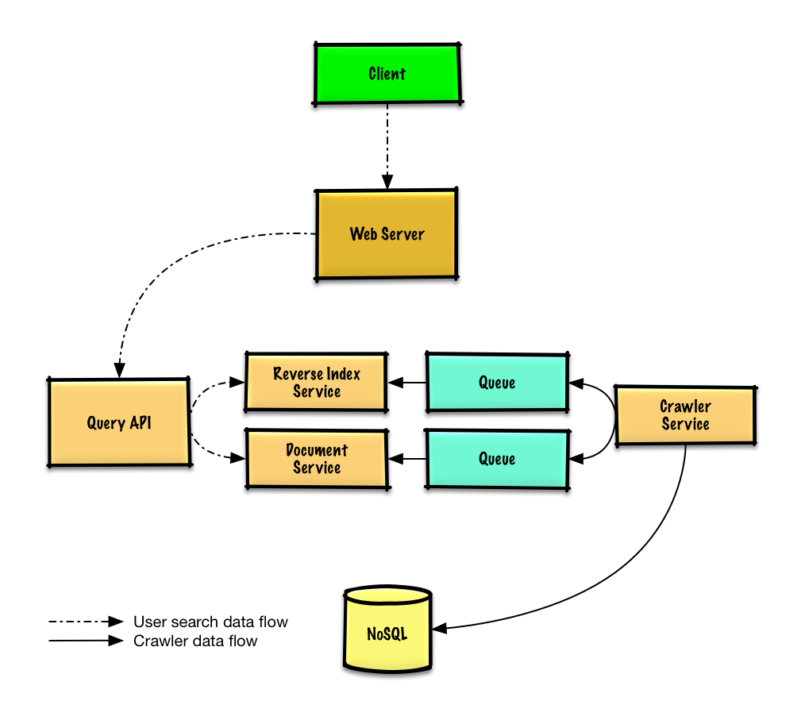](https://camo.githubusercontent.com/d3c9ba8f71820139d8cd499e4750057bbcc3eb56589da5f19003842fa524c928/687474703a2f2f692e696d6775722e636f6d2f786a64414155762e706e67)

## Step 3: Design core components

Dive into details for each core component.

### Use case: Service crawls a list of urls

We'll assume we have an initial list of links\_to\_crawl ranked initially based on overall site popularity. If this is not a reasonable assumption, we can seed the crawler with popular sites that link to outside content such as [Yahoo](https://www.yahoo.com/), [DMOZ](http://www.dmoz.org/), etc.

We'll use a table crawled\_links to store processed links and their page signatures.

We could store links\_to\_crawl and crawled\_links in a key-value **NoSQL Database**. For the ranked links in links\_to\_crawl, we could use [Redis](https://redis.io/) with sorted sets to maintain a ranking of page links. We should discuss the [use cases and tradeoffs between choosing SQL or NoSQL](https://github.com/donnemartin/system-design-primer#sql-or-nosql).

* The **Crawler Service** processes each page link by doing the following in a loop:
  + Takes the top ranked page link to crawl
    - Checks crawled\_links in the **NoSQL Database** for an entry with a similar page signature
      * If we have a similar page, reduces the priority of the page link
        + This prevents us from getting into a cycle
        + Continue
      * Else, crawls the link
        + Adds a job to the **Reverse Index Service** queue to generate a [reverse index](https://en.wikipedia.org/wiki/Search_engine_indexing)
        + Adds a job to the **Document Service** queue to generate a static title and snippet
        + Generates the page signature
        + Removes the link from links\_to\_crawl in the **NoSQL Database**
        + Inserts the page link and signature to crawled\_links in the **NoSQL Database**

**Clarify with your interviewer how much code you are expected to write**.

PagesDataStore is an abstraction within the **Crawler Service** that uses the **NoSQL Database**:

class PagesDataStore(object):

def \_\_init\_\_(self, db);

self.db = db

...

def add\_link\_to\_crawl(self, url):

"""Add the given link to `links\_to\_crawl`."""

...

def remove\_link\_to\_crawl(self, url):

"""Remove the given link from `links\_to\_crawl`."""

...

def reduce\_priority\_link\_to\_crawl(self, url)

"""Reduce the priority of a link in `links\_to\_crawl` to avoid cycles."""

...

def extract\_max\_priority\_page(self):

"""Return the highest priority link in `links\_to\_crawl`."""

...

def insert\_crawled\_link(self, url, signature):

"""Add the given link to `crawled\_links`."""

...

def crawled\_similar(self, signature):

"""Determine if we've already crawled a page matching the given signature"""

...

Page is an abstraction within the **Crawler Service** that encapsulates a page, its contents, child urls, and signature:

class Page(object):

def \_\_init\_\_(self, url, contents, child\_urls, signature):

self.url = url

self.contents = contents

self.child\_urls = child\_urls

self.signature = signature

Crawler is the main class within **Crawler Service**, composed of Page and PagesDataStore.

class Crawler(object):

def \_\_init\_\_(self, data\_store, reverse\_index\_queue, doc\_index\_queue):

self.data\_store = data\_store

self.reverse\_index\_queue = reverse\_index\_queue

self.doc\_index\_queue = doc\_index\_queue

def create\_signature(self, page):

"""Create signature based on url and contents."""

...

def crawl\_page(self, page):

for url in page.child\_urls:

self.data\_store.add\_link\_to\_crawl(url)

page.signature = self.create\_signature(page)

self.data\_store.remove\_link\_to\_crawl(page.url)

self.data\_store.insert\_crawled\_link(page.url, page.signature)

def crawl(self):

while True:

page = self.data\_store.extract\_max\_priority\_page()

if page is None:

break

if self.data\_store.crawled\_similar(page.signature):

self.data\_store.reduce\_priority\_link\_to\_crawl(page.url)

else:

self.crawl\_page(page)

### Handling duplicates

We need to be careful the web crawler doesn't get stuck in an infinite loop, which happens when the graph contains a cycle.

**Clarify with your interviewer how much code you are expected to write**.

We'll want to remove duplicate urls:

* For smaller lists we could use something like sort | unique
* With 1 billion links to crawl, we could use **MapReduce** to output only entries that have a frequency of 1

class RemoveDuplicateUrls(MRJob):

def mapper(self, \_, line):

yield line, 1

def reducer(self, key, values):

total = sum(values)

if total == 1:

yield key, total

Detecting duplicate content is more complex. We could generate a signature based on the contents of the page and compare those two signatures for similarity. Some potential algorithms are [Jaccard index](https://en.wikipedia.org/wiki/Jaccard_index) and [cosine similarity](https://en.wikipedia.org/wiki/Cosine_similarity).

### Determining when to update the crawl results

Pages need to be crawled regularly to ensure freshness. Crawl results could have a timestamp field that indicates the last time a page was crawled. After a default time period, say one week, all pages should be refreshed. Frequently updated or more popular sites could be refreshed in shorter intervals.

Although we won't dive into details on analytics, we could do some data mining to determine the mean time before a particular page is updated, and use that statistic to determine how often to re-crawl the page.

We might also choose to support a Robots.txt file that gives webmasters control of crawl frequency.

### Use case: User inputs a search term and sees a list of relevant pages with titles and snippets

* The **Client** sends a request to the **Web Server**, running as a [reverse proxy](https://github.com/donnemartin/system-design-primer#reverse-proxy-web-server)
* The **Web Server** forwards the request to the **Query API** server
* The **Query API** server does the following:
  + Parses the query
    - Removes markup
    - Breaks up the text into terms
    - Fixes typos
    - Normalizes capitalization
    - Converts the query to use boolean operations
  + Uses the **Reverse Index Service** to find documents matching the query
    - The **Reverse Index Service** ranks the matching results and returns the top ones
  + Uses the **Document Service** to return titles and snippets

We'll use a public [**REST API**](https://github.com/donnemartin/system-design-primer#representational-state-transfer-rest):

$ curl https://search.com/api/v1/search?query=hello+world

Response:

{

"title": "foo's title",

"snippet": "foo's snippet",

"link": "https://foo.com",

},

{

"title": "bar's title",

"snippet": "bar's snippet",

"link": "https://bar.com",

},

{

"title": "baz's title",

"snippet": "baz's snippet",

"link": "https://baz.com",

},

For internal communications, we could use [Remote Procedure Calls](https://github.com/donnemartin/system-design-primer#remote-procedure-call-rpc).

## Step 4: Scale the design

Identify and address bottlenecks, given the constraints.

[](https://camo.githubusercontent.com/dc86675eb283455780cc9c1703a6a8a3bc449546ce09de2f5f4f6ff7e130c509/687474703a2f2f692e696d6775722e636f6d2f625778507451412e706e67)

**Important: Do not simply jump right into the final design from the initial design!**

State you would 1) **Benchmark/Load Test**, 2) **Profile** for bottlenecks 3) address bottlenecks while evaluating alternatives and trade-offs, and 4) repeat. See [Design a system that scales to millions of users on AWS](https://github.com/donnemartin/system-design-primer/blob/master/solutions/system_design/scaling_aws/README.md) as a sample on how to iteratively scale the initial design.

It's important to discuss what bottlenecks you might encounter with the initial design and how you might address each of them. For example, what issues are addressed by adding a **Load Balancer** with multiple **Web Servers**? **CDN**? **Master-Slave Replicas**? What are the alternatives and **Trade-Offs** for each?

We'll introduce some components to complete the design and to address scalability issues. Internal load balancers are not shown to reduce clutter.

To avoid repeating discussions, refer to the following [system design topics](https://github.com/donnemartin/system-design-primer#index-of-system-design-topics) for main talking points, tradeoffs, and alternatives:

* [DNS](https://github.com/donnemartin/system-design-primer#domain-name-system)
* [Load balancer](https://github.com/donnemartin/system-design-primer#load-balancer)
* [Horizontal scaling](https://github.com/donnemartin/system-design-primer#horizontal-scaling)
* [Web server (reverse proxy)](https://github.com/donnemartin/system-design-primer#reverse-proxy-web-server)
* [API server (application layer)](https://github.com/donnemartin/system-design-primer#application-layer)
* [Cache](https://github.com/donnemartin/system-design-primer#cache)
* [NoSQL](https://github.com/donnemartin/system-design-primer#nosql)
* [Consistency patterns](https://github.com/donnemartin/system-design-primer#consistency-patterns)
* [Availability patterns](https://github.com/donnemartin/system-design-primer#availability-patterns)

Some searches are very popular, while others are only executed once. Popular queries can be served from a **Memory Cache** such as Redis or Memcached to reduce response times and to avoid overloading the **Reverse Index Service** and **Document Service**. The **Memory Cache** is also useful for handling the unevenly distributed traffic and traffic spikes. Reading 1 MB sequentially from memory takes about 250 microseconds, while reading from SSD takes 4x and from disk takes 80x longer.[1](https://github.com/donnemartin/system-design-primer#latency-numbers-every-programmer-should-know)

Below are a few other optimizations to the **Crawling Service**:

* To handle the data size and request load, the **Reverse Index Service** and **Document Service** will likely need to make heavy use sharding and federation.
* DNS lookup can be a bottleneck, the **Crawler Service** can keep its own DNS lookup that is refreshed periodically
* The **Crawler Service** can improve performance and reduce memory usage by keeping many open connections at a time, referred to as [connection pooling](https://en.wikipedia.org/wiki/Connection_pool)
  + Switching to [UDP](https://github.com/donnemartin/system-design-primer#user-datagram-protocol-udp) could also boost performance
* Web crawling is bandwidth intensive, ensure there is enough bandwidth to sustain high throughput

## Additional talking points

Additional topics to dive into, depending on the problem scope and time remaining.

### SQL scaling patterns

* [Read replicas](https://github.com/donnemartin/system-design-primer#master-slave-replication)
* [Federation](https://github.com/donnemartin/system-design-primer#federation)
* [Sharding](https://github.com/donnemartin/system-design-primer#sharding)
* [Denormalization](https://github.com/donnemartin/system-design-primer#denormalization)
* [SQL Tuning](https://github.com/donnemartin/system-design-primer#sql-tuning)

#### NoSQL

* [Key-value store](https://github.com/donnemartin/system-design-primer#key-value-store)
* [Document store](https://github.com/donnemartin/system-design-primer#document-store)
* [Wide column store](https://github.com/donnemartin/system-design-primer#wide-column-store)
* [Graph database](https://github.com/donnemartin/system-design-primer#graph-database)
* [SQL vs NoSQL](https://github.com/donnemartin/system-design-primer#sql-or-nosql)

### Caching

* Where to cache
  + [Client caching](https://github.com/donnemartin/system-design-primer#client-caching)
  + [CDN caching](https://github.com/donnemartin/system-design-primer#cdn-caching)
  + [Web server caching](https://github.com/donnemartin/system-design-primer#web-server-caching)
  + [Database caching](https://github.com/donnemartin/system-design-primer#database-caching)
  + [Application caching](https://github.com/donnemartin/system-design-primer#application-caching)
* What to cache
  + [Caching at the database query level](https://github.com/donnemartin/system-design-primer#caching-at-the-database-query-level)
  + [Caching at the object level](https://github.com/donnemartin/system-design-primer#caching-at-the-object-level)
* When to update the cache
  + [Cache-aside](https://github.com/donnemartin/system-design-primer#cache-aside)
  + [Write-through](https://github.com/donnemartin/system-design-primer#write-through)
  + [Write-behind (write-back)](https://github.com/donnemartin/system-design-primer#write-behind-write-back)
  + [Refresh ahead](https://github.com/donnemartin/system-design-primer#refresh-ahead)

### Asynchronism and microservices

* [Message queues](https://github.com/donnemartin/system-design-primer#message-queues)
* [Task queues](https://github.com/donnemartin/system-design-primer#task-queues)
* [Back pressure](https://github.com/donnemartin/system-design-primer#back-pressure)
* [Microservices](https://github.com/donnemartin/system-design-primer#microservices)

### Communications

* Discuss tradeoffs:
  + External communication with clients - [HTTP APIs following REST](https://github.com/donnemartin/system-design-primer#representational-state-transfer-rest)
  + Internal communications - [RPC](https://github.com/donnemartin/system-design-primer#remote-procedure-call-rpc)
* [Service discovery](https://github.com/donnemartin/system-design-primer#service-discovery)

### Security

Refer to the [security section](https://github.com/donnemartin/system-design-primer#security).

### Latency numbers

See [Latency numbers every programmer should know](https://github.com/donnemartin/system-design-primer#latency-numbers-every-programmer-should-know).

### Ongoing

* Continue benchmarking and monitoring your system to address bottlenecks as they come up
* Scaling is an iterative process

# Design BookMyShow – A System Design Interview Question

# ***It’s really easy to search for your favorite movie in a theatre, check the seat availability, and, book the ticket on the BookMyShow app within just 5-10 minutes without much effort***…

We all know the services of BookMyShow (after all we all love to watch the movies…lolz) and how it works, but can you imagine that behind this gigantic website how engineers have used their brains to build the complex architecture of this system.



And what if we ask you to design this system within just 45 minutes (or less) of a short time (*is it a joke...??*) …? We are not joking but if you’re someone who is preparing yourself to get into the top tech giant companies, you may face the system design round in interviews (especially for the role of senior engineer) and designing a system like BookMyShow is quite a common question of this round.

In this blog, we will discuss how to design an online ticket booking system like BookMyShow but before we go further we want you to read the article “[How to crack system design round in interviews?](https://www.geeksforgeeks.org/how-to-crack-system-design-round-in-interviews/)”. It will give you an idea that what this round looks like, what you are expected to do, and what mistakes you should avoid in front of the interviewer.

### 1. Define Goals and Requirements

Tell your interviewer that you’re going to support the features below. If the interviewer wants to add some more features, he/she will mention that.

* The portal should list the different cities where the theatres are located. (RDBMS)
* Once the user selects the city it should display the movies released in that particular city to that user.
* Once the user selects the movie, the portal should display the cinemas running that movie and the available shows.
* Users should be able to select the show at a particular theatre & book the tickets (third-party payment support).
* Send a copy of tickets via SMS notification or Email. (workers and GCM)
* Movies suggestions when login (Hadoop and spark streaming with ML to get recommendation engine), real-time notifications to the user about new movie releases & other stuff.
* The portal should display the seating arrangement of the cinema hall to the user.
* Users should be able to select multiple seats according to their choice.
* Users should be able to hold the seats for 5-10 minutes before he/she finalized the payment.
* The portal should serve the tickets in a First In First Out manner
* Comments and rating (Cassandra)
* The system should be highly concurrent because there will be multiple booking requests for the same seat at the same time.
* The core thing of the portal is ticket bookings which mean financial transactions. So the system should be secure and ACID compliant.
* Responsive design (ReactJS and Bootstrap) to run on devices of various sizes like mobile, tablet, desktop, etc.
* Movie information.

### 2. How does Bookmyshow Talk to Theatres?

When you visit any third-party application/movie tickets aggregator using the mobile app or website, you see the available and occupied seats for a movie show in that theatre. Now the question is how these third-party aggregators talk to the theatres, get the available seat information, and display it to the users. Definitely, the app needs to work with the theatre’s server to get the seat allocation and give it to the users. There are mainly two strategies to allocate the seats to these aggregators.

* A specific number of seats will be dedicated to every aggregator and then these seats will be offered to the users. In this strategy, some seats are already reserved for these aggregators, so there is no need to keep updating the seat information from all the theatres.
* In the second strategy, the app can work along with the theatre and other aggregators to keep updating the seat availability information. Then the ticket will be offered to the users.

### 3. How to Get The Seat Availability Information?

There are mainly two ways to get this information…

* The aggregators can connect to the theatre’s DB directly and get the information from the database table. Then this information can be cached and displayed to the user.
* Use the theatre’s server API to get the available seat information and book the tickets.

*What will happen if multiple users will try to book the same ticket using different platforms?* *How to solve this problem?*

The theatre’s server needs to follow a timeout locking mechanism strategy where a seat will be locked temporarily for a user for a specific time session (for example, 5-10 minutes). If the user is not able to book the seat within that timeframe then release the seat for another user. This should be done on a first come first serve basis.

If you’re using the theatres’ server API then you will be making a lot of requests or IO blocking calls from your server to the theatre’s server. To achieve the better performance we should use async in python or Erlangs lightweight threads or Go Coroutines in Go.

### High-Level Architecture

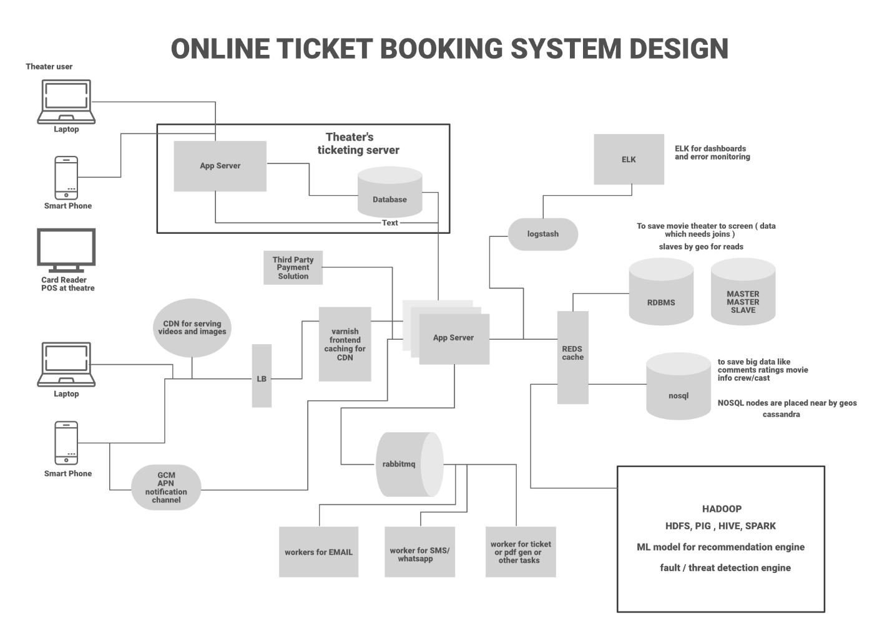

BookMyShow is built on **microservice architecture**. Let’s look at the components individually.

### Load Balancer

A load balancer is used to distribute the load on the server and to keep the system highly concurrent when we are scaling the app server horizontally. The load balancer can use multiple techniques to balance the load and these are…

1. Consistent Hashing
2. Round Robin
3. Weighted Round Robin
4. Least Connection

### Frontend Caching and CDN

We do frontend caching using **Varnish**to reduce the load from the backend infrastructure. We can also use CDN Cloudflare to cache the pages, API, video, images, and other content.

### App Servers

There will be multiple **app servers** and BookMyShow uses **Java, Spring Boot, Swagger, and Hibernate** for the app servers. We can also go with Python-based or NodeJS servers (Depending on requirements). We also need to scale these app servers horizontally to take the heavy load and to handle a lot of requests in parallel.

### Elastic Search

Elastic search is used to support the search APIs on Bookmyshow (to search movies or shows). Elastic search is distributed and it has RESTful search APIs available in the system. It can be also used as an analytics engine that works as an App-level search engine to answer all the search queries from the frontend.

### Caching

To save the information related to the movies, seat ordering, theatres, etc, we need to use **caching**. We can use **Memcache or Redis** for caching to save all this information in Bookmyshow. Redis is open-source and it can be also used for the locking mechanism to block the tickets temporarily for a user. It means when a user is trying to book the ticket Redis will block the tickets with a specific TTL.

### Database

We need to use both RDBMS and NoSQL databases for different purposes. Let’s analyze what we need in our system and which database is suitable for what kind of data…

* **RDBMS:** We have mentioned that we need ACID property in our system. Also, we have countries, cities, theatres in cities, multiple screens in these theatres, and multiple rows of seats on each screen. So here it is clear that we need a proper relationship representation. Also, we need to handle the transaction. RDBMS is fit for these cases. The portal will be read-heavy so we need to shard the data by Geo or we need to use master-master slave architecture. Slaves can be used for reading and master for writing.
* **NoSQL:** We also have a huge amount of data like movies information, actors, crew, comments, and reviews. RDBMS can not handle this much amount of data so we need to use the NoSQL database which can be distributed. Cassandra can be a good choice to handle this ton of information. We can save multiple copies of data in multiple nodes deployed in multiple regions. This ensures the high availability and durability of data (if a node goes down, we will have data available in other nodes).
* Use **HDFS** to run queries for analytics.

### Async Workers

The main task of the Async worker is to execute the tasks such as generating the pdf or png of the images for booked tickets and sending the notification to the users. For push notifications, SMS notifications, or emails we need to call third-party APIs. These are network IO and it adds a lot of latency. Also, these time-consuming tasks can not be executed synchronously. To solve this problem, as soon as the app server confirms the booking of the tickets, it will send the message to the message queue, a free worker will pick up the task, execute it asynchronously and provide the SMS notification, other notifications, or email to the users. **RabbitMQ**or **Kafka**can be used for Message Queueing System and **Python celery** can be used for workers. For browser notification or phone Notification use **GCM/ APN.**

### Business Intelligence and ML

For data analysis of business information, we need to have a **Hadoop**platform. All the logs, user activity, and information can be dumped into Hadoop, and on top of it we can run **PIG/Hive** queries to extract the information like user behavior or user graph. ML is used to understand the user’s behavior and to generate movie recommendations etc. For real-time analysis, we can use **Spark**streaming. We can also figure out fraud detection and mitigation strategy using the Spark or **Storm** stream processing engine.

### Log Management

**ELK**(ElasticSearch, Logstash, Kibana) stack is used for the logging system. All the logs are pushed into the Logstash. Logstash collects data from all the servers via Files/Syslog/socket/AMQP etc and based on a different set of filters it redirects the logs to Queue/File/Hipchat/Whatsapp/JIRA etc.

### Step By Step Working

* The customer visits the portal and filters the location. To find the location we can use GPS (if it’s a mobile phone) or ISP (if it’s a laptop). Then the theatres and movies released in that theatres will be suggested to the user. Data will be provided from DB and ELK recommendation engine.
* Users select the movie and check the different timing for the movies in all the nearby theatres.
* Users select a particular date and time for a movie in his/her own choice of theatre. The available seat information will be fetched from the database and it will be displayed to the user.
* Once the user selects the available seat, BMS locks the seat temporarily for the next 10 minutes. BMS interacts with the theatres DB and blocks the seat for the user. The ticket will be booked temporarily for the current user and for all the other users using different aggregators or apps the seat will be unavailable for the next 10 minutes. If the user is failed to book the ticket within that timeframe the seat will be released for the other aggregators.
* If the user continues with the booking he/she will check the invoice with the payment option and after the payment via the payment gateway, the app server will be notified about the successful payment.
* After successful payment, a unique ID will be generated by the theatre and it will be provided to the app server.
* Using that unique ID a ticket will be generated with a QR code and a copy of the ticket will be shown to the user. Also, a message to the queue will be added to send the invoice copy of the ticket to the user via SMS notification or email. The ticket will have all the details such as the movie, address of the theatre, timing, theatre number, etc.
* At movie time, when the customer visits the theatre the QR code will be scanned and the customer will be allowed to enter the theatre if the ID will be matched on both customer’s ticket and the theatre’s ticket.

### APIs Needed

* GetListOfCities()
* GetListOfEventsByCity(CityId)
* GetLocationsByCity(CityId)
* GetLocationsByEventandCity(cityid, eventid)
* GetEventsByLocationandCity(CityId, LocationId)
* GetShowTiming(eventid, locationid)
* GetAvailableSeats(eventid, locationid, showtimeid)
* VarifyUserSelectedSeatsAvailable(eventid, locationid, showtimeid, seats)
* BlockUserSelectedSeats()
* BookUserSelectedSeat()
* GetTimeoutForUserSelectedSeats()

### RDBMS Tables

* Place (To save the hierarchal data for any given theatre-like country, state, city, and street)
* Theatre
* Screen
* Tier (tier of seats)
* Seats
* Movie
* Offers
* Ticket
* User

**Relationship Between RDBMS Tables:**

* **One to many:** Place and theatre.
* **One to many:** Theatre and screen
* **One to many:** Screen and Tier
* **One to many:** Tier and seats
* **One to one:** Screen and Movie
* **One to many:** User and Tickets
* **One to many:** Tickets and Seats

### NoSQL Tables

There will be no relationship between these tables.

* Comments
* Ratings
* Movie Information
* Trailers or Gallery
* Artists
* Cast and Crew
* Reviews
* Analytics Data

### Technologies Used By Bookmyshow

* **User Interface:** ReactJS & BootStrapJS
* **Server language and Framework:** Java, Spring Boot, Swagger, Hibernate
* **Security:** Spring Security
* **Database:** MySQL
* **Server:** Tomcat
* **Caching:** In memory cache Hazelcast.
* **Notifications:** RabbitMQ. A Distributed message queue for push notifications.
* **Payment API:** Popular ones are Paypal, Stripe, Square
* **Deployment:** Docker & Ansible
* **Code repository:** Git
* **Logging:** Log4J
* **Log Management:** ELK Stack
* **Load balancer:** Nginx

A lot of candidates get afraid of the system design round more than the coding round. The reason is… they don’t get the idea that what topics and tradeoffs they should cover within this limited timeframe. They need to keep in mind that the system design round is extremely open-ended and there’s no such thing as a standard answer. For the same questions, the conversation with the different interviewers can be different. Your practical experience, your knowledge, your understanding of the modern software system, and how you express yourself clearly during your interview matter a lot to designing a system successfully.

# Design Dropbox – A System Design Interview Question

# **System Design Dropbox**….You might have used this file hosting service multiple times to upload and share the files or images but what if somebody asks you to design this gigantic system within just 45 minutes?



Yes, this is what you are expected to do in your system design round of interviews. We are not joking but you need to tell your approach about designing a system like dropbox (within 45 minutes or less) which has hundreds of software engineers working on it for a decade. **System Design dropbox** (or design google drive or any other file sharing and upload service) is a quite common question of system design round.

In this blog, we will discuss how to design a website like dropbox or google drive but before we go further we want you to read the article “[How to crack system design round in interviews?](https://www.geeksforgeeks.org/how-to-crack-system-design-round-in-interviews/)“. It will give you an idea that what this round looks like, what you are expected to do in this round and what mistakes you should avoid in front of the interviewer.

Now let’s jump to the question straightforward “How would you design Dropbox?”

## How Would You Design Dropbox?

Don’t jump into the technical details immediately when you are asked this question in your interviews. Do not run in one direction, it will just create confusion between you and the interviewer. Most of the candidates make mistakes here and immediately they start listing out some bunch of tools, frameworks, or databases. Remember that your interviewer wants high-level ideas about how you will solve the problem. It doesn’t matter what tools you will use, but how you define the problem, how you design the solution, and how you analyze the issue step by step.  
In this blog, instead of talking a lot about the web kind of services, we will assume there is a sync client installed in your computer or system and that client is always looking into particular sync folders in which it is always monitoring the changes to the files and uploads it. Also, we won’t be talking about how do we build cloud storage. We will use some cloud storage services like Amazon S3 or any other storage services that keep the file in the cloud.

### 1. Discuss About The Core Features

Before you jump into the solution always clarify all the assumptions you’re making at the beginning of the interview. Ask questions to identify the scope of the system. This will clear the initial doubt and you will get to know what are specific detail the interviewer wants to consider in this service. So start with the core features of dropbox to discuss with the interviewers. If the interviewers want to add some more features (such as API integration) they will let you know.

* User should be able to upload/download, update and delete the files
* File versioning (History of updates)
* File and folder sync

### 2. Traffic

* 12+ million unique users
* 100 million request per day with lots of reads and write.

### 3. Discuss The Problem Statement

A lot of people assume designing a dropbox is that all they just need to do is to use some cloud services, upload the file, and download the file whenever they want but that’s not how it works. The core problem is “Where and how to save the files?“.

Suppose you want to share a file that can be of any size (small or big) and you upload it into the cloud. Everything is fine till here but later if you have to make an update in your file then it’s not a good idea to edit the file and upload the whole file again and again into the cloud. The reason is…

* **More bandwidth and cloud space utilization:** To provide a history of the files you need to keep multiple versions of the files. This requires more bandwidth and more space in the cloud. Even for the small changes in your file, you will have to back up and transfer the whole file into the cloud again and again which is not a good idea.
* **Latency or Concurrency Utilization:** You can’t do time optimization as well. It will consume more time to upload a single file as a whole even if you make small changes in your file. It’s also not possible to make use of concurrency to upload/download the files using multi threads or multi processes.

## Discuss The Solution (High-Level Solution)

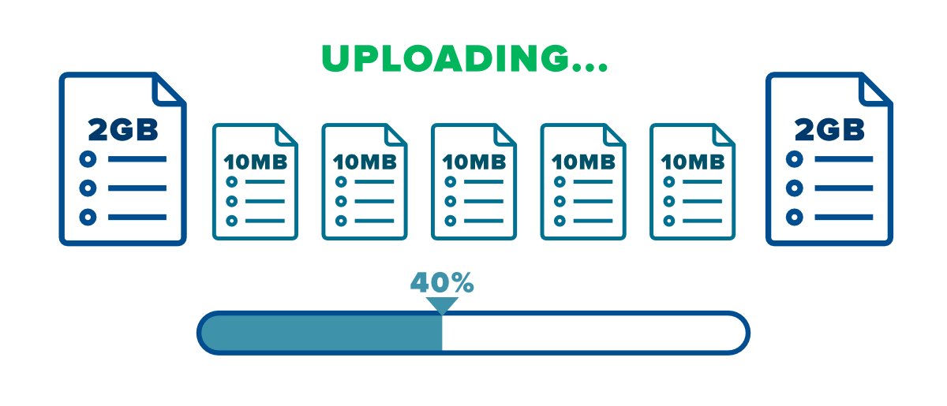

We can break the files into multiple chunks to overcome the problem we discussed above. There is no need to upload/download the whole single file after making any changes in the file. You just need to save the chunk which is updated (this will take less memory and time). It will be easier to keep the different versions of the files into various chunks.

We have considered one file which is divided into various chunks. If there are multiple files then we need to know which chunks belong to which file. To keep this information we will create one more file named as a **metadata file**. This file contains the indexes of the chunks (chunk names and order information). You need to mention the hash of the chunks (or some reference) in this metadata file and you need to sync this file into the cloud. We can download the metadata file from the cloud whenever we want and we can recreate the file using various chunks.

Now let’s talk about the various components for the complete system design solution of the dropbox service.

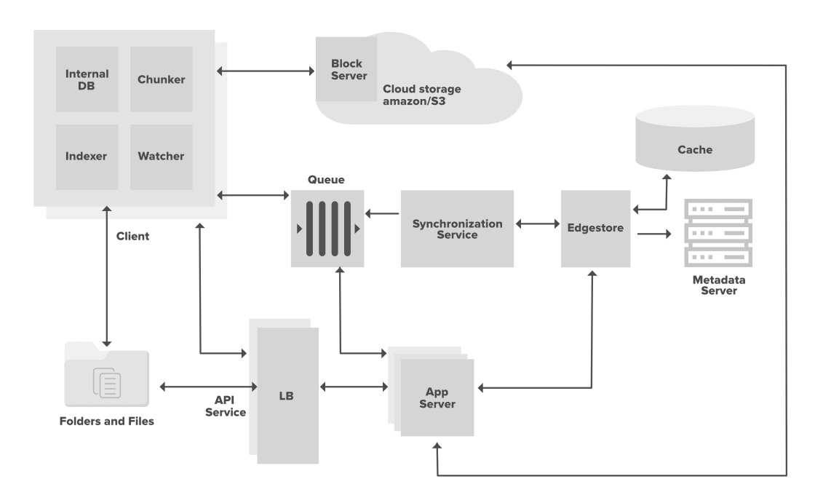

Let’s assume we have a client installed on our computer (an app installed on your computer) and this client has 4 basic components. These basic components are Watcher, Chunker, Indexer, and Internal DB. We have considered only one client but there can be multiple clients belongs to the same user with the same basic components.

* The client is responsible for uploading/downloading the files, identifying the file changes in the sync folder, and handling conflicts due to offline or concurrent updates.
* The client is actively monitoring the folders for all the updates or changes happening in the files.
* To handle file metadata updates (e.g. file name, size, modification date, etc.) this client interacts with the Messaging services and Synchronization Service.
* It also interacts with the remote cloud storage (Amazon S3 or any other cloud services) to store the actual files and to provide folder synchronization.

### Discuss The Client Components

* **Watcher** is responsible for monitoring the sync folder for all the activities performed by the user such as create, update or delete files/folders. It gives notification to the indexer and chunker if any action is performed in the files or folders.
* **Chunker** break the files into multiple small pieces called chunks and upload it to the cloud storage with a unique id or hash of these chunks. To recreate the files these chunks can be joined together. For any changes in the files, the chunking algorithm detects the specific chunk which is modified and only saves that specific part/chunks to the cloud storage. It reduces the bandwidth usage, synchronization time, and storage space in the cloud.
* **Indexer** is responsible for updating the internal database when it receives the notification from the watcher (for any action performed in folders/files). It receives the URL of the chunks from the chunker along with the hash and updates the file with modified chunks. Indexer communicates with the Synchronization Service using the Message Queuing Service, once the chunks are successfully submitted to the cloud Storage.
* **Internal database** store all the files and chunks information, their versions, and their location in the file system.

### Discuss The Other Components

#### 1. Metadata Database

The metadata database maintains the indexes of the various chunks. The information contains files/chunks names, their different versions along with the information of users and workspace. You can use RDBMS or NoSQL but make sure that you meet the data consistency property because multiple clients will be working on the same file. With RDBMS there is no problem with the consistency but with NoSQL, you will get eventual consistency. If you decide to use NoSQL then you need to do different configurations for different databases (For example, Cassandra replication factor gives the consistency level).

Relational databases are difficult to scale so if you’re using the MySQL database then you need to use a database sharding technique (or master-slave technique) to scale the application. In databases sharding, you need to add multiple MySQL databases, but it will be difficult to manage these databases for any update or for any new information that will be added to the databases. To overcome this problem, we need to build an edge wrapper around the sharded databases. This edge wrapper provides the ORM, and the client can easily use this edge wrapper’s ORM to interact with the database (instead of interacting with the databases directly).

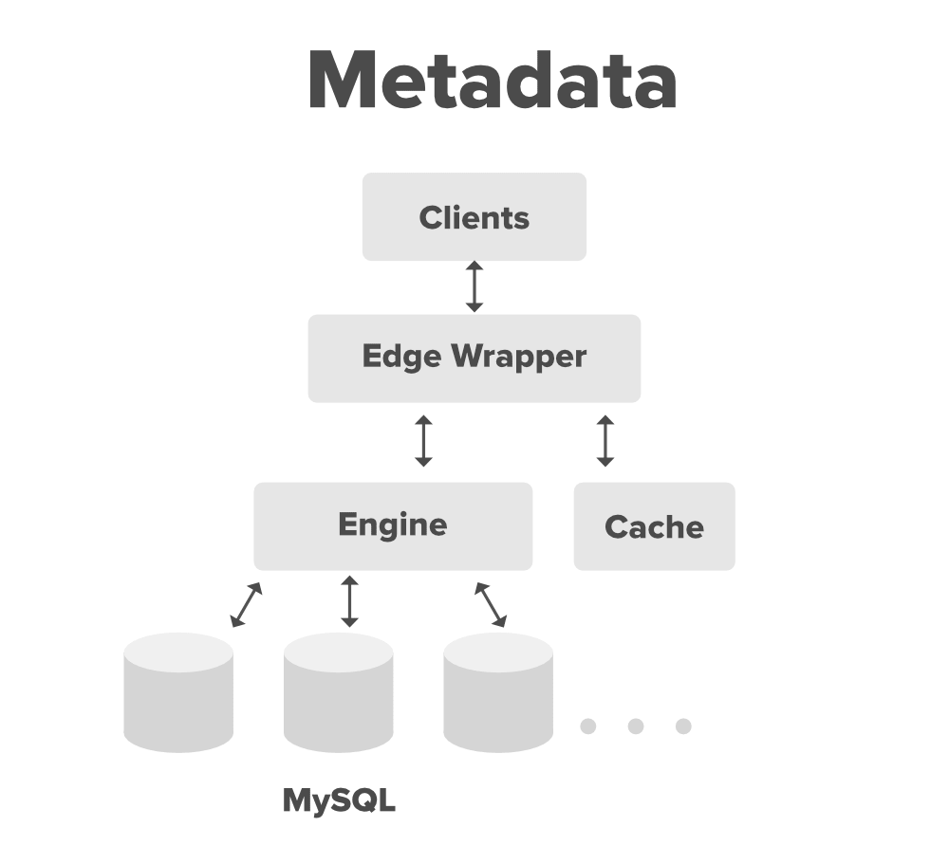

#### 2. Message Queuing Service

The messaging service queue will be responsible for the asynchronous communication between the clients and the synchronization service.

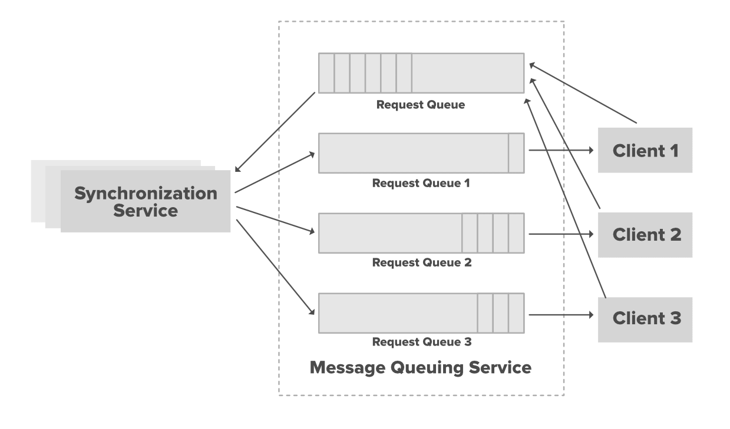

Below are the main requirements of the Message Queuing Service.

* Ability to handle lots of reads and writes requests.
* Store lots of messages in a highly available and reliable queue.
* High performance and high scalability.
* Provides load balancing and elasticity for multiple instances of the Synchronization Service.

There will be two types of messaging queues in the service.

* **Request Queue:** This will be a global request queue shared among all the clients. Whenever a client receives any update or changes in the files/folder it sends the request through the request queue. This request is received by the synchronization service to update the metadata database.
* **Response Queue:** There will be individual response queue corresponding to the individual clients. The synchronization service broadcast the update through this response queue and this response queue will deliver the updated messages to each client and then these clients will update their respective files accordingly. The message will never be lost even if the client will be disconnected from the internet (the benefit of using the messaging queue service).

We are creating n number of response queues for n number of clients because the message will be deleted from the queue once it will be received by the client and we need to share the updated message to the various subscribed clients.

#### 3. Synchronization Service

The client communicates with the synchronization services either to receive the latest update from the cloud storage or to send the latest request/updates to the Cloud Storage.

The synchronization service receives the request from the request queue of the messaging services and updates the metadata database with the latest changes. Also, the synchronization service broadcast the latest update to the other clients (if there are multiple clients) through the response queue so that the other client’s indexer can fetch back the chunks from the cloud storage and recreate the files with the latest update. It also updates the local database with the information stored in the Metadata Database. If a client is not connected with the internet or offline for some time, it polls the system for new updates as soon as it goes online.

#### 4. Cloud Storage

You can use any cloud storage service like Amazon S3 to store the chunks of the files uploaded by the user. The client communicates with the cloud storage for any action performed in the files/folders using the API provided by the cloud provider.

A lot of candidates get afraid of this round more than the coding round because they don’t get the idea that what topics and tradeoffs they should cover within this limited timeframe. Firstly, remember that the system design round is extremely open-ended and there’s no such thing as a standard answer. Even for the same question(**System Design Dropbox**), you’ll have a different discussion with different interviewers.

# System Design Netflix – A Complete Architecture

**Can you design Netflix in 45 minutes?**

*What??? Are you serious?? (I can watch it for the whole night but…). It’s impossible to explain even a single component of Netflix and you are asking me to design it within just 45 minutes of a short time??*

Yes, this is what you are expected to do in your system design interviews if you want to get your dream job in big tech giant companies. Designing Netflix is a quite common question of system design round in interviews. A lot of candidates get afraid of this round more than the coding round because they don’t get the idea that what topics and tradeoffs they should cover within this limited timeframe. Firstly, remember that the system design round is extremely open-ended and there’s no such thing as a standard answer. Even for the same question, you’ll have a totally different discussion with different interviewers.



In this blog, we will discuss how to design a website like dropbox or google drive but before we go further we want you to read the article “[How to crack system design round in interviews?](https://www.geeksforgeeks.org/how-to-crack-system-design-round-in-interviews/)”. You’ll have an idea that what this round looks like, what you are expected to do in this round and what mistakes you should avoid in front of the interviewer.

### Netflix High Level System Architecture

We all are familiar with Netflix services. It handles large categories of movies and television content and users pay the monthly rent to access these contents. Netflix has **180+M**subscribers in **200+** countries.

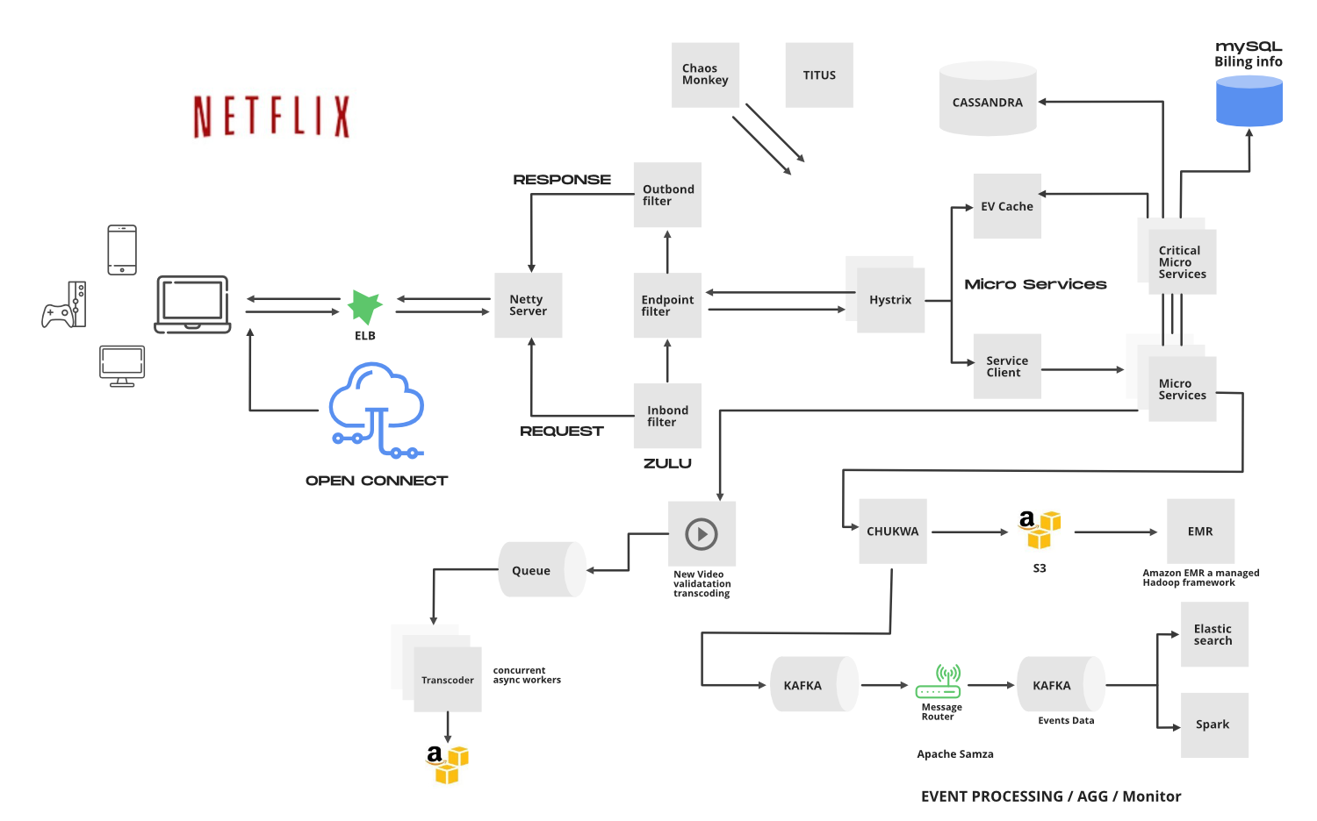

Netflix works on two clouds…**AWS**and **Open Connect**. These two clouds work together as the backbone of Netflix and both are highly responsible for providing the best video to the subscribers.

The application has mainly 3 components…

* **Client:** Device (User Interface) which is used to browse and play Netflix videos. TV, XBOX, laptop or mobile phone, etc
* **OC (Open connect) or Netflix CDN:** CDN is the network of distributed servers in different geographical locations and Open Connect is Netflix’s own custom global CDN (Content delivery network). It handles everything which involves video streaming. It is distributed in different locations and once you hit the play button the video stream from this component is displayed on your device. So if you’re trying to play the video sitting in North America, the video will be served from the nearest open connect (or server) instead of the original server (faster response from the nearest server).
* **Backend (Database)**: This part handles everything that doesn’t involve video streaming (before you hit the play button) such as onboarding new content, processing videos, distributing them on servers located in different parts of the world, and managing the network traffic. Most of the processes are take care of by Amazon Web Services.

Netflix frontend is written in **ReactJS**for mainly three reasons…startup speed, runtime performance, and modularity. Let’s discuss the components and working of Netflix.

### How Netflix Onboard a Movie/Video?

Netflix receives very high-quality videos and content from the production houses so before serving the videos to the users it does some preprocessing. Netflix supports more than 2200 devices and each one of them requires different resolutions and formats. To make the videos viewable on different devices Netflix performs **transcoding or encoding** which involves finding errors and converting the original video into different formats and resolutions.

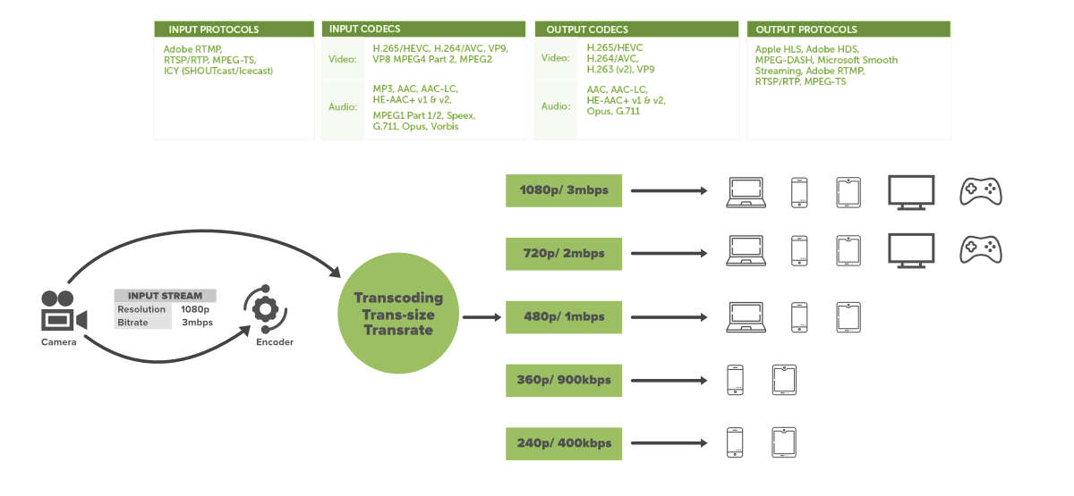

Netflix also creates file optimization for different network speeds. The quality of a video is good when you’re watching the video on high network speed. Netflix creates multiple replicas (approx 1100-1200) for the same movie with different resolutions. These replicas require a lot of transcoding and preprocessing. Netflix breaks the original video into different smaller chunks and using parallel workers in AWS it converts these chunks into different formats (like mp4, 3gp, etc) across different resolutions(like 4k, 1080p, and more).

After transcoding, once we have multiple copies of the files for the same movie, these files are transferred to each and every Open Connect server which is placed in different locations across the world.

When the user loads the Netflix app on his/her device firstly AWS instances come into the picture and handles some tasks such as login, recommendations, search, user history, the home page, billing, customer support, etc. After that when the user hits the play button on a video, Netflix analyzes the network speed or connection stability, and then it figures out the best Open Connect server near to the user. Depending on the device and screen size, the right video format is streamed into the user’s device. While watching a video you might have noticed that the video appears pixelated and snaps back to HD after a while? this happens because the application keeps checking the best streaming open connect server and switches between formats (for best viewing experience) when it’s needed.

User data which is saved in AWS such as searches, viewing, location, device, reviews, and likes, Netflix uses it to build the movie recommendation for users using the Machine learning model or Hadoop.

**Open Connect Advantages:**

* Less Expensive
* Better Quality
* More Scalable

### 1. Elastic Load Balancer

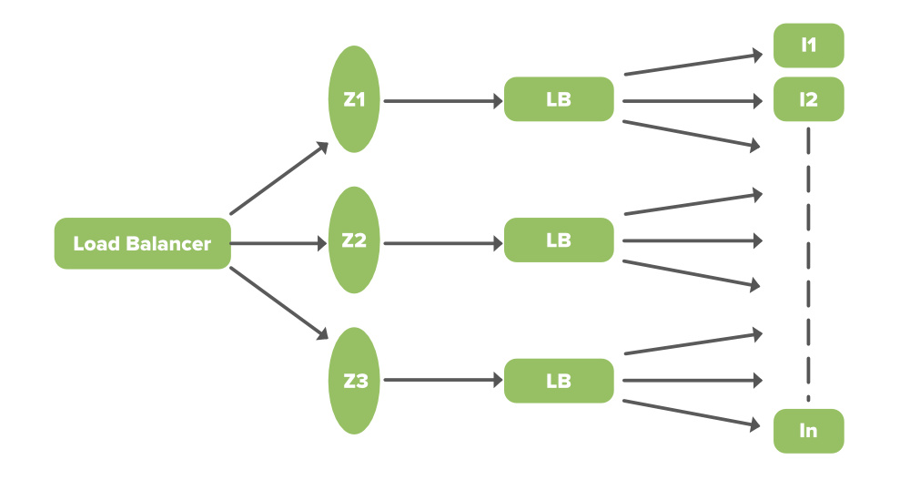

ELB in Netflix is responsible for routing the traffic to frontend services. ELB performs a two-tier load-balancing scheme where the load is balanced over zones first and then instances (servers).

* The First-tier consist of basic DNS based Round Robin Balancing. When the request lands on the first load balancing ( see the figure), it is balanced across one of the zones (using round-robin) that your ELB is configured to use.
* The second tier is an array of load balancer instances and it performs the Round Robin Balancing technique to distribute the request across the instances that are behind it in the same zone.

### 2. ZUUL

ZUUL is a gateway service that provides dynamic routing, monitoring, resiliency, and security. It provides easy routing based on query params, URL, path. Let’s understand the working of its different parts…

* **Netty server** takes the responsibility to handle the network protocol, web server, connection management, and proxying work. When the request will hit the Netty server, it will proxy the request to the inbound filter.
* **The inbound filter** is responsible for authentication, routing, or decorating the request. Then it forwards the request to the endpoint filter.
* **Endpoint filter** is used to return a static response or to forward the request to the backend service (or origin as we call it). Once it receives the response from the backend service, it sends the request to the outbound filter.
* **Outbound filter** is used for zipping the content, to calculate the metrics, or adding/removing custom headers. After that, the response is sent back to the Netty server and then it is received by the client.

**Advantages:**

* You can create some rules and **shard the traffic** by distributing the different part of the traffic to different servers.
* Developers can also do **load testing** on newly deployed clusters in some machine. They can route some existing traffic on these clusters and check how much load a specific server can bear.
* You can also **test new services**. When you upgrade the service and you want to check how it behaves with the real-time API requests, in that case, you can deploy the particular service on one server and you can redirect some part of the traffic to the new service to check the service in real-time.
* We can also **filter the bad request** by setting the custom rules at the endpoint filter or firewall.

### 3. Hystrix

In a complex distributed system a server may rely on the response of another server. Dependencies among these servers can create latency and the entire system may stop working if one of the servers will inevitably fail at some point. To solve this problem we can isolate the host application from these external failures. Hystrix library is designed to do this job. It helps you to control the interactions between these distributed services by adding latency tolerance and fault tolerance logic. Hystrix does this by isolating points of access between the services, remote system, and 3rd party libraries. The library helps in..

* Stop cascading failures in a complex distributed system.
* control over latency and failure from dependencies accessed (typically over the network) via third-party client libraries.
* Fail fast and rapidly recover.
* Fallback and gracefully degrade when possible.
* Enable near real-time monitoring, alerting, and operational control.
* Concurrency aware request caching. Automated batching through request collapsing

### 4. Microservice Architecture of Netflix

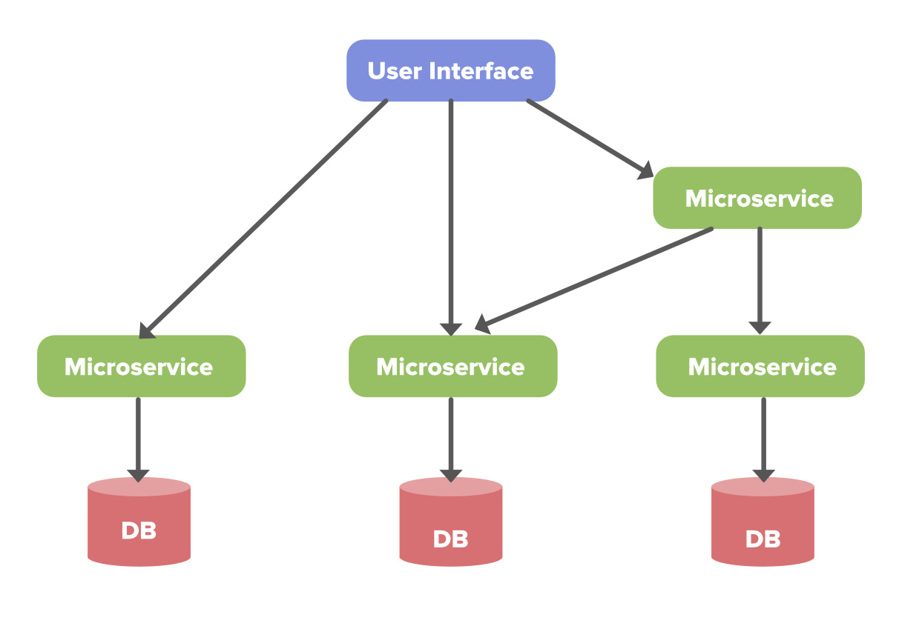

Netflix’s architectural style is built as a collection of services. This is known as microservices architecture and this power all of the APIs needed for applications and Web apps. When the request arrives at the endpoint it calls the other microservices for required data and these microservices can also request for the data to different microservices. After that, a complete response for the API request is sent back to the endpoint.

In a microservice architecture, services should be independent of each other, for example, the video storage service would be decoupled from the service responsible for transcoding videos. Now, let’s understand how to make it reliable…

**How to make microservice architecture reliable?**

* Use Hysterix (Already explained)
* **Separate Critical Microservices:** We can separate out some critical services (or endpoint or APIs) and make it less dependent or independent on other services. You can also make some critical services dependent only on other reliable services. While choosing the critical microservices you can include all the basic functionalities, like searching a video, navigating to the videos, hit and play the video, etc. This way you can make the endpoints highly available and even in worst-case scenarios at least a user will be able to do the basic things.
* **Treat Servers as Stateless:** This may sound funny to you but to understand this concept think of your servers like a herd of cows and you care about how many gallons of milk you get every day. If one day you notice that you’re getting less milk from a cow then you just need to replace that cow (producing less milk) with another cow. You don’t need to be dependent on a specific cow to get the required amount of milk.   
  We can relate the above example with our application. The idea is to design the service in such a way that if one of the endpoints is giving the error or if it’s not serving the request in a timely fashion then you can switch to another server and get your work done. Instead of relying on a specific server and preserving the state in that server, you can route the request to another service instance and you can automatically spin up a new node to replace it. If a server stops working, it will be replaced by another one.

### 5. EV Cache

In most applications, some amount of data is frequently used. For faster response, these data can be cached in so many endpoints and it can be fetched from the cache instead of the original server. This reduces the load from the original server but the problem is if the node goes down all the cache goes down and this can hit the performance of the application. To solve this problem Netflix has built its own custom caching layer called EV cache. EV cache is based on **Memcached**and it is actually a wrapper around Memcached.

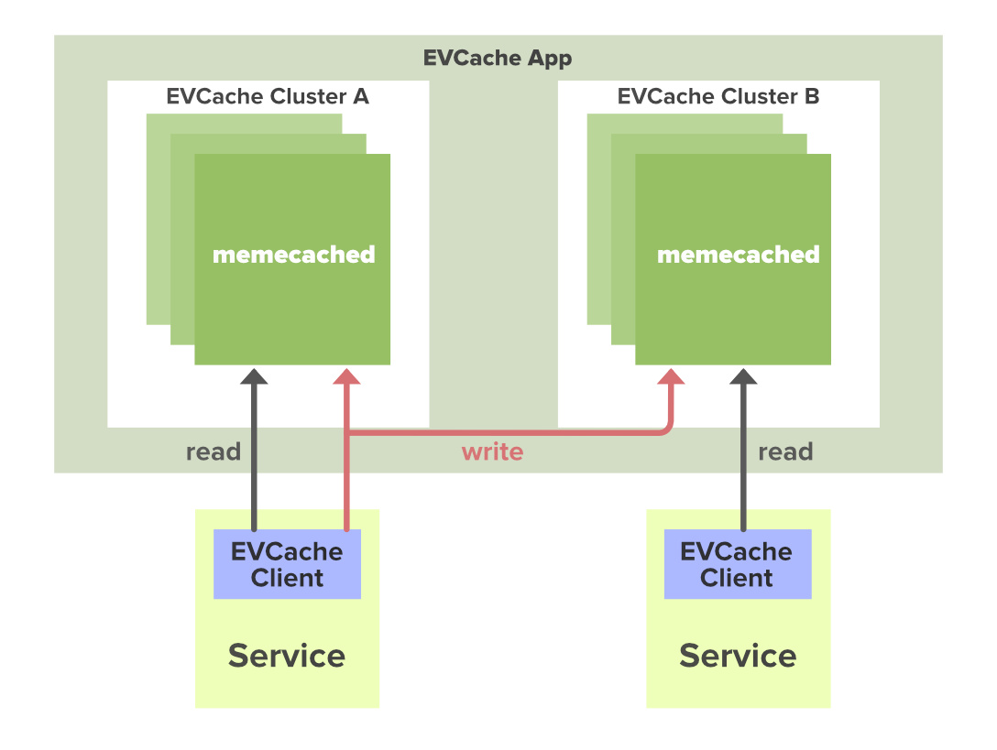

*3 Node Memcached Cluster in 2 Availability Zones With a Client in Each Zone*

Netflix has deployed a lot of clusters in a number of AWS EC2 instances and these clusters have so many nodes of Memcached and they also have cache clients. The data is shared across the cluster within the same zone and multiple copies of cache are stored in sharded nodes. Every time when write happens to the client all the nodes in all the clusters are updated but when the read happens to the cache, it is only sent to the nearest cluster (not all the cluster and nodes) and its nodes. In case, a node is not available then read from a different available node. This approach increases performance, availability, and reliability.

### 6. Database

Netflix uses two different databases i.e. MySQL(RDBMS) and Cassandra(NoSQL) for different purposes.

#### EC2 Deployed MySQL

Netflix saves data like billing information, user information, and transaction information in MySQL because it needs ACID compliance. Netflix has a master-master setup for MySQL and it is deployed on Amazon large EC2 instances using InnoDB.

The setup follows the “**Synchronous replication protocol**” where if the write happens to the primary master node then it will be also replicated to another master node. The acknowledgment will be sent only if both the primary and remote master nodes write have been confirmed. This ensures the high availability of data.   
Netflix has set up the read replica for each and every node (local, as well as cross-region). This ensures high availability and scalability.

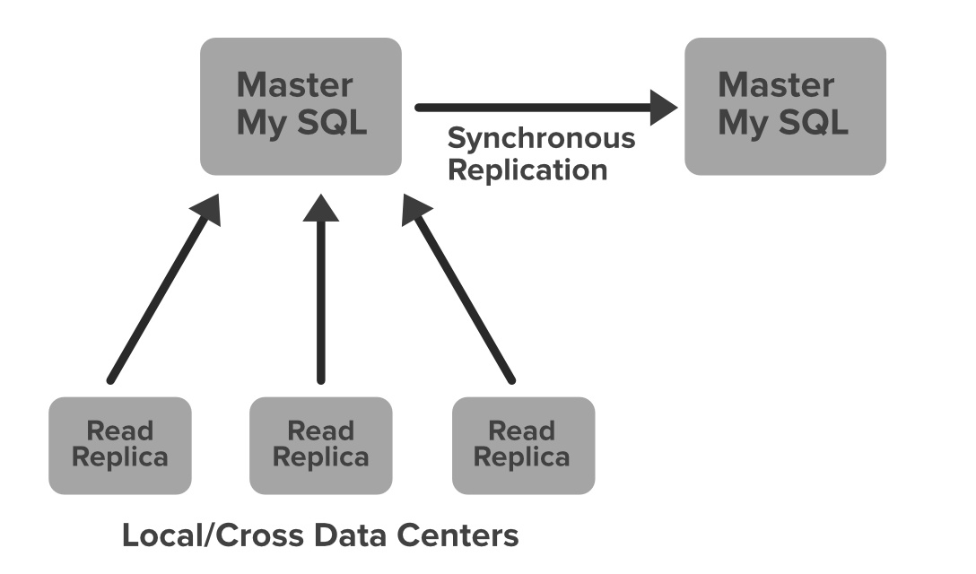

All the read queries are redirected to the read replicas and only the write queries are redirected to the master nodes. In the case of a primary master MySQL failure, the secondary master node will take over the primary role and the route53 (DNS configuration) entry for the database will be changed to this new primary node. This will also redirect the write queries to this new primary master node.

#### Cassandra

Cassandra is a NoSQL database that can handle large amounts of data and it can also handle heavy write and read. When Netflix started acquiring more users, the viewing history data for each member also started increasing. This increases the total number of viewing history data and it becomes challenging for Netflix to handle this massive amount of data. Netflix scaled the storage of viewing history data-keeping two main goals in their mind…

* Smaller Storage Footprint.
* Consistent Read/Write Performance as viewing per member grows (viewing history data write to read ratio is about 9:1 in Cassandra).

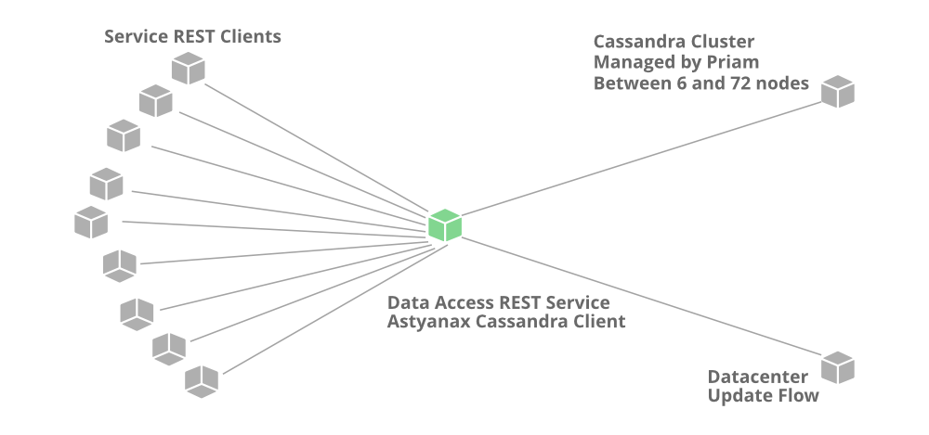

**Total Denormalized Data Model**

* Over 50 Cassandra Clusters
* Over 500 Nodes
* Over 30TB of daily backups
* Biggest cluster 72 nodes.
* 1 cluster over 250K writes/s

Initially, the viewing history was stored in Cassandra in a single row. When the users started increasing on Netflix the row sizes as well as the overall data size increased. This resulted in high storage, more operational cost, and slow performance of the application. The solution to this problem was to compress the old rows…   
Netflix divided the data into two parts…

* **Live Viewing History (LiveVH):** This section included the small number of recent viewing historical data of users with frequent updates. The data is frequently used for the ETL jobs and stored in uncompressed form.
* **Compressed Viewing History (CompressedVH):** A large amount of older viewing records with rare updates is categorized in this section. The data is stored in a single column per row key, also in compressed form to reduce the storage footprint.

### 7. Data Processing in Netflix Using Kafka And Apache Chukwa

When you click on a video Netflix starts processing data in various terms and it takes less than a nanosecond. Let’s discuss how the evolution pipeline works on Netflix.

Netflix uses Kafka and Apache Chukwe to ingest the data which is produced in a different part of the system. Netflix provides almost **500B** data events that consume **1.3 PB/day** and 8 million events that consume 24 GB/Second during peak time. These events include information like…

* Error logs
* UI activities
* Performance events
* Video viewing activities
* Troubleshooting and diagnostic events.

**Apache Chukwe** is an open-source data collection system for collecting logs or events from a distributed system. It is built on top of HDFS and Map-reduce framework. It comes with Hadoop’s scalability and robustness features. Also, it includes a lot of powerful and flexible toolkit to display, monitor, and analyze the result. Chukwe collects the events from different parts of the system and from Chukwe you can do monitoring, analysis or you can use the dashboard to view the events. Chukwe writes the event in the Hadoop file sequence format (S3). After that Big Data team processes these S3 Hadoop files and writes Hive in Parquet data format. This process is called batch processing which basically scans the whole data at the hourly or daily frequency.

To upload online events to EMR/S3, Chukwa also provide traffic to the Kafka (main gate in real-time data processing). Kafka is responsible for moving data from fronting Kafka to various sinks: S3, Elasticsearch, and secondary Kafka. Routing of these messages is done using the **Apache Samja** framework. Traffic sends by the Chukwe can be full or filtered streams so sometimes you may have to apply further filtering on the Kafka streams. That is the reason we consider the router to take from one Kafka topic to a different Kafka topic.

### 8. Elastic Search

In recent years we have seen a massive growth of using Elasticsearch within Netflix. Netflix is running approximately **150**clusters of elastic search and **3, 500**hosts with instances.

Netflix is using elastic search for data visualization, customer support, and for some error detection in the system. For example, if a customer is unable to play the video then the customer care executive will resolve this issue using elastic search. Playback team go to the elastic search and search for the user to know why the video is not playing in the user’s device. They get to know all the information and events happening for that particular user. They get to know what caused the error in the video stream. Elastic search is also used by the admin to keep track of some information. It is also used to keep track of resource usage and to detect signup or login problems.

### 9. Apache Spark for Movie Recommendation

Netflix uses Apache Spark and Machine learning for Movie recommendation. Let’s understand how it works with an example. When you load the front page you see the multiple rows of different kinds of movies. Netflix personalizes this data and decides what kind of rows or what kind of movies should be displayed to a specific user. This data is based on the user’s historical data and preferences. Also, for that specific user, Netflix performs sorting of the movies and calculates the relevance ranking (for the recommendation) of these movies available on their platform.

In Netflix, Apache Spark is used for content recommendations and personalization. A majority of the [machine learning](https://www.geeksforgeeks.org/machine-learning/) pipelines are run on these large spark clusters. These pipelines are then used to do row selection, sorting, title relevance ranking, and artwork personalization among others.

#### Artwork Personalization

When you open the Netflix front page you might have noticed the images for each videos…these images are called header images (thumbnail). Netflix wants maximum clicks for the videos from the users and these clicks are dependent on the header images. Netflix has to choose the right compelling header image for a specific video. To do that Netflix creates multiple artworks for a specific movie and they display these images to the users randomly. For the same movie, images can be different for different users. Based on your preferences and viewing history Netflix predicts what kind of movies you like best or which actors you like the most in a movie. According to users’ tastes, the images will be displayed to them.

For example, suppose you see 9 different images for your favorite movie Good will hunting in three rows (If you like comedies then images of Robin Williams for this movie will be shown. If you like romantic movies then Netflix will show you the image of Matt Damon and Minnie Driver). Now, Netflix calculates the number of clicks a certain image receives. If the clicks for the center image of the movie are 1, 500 times and the other images have fewer clicks then Netflix will make the center image as a header image for the movie Good Will Hunting forever. This is called **data driven** and Netflix performs the data analytics with this approach. To make the right decision data is calculated based on the number of views associated with each picture.

#### Video Recommendation System

If a user wants to discover some content or video on Netflix, the recommendation system of Netflix helps users to find their favorite movies or videos. To build this recommendation system Netflix has to predict the user interest and it gathers different kinds of data from the users such as…

* User interaction with the service (viewing history and how user rated other titles)
* Other members with similar tastes and preferences.
* Metadata information from the previously watched videos for a user such as titles, genre, categories, actors, release year, etc.
* Device of the user, at what time a user is more active and for how long a user is active.

Netflix uses two different algorithms to build a recommendation system…

**1. Collaborative filtering:** The idea of this filtering is that if two users have similar rating history then they will behave similarly in the future. For example, consider there are two-person. One person has liked the movie and rated the movie with a good score. Now, there is a good chance that the other person will also have a similar pattern and he/she will do the same thing which the first person has done.

**2. Content-based filtering:** The idea is to filter those videos which are similar to the video a user has liked before. Content-based filtering is highly dependents on the information from the products such as movie title, release year, actors, the genre. So to implement this filtering it’s important to know the information describing each item and some sort of user profile describing what the user likes is also desirable.

# System Design of Uber App – Uber System Architecture

***It’s really easy to just tap a button on our mobile phone and get the cab available within few minutes whenever and wherever we want.***   
**Uber/Ola/Lyft**… using these applications and getting the hassle-free transportation service is really simple but *is it also simple to build these gigantic applications* which have hundreds of software engineers working on it for a decade…? definitely not. These systems have much more complex architecture and there are a lot of components joined together internally to provide riding services all over the world. Designing Uber (or OLA or Lyft) is a quite common question of system design round in interviews. A lot of candidates get afraid of this round more than the coding round because they don’t get the idea that what topics and tradeoffs they should cover within this limited timeframe. Firstly, remember that the system design round is extremely open-ended and there’s no such thing as a standard answer. Even for the same question, you’ll have a totally different discussion with different interviewers.



In this blog, we will discuss how to design ride-hailing services like Uber/Ola/Lyft but before we go further we want you to read the article “[How to crack system design round in interviews?](https://www.geeksforgeeks.org/how-to-crack-system-design-round-in-interviews/)”. It will give you an idea that what this round looks like, what you are expected to do, and what mistakes you should avoid in front of the interviewer.

## Uber System Architecture

We all are familiar with Uber services. A user can request a ride through the application and within a few minutes, a driver arrives nearby his/her location to take them to their destination. Earlier Uber was built on the “**monolithic**” software architecture model. They had a backend service, a frontend service, and a single database. They used Python and its frameworks and SQLAlchemy as the ORM layer to the database. This architecture was fine for a small number of trips in a few cities but when the service started expanding in other cities Uber team started facing the issue with the application. After the year 2014 Uber team decided to switch to the “**service-oriented architecture**” and now Uber also handles food delivery and cargo.

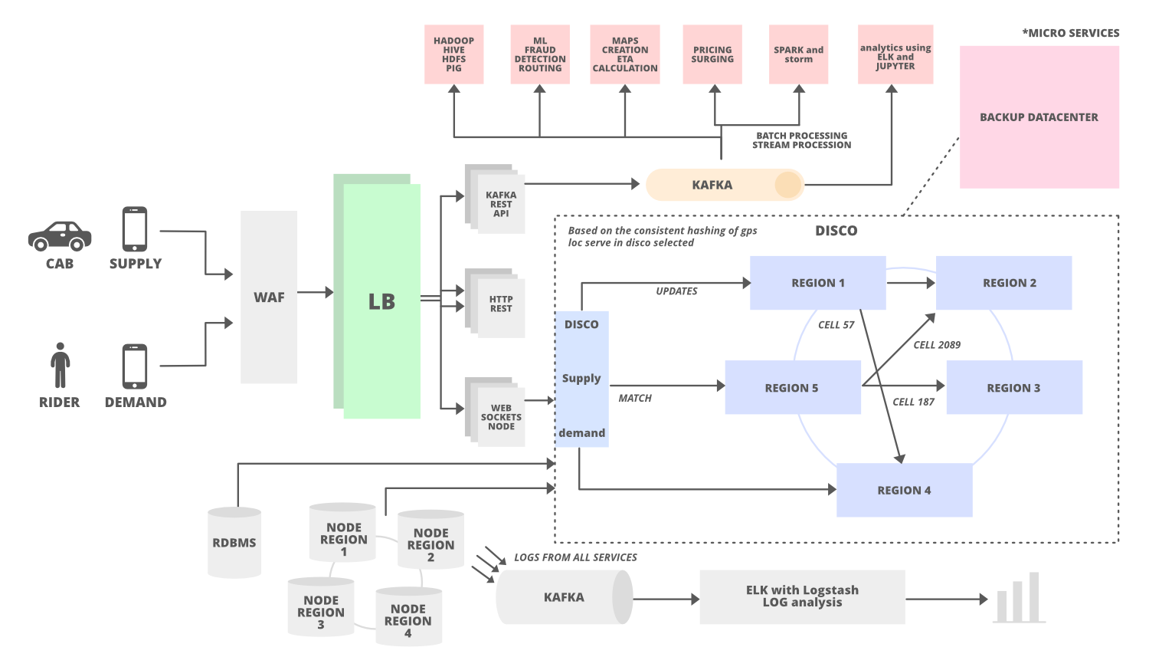

### 1. Talk About the Challenges

One of the main tasks in Uber service is to match the rider with cabs which means we need two different services in our architecture i.e.

* Supply Service (for cabs)
* Demand Service (for riders)

Uber has a **Dispatch system** (Dispatch optimization/DISCO) in its architecture to match supply with demands. This dispatch system uses mobile phones and it takes the responsibility to match the drivers with riders (supply to demand).

### 2. How Dispatch System Works?

DISCO must have these goals…

* Reduce extra driving.
* Minimum waiting time
* Minimum overall ETA

The dispatch system completely works on maps and location data/GPS, so the first thing which is important is to model our maps and location data.

* Earth has a spherical shape so it’s difficult to do summarization and approximation by using latitude and longitude. To solve this problem Uber uses **Google S2 library**. This library divides the map data into tiny cells (for example 3km) and gives the unique ID to each cell. This is an easy way to spread data in the distributed system and store it easily.
* S2 library gives the coverage for any given shape easily. Suppose you want to figure out all the supplies available within a 3km radius of a city. Using the S2 libraries you can draw a circle of 3km radius and it will filter out all the cells with IDs that lie in that particular circle. This way you can easily match the rider to the driver and you can easily find out the number of cars(supply) available in a particular region.

### 3. Supply Service And How it Works?

* In our case cabs are the supply services and they will be tracked by geolocation (latitude and longitude). All the active cabs keep on sending the location to the server once every 4 seconds through a web application firewall and load balancer. The accurate GPS location is sent to the data center through Kafka’s Rest APIs once it passes through the load balancer. Here we use **Apache Kafka** as the data hub.
* Once the latest location is updated by Kafka it slowly passes through the respective worker notes main memory.
* Also a copy of the location (state machine/latest location of cabs) will be sent to the database and to the dispatch optimization to keep the latest location updated.
* We also need to track few more things such as number of seats, presence of a car seat for children, type of vehicle, can a wheelchair be fit, and allocation ( for example, a cab may have four seats but two of those are occupied.)

### 4. Demand Service And How it Works?

* Demand service receives the request of the cab through a web socket and it tracks the GPS location of the user. It also receives different kinds of requirements such as the number of seats, type of car, or pool car.
* Demand gives the location (cell ID) and user requirement to supply and make requests for the cabs.

### 5. How Dispatch System Match the Riders to Drivers?

* We have discussed that DISCO divides the map into tiny cells with a unique ID. This ID is used as a sharding key in DISCO. When supply receives the request from demand the location gets updated using the cell ID as a shard key. These tiny cells’ responsibilities will be divided into different servers lies in multiple regions (consistent hashing). For example, we can allocate the responsibility of 12 tiny cells to 6 different servers (2 cells for each server) lies in 6 different regions.

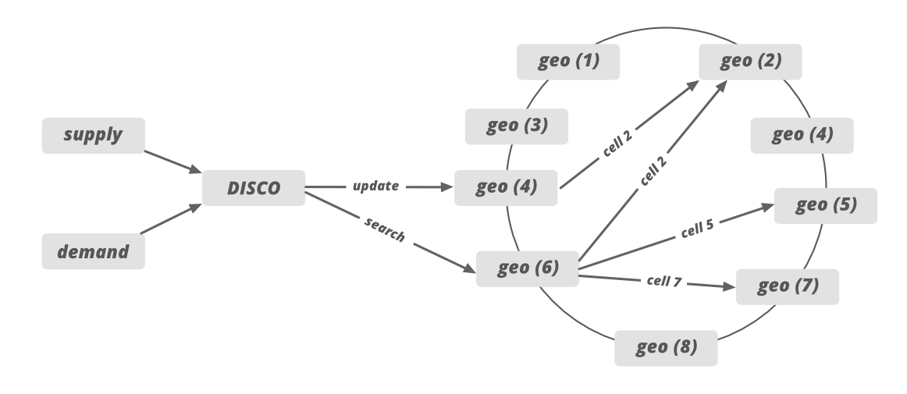

* Supply sends the request to the specific server based on the GPS location data. After that, the system draws the circle and filter out all the nearby cabs which meet the rider’s requirement.
* After that, the list of the cab is sent to the ETA to calculate the distance between the rider and the cab, not geographically but by the road system.
* Sorted ETA is then sent back to the supply system to offer it to a driver.

If we need to handle the traffic for the newly added city then we can increase the number of servers and allocate the responsibilities of newly added cities cell IDs to these servers.

### 6. How To Scale Dispatch System?

* Dispatch system (including supply, demand, and web socket) is built on **NodeJS**. NodeJS is the asynchronous and event-based framework that allows you to send and receive messages through WebSockets whenever you want.
* Uber uses an open-source ***ringpop*** to make the application cooperative and scalable for heavy traffic. Ring pop has mainly three parts and it performs the below operation to scale the dispatch system.
  1. It maintains the **consistent hashing** to assign the work across the workers. It helps in sharding the application in a way that’s scalable and fault-tolerant.
  2. Ringpop uses **RPC (Remote Procedure Call) protocol** to make calls from one server to another server.
  3. Ringpop also uses a **SWIM membership protocol/gossip protocol** that allows independent workers to discover each other’s responsibilities. This way each server/node knows the responsibility and the work of other nodes.
  4. Ringpop detects the newly added nodes to the cluster and the node which is removed from the cluster. It distributes the loads evenly when a node is added or removed.

### 7. How Uber Defines a Map Region?

Before launching a new operation in a new area, Uber onboard the new region to the map technology stack. In this map region, we define various subregions labeled with grades A, B, AB, and C.

**Grade A:** This subregion is responsible to cover the urban centers and commute areas. Around 90% of Uber traffic gets covered in this subregion, so it’s important to build the highest quality map for subregion A.

**Grade B:** This subregion covers the rural and suburban areas which are less populated and less traveled by Uber customers.

**Grade AB:** A union of grade A and B subregions.

**Grade C:** Covers the set of highway corridors connecting various Uber Territories.

### 8. How Uber Builds the Map?

Uber uses third party map service provider to build the map in their application. Earlier Uber was using [Mapbox](https://www.mapbox.com/" \t "_blank) services but later Uber switched to [Google Maps API](https://developers.google.com/maps/documentation) to track the location and to calculate ETAs.

**1. Trace coverage:** Trace coverage spot the missing road segments or incorrect road geometry. Trace coverage calculation is based on two inputs: map data under testing and historic GPS traces of all Uber rides taken over a certain period of time. It covers those GPS traces onto the map, comparing and matching them with road segments. If we find missing road segments (no road is shown) on GPS traces then we take some steps to fix the deficiency.

**2. Preferred access (pick-up) point accuracy:** We get the pickup point in our application when we book the cab in Uber. Pick-up points are really important metric in Uber especially for large venues such as airports, college campuses, stadiums, factories, or companies. We calculate the distance between the actual location and all the pickup and drop-off points used by drivers.

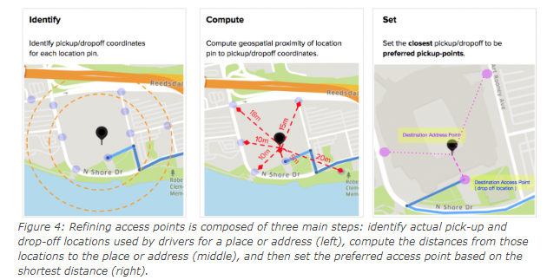

*Image Source: https://eng.uber.com/maps-metrics-computation/*

The shortest distance (closest pickup point) is then calculated and we set the pin to that location as a preferred access point on the map. When a rider requests the location indicated by the map pin, the map guides the driver to the preferred access point. The calculation continues with the latest actual pick-up and drop-off locations to ensure the freshness and accuracy of the suggested preferred access points. Uber uses machine learning and different algorithms to figure out the preferred access point.

### 9. How ETAs Are Calculated?

ETA is an extremely important metric in Uber because it directly impacts ride-matching and earnings. ETA is calculated based on the road system (not geographically) and there are a lot of factors involved in computing the ETA (like heavy traffic or road construction). When a rider requests a cab from a location the app not only identifies the free/idle cabs but also includes the cabs which are about to finish a ride. It may be possible that one of the cabs which are about to finish the ride is more close to the demand than the cab which is far away from the user. So many uber cars on the road send GPS locations every 4 seconds, so to predict traffic we can use the driver’s app’s GPS location data.

We can represent the entire road network on a graph to calculate the ETAs. We can use AI simulated algorithms or simple **Dijkstra’s algorithm** to find out the best route in this graph. In that graph, nodes represent intersections (available cabs), and edges represent road segments. We represent the road segment distance or the traveling time through the edge weight. We also represent and model some additional factors in our graph such as one-way streets, turn costs, turn restrictions, and speed limits.

Once the data structure is decided we can find the best route using [Dijkstra’s search algorithm](https://en.wikipedia.org/wiki/Dijkstra%27s_algorithm) which is one of the best modern routing algorithms today. For faster performance, we also need to use OSRM (Open Source Routing Machine) which is based on [contraction hierarchies](https://en.wikipedia.org/wiki/Contraction_hierarchies). Systems based on contraction hierarchies take just a few milliseconds to compute a route — by preprocessing the routing graph.

### 10. Databases

Uber had to consider some of the requirements for the database for a better customer experience. These requirements are…

* The database should be horizontally scalable. You can linearly add capacity by adding more servers.
* It should be able to handle a lot of reads and writes because once every 4-second cabs will be sending the GPS location and that location will be updated in the database.
* The system should never give downtime for any operation. It should be highly available no matter what operation you perform (expanding storage, backup, when new nodes are added, etc).

Earlier Uber was using the RDBMS PostgreSQL database but due to scalability issues uber switched to various databases. Uber uses a NoSQL database (schemaless) built on the top of the MySQL database.

* Redis for both caching and queuing. Some are behind [Twemproxy](https://github.com/twitter/twemproxy" \t "_blank) (provides scalability of the caching layer). Some are behind a custom clustering system.
* Uber uses schemaless (built in-house on top of MySQL), Riak, and Cassandra. Schemaless is for long-term data storage. Riak and Cassandra meet high-availability, low-latency demands.
* MySQL database.
* Uber is building their own distributed column store that’s orchestrating a bunch of MySQL instances.

### 11. Analytics

To optimize the system, to minimize the cost of the operation and for better customer experience uber does log collection and analysis. Uber uses different tools and frameworks for analytics. For log analysis, Uber uses multiple Kafka clusters. Kafka takes historical data along with real-time data. Data is archived into Hadoop before it expires from Kafka. The data is also indexed into an Elastic search stack for searching and visualizations. Elastic search does some log analysis using Kibana/Graphana. Some of the analyses performed by Uber using different tools and frameworks are…

* Track HTTP APIs
* Manage profile
* Collect feedback and ratings
* Promotion and coupons etc
* Fraud detection
* Payment fraud
* Incentive abuse by driver
* Compromised accounts by hackers. Uber uses historical data of the customer and some machine learning technique to tackle with this problem.

### 12. How To Handle The Datacenter Failure?

Datacenter failure doesn’t happen very often but Uber still maintains a backup data center to run the trip smoothly. This data center includes all the components but Uber never copies the existing data into the backup data center.

*Then how Uber tackles the datacenter failure??*

It actually uses driver phones as a source of trip data to tackle the problem of data center failure.   
When The driver’s phone app communicates with the dispatch system or the API call is happening between them, the dispatch system sends the encrypted state digest (to keep track of the latest information/data) to the driver’s phone app. Every time this state digest will be received by the driver’s phone app. In case of a datacenter failure, backup data center (backup DISCO) doesn’t know anything about the trip so it will ask for the state digest from the driver’s phone app and it will update itself with the state digest information received by the driver’s phone app.

# Designing Instagram

Let's design a photo-sharing service like Instagram, where users can upload photos to share them with other users. Similar Services: Flickr, Picasa Difficulty Level: Medium

## 1. What is Instagram?[#](https://www.educative.io/courses/grokking-the-system-design-interview/m2yDVZnQ8lG#1.-What-is-Instagram?)

Instagram is a social networking service that enables its users to upload and share their photos and videos with other users. Instagram users can choose to share information either publicly or privately. Anything shared publicly can be seen by any other user, whereas privately shared content can only be accessed by the specified set of people. Instagram also enables its users to share through many other social networking platforms, such as Facebook, Twitter, Flickr, and Tumblr.

We plan to design a simpler version of Instagram for this design problem, where a user can share photos and follow other users. The ‘News Feed’ for each user will consist of top photos of all the people the user follows.

## 2. Requirements and Goals of the System[#](https://www.educative.io/courses/grokking-the-system-design-interview/m2yDVZnQ8lG#2.-Requirements-and-Goals-of-the-System)

We’ll focus on the following set of requirements while designing Instagram:

**Functional Requirements**

1. Users should be able to upload/download/view photos.
2. Users can perform searches based on photo/video titles.
3. Users can follow other users.
4. The system should generate and display a user’s News Feed consisting of top photos from all the people the user follows.

**Non-functional Requirements**

1. Our service needs to be highly available.
2. The acceptable latency of the system is 200ms for News Feed generation.
3. Consistency can take a hit (in the interest of availability) if a user doesn’t see a photo for a while; it should be fine.
4. The system should be highly reliable; any uploaded photo or video should never be lost.

**Not in scope:** Adding tags to photos, searching photos on tags, commenting on photos, tagging users to photos, who to follow, etc.

## 3. Some Design Considerations[#](https://www.educative.io/courses/grokking-the-system-design-interview/m2yDVZnQ8lG#3.-Some-Design-Considerations)

The system would be read-heavy, so we will focus on building a system that can retrieve photos quickly.

1. Practically, users can upload as many photos as they like; therefore, efficient management of storage should be a crucial factor in designing this system.
2. Low latency is expected while viewing photos.
3. Data should be 100% reliable. If a user uploads a photo, the system will guarantee that it will never be lost.

## 4. Capacity Estimation and Constraints[#](https://www.educative.io/courses/grokking-the-system-design-interview/m2yDVZnQ8lG#4.-Capacity-Estimation-and-Constraints)

* Let’s assume we have 500M total users, with 1M daily active users.
* 2M new photos every day, 23 new photos every second.
* Average photo file size => 200KB
* Total space required for 1 day of photos

2M \* 200KB => 400 GB

* Total space required for 10 years:

400GB \* 365 (days a year) \* 10 (years) ~= 1425TB

## 5. High Level System Design[#](https://www.educative.io/courses/grokking-the-system-design-interview/m2yDVZnQ8lG#5.-High-Level-System-Design)

At a high-level, we need to support two scenarios, one to upload photos and the other to view/search photos. Our service would need some [object storage](https://en.wikipedia.org/wiki/Object_storage) servers to store photos and some database servers to store metadata information about the photos.

## 6. Database Schema[#](https://www.educative.io/courses/grokking-the-system-design-interview/m2yDVZnQ8lG#6.-Database-Schema)

💡 Defining the DB schema in the early stages of the interview would help to understand the data flow among various components and later would guide towards data partitioning.

We need to store data about users, their uploaded photos, and the people they follow. The Photo table will store all data related to a photo; we need to have an index on (PhotoID, CreationDate) since we need to fetch recent photos first.

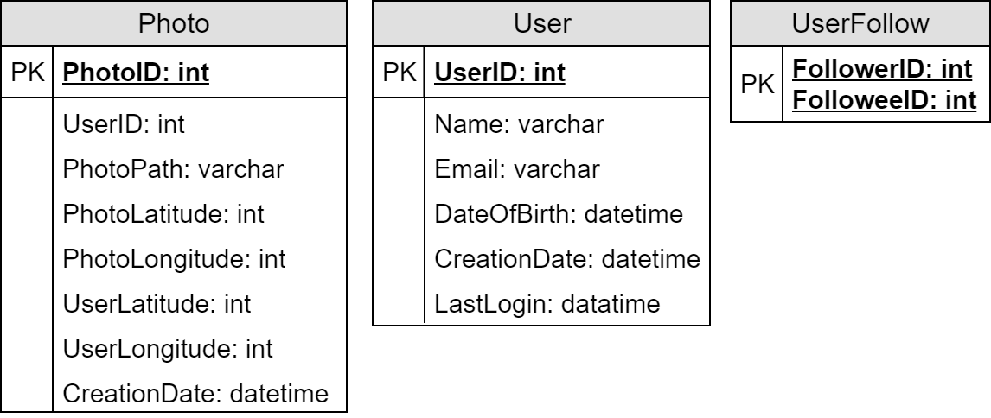

A straightforward approach for storing the above schema would be to use an RDBMS like MySQL since we require joins. But relational databases come with their challenges, especially when we need to scale them. For details, please take a look at [SQL vs. NoSQL](https://www.educative.io/collection/page/5668639101419520/5649050225344512/5728116278296576/).

We can store photos in a distributed file storage like [HDFS](https://en.wikipedia.org/wiki/Apache_Hadoop) or [S3](https://en.wikipedia.org/wiki/Amazon_S3).

We can store the above schema in a distributed key-value store to enjoy the benefits offered by NoSQL. All the metadata related to photos can go to a table where the ‘key’ would be the ‘PhotoID’ and the ‘value’ would be an object containing PhotoLocation, UserLocation, CreationTimestamp, etc.

NoSQL stores, in general, always maintain a certain number of replicas to offer reliability. Also, in such data stores, deletes don’t get applied instantly; data is retained for certain days (to support undeleting) before getting removed from the system permanently.

## 7. Data Size Estimation[#](https://www.educative.io/courses/grokking-the-system-design-interview/m2yDVZnQ8lG#7.-Data-Size-Estimation)

Let’s estimate how much data will be going into each table and how much total storage we will need for 10 years.

**User:** Assuming each “int” and “dateTime” is four bytes, each row in the User’s table will be of 68 bytes:

UserID (4 bytes) + Name (20 bytes) + Email (32 bytes) + DateOfBirth (4 bytes) + CreationDate (4 bytes) + LastLogin (4 bytes) = 68 bytes

If we have 500 million users, we will need 32GB of total storage.

500 million \* 68 ~= 32GB

**Photo:** Each row in Photo’s table will be of 284 bytes:

PhotoID (4 bytes) + UserID (4 bytes) + PhotoPath (256 bytes) + PhotoLatitude (4 bytes) + PhotoLongitude(4 bytes) + UserLatitude (4 bytes) + UserLongitude (4 bytes) + CreationDate (4 bytes) = 284 bytes

If 2M new photos get uploaded every day, we will need 0.5GB of storage for one day:

2M \* 284 bytes ~= 0.5GB per day

For 10 years we will need 1.88TB of storage.

**UserFollow:** Each row in the UserFollow table will consist of 8 bytes. If we have 500 million users and on average each user follows 500 users. We would need 1.82TB of storage for the UserFollow table:

500 million users \* 500 followers \* 8 bytes ~= 1.82TB

Total space required for all tables for 10 years will be 3.7TB:

32GB + 1.88TB + 1.82TB ~= 3.7TB

## 8. Component Design[#](https://www.educative.io/courses/grokking-the-system-design-interview/m2yDVZnQ8lG#8.-Component-Design)

Photo uploads (or writes) can be slow as they have to go to the disk, whereas reads will be faster, especially if they are being served from cache.

Uploading users can consume all the available connections, as uploading is a slow process. This means that ‘reads’ cannot be served if the system gets busy with all the ‘write’ requests. We should keep in mind that web servers have a connection limit before designing our system. If we assume that a web server can have a maximum of 500 connections at any time, then it can’t have more than 500 concurrent uploads or reads. To handle this bottleneck, we can split reads and writes into separate services. We will have dedicated servers for reads and different servers for writes to ensure that uploads don’t hog the system.

Separating photos’ read and write requests will also allow us to scale and optimize each of these operations independently.

## 9. Reliability and Redundancy[#](https://www.educative.io/courses/grokking-the-system-design-interview/m2yDVZnQ8lG#9.-Reliability-and-Redundancy)

Losing files is not an option for our service. Therefore, we will store multiple copies of each file so that if one storage server dies, we can retrieve the photo from the other copy present on a different storage server.

This same principle also applies to other components of the system. If we want to have high availability of the system, we need to have multiple replicas of services running in the system so that even if a few services die down, the system remains available and running. Redundancy removes the single point of failure in the system.

If only one instance of a service is required to run at any point, we can run a redundant secondary copy of the service that is not serving any traffic, but it can take control after the failover when the primary has a problem.

Creating redundancy in a system can remove single points of failure and provide a backup or spare functionality if needed in a crisis. For example, if there are two instances of the same service running in production and one fails or degrades, the system can failover to the healthy copy. Failover can happen automatically or require manual intervention.

## 10. Data Sharding[#](https://www.educative.io/courses/grokking-the-system-design-interview/m2yDVZnQ8lG" \l "10.-Data-Sharding)

Let’s discuss different schemes for metadata sharding:

**a. Partitioning based on UserID** Let’s assume we shard based on the ‘UserID’ so that we can keep all photos of a user on the same shard. If one DB shard is 1TB, we will need four shards to store 3.7TB of data. Let’s assume, for better performance and scalability, we keep 10 shards.

So we’ll find the shard number by **UserID % 10** and then store the data there. To uniquely identify any photo in our system, we can append the shard number with each PhotoID.

**How can we generate PhotoIDs?** Each DB shard can have its own auto-increment sequence for PhotoIDs, and since we will append ShardID with each PhotoID, it will make it unique throughout our system.

**What are the different issues with this partitioning scheme?**

1. How would we handle hot users? Several people follow such hot users, and a lot of other people see any photo they upload.
2. Some users will have a lot of photos compared to others, thus making a non-uniform distribution of storage.
3. What if we cannot store all pictures of a user on one shard? If we distribute photos of a user onto multiple shards, will it cause higher latencies?
4. Storing all photos of a user on one shard can cause issues like unavailability of all of the user’s data if that shard is down or higher latency if it is serving high load etc.

**b. Partitioning based on PhotoID** If we can generate unique PhotoIDs first and then find a shard number through “PhotoID % 10”, the above problems will have been solved. We would not need to append ShardID with PhotoID in this case, as PhotoID will itself be unique throughout the system.

**How can we generate PhotoIDs?** Here, we cannot have an auto-incrementing sequence in each shard to define PhotoID because we need to know PhotoID first to find the shard where it will be stored. One solution could be that we dedicate a separate database instance to generate auto-incrementing IDs. If our PhotoID can fit into 64 bits, we can define a table containing only a 64 bit ID field. So whenever we would like to add a photo in our system, we can insert a new row in this table and take that ID to be our PhotoID of the new photo.

**Wouldn’t this key generating DB be a single point of failure?** Yes, it would be. A workaround for that could be to define two such databases, one generating even-numbered IDs and the other odd-numbered. For MySQL, the following script can define such sequences:

KeyGeneratingServer1:  
auto-increment-increment = 2  
auto-increment-offset = 1  
  
KeyGeneratingServer2:  
auto-increment-increment = 2  
auto-increment-offset = 2

We can put a load balancer in front of both of these databases to round-robin between them and to deal with downtime. Both these servers could be out of sync, with one generating more keys than the other, but this will not cause any issue in our system. We can extend this design by defining separate ID tables for Users, Photo-Comments, or other objects present in our system.

**Alternately,** we can implement a ‘key’ generation scheme similar to what we have discussed in [Designing a URL Shortening service like TinyURL](https://www.educative.io/collection/page/5668639101419520/5649050225344512/5668600916475904).

**How can we plan for the future growth of our system?** We can have a large number of logical partitions to accommodate future data growth, such that in the beginning, multiple logical partitions reside on a single physical database server. Since each database server can have multiple database instances running on it, we can have separate databases for each logical partition on any server. So whenever we feel that a particular database server has a lot of data, we can migrate some logical partitions from it to another server. We can maintain a config file (or a separate database) that can map our logical partitions to database servers; this will enable us to move partitions around easily. Whenever we want to move a partition, we only have to update the config file to announce the change.

## 11. Ranking and News Feed Generation[#](https://www.educative.io/courses/grokking-the-system-design-interview/m2yDVZnQ8lG#11.-Ranking-and-News-Feed-Generation)

To create the News Feed for any given user, we need to fetch the latest, most popular, and relevant photos of the people the user follows.

For simplicity, let’s assume we need to fetch the top 100 photos for a user’s News Feed. Our application server will first get a list of people the user follows and then fetch metadata info of each user’s latest 100 photos. In the final step, the server will submit all these photos to our ranking algorithm, which will determine the top 100 photos (based on recency, likeness, etc.) and return them to the user. A possible problem with this approach would be higher latency as we have to query multiple tables and perform sorting/merging/ranking on the results. To improve the efficiency, we can pre-generate the News Feed and store it in a separate table.

**Pre-generating the News Feed:** We can have dedicated servers that are continuously generating users’ News Feeds and storing them in a ‘UserNewsFeed’ table. So whenever any user needs the latest photos for their News-Feed, we will simply query this table and return the results to the user.

Whenever these servers need to generate the News Feed of a user, they will first query the UserNewsFeed table to find the last time the News Feed was generated for that user. Then, new News-Feed data will be generated from that time onwards (following the steps mentioned above).

**What are the different approaches for sending News Feed contents to the users?**

**1. Pull:** Clients can pull the News-Feed contents from the server at a regular interval or manually whenever they need it. Possible problems with this approach are a) New data might not be shown to the users until clients issue a pull request b) Most of the time, pull requests will result in an empty response if there is no new data.

**2. Push:** Servers can push new data to the users as soon as it is available. To efficiently manage this, users have to maintain a [Long Poll](https://en.wikipedia.org/wiki/Push_technology#Long_polling) request with the server for receiving the updates. A possible problem with this approach is a user who follows a lot of people or a celebrity user who has millions of followers; in this case, the server has to push updates quite frequently.

**3. Hybrid:** We can adopt a hybrid approach. We can move all the users who have a high number of followers to a pull-based model and only push data to those who have a few hundred (or thousand) follows. Another approach could be that the server pushes updates to all the users not more than a certain frequency and letting users with a lot of updates to pull data regularly.

For a detailed discussion about News-Feed generation, take a look at [Designing Facebook’s Newsfeed](https://www.educative.io/collection/page/5668639101419520/5649050225344512/5641332169113600).

## 12. News Feed Creation with Sharded Data[#](https://www.educative.io/courses/grokking-the-system-design-interview/m2yDVZnQ8lG#12.-News-Feed-Creation-with-Sharded-Data)

One of the most important requirements to create the News Feed for any given user is to fetch the latest photos from all people the user follows. For this, we need to have a mechanism to sort photos on their time of creation. To efficiently do this, we can make photo creation time part of the PhotoID. As we will have a primary index on PhotoID, it will be quite quick to find the latest PhotoIDs.

We can use epoch time for this. Let’s say our PhotoID will have two parts; the first part will be representing epoch time, and the second part will be an auto-incrementing sequence. So to make a new PhotoID, we can take the current epoch time and append an auto-incrementing ID from our key-generating DB. We can figure out the shard number from this PhotoID ( PhotoID % 10) and store the photo there.

**What could be the size of our PhotoID**? Let’s say our epoch time starts today; how many bits we would need to store the number of seconds for the next 50 years?

86400 sec/day \* 365 (days a year) \* 50 (years) => 1.6 billion seconds

We would need 31 bits to store this number. Since, on average, we are expecting 23 new photos per second, we can allocate 9 additional bits to store the auto-incremented sequence. So every second, we can store (2^9 => 512)(29=>512) new photos. We are allocating 9 bits for the sequence number which is more than what we require; we are doing this to get a full byte number (as 40 bits = 5 bytes40*bits*=5*bytes*). We can reset our auto-incrementing sequence every second.

We will discuss this technique under ‘Data Sharding’ in [Designing Twitter](https://www.educative.io/collection/page/5668639101419520/5649050225344512/5741031244955648).

## 13. Cache and Load balancing[#](https://www.educative.io/courses/grokking-the-system-design-interview/m2yDVZnQ8lG#13.-Cache-and-Load-balancing)

Our service would need a massive-scale photo delivery system to serve globally distributed users. Our service should push its content closer to the user using a large number of geographically distributed photo cache servers and use CDNs (for details, see [Caching](https://www.educative.io/collection/page/5668639101419520/5649050225344512/5643440998055936/)).

We can introduce a cache for metadata servers to cache hot database rows. We can use Memcache to cache the data, and Application servers before hitting the database can quickly check if the cache has desired rows. Least Recently Used (LRU) can be a reasonable cache eviction policy for our system. Under this policy, we discard the least recently viewed row first.

**How can we build a more intelligent cache?** If we go with the eighty-twenty rule, i.e., 20% of daily read volume for photos is generating 80% of the traffic, which means that certain photos are so popular that most people read them. This dictates that we can try caching 20% of the daily read volume of photos and metadata.

# Designing a URL Shortening service like TinyURL

Let's design a URL shortening service like TinyURL. This service will provide short aliases redirecting to long URLs. Similar services: bit.ly, ow.ly, short.io Difficulty Level: Easy

## 1. Why do we need URL shortening?[#](https://www.educative.io/courses/grokking-the-system-design-interview/m2ygV4E81AR#1.-Why-do-we-need-URL-shortening?)

URL shortening is used to create shorter aliases for long URLs. We call these shortened aliases “short links.” Users are redirected to the original URL when they hit these short links. Short links save a lot of space when displayed, printed, messaged, or tweeted. Additionally, users are less likely to mistype shorter URLs.

For example, if we shorten the following URL through TinyURL:

<https://www.educative.io/courses/grokking-the-system-design-interview/m2ygV4E81AR>

We would get:

<https://tinyurl.com/rxcsyr3r>

The shortened URL is nearly one-third the size of the actual URL.

URL shortening is used to optimize links across devices, track individual links to analyze audience, measure ad campaigns’ performance, or hide affiliated original URLs.

If you haven’t used [tinyurl.com](http://tinyurl.com/) before, please try creating a new shortened URL and spend some time going through the various options their service offers. This will help you a lot in understanding this chapter.

## 2. Requirements and Goals of the System[#](https://www.educative.io/courses/grokking-the-system-design-interview/m2ygV4E81AR#2.-Requirements-and-Goals-of-the-System)

💡 You should always clarify requirements at the beginning of the interview. Be sure to ask questions to find the exact scope of the system that the interviewer has in mind.

Our URL shortening system should meet the following requirements:

**Functional Requirements:**

1. Given a URL, our service should generate a shorter and unique alias of it. This is called a short link. This link should be short enough to be easily copied and pasted into applications.
2. When users access a short link, our service should redirect them to the original link.
3. Users should optionally be able to pick a custom short link for their URL.
4. Links will expire after a standard default timespan. Users should be able to specify the expiration time.

**Non-Functional Requirements:**

1. The system should be highly available. This is required because, if our service is down, all the URL redirections will start failing.
2. URL redirection should happen in real-time with minimal latency.
3. Shortened links should not be guessable (not predictable).

**Extended Requirements:**

1. Analytics; e.g., how many times a redirection happened?
2. Our service should also be accessible through REST APIs by other services.

## 3. Capacity Estimation and Constraints[#](https://www.educative.io/courses/grokking-the-system-design-interview/m2ygV4E81AR#3.-Capacity-Estimation-and-Constraints)

Our system will be read-heavy. There will be lots of redirection requests compared to new URL shortenings. Let’s assume a 100:1 ratio between read and write.

**Traffic estimates:** Assuming, we will have 500M new URL shortenings per month, with 100:1 read/write ratio, we can expect 50B redirections during the same period:

100 \* 500M => 50B

What would be Queries Per Second (QPS) for our system? New URLs shortenings per second:

500 million / (30 days \* 24 hours \* 3600 seconds) = ~200 URLs/s

Considering 100:1 read/write ratio, URLs redirections per second will be:

100 \* 200 URLs/s = 20K/s

**Storage estimates:** Let’s assume we store every URL shortening request (and associated shortened link) for 5 years. Since we expect to have 500M new URLs every month, the total number of objects we expect to store will be 30 billion:

500 million \* 5 years \* 12 months = 30 billion

Let’s assume that each stored object will be approximately 500 bytes (just a ballpark estimate–we will dig into it later). We will need 15TB of total storage:

30 billion \* 500 bytes = 15 TB

In the following table, we can change our assumptions to see how the estimates change:

**Bandwidth estimates:** For write requests, since we expect 200 new URLs every second, total incoming data for our service will be 100KB per second:

200 \* 500 bytes = 100 KB/s

For read requests, since every second we expect ~20K URLs redirections, total outgoing data for our service would be 10MB per second:

20K \* 500 bytes = ~10 MB/s

**Memory estimates:** If we want to cache some of the hot URLs that are frequently accessed, how much memory will we need to store them? If we follow the 80-20 rule, meaning 20% of URLs generate 80% of traffic, we would like to cache these 20% hot URLs.

Since we have 20K requests per second, we will be getting 1.7 billion requests per day:

20K \* 3600 seconds \* 24 hours = ~1.7 billion

To cache 20% of these requests, we will need 170GB of memory.

0.2 \* 1.7 billion \* 500 bytes = ~170GB

One thing to note here is that since there will be many duplicate requests (of the same URL), our actual memory usage will be less than 170GB.

**High-level estimates:** Assuming 500 million new URLs per month and 100:1 read:write ratio, following is the summary of the high level estimates for our service:

|  |  |
| --- | --- |
| Types of URLs | Time estimates |
| New URLs | 200/s |
| URL redirections | 20K/s |
| Incoming data | 100KB/s |
| Outgoing data | 10 MB/s |
| Storage for 5 years | 15 TB |
| Memory for cache | 170 GB |

## 4. System APIs[#](https://www.educative.io/courses/grokking-the-system-design-interview/m2ygV4E81AR#4.-System-APIs)

💡 Once we’ve finalized the requirements, it’s always a good idea to define the system APIs. This should explicitly state what is expected from the system.

We can have SOAP or REST APIs to expose the functionality of our service. Following could be the definitions of the APIs for creating and deleting URLs:

createURL(api\_dev\_key, original\_url, custom\_alias=None, user\_name=None, expire\_date=None)

**Parameters:**  
api\_dev\_key (string): The API developer key of a registered account. This will be used to, among other things, throttle users based on their allocated quota.  
original\_url (string): Original URL to be shortened.  
custom\_alias (string): Optional custom key for the URL.  
user\_name (string): Optional user name to be used in the encoding.  
expire\_date (string): Optional expiration date for the shortened URL.

**Returns:** (string)  
A successful insertion returns the shortened URL; otherwise, it returns an error code.

deleteURL(api\_dev\_key, url\_key)

Where “url\_key” is a string representing the shortened URL to be retrieved; a successful deletion returns ‘URL Removed’.

**How do we detect and prevent abuse?** A malicious user can put us out of business by consuming all URL keys in the current design. To prevent abuse, we can limit users via their api\_dev\_key. Each api\_dev\_key can be limited to a certain number of URL creations and redirections per some time period (which may be set to a different duration per developer key).

## 5. Database Design[#](https://www.educative.io/courses/grokking-the-system-design-interview/m2ygV4E81AR#5.-Database-Design)

💡 Defining the DB schema in the early stages of the interview would help to understand the data flow among various components and later would guide towards data partitioning.

A few observations about the nature of the data we will store:

1. We need to store billions of records.
2. Each object we store is small (less than 1K).
3. There are no relationships between records—other than storing which user created a URL.
4. Our service is read-heavy.

### Database Schema:[#](https://www.educative.io/courses/grokking-the-system-design-interview/m2ygV4E81AR#Database-Schema:)

We would need two tables: one for storing information about the URL mappings and one for the user’s data who created the short link.

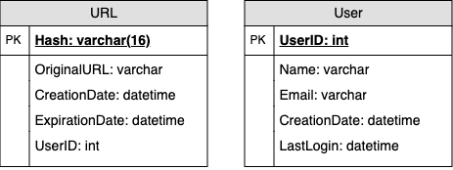

URL Shortening DB Schema

**What kind of database should we use?** Since we anticipate storing billions of rows, and we don’t need to use relationships between objects – a NoSQL store like [DynamoDB](https://en.wikipedia.org/wiki/Amazon_DynamoDB), [Cassandra](https://en.wikipedia.org/wiki/Apache_Cassandra) or [Riak](https://en.wikipedia.org/wiki/Riak) is a better choice. A NoSQL choice would also be easier to scale. Please see [SQL vs NoSQL](https://www.educative.io/collection/page/5668639101419520/5649050225344512/5728116278296576/) for more details.

## 6. Basic System Design and Algorithm[#](https://www.educative.io/courses/grokking-the-system-design-interview/m2ygV4E81AR#6.-Basic-System-Design-and-Algorithm)

The problem we are solving here is how to generate a short and unique key for a given URL.

In the TinyURL example in Section 1, the shortened URL is “[https://tinyurl.com/rxcsyr3r”](https://tinyurl.com/rxcsyr3r%E2%80%9D). The last eight characters of this URL constitute the short key we want to generate. We’ll explore two solutions here:

### a. Encoding actual URL[#](https://www.educative.io/courses/grokking-the-system-design-interview/m2ygV4E81AR#a.-Encoding-actual-URL)

We can compute a unique hash (e.g., [MD5](https://en.wikipedia.org/wiki/MD5) or [SHA256](https://en.wikipedia.org/wiki/SHA-2), etc.) of the given URL. The hash can then be encoded for display. This encoding could be base36 ([a-z ,0-9]) or base62 ([A-Z, a-z, 0-9]) and if we add ‘+’ and ‘/’ we can use [Base64](https://en.wikipedia.org/wiki/Base64#Base64_table) encoding. A reasonable question would be, what should be the length of the short key? 6, 8, or 10 characters?

Using base64 encoding, a 6 letters long key would result in 64^6 = ~68.7 billion possible strings.  
Using base64 encoding, an 8 letters long key would result in 64^8 = ~281 trillion possible strings.

With 68.7B unique strings, let’s assume six letter keys would suffice for our system.

If we use the MD5 algorithm as our hash function, it will produce a 128-bit hash value. After base64 encoding, we’ll get a string having more than 21 characters (since each base64 character encodes 6 bits of the hash value). Now we only have space for 6 (or 8) characters per short key; how will we choose our key then? We can take the first 6 (or 8) letters for the key. This could result in key duplication; to resolve that, we can choose some other characters out of the encoding string or swap some characters.

**What are the different issues with our solution?** We have the following couple of problems with our encoding scheme:

1. If multiple users enter the same URL, they can get the same shortened URL, which is not acceptable.
2. What if parts of the URL are URL-encoded? e.g., <http://www.educative.io/distributed.php?id=design>, and <http://www.educative.io/distributed.php%3Fid%3Ddesign> are identical except for the URL encoding.

**Workaround for the issues:** We can append an increasing sequence number to each input URL to make it unique and then generate its hash. We don’t need to store this sequence number in the databases, though. Possible problems with this approach could be an ever-increasing sequence number. Can it overflow? Appending an increasing sequence number will also impact the performance of the service.

Another solution could be to append the user id (which should be unique) to the input URL. However, if the user has not signed in, we would have to ask the user to choose a uniqueness key. Even after this, if we have a conflict, we have to keep generating a key until we get a unique one.

Request flow for shortening of a URL

**1** of 9

### b. Generating keys offline[#](https://www.educative.io/courses/grokking-the-system-design-interview/m2ygV4E81AR#b.-Generating-keys-offline)

We can have a standalone **Key Generation Service (KGS)** that generates random six-letter strings beforehand and stores them in a database (let’s call it key-DB). Whenever we want to shorten a URL, we will take one of the already-generated keys and use it. This approach will make things quite simple and fast. Not only are we not encoding the URL, but we won’t have to worry about duplications or collisions. KGS will make sure all the keys inserted into key-DB are unique

**Can concurrency cause problems?** As soon as a key is used, it should be marked in the database to ensure that it is not used again. If there are multiple servers reading keys concurrently, we might get a scenario where two or more servers try to read the same key from the database. How can we solve this concurrency problem?

Servers can use KGS to read/mark keys in the database. KGS can use two tables to store keys: one for keys that are not used yet, and one for all the used keys. As soon as KGS gives keys to one of the servers, it can move them to the used keys table. KGS can always keep some keys in memory to quickly provide them whenever a server needs them.

For simplicity, as soon as KGS loads some keys in memory, it can move them to the used keys table. This ensures each server gets unique keys. If KGS dies before assigning all the loaded keys to some server, we will be wasting those keys–which could be acceptable, given the huge number of keys we have.

KGS also has to make sure not to give the same key to multiple servers. For that, it must synchronize (or get a lock on) the data structure holding the keys before removing keys from it and giving them to a server.

**What would be the key-DB size?** With base64 encoding, we can generate 68.7B unique six letters keys. If we need one byte to store one alpha-numeric character, we can store all these keys in:

6 (characters per key) \* 68.7B (unique keys) = 412 GB.

**Isn’t KGS a single point of failure?** Yes, it is. To solve this, we can have a standby replica of KGS. Whenever the primary server dies, the standby server can take over to generate and provide keys.

**Can each app server cache some keys from key-DB?** Yes, this can surely speed things up. Although, in this case, if the application server dies before consuming all the keys, we will end up losing those keys. This can be acceptable since we have 68B unique six-letter keys.

**How would we perform a key lookup?** We can look up the key in our database to get the full URL. If it’s present in the DB, issue an “HTTP 302 Redirect” status back to the browser, passing the stored URL in the “Location” field of the request. If that key is not present in our system, issue an “HTTP 404 Not Found” status or redirect the user back to the homepage.

**Should we impose size limits on custom aliases?** Our service supports custom aliases. Users can pick any ‘key’ they like, but providing a custom alias is not mandatory. However, it is reasonable (and often desirable) to impose a size limit on a custom alias to ensure we have a consistent URL database. Let’s assume users can specify a maximum of 16 characters per customer key (as reflected in the above database schema).

High level system design for URL shortening

## 7. Data Partitioning and Replication[#](https://www.educative.io/courses/grokking-the-system-design-interview/m2ygV4E81AR#7.-Data-Partitioning-and-Replication)

To scale out our DB, we need to partition it so that it can store information about billions of URLs. Therefore, we need to develop a partitioning scheme that would divide and store our data into different DB servers.

**a. Range Based Partitioning:** We can store URLs in separate partitions based on the hash key’s first letter. Hence we will save all the URL hash keys starting with the letter ‘A’ (and ‘a’) in one partition, save those that start with the letter ‘B’ in another partition, and so on. This approach is called range-based partitioning. We can even combine certain less frequently occurring letters into one database partition. Thus, we should develop a static partitioning scheme to always store/find a URL in a predictable manner.

The main problem with this approach is that it can lead to unbalanced DB servers. For example, we decide to put all URLs starting with the letter ‘E’ into a DB partition, but later we realize that we have too many URLs that start with the letter ‘E.’

**b. Hash-Based Partitioning:** In this scheme, we take a hash of the object we are storing. We then calculate which partition to use based upon the hash. In our case, we can take the hash of the ‘key’ or the short link to determine the partition in which we store the data object.

Our hashing function will randomly distribute URLs into different partitions (e.g., our hashing function can always map any ‘key’ to a number between [1…256]). This number would represent the partition in which we store our object.

This approach can still lead to overloaded partitions, which can be solved using [Consistent Hashing](https://www.educative.io/collection/page/5668639101419520/5649050225344512/5709068098338816/).

## 8. Cache[#](https://www.educative.io/courses/grokking-the-system-design-interview/m2ygV4E81AR#8.-Cache)

We can cache URLs that are frequently accessed. We can use any off-the-shelf solution like [Memcached](https://en.wikipedia.org/wiki/Memcached), which can store full URLs with their respective hashes. Thus, the application servers, before hitting the backend storage, can quickly check if the cache has the desired URL.

**How much cache memory should we have?** We can start with 20% of daily traffic and, based on clients’ usage patterns, we can adjust how many cache servers we need. As estimated above, we need 170GB of memory to cache 20% of daily traffic. Since a modern-day server can have 256GB of memory, we can easily fit all the cache into one machine. Alternatively, we can use a couple of smaller servers to store all these hot URLs.

**Which cache eviction policy would best fit our needs?** When the cache is full, and we want to replace a link with a newer/hotter URL, how would we choose? Least Recently Used (LRU) can be a reasonable policy for our system. Under this policy, we discard the least recently used URL first. We can use a [Linked Hash Map](https://docs.oracle.com/javase/7/docs/api/java/util/LinkedHashMap.html) or a similar data structure to store our URLs and Hashes, which will also keep track of the URLs that have been accessed recently.

To further increase the efficiency, we can replicate our caching servers to distribute the load between them.

**How can each cache replica be updated?** Whenever there is a cache miss, our servers would be hitting a backend database. Whenever this happens, we can update the cache and pass the new entry to all the cache replicas. Each replica can update its cache by adding the new entry. If a replica already has that entry, it can simply ignore it.

Request flow for accessing a shortened URL

**1** of 11

## 9. Load Balancer (LB)[#](https://www.educative.io/courses/grokking-the-system-design-interview/m2ygV4E81AR#9.-Load-Balancer-(LB))

We can add a Load balancing layer at three places in our system:

1. Between Clients and Application servers
2. Between Application Servers and database servers
3. Between Application Servers and Cache servers

Initially, we could use a simple Round Robin approach that distributes incoming requests equally among backend servers. This LB is simple to implement and does not introduce any overhead. Another benefit of this approach is that if a server is dead, LB will take it out of the rotation and stop sending any traffic to it.

A problem with Round Robin LB is that we do not consider the server load. As a result, if a server is overloaded or slow, the LB will not stop sending new requests to that server. To handle this, a more intelligent LB solution can be placed that periodically queries the backend server about its load and adjusts traffic based on that.

## 10. Purging or DB cleanup[#](https://www.educative.io/courses/grokking-the-system-design-interview/m2ygV4E81AR#10.-Purging-or-DB-cleanup)

Should entries stick around forever, or should they be purged? If a user-specified expiration time is reached, what should happen to the link?

If we chose to continuously search for expired links to remove them, it would put a lot of pressure on our database. Instead, we can slowly remove expired links and do a lazy cleanup. Our service will ensure that only expired links will be deleted, although some expired links can live longer but will never be returned to users.

* Whenever a user tries to access an expired link, we can delete the link and return an error to the user.
* A separate Cleanup service can run periodically to remove expired links from our storage and cache. This service should be very lightweight and scheduled to run only when the user traffic is expected to be low.
* We can have a default expiration time for each link (e.g., two years).
* After removing an expired link, we can put the key back in the key-DB to be reused.
* Should we remove links that haven’t been visited in some length of time, say six months? This could be tricky. Since storage is getting cheap, we can decide to keep links forever.

Detailed component design for URL shortening

## 11. Telemetry[#](https://www.educative.io/courses/grokking-the-system-design-interview/m2ygV4E81AR#11.-Telemetry)

How many times a short URL has been used, what were user locations, etc.? How would we store these statistics? If it is part of a DB row that gets updated on each view, what will happen when a popular URL is slammed with a large number of concurrent requests?

Some statistics worth tracking: country of the visitor, date and time of access, web page that referred the click, browser, or platform from where the page was accessed.

## 12. Security and Permissions[#](https://www.educative.io/courses/grokking-the-system-design-interview/m2ygV4E81AR#12.-Security-and-Permissions)

Can users create private URLs or allow a particular set of users to access a URL?

We can store the permission level (public/private) with each URL in the database. We can also create a separate table to store UserIDs that have permission to see a specific URL. If a user does not have permission and tries to access a URL, we can send an error (HTTP 401) back. Given that we are storing our data in a NoSQL wide-column database like Cassandra, the key for the table storing permissions would be the ‘Hash’ (or the KGS generated ‘key’). The columns will store the UserIDs of those users that have permission to see the URL.

# High-Level Design for WhatsApp

## Prioritized requirements

* We must implement one-to-one chat messaging.
* We must also show the users, what stage the message is currently on. (**Sent, Delivered, and Read Receipts**)
* Group messaging is also allowed.
* Users can share images, audio, and video files.
* We will also show the Online/Last seen status of users.
* Chat will be temporary. (i.e. They will be stored on the client-side)

## Requirements not a part of our design

* Authentication service (You can find details about this service [here](https://get.interviewready.io/blog/gmail-design))
* Profile service
* Call Service (We have discussed this topic in detail [here](https://get.interviewready.io/blog/whatsapp-calling-design))

## One to One messaging and Read Receipts

Whenever users want to send a message they send a request to our server. This request is received by the gateway service. Then the client applications maintain a TCP Connection with the gateway service to send messages.

Once the server sends the message to the recipient, our system must also notify the sender that the message has been delivered. So we also send a parallel response to the sender that the message has been delivered. (**Note: To ensure that message will be delivered we store the message in the database and keep retrying till the recipient gets the message.**) This takes care of **Sent receipts.**

When the recipient receives the message it sends a response (or acknowledgment) to our system. This response is then routed to session service. It finds the sender from the mapping and sends the **Delivery receipts.**

The process to send the **Read receipts** is also the same. As soon as the user reads the message we perform the above process.

**Note:** The response from the client consists of **sender** and **receiver** fields.

### Components required

* **Gateway Service**
  + This service consists of multiple servers.
  + It will receive all the requests from the users.
  + It maintains the TCP connections with the users.
  + Furthermore, it also interacts with all the internal services.
* **Session Service** Gateway service is also distributed. So if we want to send messages from one user to another we must know which user is connected to which gateway server. This is handled by session service. It maps each user (userID) to the particular gateway server.
* **Database** All the mappings must be persisted in non-volatile storage. For that, we need a database.

### Trade-offs

* **Storing the mapping in gateway service v/s Storing it in session service**
  + If we store the mapping in the gateway service then we can access it faster. To get the mappings from the session service we have to make a network call.
  + Gateway services have limited memory. If we store the mapping of the gateway we have to reduce the number of TCP connections.
  + Gateway service is distributed. So there are multiple servers. In that case, there will be a lot of duplication. Also every time there is an update we have to update the data on every server.

So we can conclude that **storing the mapping in the session service is a better idea.**

* **Using HTTP for messaging v/s Websockets (WSS)**
  + HTTP can only send messages from client to server. The only way we can allow messaging is by constantly sending a request to the server to check if there is any new message (Long Polling).
  + WSS is a peer-to-peer protocol that allows clients and servers to send messages to each other.

As we do not need to **constantly send requests to the server, using XMPP will be more efficient**.

### Diagram

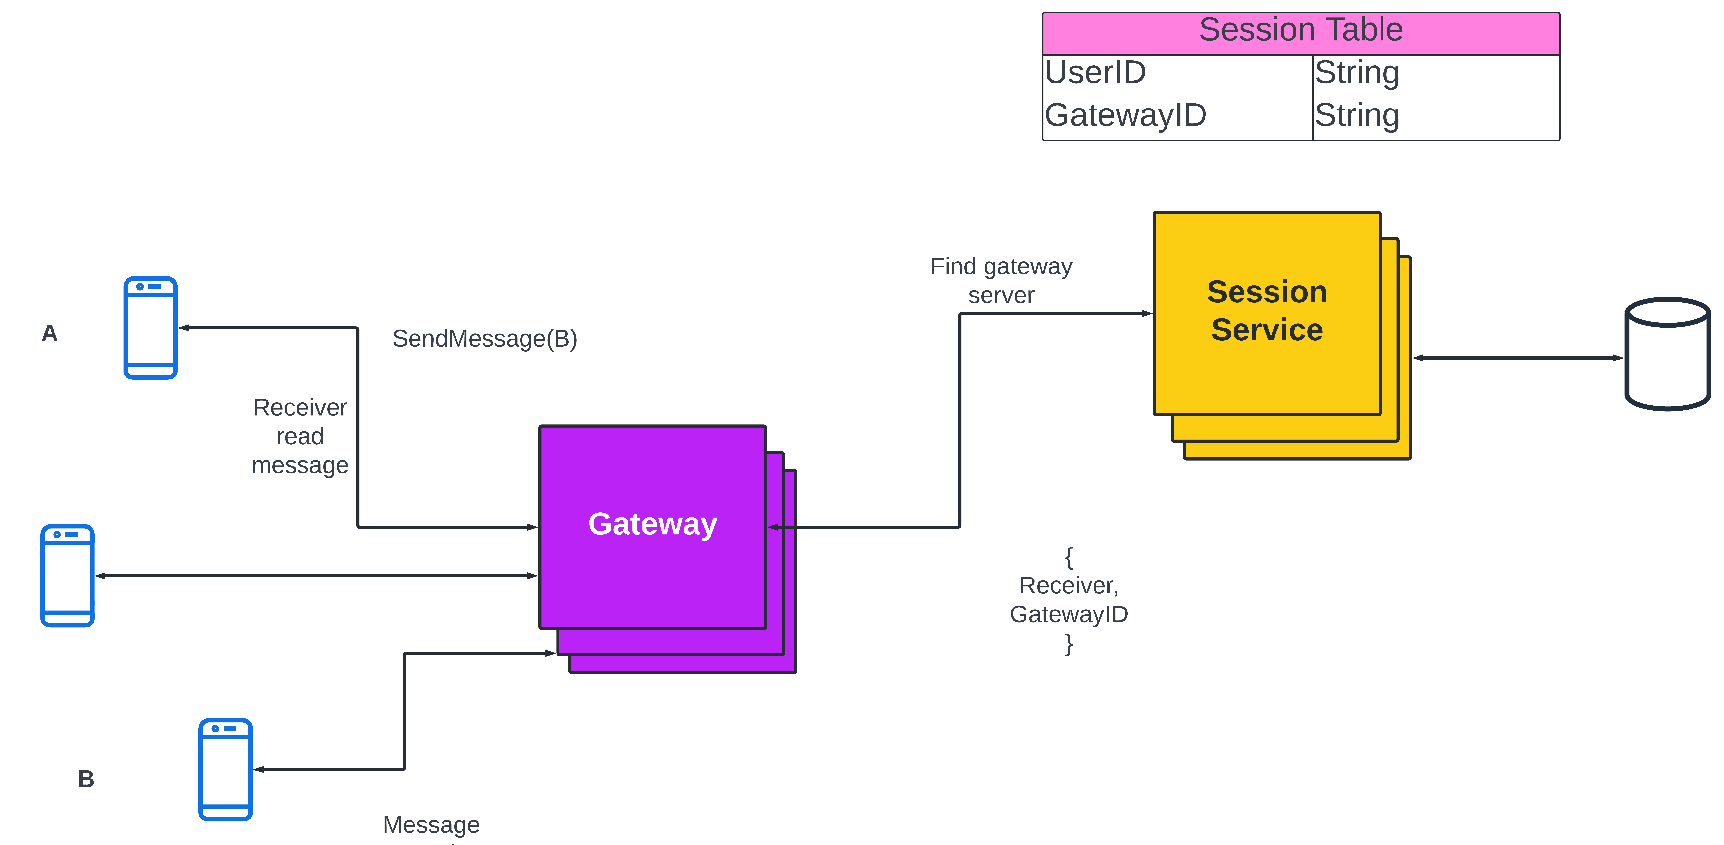

## Last Seen Timestamps of users

We want to show other users whether any user is online or when was he/she last seen. To implement this we can store a table that contains the **userID** and the **LastSeenTimestamps**. Whenever any user makes an activity (like sending or reading a message) that request is sent to the server. At the time at which the request is sent we update the key-value pair. We must also consider the **requests sent by the application and not by the user** (like polling for messages etc.) These requests do not count as user activity so we won't be logging them. We can have an additional flag (something like **application\_activity**) to differentiate the two.

We also need to define a threshold. If the last seen is below the threshold then instead of showing the exact time difference, we will just show **online**.

E.g. if the last seen of user X is 3sec and the threshold is 5sec then other users will see X as online.

### Components Required

* **Last Seen service** Every time there is a user activity it is routed to this service. It persists in the key-value pair in a non-volatile database.
* **Database**

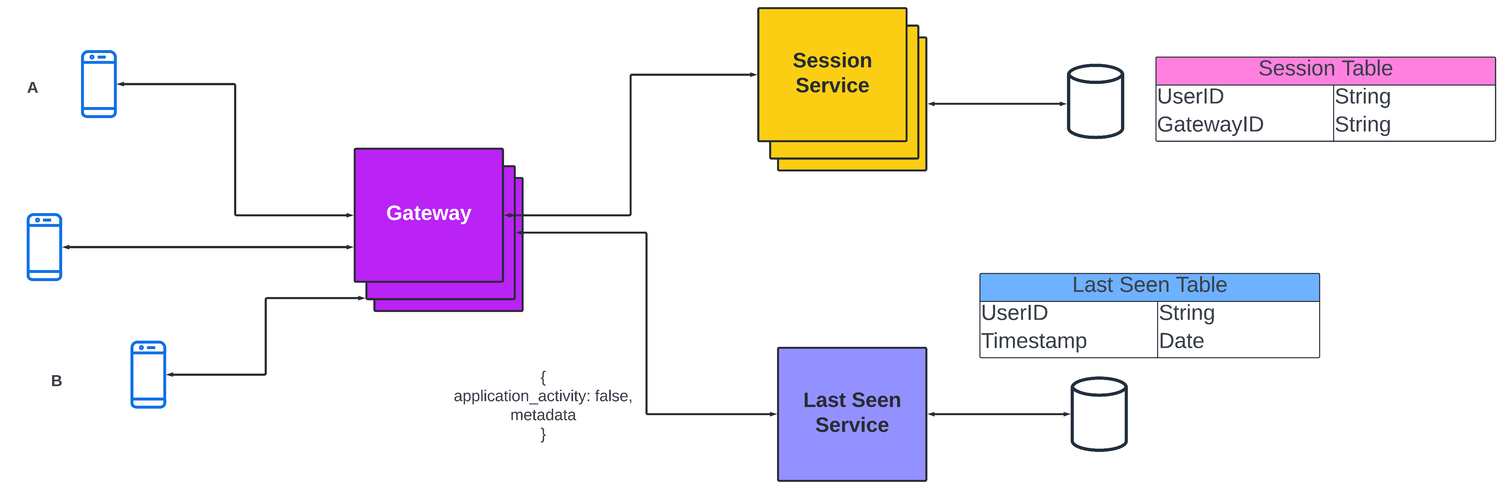

## Group Messaging

Each group will have many users. Whenever a participant in a group sends a message we first find the list of users present in the group. Once the session service has the list of users it finds the gateway services that the users are connected to and then sends the message. **Note: We should also limit the number of users in a group. If there are a lot of users then it can cause a fanout. We can ask the client applications to pull new messages from our system but our messages won't be real-time in such case.**

* We do not want the gateway service to parse messages because we want to minimize the memory usage and maximize the TCP connections. So we will use a message parser to convert the unparsed to sensible message.
* We have a mapping of groupID to userID. This is one too many relationships. Group messaging service has multiple servers so there can be data redundancy. To reduce redundancy we use consistent hashing. We hash the groupID and send the request to the server according to the result.
* We also need to use a message queue in case there are any failures while sending requests. Once we give a request to the message queue it ensures that message will be sent. If we reach the maximum number of retries it tells the sender that it failed and we can notify the user.
* While sending messages in a group we must take care of three things
  + **Retries** - The message queue takes care of that.
  + **Idempotency** - It means that each message should be sent **only once**. We can achieve this by sending messages to queue **at least** once but each message will have a unique ID. If the service has already seen the ID then it means that message is already sent to the new message is ignored.
  + **Ordering of messages** - Messages must be ordered by their timestamps in a group. To ensure this we always assign the messages of a particular group to a particular thread from the thread pool.

### Components Required

* **Group Messaging service** It stores the mapping of groupID to userID and provides this data to the session service.
* **Message parser service** It receives the unparsed message from the gateway service and converts it to a sensible format before sending it to other services.
* **Message queue**

### Diagram

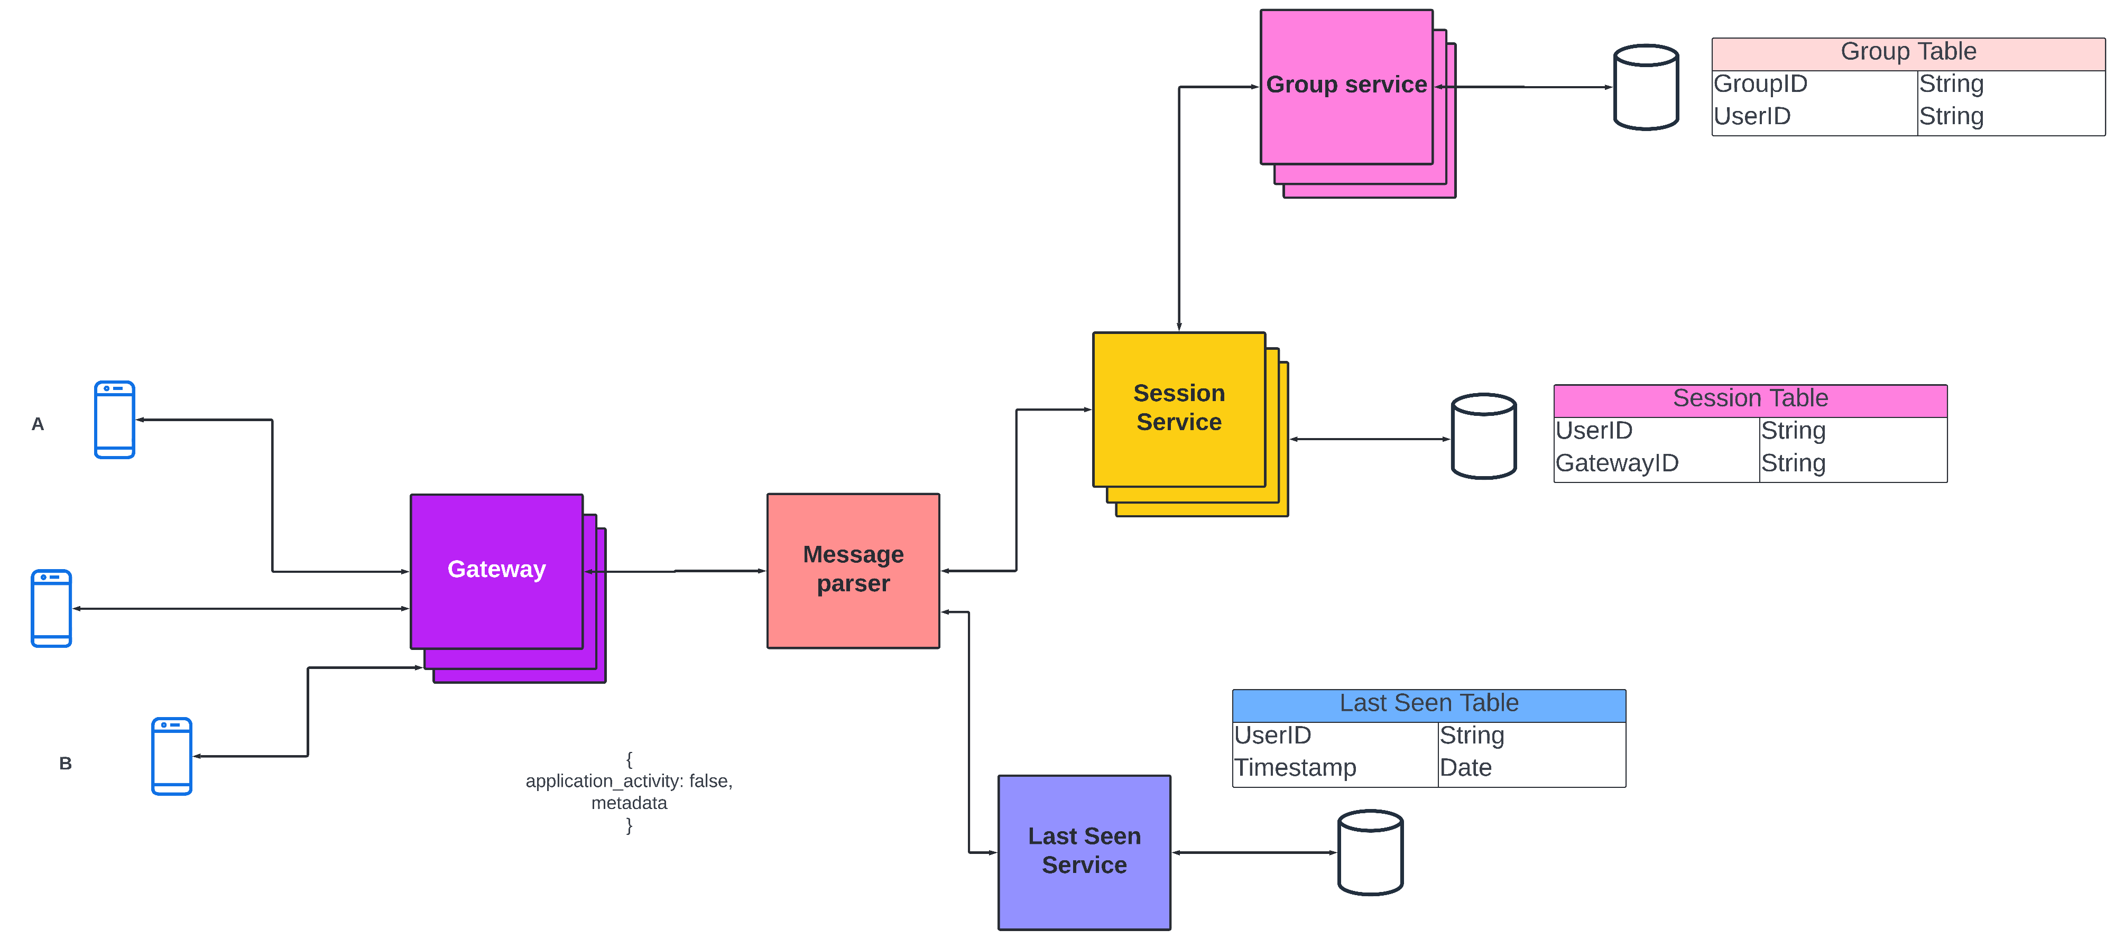

## Sending Image, Audio, and Video files

We can use a distributed file service to store the files as they are much more efficient and cost-effective compared to storing images as BLOBs in a database. Every time a user sends an image we can store it in the file service and when we can get the image when we need to send it.

**(Note: We have already discussed the trade-offs of storing the image in the file service v/s database**[here](https://get.interviewready.io/blog/tinder-system-design)**)**

### Components required

* **Distributed File System**

### Diagram

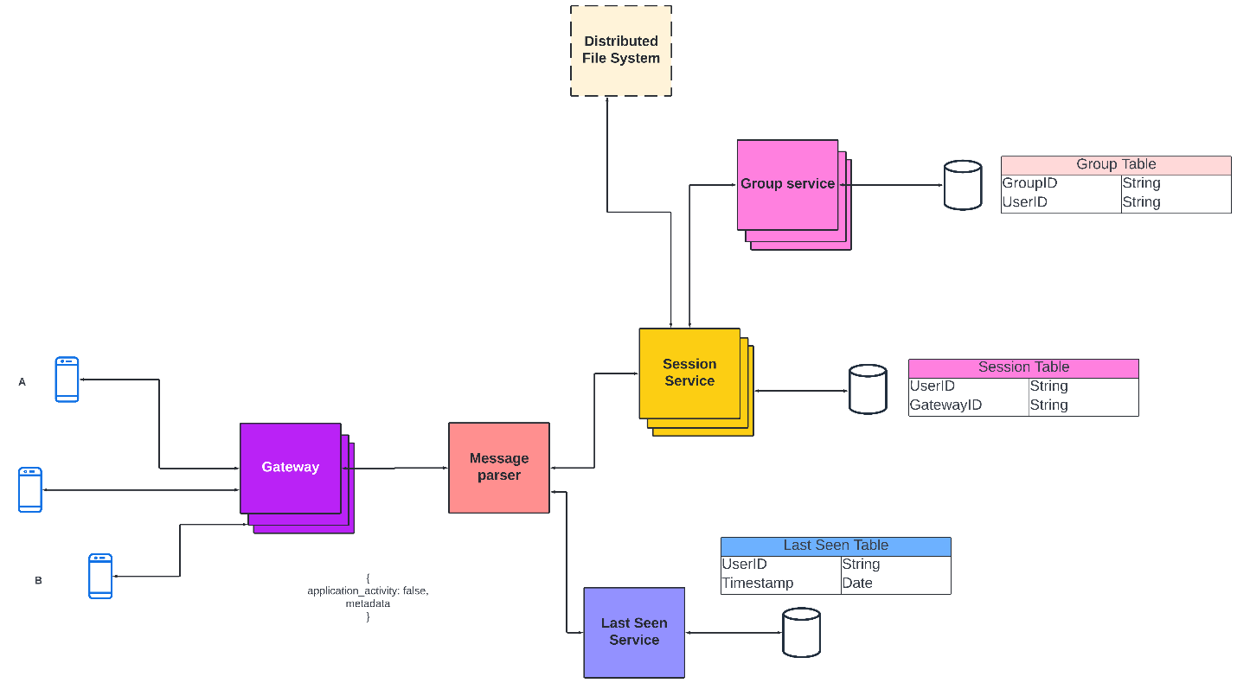

## Some more optimizations

* **Graceful degradations** On some occasions, our system might get so many messages that systems get overloaded. In such cases, we can temporarily shut down services that are not critical to our service (like sending read receipts or last seen status, etc).
* **Rate Limiting** In some situations, it might happen that we cannot handle any more requests. In such cases, we can rate-limit the number of requests and drop extra requests. However, this results in a bad user experience.

# Design Ticketmaster (\*New\*)

Let's design an online ticketing system that sells movie tickets like Ticketmaster or BookMyShow. Similar Services: bookmyshow.com, ticketmaster.com Difficulty Level: Hard

### 1. What is an online movie ticket booking system?

A movie ticket booking system provides its customers the ability to purchase theatre seats online. E-ticketing systems allow the customers to browse through movies currently being played and to book seats, anywhere anytime.

### 2. Requirements and Goals of the System

Our ticket booking service should meet the following requirements:

**Functional Requirements:**

1. Our ticket booking service should be able to list different cities where its affiliate cinemas are located.
2. Once the user selects the city, the service should display the movies released in that particular city.
3. Once the user selects a movie, the service should display the cinemas running that movie and its available show times.
4. The user should be able to choose a show at a particular cinema and book their tickets.
5. The service should be able to show the user the seating arrangement of the cinema hall. The user should be able to select multiple seats according to their preference.
6. The user should be able to distinguish available seats from booked ones.
7. Users should be able to put a hold on the seats for five minutes before they make a payment to finalize the booking.
8. The user should be able to wait if there is a chance that the seats might become available, e.g., when holds by other users expire.
9. Waiting customers should be serviced in a fair, first come, first serve manner.

**Non-Functional Requirements:**

1. The system would need to be highly concurrent. There will be multiple booking requests for the same seat at any particular point in time. The service should handle this gracefully and fairly.
2. The core thing of the service is ticket booking, which means financial transactions. This means that the system should be secure and the database ACID compliant.

### 3. Some Design Considerations

1. For simplicity, let’s assume our service does not require any user authentication.
2. The system will not handle partial ticket orders. Either user gets all the tickets they want or they get nothing.
3. Fairness is mandatory for the system.
4. To stop system abuse, we can restrict users from booking more than ten seats at a time.
5. We can assume that traffic would spike on popular/much-awaited movie releases and the seats would fill up pretty fast. The system should be scalable and highly available to keep up with the surge in traffic.

### 4. Capacity Estimation

**Traffic estimates:** Let’s assume that our service has 3 billion page views per month and sells 10 million tickets a month.

**Storage estimates:** Let’s assume that we have 500 cities and, on average each city has ten cinemas. If there are 2000 seats in each cinema and on average, there are two shows every day.

Let’s assume each seat booking needs 50 bytes (IDs, NumberOfSeats, ShowID, MovieID, SeatNumbers, SeatStatus, Timestamp, etc.) to store in the database. We would also need to store information about movies and cinemas; let’s assume it’ll take 50 bytes. So, to store all the data about all shows of all cinemas of all cities for a day:

500 cities \* 10 cinemas \* 2000 seats \* 2 shows \* (50+50) bytes = 2GB / day

To store five years of this data, we would need around 3.6TB.

### 5. System APIs

We can have SOAP or REST APIs to expose the functionality of our service. The following could be the definition of the APIs to search movie shows and reserve seats.

SearchMovies(api\_dev\_key, keyword, city, lat\_long, radius, start\_datetime, end\_datetime, postal\_code,   
includeSpellcheck, results\_per\_page, sorting\_order)

**Parameters:**  
**api\_dev\_key (string):** The API developer key of a registered account. This will be used to, among other things, throttle users based on their allocated quota.  
**keyword (string):** Keyword to search on.  
**city (string):** City to filter movies by.  
**lat\_long (string):** Latitude and longitude to filter by. **radius (number):** Radius of the area in which we want to search for events.  
**start\_datetime (string):** Filter movies with a starting datetime.  
**end\_datetime (string):** Filter movies with an ending datetime.  
**postal\_code (string):** Filter movies by postal code / zipcode.  
**includeSpellcheck (Enum: “yes” or “no”):** Yes, to include spell check suggestions in the response.  
**results\_per\_page (number):** Number of results to return per page. Maximum is 30.  
**sorting\_order (string):** Sorting order of the search result. Some allowable values : ‘name,asc’, ‘name,desc’, ‘date,asc’, ‘date,desc’, ‘distance,asc’, ‘name,date,asc’, ‘name,date,desc’, ‘date,name,asc’, ‘date,name,desc’.

**Returns: (JSON)**  
Here is a sample list of movies and their shows:

[  
  {  
    "MovieID": 1,  
    "ShowID": 1,  
    "Title": "Cars 2",  
    "Description": "About cars",  
    "Duration": 120,  
    "Genre": "Animation",  
    "Language": "English",  
    "ReleaseDate": "8th Oct. 2014",  
    "Country": USA,  
    "StartTime": "14:00",  
    "EndTime": "16:00",  
    "Seats":   
    [  
      {    
        "Type": "Regular"  
        "Price": 14.99  
        "Status: "Almost Full"  
      },  
      {    
        "Type": "Premium"  
        "Price": 24.99  
        "Status: "Available"  
      }  
    ]  
  },  
  {  
    "MovieID": 1,  
    "ShowID": 2,  
    "Title": "Cars 2",  
    "Description": "About cars",  
    "Duration": 120,  
    "Genre": "Animation",  
    "Language": "English",  
    "ReleaseDate": "8th Oct. 2014",  
    "Country": USA,  
    "StartTime": "16:30",  
    "EndTime": "18:30",  
    "Seats":   
    [  
        {    
          "Type": "Regular"  
          "Price": 14.99  
          "Status: "Full"  
      },  
        {    
          "Type": "Premium"  
        "Price": 24.99  
        "Status: "Almost Full"  
      }  
    ]  
  },  
 ]

ReserveSeats(api\_dev\_key, session\_id, movie\_id, show\_id, seats\_to\_reserve[])

**Parameters:**  
**api\_dev\_key (string):** same as above  
**session\_id (string):** User’s session ID to track this reservation. Once the reservation time expires, user’s reservation on the server will be removed using this ID.  
**movie\_id (string):** Movie to reserve.  
**show\_id (string):** Show to reserve.  
**seats\_to\_reserve (number):** An array containing seat IDs to reserve.

**Returns:** (JSON)  
Returns the status of the reservation, which would be one of the following: 1) “Reservation Successful” 2) “Reservation Failed - Show Full,” 3) “Reservation Failed - Retry, as other users are holding reserved seats”.

### 6. Database Design

Here are a few observations about the data we are going to store:

1. Each City can have multiple Cinemas.
2. Each Cinema will have multiple halls.
3. Each Movie will have many Shows and each Show will have multiple Bookings.
4. A user can have multiple bookings.

### 7. High Level Design

At a high-level, our web servers will manage users’ sessions and application servers will handle all the ticket management, storing data in the databases as well as working with the cache servers to process reservations.

### 8. Detailed Component Design

First, let’s try to build our service assuming it is being served from a single server.

**Ticket Booking Workflow:** The following would be a typical ticket booking workflow:

1. The user searches for a movie.
2. The user selects a movie.
3. The user is shown the available shows of the movie.
4. The user selects a show.
5. The user selects the number of seats to be reserved.
6. If the required number of seats are available, the user is shown a map of the theater to select seats. If not, the user is taken to ‘step 8’ below.
7. Once the user selects the seat, the system will try to reserve those selected seats.
8. If seats can’t be reserved, we have the following options:

* Show is full; the user is shown the error message.
* The seats the user wants to reserve are no longer available, but there are other seats available, so the user is taken back to the theater map to choose different seats.
* There are no seats available to reserve, but all the seats are not booked yet, as there are some seats that other users are holding in the reservation pool and have not booked yet. The user will be taken to a waiting page where they can wait until the required seats get freed from the reservation pool. This waiting could result in the following options:
  + If the required number of seats become available, the user is taken to the theater map page where they can choose seats.
  + While waiting, if all seats get booked or there are fewer seats in the reservation pool than the user intend to book, the user is shown the error message.
  + User cancels the waiting and is taken back to the movie search page.
  + At maximum, a user can wait one hour, after that user’s session gets expired and the user is taken back to the movie search page.

1. If seats are reserved successfully, the user has five minutes to pay for the reservation. After payment, booking is marked complete. If the user is not able to pay within five minutes, all their reserved seats are freed to become available to other users.

**1** of 8

**How would the server keep track of all the active reservation that haven’t been booked yet? And how would the server keep track of all the waiting customers?**  
We need two daemon services, one to keep track of all active reservations and remove any expired reservation from the system; let’s call it **ActiveReservationService**. The other service would be keeping track of all the waiting user requests and, as soon as the required number of seats become available, it will notify the (the longest waiting) user to choose the seats; let’s call it **WaitingUserService**.

**a. ActiveReservationsService**

We can keep all the reservations of a ‘show’ in memory in a data structure similar to [Linked HashMap](https://docs.oracle.com/javase/7/docs/api/java/util/LinkedHashMap.html) or a [TreeMap](https://docs.oracle.com/javase/6/docs/api/java/util/TreeMap.html" \t "_blank) in addition to keeping all the data in the database. We will need a linked HashMap kind of data structure that allows us to jump to any reservation to remove it when the booking is complete. Also, since we will have expiry time associated with each reservation, the head of the HashMap will always point to the oldest reservation record so that the reservation can be expired when the timeout is reached.

To store every reservation for every show, we can have a HashTable where the ‘key’ would be ‘ShowID’ and the ‘value’ would be the Linked HashMap containing ‘BookingID’ and creation ‘Timestamp’.

In the database, we will store the reservation in the ‘Booking’ table and the expiry time will be in the Timestamp column. The ‘Status’ field will have a value of ‘Reserved (1)’ and, as soon as a booking is complete, the system will update the ‘Status’ to ‘Booked (2)’ and remove the reservation record from the Linked HashMap of the relevant show. When the reservation is expired, we can either remove it from the Booking table or mark it ‘Expired (3)’ in addition to removing it from memory.

ActiveReservationsService will also work with the external financial service to process user payments. Whenever a booking is completed, or a reservation gets expired, WaitingUsersService will get a signal so that any waiting customer can be served.

ActiveReservationsService keeping track of all active reservations

**b. WaitingUsersService**

Just like ActiveReservationsService, we can keep all the waiting users of a show in memory in a Linked HashMap or a TreeMap. We need a data structure similar to Linked HashMap so that we can jump to any user to remove them from the HashMap when the user cancels their request. Also, since we are serving in a first-come-first-serve manner, the head of the Linked HashMap would always be pointing to the longest waiting user, so that whenever seats become available, we can serve users in a fair manner.

We will have a HashTable to store all the waiting users for every Show. The ‘key’ would be 'ShowID, and the ‘value’ would be a Linked HashMap containing ‘UserIDs’ and their wait-start-time.

Clients can use [Long Polling](https://en.wikipedia.org/wiki/Push_technology#Long_polling) for keeping themselves updated for their reservation status. Whenever seats become available, the server can use this request to notify the user.

**Reservation Expiration**  
On the server, ActiveReservationsService keeps track of expiry (based on reservation time) of active reservations. As the client will be shown a timer (for the expiration time), which could be a little out of sync with the server, we can add a buffer of five seconds on the server to safeguard from a broken experience, such that the client never times out after the server, preventing a successful purchase.

### 9. Concurrency

**How to handle concurrency, such that no two users are able to book same seat.** We can use transactions in SQL databases to avoid any clashes. For example, if we are using an SQL server we can utilize [Transaction Isolation Levels](https://docs.microsoft.com/en-us/sql/odbc/reference/develop-app/transaction-isolation-levels) to lock the rows before we can update them. Here is the sample code:

SET TRANSACTION ISOLATION LEVEL SERIALIZABLE;  
   
BEGIN TRANSACTION;  
   
    -- Suppose we intend to reserve three seats (IDs: 54, 55, 56) for ShowID=99   
    Select \* From Show\_Seat where ShowID=99 && ShowSeatID in (54, 55, 56) && Status=0 -- free   
   
    -- if the number of rows returned by the above statement is three, we can update to   
    -- return success otherwise return failure to the user.  
    update Show\_Seat ...  
    update Booking ...  
   
COMMIT TRANSACTION;

‘Serializable’ is the highest isolation level and guarantees safety from [Dirty](https://en.wikipedia.org/wiki/Isolation_(database_systems)#Dirty_reads), [Nonrepeatable](https://en.wikipedia.org/wiki/Isolation_(database_systems)#Non-repeatable_reads), and [Phantoms](https://en.wikipedia.org/wiki/Isolation_(database_systems)#Phantom_reads) reads. One thing to note here; within a transaction, if we read rows, we get a write lock on them so that they can’t be updated by anyone else.

Once the above database transaction is successful, we can start tracking the reservation in ActiveReservationService.

### 10. Fault Tolerance

**What happens when ActiveReservationsService or WaitingUsersService crashes?**  
Whenever ActiveReservationsService crashes, we can read all the active reservations from the ‘Booking’ table. Remember that we keep the ‘Status’ column as ‘Reserved (1)’ until a reservation gets booked. Another option is to have a master-slave configuration so that, when the master crashes, the slave can take over. We are not storing the waiting users in the database, so, when WaitingUsersService crashes, we don’t have any means to recover that data unless we have a master-slave setup.

Similarly, we’ll have a master-slave setup for databases to make them fault tolerant.

### 11. Data Partitioning

**Database partitioning:** If we partition by ‘MovieID’, then all the Shows of a movie will be on a single server. For a very hot movie, this could cause a lot of load on that server. A better approach would be to partition based on ShowID; this way, the load gets distributed among different servers.

**ActiveReservationService and WaitingUserService partitioning:** Our web servers will manage all the active users’ sessions and handle all the communication with the users. We can use the Consistent Hashing to allocate application servers for both ActiveReservationService and WaitingUserService based upon the ‘ShowID’. This way, all reservations and waiting users of a particular show will be handled by a certain set of servers. Let’s assume for load balancing our [Consistent Hashing](https://www.educative.io/courses/system-design-basics/consistent-hashing.html) allocates three servers for any Show, so whenever a reservation is expired, the server holding that reservation will do the following things:

1. Update database to remove the Booking (or mark it expired) and update the seats’ Status in ‘Show\_Seats’ table.
2. Remove the reservation from the Linked HashMap.
3. Notify the user that their reservation has expired.
4. Broadcast a message to all WaitingUserService servers that are holding waiting users of that Show to figure out the longest waiting user. Consistent Hashing scheme will tell what servers are holding these users.
5. Send a message to the WaitingUserService server holding the longest waiting user to process their request if required seats have become available.

Whenever a reservation is successful, following things will happen:

1. The server holding that reservation sends a message to all servers holding the waiting users of that Show, so that those servers can expire all the waiting users that need more seats than the available seats.
2. Upon receiving the above message, all servers holding the waiting users will query the database to find how many free seats are available now. A database cache would greatly help here to run this query only once.
3. Expire all waiting users who want to reserve more seats than the available seats. For this, WaitingUserService has to iterate through the Linked HashMap of all the waiting users.

# [Designing Typeahead Suggestion](https://www.educative.io/courses/grokking-the-system-design-interview/mE2XkgGRnmp)

[Let's design a real-time suggestion service, which will recommend terms to users as they enter text for searching. Similar Services: Auto-suggestions, Typeahead search Difficulty: Medium](https://www.educative.io/courses/grokking-the-system-design-interview/mE2XkgGRnmp)

### [1. What is Typeahead Suggestion?](https://www.educative.io/courses/grokking-the-system-design-interview/mE2XkgGRnmp)

[Typeahead suggestions enable users to search for known and frequently searched terms. As the user types into the search box, it tries to predict the query based on the characters the user has entered and gives a list of suggestions to complete the query. Typeahead suggestions help the user to articulate their search queries better. It’s not about speeding up the search process but rather about guiding the users and lending them a helping hand in constructing their search query.](https://www.educative.io/courses/grokking-the-system-design-interview/mE2XkgGRnmp)

### [2. Requirements and Goals of the System](https://www.educative.io/courses/grokking-the-system-design-interview/mE2XkgGRnmp)

**[Functional Requirements:](https://www.educative.io/courses/grokking-the-system-design-interview/mE2XkgGRnmp)**[As the user types in their query, our service should suggest top 10 terms starting with whatever the user has typed.](https://www.educative.io/courses/grokking-the-system-design-interview/mE2XkgGRnmp)

**[Non-function Requirements:](https://www.educative.io/courses/grokking-the-system-design-interview/mE2XkgGRnmp)**[The suggestions should appear in real-time. The user should be able to see the suggestions within 200ms.](https://www.educative.io/courses/grokking-the-system-design-interview/mE2XkgGRnmp)

### [3. Basic System Design and Algorithm](https://www.educative.io/courses/grokking-the-system-design-interview/mE2XkgGRnmp)

[The problem we are solving is that we have a lot of ‘strings’ that we need to store in such a way that users can search with any prefix. Our service will suggest next terms that will match the given prefix. For example, if our database contains the following terms: cap, cat, captain, or capital and the user has typed in ‘cap’, our system should suggest ‘cap’, ‘captain’ and ‘capital’.](https://www.educative.io/courses/grokking-the-system-design-interview/mE2XkgGRnmp)

[Since we’ve got to serve a lot of queries with minimum latency, we need to come up with a scheme that can efficiently store our data such that it can be queried quickly. We can’t depend upon some database for this; we need to store our index in memory in a highly efficient data structure.](https://www.educative.io/courses/grokking-the-system-design-interview/mE2XkgGRnmp)

[One of the most appropriate data structures that can serve our purpose is the Trie (pronounced “try”). A trie is a tree-like data structure used to store phrases where each node stores a character of the phrase in a sequential manner. For example, if we need to store ‘cap, cat, caption, captain, capital’ in the trie, it would look like:](https://www.educative.io/courses/grokking-the-system-design-interview/mE2XkgGRnmp)

**[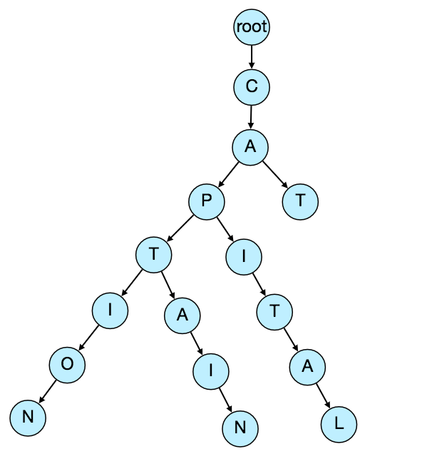](https://www.educative.io/courses/grokking-the-system-design-interview/mE2XkgGRnmp)**

[Now if the user has typed ‘cap’, our service can traverse the trie to go to the node ‘P’ to find all the terms that start with this prefix (e.g., cap-tion, cap-ital etc).](https://www.educative.io/courses/grokking-the-system-design-interview/mE2XkgGRnmp)

[We can merge nodes that have only one branch to save storage space. The above trie can be stored like this:](https://www.educative.io/courses/grokking-the-system-design-interview/mE2XkgGRnmp)

**[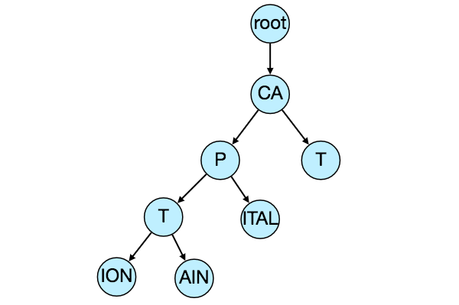](https://www.educative.io/courses/grokking-the-system-design-interview/mE2XkgGRnmp)**

**[Should we have case insensitive trie?](https://www.educative.io/courses/grokking-the-system-design-interview/mE2XkgGRnmp)**[For simplicity and search use-case, let’s assume our data is case insensitive.](https://www.educative.io/courses/grokking-the-system-design-interview/mE2XkgGRnmp)

**[How to find top suggestion?](https://www.educative.io/courses/grokking-the-system-design-interview/mE2XkgGRnmp)**[Now that we can find all the terms for a given prefix, how can we find the top 10 terms for the given prefix? One simple solution could be to store the count of searches that terminated at each node, e.g., if users have searched about ‘CAPTAIN’ 100 times and ‘CAPTION’ 500 times, we can store this number with the last character of the phrase. Now if the user types ‘CAP’ we know the top most searched word under the prefix ‘CAP’ is ‘CAPTION’. So, to find the top suggestions for a given prefix, we can traverse the sub-tree under it.](https://www.educative.io/courses/grokking-the-system-design-interview/mE2XkgGRnmp)

**[Given a prefix, how much time will it take to traverse its sub-tree?](https://www.educative.io/courses/grokking-the-system-design-interview/mE2XkgGRnmp)**[Given the amount of data we need to index, we should expect a huge tree. Even traversing a sub-tree would take really long, e.g., the phrase ‘system design interview questions’ is 30 levels deep. Since we have very strict latency requirements we do need to improve the efficiency of our solution.](https://www.educative.io/courses/grokking-the-system-design-interview/mE2XkgGRnmp)

**[Can we store top suggestions with each node?](https://www.educative.io/courses/grokking-the-system-design-interview/mE2XkgGRnmp)**[This can surely speed up our searches but will require a lot of extra storage. We can store top 10 suggestions at each node that we can return to the user. We have to bear the big increase in our storage capacity to achieve the required efficiency.](https://www.educative.io/courses/grokking-the-system-design-interview/mE2XkgGRnmp)

[We can optimize our storage by storing only references of the terminal nodes rather than storing the entire phrase. To find the suggested terms we need to traverse back using the parent reference from the terminal node. We will also need to store the frequency with each reference to keep track of top suggestions.](https://www.educative.io/courses/grokking-the-system-design-interview/mE2XkgGRnmp)

**[How would we build this trie?](https://www.educative.io/courses/grokking-the-system-design-interview/mE2XkgGRnmp)**[We can efficiently build our trie bottom up. Each parent node will recursively call all the child nodes to calculate their top suggestions and their counts. Parent nodes will combine top suggestions from all of their children to determine their top suggestions.](https://www.educative.io/courses/grokking-the-system-design-interview/mE2XkgGRnmp)

**[How to update the trie?](https://www.educative.io/courses/grokking-the-system-design-interview/mE2XkgGRnmp)**[Assuming five billion searches every day, which would give us approximately 60K queries per second. If we try to update our trie for every query it’ll be extremely resource intensive and this can hamper our read requests, too. One solution to handle this could be to update our trie offline after a certain interval.](https://www.educative.io/courses/grokking-the-system-design-interview/mE2XkgGRnmp)

[As the new queries come in we can log them and also track their frequencies. Either we can log every query or do sampling and log every 1000th query. For example, if we don’t want to show a term which is searched for less than 1000 times, it’s safe to log every 1000th searched term.](https://www.educative.io/courses/grokking-the-system-design-interview/mE2XkgGRnmp)

[We can have a](https://www.educative.io/courses/grokking-the-system-design-interview/mE2XkgGRnmp)[[Map-Reduce (MR)](https://www.educative.io/courses/grokking-the-system-design-interview/mE2XkgGRnmp)](https://en.wikipedia.org/wiki/MapReduce)[set-up to process all the logging data periodically say every hour. These MR jobs will calculate frequencies of all searched terms in the past hour. We can then update our trie with this new data. We can take the current snapshot of the trie and update it with all the new terms and their frequencies. We should do this offline as we don’t want our read queries to be blocked by update trie requests. We can have two options:](https://www.educative.io/courses/grokking-the-system-design-interview/mE2XkgGRnmp)

1. [We can make a copy of the trie on each server to update it offline. Once done we can switch to start using it and discard the old one.](https://www.educative.io/courses/grokking-the-system-design-interview/mE2XkgGRnmp)
2. [Another option is we can have a master-slave configuration for each trie server. We can update slave while the master is serving traffic. Once the update is complete, we can make the slave our new master. We can later update our old master, which can then start serving traffic, too.](https://www.educative.io/courses/grokking-the-system-design-interview/mE2XkgGRnmp)

**[How can we update the frequencies of typeahead suggestions?](https://www.educative.io/courses/grokking-the-system-design-interview/mE2XkgGRnmp)**[Since we are storing frequencies of our typeahead suggestions with each node, we need to update them too! We can update only differences in frequencies rather than recounting all search terms from scratch. If we’re keeping count of all the terms searched in last 10 days, we’ll need to subtract the counts from the time period no longer included and add the counts for the new time period being included. We can add and subtract frequencies based on](https://www.educative.io/courses/grokking-the-system-design-interview/mE2XkgGRnmp)[[Exponential Moving Average (EMA)](https://www.educative.io/courses/grokking-the-system-design-interview/mE2XkgGRnmp)](https://en.wikipedia.org/wiki/Moving_average#Exponential_moving_average)[of each term. In EMA, we give more weight to the latest data. It’s also known as the exponentially weighted moving average.](https://www.educative.io/courses/grokking-the-system-design-interview/mE2XkgGRnmp)

[After inserting a new term in the trie, we’ll go to the terminal node of the phrase and increase its frequency. Since we’re storing the top 10 queries in each node, it is possible that this particular search term jumped into the top 10 queries of a few other nodes. So, we need to update the top 10 queries of those nodes then. We have to traverse back from the node to all the way up to the root. For every parent, we check if the current query is part of the top 10. If so, we update the corresponding frequency. If not, we check if the current query’s frequency is high enough to be a part of the top 10. If so, we insert this new term and remove the term with the lowest frequency.](https://www.educative.io/courses/grokking-the-system-design-interview/mE2XkgGRnmp)

**[How can we remove a term from the trie?](https://www.educative.io/courses/grokking-the-system-design-interview/mE2XkgGRnmp)**[Let’s say we have to remove a term from the trie because of some legal issue or hate or piracy etc. We can completely remove such terms from the trie when the regular update happens, meanwhile, we can add a filtering layer on each server which will remove any such term before sending them to users.](https://www.educative.io/courses/grokking-the-system-design-interview/mE2XkgGRnmp)

**[What could be different ranking criteria for suggestions?](https://www.educative.io/courses/grokking-the-system-design-interview/mE2XkgGRnmp)**[In addition to a simple count, for terms ranking, we have to consider other factors too, e.g., freshness, user location, language, demographics, personal history etc.](https://www.educative.io/courses/grokking-the-system-design-interview/mE2XkgGRnmp)

### [4. Permanent Storage of the Trie](https://www.educative.io/courses/grokking-the-system-design-interview/mE2XkgGRnmp)

**[How to store trie in a file so that we can rebuild our trie easily - this will be needed when a machine restarts?](https://www.educative.io/courses/grokking-the-system-design-interview/mE2XkgGRnmp)**[We can take a snapshot of our trie periodically and store it in a file. This will enable us to rebuild a trie if the server goes down. To store, we can start with the root node and save the trie level-by-level. With each node, we can store what character it contains and how many children it has. Right after each node, we should put all of its children. Let’s assume we have the following trie:](https://www.educative.io/courses/grokking-the-system-design-interview/mE2XkgGRnmp)

**[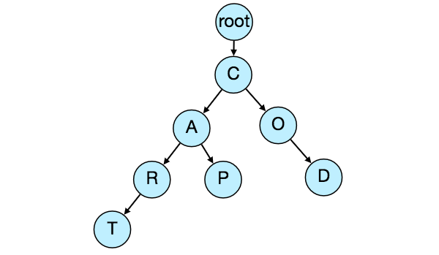](https://www.educative.io/courses/grokking-the-system-design-interview/mE2XkgGRnmp)**

[If we store this trie in a file with the above-mentioned scheme, we will have: “C2,A2,R1,T,P,O1,D”. From this, we can easily rebuild our trie.](https://www.educative.io/courses/grokking-the-system-design-interview/mE2XkgGRnmp)

[If you’ve noticed, we are not storing top suggestions and their counts with each node. It is hard to store this information; as our trie is being stored top down, we don’t have child nodes created before the parent, so there is no easy way to store their references. For this, we have to recalculate all the top terms with counts. This can be done while we are building the trie. Each node will calculate its top suggestions and pass it to its parent. Each parent node will merge results from all of its children to figure out its top suggestions.](https://www.educative.io/courses/grokking-the-system-design-interview/mE2XkgGRnmp)

### [5. Scale Estimation](https://www.educative.io/courses/grokking-the-system-design-interview/mE2XkgGRnmp)

[If we are building a service that has the same scale as that of Google we can expect 5 billion searches every day, which would give us approximately 60K queries per second.](https://www.educative.io/courses/grokking-the-system-design-interview/mE2XkgGRnmp)

[Since there will be a lot of duplicates in 5 billion queries, we can assume that only 20% of these will be unique. If we only want to index the top 50% of the search terms, we can get rid of a lot of less frequently searched queries. Let’s assume we will have 100 million unique terms for which we want to build an index.](https://www.educative.io/courses/grokking-the-system-design-interview/mE2XkgGRnmp)

**[Storage Estimation:](https://www.educative.io/courses/grokking-the-system-design-interview/mE2XkgGRnmp)**[If on the average each query consists of 3 words and if the average length of a word is 5 characters, this will give us 15 characters of average query size. Assuming we need 2 bytes to store a character, we will need 30 bytes to store an average query. So total storage we will need:](https://www.educative.io/courses/grokking-the-system-design-interview/mE2XkgGRnmp)

[100 million \* 30 bytes => 3 GB](https://www.educative.io/courses/grokking-the-system-design-interview/mE2XkgGRnmp)

[We can expect some growth in this data every day, but we should also be removing some terms that are not searched anymore. If we assume we have 2% new queries every day and if we are maintaining our index for the last one year, total storage we should expect:](https://www.educative.io/courses/grokking-the-system-design-interview/mE2XkgGRnmp)

[3GB + (0.02 \* 3 GB \* 365 days) => 25 GB](https://www.educative.io/courses/grokking-the-system-design-interview/mE2XkgGRnmp)

### [6. Data Partition](https://www.educative.io/courses/grokking-the-system-design-interview/mE2XkgGRnmp)

[Although our index can easily fit on one server, we can still partition it in order to meet our requirements of higher efficiency and lower latencies. How can we efficiently partition our data to distribute it onto multiple servers?](https://www.educative.io/courses/grokking-the-system-design-interview/mE2XkgGRnmp)

**[a. Range Based Partitioning:](https://www.educative.io/courses/grokking-the-system-design-interview/mE2XkgGRnmp)**[What if we store our phrases in separate partitions based on their first letter. So we save all the terms starting with the letter ‘A’ in one partition and those that start with the letter ‘B’ into another partition and so on. We can even combine certain less frequently occurring letters into one partition. We should come up with this partitioning scheme statically so that we can always store and search terms in a predictable manner.](https://www.educative.io/courses/grokking-the-system-design-interview/mE2XkgGRnmp)

[The main problem with this approach is that it can lead to unbalanced servers, for instance, if we decide to put all terms starting with the letter ‘E’ into one partition, but later we realize that we have too many terms that start with letter ‘E’ that we can’t fit into one partition.](https://www.educative.io/courses/grokking-the-system-design-interview/mE2XkgGRnmp)

[We can see that the above problem will happen with every statically defined scheme. It is not possible to calculate if each of our partitions will fit on one server statically.](https://www.educative.io/courses/grokking-the-system-design-interview/mE2XkgGRnmp)

**[b. Partition based on the maximum capacity of the server:](https://www.educative.io/courses/grokking-the-system-design-interview/mE2XkgGRnmp)**[Let’s say we partition our trie based on the maximum memory capacity of the servers. We can keep storing data on a server as long as it has memory available. Whenever a sub-tree cannot fit into a server, we break our partition there to assign that range to this server and move on the next server to repeat this process. Let’s say if our first trie server can store all terms from ‘A’ to ‘AABC’, which mean our next server will store from ‘AABD’ onwards. If our second server could store up to ‘BXA’, the next server will start from ‘BXB’, and so on. We can keep a hash table to quickly access this partitioning scheme:](https://www.educative.io/courses/grokking-the-system-design-interview/mE2XkgGRnmp)

[Server 1, A-AABC  
Server 2, AABD-BXA  
Server 3, BXB-CDA](https://www.educative.io/courses/grokking-the-system-design-interview/mE2XkgGRnmp)

[For querying, if the user has typed ‘A’ we have to query both server 1 and 2 to find the top suggestions. When the user has typed ‘AA’, we still have to query server 1 and 2, but when the user has typed ‘AAA’ we only need to query server 1.](https://www.educative.io/courses/grokking-the-system-design-interview/mE2XkgGRnmp)

[We can have a load balancer in front of our trie servers which can store this mapping and redirect traffic. Also, if we are querying from multiple servers, either we need to merge the results on the server side to calculate the overall top results or make our clients do that. If we prefer to do this on the server side, we need to introduce another layer of servers between load balancers and trie severs (let’s call them aggregator). These servers will aggregate results from multiple trie servers and return the top results to the client.](https://www.educative.io/courses/grokking-the-system-design-interview/mE2XkgGRnmp)

[Partitioning based on the maximum capacity can still lead us to hotspots, e.g., if there are a lot of queries for terms starting with ‘cap’, the server holding it will have a high load compared to others.](https://www.educative.io/courses/grokking-the-system-design-interview/mE2XkgGRnmp)

**[c. Partition based on the hash of the term:](https://www.educative.io/courses/grokking-the-system-design-interview/mE2XkgGRnmp)**[Each term will be passed to a hash function, which will generate a server number and we will store the term on that server. This will make our term distribution random and hence minimize hotspots. The disadvantage of this scheme is, to find typeahead suggestions for a term we have to ask all the servers and then aggregate the results.](https://www.educative.io/courses/grokking-the-system-design-interview/mE2XkgGRnmp)

### [7. Cache](https://www.educative.io/courses/grokking-the-system-design-interview/mE2XkgGRnmp)

[We should realize that caching the top searched terms will be extremely helpful in our service. There will be a small percentage of queries that will be responsible for most of the traffic. We can have separate cache servers in front of the trie servers holding most frequently searched terms and their typeahead suggestions. Application servers should check these cache servers before hitting the trie servers to see if they have the desired searched terms. This will save us time to traverse the tri.](https://www.educative.io/courses/grokking-the-system-design-interview/mE2XkgGRnmp)

[We can also build a simple Machine Learning (ML) model that can try to predict the engagement on each suggestion based on simple counting, personalization, or trending data, and cache these terms beforehand.](https://www.educative.io/courses/grokking-the-system-design-interview/mE2XkgGRnmp)

### [8. Replication and Load Balancer](https://www.educative.io/courses/grokking-the-system-design-interview/mE2XkgGRnmp)

[We should have replicas for our trie servers both for load balancing and also for fault tolerance. We also need a load balancer that keeps track of our data partitioning scheme and redirects traffic based on the prefixes.](https://www.educative.io/courses/grokking-the-system-design-interview/mE2XkgGRnmp)

### [9. Fault Tolerance](https://www.educative.io/courses/grokking-the-system-design-interview/mE2XkgGRnmp)

**[What will happen when a trie server goes down?](https://www.educative.io/courses/grokking-the-system-design-interview/mE2XkgGRnmp)**[As discussed above we can have a master-slave configuration; if the master dies, the slave can take over after failover. Any server that comes back up, can rebuild the trie based on the last snapshot.](https://www.educative.io/courses/grokking-the-system-design-interview/mE2XkgGRnmp)

### [10. Typeahead Client](https://www.educative.io/courses/grokking-the-system-design-interview/mE2XkgGRnmp)

[We can perform the following optimizations on the client side to improve user’s experience:](https://www.educative.io/courses/grokking-the-system-design-interview/mE2XkgGRnmp)

1. [The client should only try hitting the server if the user has not pressed any key for 50ms.](https://www.educative.io/courses/grokking-the-system-design-interview/mE2XkgGRnmp)
2. [If the user is constantly typing, the client can cancel the in-progress requests.](https://www.educative.io/courses/grokking-the-system-design-interview/mE2XkgGRnmp)
3. [Initially, the client can wait until the user enters a couple of characters.](https://www.educative.io/courses/grokking-the-system-design-interview/mE2XkgGRnmp)
4. [Clients can pre-fetch some data from the server to save future requests.](https://www.educative.io/courses/grokking-the-system-design-interview/mE2XkgGRnmp)
5. [Clients can store the recent history of suggestions locally. Recent history has a very high rate of being reused.](https://www.educative.io/courses/grokking-the-system-design-interview/mE2XkgGRnmp)
6. [Establishing an early connection with the server turns out to be one of the most important factors. As soon as the user opens the search engine website, the client can open a connection with the server. So when a user types in the first character, the client doesn’t waste time in establishing the connection.](https://www.educative.io/courses/grokking-the-system-design-interview/mE2XkgGRnmp)
7. [The server can push some part of their cache to CDNs and Internet Service Providers (ISPs) for efficiency.](https://www.educative.io/courses/grokking-the-system-design-interview/mE2XkgGRnmp)

### [11. Personalization](https://www.educative.io/courses/grokking-the-system-design-interview/mE2XkgGRnmp)

[Users will receive some typeahead suggestions based on their historical searches, location, language, etc. We can store the personal history of each user separately on the server and also cache them on the client. The server can add these personalized terms in the final set before sending it to the user. Personalized searches should always come before others.](https://www.educative.io/courses/grokking-the-system-design-interview/mE2XkgGRnmp)

# Designing an API Rate Limiter

Let's design an API Rate Limiter which will throttle users based upon the number of the requests they are sending. Difficulty Level: Medium

### 1. What is a Rate Limiter?

Imagine we have a service which is receiving a huge number of requests, but it can only serve a limited number of requests per second. To handle this problem we would need some kind of throttling or rate limiting mechanism that would allow only a certain number of requests so our service can respond to all of them. A rate limiter, at a high-level, limits the number of events an entity (user, device, IP, etc.) can perform in a particular time window. For example:

* A user can send only one message per second.
* A user is allowed only three failed credit card transactions per day.
* A single IP can only create twenty accounts per day.

In general, a rate limiter caps how many requests a sender can issue in a specific time window. It then blocks requests once the cap is reached.

### 2. Why do we need API rate limiting?

Rate Limiting helps to protect services against abusive behaviors targeting the application layer like [Denial-of-service (DOS)](https://en.wikipedia.org/wiki/Denial-of-service_attack) attacks, brute-force password attempts, brute-force credit card transactions, etc. These attacks are usually a barrage of HTTP/S requests which may look like they are coming from real users, but are typically generated by machines (or bots). As a result, these attacks are often harder to detect and can more easily bring down a service, application, or an API.

Rate limiting is also used to prevent revenue loss, to reduce infrastructure costs, to stop spam, and to stop online harassment. Following is a list of scenarios that can benefit from Rate limiting by making a service (or API) more reliable:

* **Misbehaving clients/scripts:** Either intentionally or unintentionally, some entities can overwhelm a service by sending a large number of requests. Another scenario could be when a user is sending a lot of lower-priority requests and we want to make sure that it doesn’t affect the high-priority traffic. For example, users sending a high volume of requests for analytics data should not be allowed to hamper critical transactions for other users.
* **Security:** By limiting the number of the second-factor attempts (in 2-factor auth) that the users are allowed to perform, for example, the number of times they’re allowed to try with a wrong password.
* **To prevent abusive behavior and bad design practices:** Without API limits, developers of client applications would use sloppy development tactics, for example, requesting the same information over and over again.
* **To keep costs and resource usage under control:** Services are generally designed for normal input behavior, for example, a user writing a single post in a minute. Computers could easily push thousands/second through an API. Rate limiter enables controls on service APIs.
* **Revenue:** Certain services might want to limit operations based on the tier of their customer’s service and thus create a revenue model based on rate limiting. There could be default limits for all the APIs a service offers. To go beyond that, the user has to buy higher limits
* **To eliminate spikiness in traffic:** Make sure the service stays up for everyone else.

### 3. Requirements and Goals of the System

Our Rate Limiter should meet the following requirements:

**Functional Requirements:**

1. Limit the number of requests an entity can send to an API within a time window, e.g., 15 requests per second.
2. The APIs are accessible through a cluster, so the rate limit should be considered across different servers. The user should get an error message whenever the defined threshold is crossed within a single server or across a combination of servers.

**Non-Functional Requirements:**

1. The system should be highly available. The rate limiter should always work since it protects our service from external attacks.
2. Our rate limiter should not introduce substantial latencies affecting the user experience.

### 4. How to do Rate Limiting?

**Rate Limiting** is a process that is used to define the rate and speed at which consumers can access APIs. **Throttling** is the process of controlling the usage of the APIs by customers during a given period. Throttling can be defined at the application level and/or API level. When a throttle limit is crossed, the server returns HTTP status “429 - Too many requests".

### 5. What are different types of throttling?

Here are the three famous throttling types that are used by different services:

**Hard Throttling:** The number of API requests cannot exceed the throttle limit.

**Soft Throttling:** In this type, we can set the API request limit to exceed a certain percentage. For example, if we have rate-limit of 100 messages a minute and 10% exceed-limit, our rate limiter will allow up to 110 messages per minute.

**Elastic or Dynamic Throttling**: Under Elastic throttling, the number of requests can go beyond the threshold if the system has some resources available. For example, if a user is allowed only 100 messages a minute, we can let the user send more than 100 messages a minute when there are free resources available in the system.

### 6. What are different types of algorithms used for Rate Limiting?

Following are the two types of algorithms used for Rate Limiting:

**Fixed Window Algorithm:** In this algorithm, the time window is considered from the start of the time-unit to the end of the time-unit. For example, a period would be considered 0-60 seconds for a minute irrespective of the time frame at which the API request has been made. In the diagram below, there are two messages between 0-1 second and three messages between 1-2 seconds. If we have a rate limiting of two messages a second, this algorithm will throttle only ‘m5’.

**Rolling Window Algorithm:** In this algorithm, the time window is considered from the fraction of the time at which the request is made plus the time window length. For example, if there are two messages sent at the 300th millisecond and 400th millisecond of a second, we’ll count them as two messages from the 300th millisecond of that second up to the 300th millisecond of next second. In the above diagram, keeping two messages a second, we’ll throttle ‘m3’ and ‘m4’.

### 7. High level design for Rate Limiter

Rate Limiter will be responsible for deciding which request will be served by the API servers and which request will be declined. Once a new request arrives, the Web Server first asks the Rate Limiter to decide if it will be served or throttled. If the request is not throttled, then it’ll be passed to the API servers.

**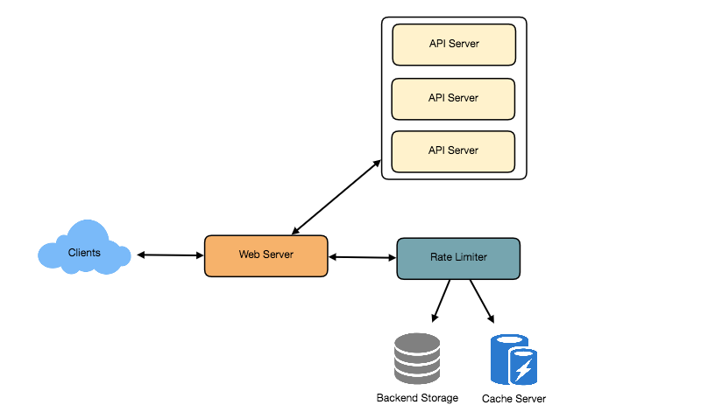**

High level design for Rate Limiter

### 8. Basic System Design and Algorithm

Let’s take the example where we want to limit the number of requests per user. Under this scenario, for each unique user, we would keep a count representing how many requests the user has made and a timestamp when we started counting the requests. We can keep it in a hashtable, where the ‘key’ would be the ‘UserID’ and ‘value’ would be a structure containing an integer for the ‘Count’ and an integer for the Epoch time:

Let’s assume our rate limiter is allowing three requests per minute per user, so whenever a new request comes in, our rate limiter will perform the following steps:

1. If the ‘UserID’ is not present in the hash-table, insert it, set the ‘Count’ to 1, set ‘StartTime’ to the current time (normalized to a minute), and allow the request.
2. Otherwise, find the record of the ‘UserID’ and if CurrentTime – StartTime >= 1 min, set the ‘StartTime’ to the current time, ‘Count’ to 1, and allow the request.
3. If CurrentTime - StartTime <= 1 min and
   * If ‘Count < 3’, increment the Count and allow the request.
   * If ‘Count >= 3’, reject the request.

**What are some of the problems with our algorithm?**

1. This is a **Fixed Window** algorithm since we’re resetting the ‘StartTime’ at the end of every minute, which means it can potentially allow twice the number of requests per minute. Imagine if Kristie sends three requests at the last second of a minute, then she can immediately send three more requests at the very first second of the next minute, resulting in 6 requests in the span of two seconds. The solution to this problem would be a sliding window algorithm which we’ll discuss later.
2. **Atomicity:** In a distributed environment, the “read-and-then-write” behavior can create a race condition. Imagine if Kristie’s current ‘Count’ is “2” and that she issues two more requests. If two separate processes served each of these requests and concurrently read the Count before either of them updated it, each process would think that Kristie could have one more request and that she had not hit the rate limit.

If we are using [Redis](https://en.wikipedia.org/wiki/Redis) to store our key-value, one solution to resolve the atomicity problem is to use [Redis lock](https://redis.io/topics/distlock) for the duration of the read-update operation. This, however, would come at the expense of slowing down concurrent requests from the same user and introducing another layer of complexity. We can use [Memcached](https://en.wikipedia.org/wiki/Memcached), but it would have comparable complications.

If we are using a simple hash-table, we can have a custom implementation for ‘locking’ each record to solve our atomicity problems.

**How much memory would we need to store all of the user data?** Let’s assume the simple solution where we are keeping all of the data in a hash-table.

Let’s assume ‘UserID’ takes 8 bytes. Let’s also assume a 2 byte ‘Count’, which can count up to 65k, is sufficient for our use case. Although epoch time will need 4 bytes, we can choose to store only the minute and second part, which can fit into 2 bytes. Hence, we need a total of 12 bytes to store a user’s data:

8 + 2 + 2 = 12 bytes

Let’s assume our hash-table has an overhead of 20 bytes for each record. If we need to track one million users at any time, the total memory we would need would be 32MB:

(12 + 20) bytes \* 1 million => 32MB

If we assume that we would need a 4-byte number to lock each user’s record to resolve our atomicity problems, we would require a total 36MB memory.

This can easily fit on a single server; however we would not like to route all of our traffic through a single machine. Also, if we assume a rate limit of 10 requests per second, this would translate into 10 million QPS for our rate limiter! This would be too much for a single server. Practically, we can assume we would use a Redis or Memcached kind of a solution in a distributed setup. We’ll be storing all the data in the remote Redis servers and all the Rate Limiter servers will read (and update) these servers before serving or throttling any request.

### 9. Sliding Window algorithm

We can maintain a sliding window if we can keep track of each request per user. We can store the timestamp of each request in a Redis [Sorted Set](https://redis.io/topics/data-types) in our ‘value’ field of hash-table.

Let’s assume our rate limiter is allowing three requests per minute per user, so, whenever a new request comes in, the Rate Limiter will perform following steps:

1. Remove all the timestamps from the Sorted Set that are older than “CurrentTime - 1 minute”.
2. Count the total number of elements in the sorted set. Reject the request if this count is greater than our throttling limit of “3”.
3. Insert the current time in the sorted set and accept the request.

**How much memory would we need to store all of the user data for sliding window?** Let’s assume ‘UserID’ takes 8 bytes. Each epoch time will require 4 bytes. Let’s suppose we need a rate limiting of 500 requests per hour. Let’s assume 20 bytes overhead for hash-table and 20 bytes overhead for the Sorted Set. At max, we would need a total of 12KB to store one user’s data:

8 + (4 + 20 (sorted set overhead)) \* 500 + 20 (hash-table overhead) = 12KB

Here we are reserving 20 bytes overhead per element. In a sorted set, we can assume that we need at least two pointers to maintain order among elements — one pointer to the previous element and one to the next element. On a 64bit machine, each pointer will cost 8 bytes. So we will need 16 bytes for pointers. We added an extra word (4 bytes) for storing other overhead.

If we need to track one million users at any time, total memory we would need would be 12GB:

12KB \* 1 million ~= 12GB

Sliding Window Algorithm takes a lot of memory compared to the Fixed Window; this would be a scalability issue. What if we can combine the above two algorithms to optimize our memory usage?

### 10. Sliding Window with Counters

What if we keep track of request counts for each user using multiple fixed time windows, e.g., 1/60th the size of our rate limit’s time window. For example, if we have an hourly rate limit we can keep a count for each minute and calculate the sum of all counters in the past hour when we receive a new request to calculate the throttling limit. This would reduce our memory footprint. Let’s take an example where we rate-limit at 500 requests per hour with an additional limit of 10 requests per minute. This means that when the sum of the counters with timestamps in the past hour exceeds the request threshold (500), Kristie has exceeded the rate limit. In addition to that, she can’t send more than ten requests per minute. This would be a reasonable and practical consideration, as none of the real users would send frequent requests. Even if they do, they will see success with retries since their limits get reset every minute.

We can store our counters in a [Redis Hash](https://redis.io/topics/data-types) since it offers incredibly efficient storage for fewer than 100 keys. When each request increments a counter in the hash, it also sets the hash to [expire](https://redis.io/commands/ttl) an hour later. We will normalize each ‘time’ to a minute.

**How much memory we would need to store all the user data for sliding window with counters?** Let’s assume ‘UserID’ takes 8 bytes. Each epoch time will need 4 bytes, and the Counter would need 2 bytes. Let’s suppose we need a rate limiting of 500 requests per hour. Assume 20 bytes overhead for hash-table and 20 bytes for Redis hash. Since we’ll keep a count for each minute, at max, we would need 60 entries for each user. We would need a total of 1.6KB to store one user’s data:

8 + (4 + 2 + 20 (Redis hash overhead)) \* 60 + 20 (hash-table overhead) = 1.6KB

If we need to track one million users at any time, total memory we would need would be 1.6GB:

1.6KB \* 1 million ~= 1.6GB

So, our ‘Sliding Window with Counters’ algorithm uses 86% less memory than the simple sliding window algorithm.

### 11. Data Sharding and Caching

We can shard based on the ‘UserID’ to distribute the user’s data. For fault tolerance and replication we should use [Consistent Hashing](https://www.educative.io/courses/system-design-basics/consistent-hashing.html). If we want to have different throttling limits for different APIs, we can choose to shard per user per API. Take the example of [URL Shortener](https://www.educative.io/courses/grokking-the-system-design-interview/url-shortening-service-like-tiny-url.html); we can have different rate limiter for createURL() and deleteURL() APIs for each user or IP.

If our APIs are partitioned, a practical consideration could be to have a separate (somewhat smaller) rate limiter for each API shard as well. Let’s take the example of our URL Shortener where we want to limit each user not to create more than 100 short URLs per hour. Assuming we are using **Hash-Based Partitioning** for our createURL() API, we can rate limit each partition to allow a user to create not more than three short URLs per minute in addition to 100 short URLs per hour.

Our system can get huge benefits from caching recent active users. Application servers can quickly check if the cache has the desired record before hitting backend servers. Our rate limiter can significantly benefit from the **Write-back cache** by updating all counters and timestamps in cache only. The write to the permanent storage can be done at fixed intervals. This way we can ensure minimum latency added to the user’s requests by the rate limiter. The reads can always hit the cache first; which will be extremely useful once the user has hit their maximum limit and the rate limiter will only be reading data without any updates.

Least Recently Used (LRU) can be a reasonable cache eviction policy for our system.

### 12. Should we rate limit by IP or by user?

Let’s discuss the pros and cons of using each one of these schemes:

**IP:** In this scheme, we throttle requests per-IP; although it’s not optimal in terms of differentiating between ‘good’ and ‘bad’ actors, it’s still better than not have rate limiting at all. The biggest problem with IP based throttling is when multiple users share a single public IP like in an internet cafe or smartphone users that are using the same gateway. One bad user can cause throttling to other users. Another issue could arise while caching IP-based limits, as there are a huge number of IPv6 addresses available to a hacker from even one computer, it’s trivial to make a server run out of memory tracking IPv6 addresses!

**User:** Rate limiting can be done on APIs after user authentication. Once authenticated, the user will be provided with a token which the user will pass with each request. This will ensure that we will rate limit against a particular API that has a valid authentication token. But what if we have to rate limit on the login API itself? The weakness of this rate-limiting would be that a hacker can perform a denial of service attack against a user by entering wrong credentials up to the limit; after that the actual user will not be able to log-in.

**How about if we combine the above two schemes?**

**Hybrid:** A right approach could be to do both per-IP and per-user rate limiting, as they both have weaknesses when implemented alone, though, this will result in more cache entries with more details per entry, hence requiring more memory and storage.

# Designing Yelp or Nearby Friends

Let's design a Yelp like service, where users can search for nearby places like restaurants, theaters, or shopping malls, etc., and can also add/view reviews of places. Similar Services: Proximity server. Difficulty Level: Hard

### 1. Why Yelp or Proximity Server?

Proximity servers are used to discover nearby attractions like places, events, etc. If you haven’t used [yelp.com](http://yelp.com/) before, please try it before proceeding (you can search for nearby restaurants, theaters, etc.) and spend some time understanding different options that the website offers. This will help you a lot in understanding this chapter better.

### 2. Requirements and Goals of the System

**What do we wish to achieve from a Yelp like service?** Our service will be storing information about different places so that users can perform a search on them. Upon querying, our service will return a list of places around the user.

Our Yelp-like service should meet the following requirements:

**Functional Requirements:**

1. Users should be able to add/delete/update Places.
2. Given their location (longitude/latitude), users should be able to find all nearby places within a given radius.
3. Users should be able to add feedback/review about a place. The feedback can have pictures, text, and a rating.

**Non-functional Requirements:**

1. Users should have a real-time search experience with minimum latency.
2. Our service should support a heavy search load. There will be a lot of search requests compared to adding a new place.

### 3. Scale Estimation

Let’s build our system assuming that we have 500M places and 100K queries per second (QPS). Let’s also assume a 20% growth in the number of places and QPS each year.

### 4. Database Schema

Each Place can have the following fields:

1. LocationID (8 bytes): Uniquely identifies a location.
2. Name (256 bytes)
3. Latitude (8 bytes)
4. Longitude (8 bytes)
5. Description (512 bytes)
6. Category (1 byte): E.g., coffee shop, restaurant, theater, etc.

Although a four bytes number can uniquely identify 500M locations, with future growth in mind, we will go with 8 bytes for LocationID.

Total size: 8 + 256 + 8 + 8 + 512 + 1 => 793 bytes

We also need to store reviews, photos, and ratings of a Place. We can have a separate table to store reviews for Places:

1. LocationID (8 bytes)
2. ReviewID (4 bytes): Uniquely identifies a review, assuming any location will not have more than 2^32 reviews.
3. ReviewText (512 bytes)
4. Rating (1 byte): how many stars a place gets out of ten.

Similarly, we can have a separate table to store photos for Places and Reviews.

### 5. System APIs

We can have SOAP or REST APIs to expose the functionality of our service. The following could be the definition of the API for searching:

search(api\_dev\_key, search\_terms, user\_location, radius\_filter, maximum\_results\_to\_return,   
    category\_filter, sort, page\_token)

**Parameters:**  
api\_dev\_key (string): The API developer key of a registered account. This will be used to, among other things, throttle users based on their allocated quota.  
search\_terms (string): A string containing the search terms.  
user\_location (string): Location of the user performing the search.  
radius\_filter (number): Optional search radius in meters.  
maximum\_results\_to\_return (number): Number of business results to return.  
category\_filter (string): Optional category to filter search results, e.g., Restaurants, Shopping Centers, etc.  
sort (number): Optional sort mode: Best matched (0 - default), Minimum distance (1), Highest rated (2).  
page\_token (string): This token will specify a page in the result set that should be returned.

**Returns:** (JSON)  
A JSON containing information about a list of businesses matching the search query. Each result entry will have the business name, address, category, rating, and thumbnail.

### 6. Basic System Design and Algorithm

At a high level, we need to store and index each dataset described above (places, reviews, etc.). For users to query this massive database, the indexing should be read efficient, since while searching for the nearby places users expect to see the results in real-time.

Given that the location of a place doesn’t change that often, we don’t need to worry about frequent updates of the data. As a contrast, if we intend to build a service where objects do change their location frequently, e.g., people or taxis, then we might come up with a very different design.

Let’s see what are different ways to store this data and also find out which method will suit best for our use cases:

### a. SQL solution

One simple solution could be to store all the data in a database like MySQL. Each place will be stored in a separate row, uniquely identified by LocationID. Each place will have its longitude and latitude stored separately in two different columns, and to perform a fast search; we should have indexes on both these fields.

To find all the nearby places of a given location (X, Y) within a radius ‘D’, we can query like this:

Select \* from Places where Latitude between X-D and X+D and Longitude between Y-D and Y+D

The above query is not completely accurate, as we know that to find the distance between two points we have to use the distance formula (Pythagorean theorem), but for simplicity let’s take this.

**How efficient would this query be?** We have estimated 500M places to be stored in our service. Since we have two separate indexes, each index can return a huge list of places and performing an intersection on those two lists won’t be efficient. Another way to look at this problem is that there could be too many locations between ‘X-D’ and ‘X+D’, and similarly between ‘Y-D’ and ‘Y+D’. If we can somehow shorten these lists, it can improve the performance of our query.

### b. Grids

We can divide the whole map into smaller grids to group locations into smaller sets. Each grid will store all the Places residing within a specific range of longitude and latitude. This scheme would enable us to query only a few grids to find nearby places. Based on a given location and radius, we can find all the neighboring grids and then query these grids to find nearby places.

**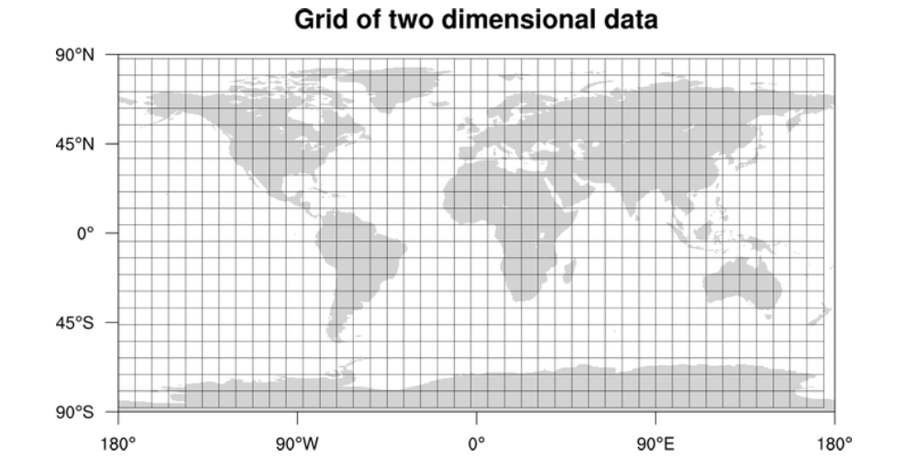**

Let’s assume that GridID (a four bytes number) would uniquely identify grids in our system.

**What could be a reasonable grid size?** Grid size could be equal to the distance we would like to query since we also want to reduce the number of grids. If the grid size is equal to the distance we want to query, then we only need to search within the grid which contains the given location and neighboring eight grids. Since our grids would be statically defined (from the fixed grid size), we can easily find the grid number of any location (lat, long) and its neighboring grids.

In the database, we can store the GridID with each location and have an index on it, too, for faster searching. Now, our query will look like:

Select \* from Places where Latitude between X-D and X+D and Longitude between Y-D and Y+D and GridID in (GridID, GridID1, GridID2, ..., GridID8)

This will undoubtedly improve the runtime of our query.

**Should we keep our index in memory?** Maintaining the index in memory will improve the performance of our service. We can keep our index in a hash table where ‘key’ is the grid number and ‘value’ is the list of places contained in that grid.

**How much memory will we need to store the index?** Let’s assume our search radius is 10 miles; given that the total area of the earth is around 200 million square miles, we will have 20 million grids. We would need a four bytes number to uniquely identify each grid and, since LocationID is 8 bytes, we would need 4GB of memory (ignoring hash table overhead) to store the index.

(4 \* 20M) + (8 \* 500M) ~= 4 GB

This solution can still run slow for those grids that have a lot of places since our places are not uniformly distributed among grids. We can have a thickly dense area with a lot of places, and on the other hand, we can have areas which are sparsely populated.

This problem can be solved if we can dynamically adjust our grid size such that whenever we have a grid with a lot of places we break it down to create smaller grids. A couple of challenges with this approach could be: 1) how to map these grids to locations and 2) how to find all the neighboring grids of a grid.

### c. Dynamic size grids

Let’s assume we don’t want to have more than 500 places in a grid so that we can have a faster searching. So, whenever a grid reaches this limit, we break it down into four grids of equal size and distribute places among them. This means thickly populated areas like downtown San Francisco will have a lot of grids, and sparsely populated area like the Pacific Ocean will have large grids with places only around the coastal lines.

**What data-structure can hold this information?** A tree in which each node has four children can serve our purpose. Each node will represent a grid and will contain information about all the places in that grid. If a node reaches our limit of 500 places, we will break it down to create four child nodes under it and distribute places among them. In this way, all the leaf nodes will represent the grids that cannot be further broken down. So leaf nodes will keep a list of places with them. This tree structure in which each node can have four children is called a [QuadTree](https://en.wikipedia.org/wiki/Quadtree" \t "_blank)

**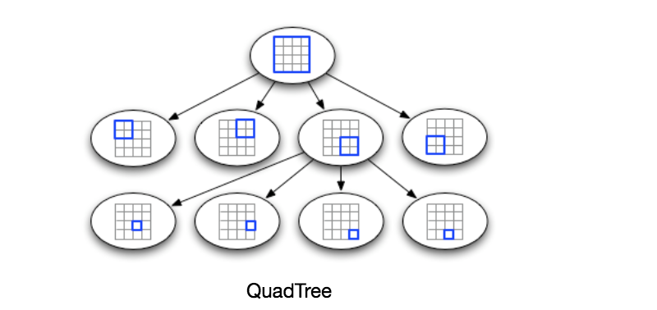**

**How will we build a QuadTree?** We will start with one node that will represent the whole world in one grid. Since it will have more than 500 locations, we will break it down into four nodes and distribute locations among them. We will keep repeating this process with each child node until there are no nodes left with more than 500 locations.

**How will we find the grid for a given location?** We will start with the root node and search downward to find our required node/grid. At each step, we will see if the current node we are visiting has children. If it has, we will move to the child node that contains our desired location and repeat this process. If the node does not have any children, then that is our desired node.

**How will we find neighboring grids of a given grid?** Since only leaf nodes contain a list of locations, we can connect all leaf nodes with a doubly linked list. This way we can iterate forward or backward among the neighboring leaf nodes to find out our desired locations. Another approach for finding adjacent grids would be through parent nodes. We can keep a pointer in each node to access its parent, and since each parent node has pointers to all of its children, we can easily find siblings of a node. We can keep expanding our search for neighboring grids by going up through the parent pointers.

Once we have nearby LocationIDs, we can query the backend database to find details about those places.

**What will be the search workflow?** We will first find the node that contains the user’s location. If that node has enough desired places, we can return them to the user. If not, we will keep expanding to the neighboring nodes (either through the parent pointers or doubly linked list) until either we find the required number of places or exhaust our search based on the maximum radius.

**How much memory will be needed to store the QuadTree?** For each Place, if we cache only LocationID and Lat/Long, we would need 12GB to store all places.

24 \* 500M => 12 GB

Since each grid can have a maximum of 500 places, and we have 500M locations, how many total grids we will have?

500M / 500 => 1M grids

Which means we will have 1M leaf nodes and they will be holding 12GB of location data. A QuadTree with 1M leaf nodes will have approximately 1/3rd internal nodes, and each internal node will have 4 pointers (for its children). If each pointer is 8 bytes, then the memory we need to store all internal nodes would be:

1M \* 1/3 \* 4 \* 8 = 10 MB

So, total memory required to hold the whole QuadTree would be 12.01GB. This can easily fit into a modern-day server.

**How would we insert a new Place into our system?** Whenever a new Place is added by a user, we need to insert it into the databases as well as in the QuadTree. If our tree resides on one server, it is easy to add a new Place, but if the QuadTree is distributed among different servers, first we need to find the grid/server of the new Place and then add it there (discussed in the next section).

### 7. Data Partitioning

What if we have a huge number of places such that our index does not fit into a single machine’s memory? With 20% growth each year we will reach the memory limit of the server in the future. Also, what if one server cannot serve the desired read traffic? To resolve these issues, we must partition our QuadTree!

We will explore two solutions here (both of these partitioning schemes can be applied to databases, too):

**a. Sharding based on regions:** We can divide our places into regions (like zip codes), such that all places belonging to a region will be stored on a fixed node. To store a place we will find the server through its region and, similarly, while querying for nearby places we will ask the region server that contains user’s location. This approach has a couple of issues:

1. What if a region becomes hot? There would be a lot of queries on the server holding that region, making it perform slow. This will affect the performance of our service.
2. Over time, some regions can end up storing a lot of places compared to others. Hence, maintaining a uniform distribution of places, while regions are growing is quite difficult.

To recover from these situations, either we have to repartition our data or use consistent hashing.

**b. Sharding based on LocationID:** Our hash function will map each LocationID to a server where we will store that place. While building our QuadTree, we will iterate through all the places and calculate the hash of each LocationID to find a server where it would be stored. To find places near a location, we have to query all servers and each server will return a set of nearby places. A centralized server will aggregate these results to return them to the user.

**Will we have different QuadTree structure on different partitions?** Yes, this can happen since it is not guaranteed that we will have an equal number of places in any given grid on all partitions. However, we do make sure that all servers have approximately an equal number of Places. This different tree structure on different servers will not cause any issue though, as we will be searching all the neighboring grids within the given radius on all partitions.

The remaining part of this chapter assumes that we have partitioned our data based on LocationID.

**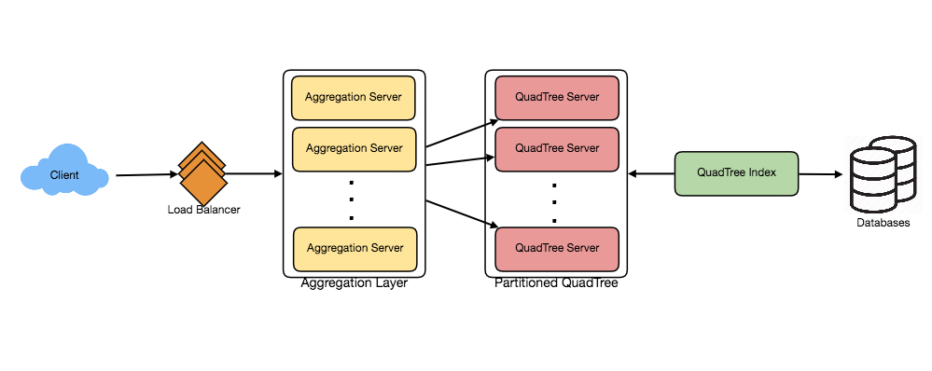**

### 8. Replication and Fault Tolerance

Having replicas of QuadTree servers can provide an alternate to data partitioning. To distribute read traffic, we can have replicas of each QuadTree server. We can have a master-slave configuration where replicas (slaves) will only serve read traffic; all write traffic will first go to the master and then applied to slaves. Slaves might not have some recently inserted places (a few milliseconds delay will be there), but this could be acceptable.

What will happen when a QuadTree server dies? We can have a secondary replica of each server and, if primary dies, it can take control after the failover. Both primary and secondary servers will have the same QuadTree structure.

**What if both primary and secondary servers die at the same time?** We have to allocate a new server and rebuild the same QuadTree on it. How can we do that, since we don’t know what places were kept on this server? The brute-force solution would be to iterate through the whole database and filter LocationIDs using our hash function to figure out all the required places that will be stored on this server. This would be inefficient and slow; also, during the time when the server is being rebuilt, we will not be able to serve any query from it, thus missing some places that should have been seen by users.

**How can we efficiently retrieve a mapping between Places and QuadTree server?** We have to build a reverse index that will map all the Places to their QuadTree server. We can have a separate QuadTree Index server that will hold this information. We will need to build a HashMap where the ‘key’ is the QuadTree server number and the ‘value’ is a HashSet containing all the Places being kept on that QuadTree server. We need to store LocationID and Lat/Long with each place because information servers can build their QuadTrees through this. Notice that we are keeping Places’ data in a HashSet, this will enable us to add/remove Places from our index quickly. So now, whenever a QuadTree server needs to rebuild itself, it can simply ask the QuadTree Index server for all the Places it needs to store. This approach will surely be quite fast. We should also have a replica of the QuadTree Index server for fault tolerance. If a QuadTree Index server dies, it can always rebuild its index from iterating through the database.

### 9. Cache

To deal with hot Places, we can introduce a cache in front of our database. We can use an off-the-shelf solution like Memcache, which can store all data about hot places. Application servers, before hitting the backend database, can quickly check if the cache has that Place. Based on clients’ usage pattern, we can adjust how many cache servers we need. For cache eviction policy, Least Recently Used (LRU) seems suitable for our system.

### 10. Load Balancing (LB)

We can add LB layer at two places in our system 1) Between Clients and Application servers and 2) Between Application servers and Backend server. Initially, a simple Round Robin approach can be adopted; that will distribute all incoming requests equally among backend servers. This LB is simple to implement and does not introduce any overhead. Another benefit of this approach is if a server is dead the load balancer will take it out of the rotation and will stop sending any traffic to it.

A problem with Round Robin LB is, it won’t take server load into consideration. If a server is overloaded or slow, the load balancer will not stop sending new requests to that server. To handle this, a more intelligent LB solution would be needed that periodically queries backend server about their load and adjusts traffic based on that.

### 11. Ranking

How about if we want to rank the search results not just by proximity but also by popularity or relevance?

**How can we return most popular places within a given radius?** Let’s assume we keep track of the overall popularity of each place. An aggregated number can represent this popularity in our system, e.g., how many stars a place gets out of ten (this would be an average of different rankings given by users)? We will store this number in the database as well as in the QuadTree. While searching for the top 100 places within a given radius, we can ask each partition of the QuadTree to return the top 100 places with maximum popularity. Then the aggregator server can determine the top 100 places among all the places returned by different partitions.

Remember that we didn’t build our system to update place’s data frequently. With this design, how can we modify the popularity of a place in our QuadTree? Although we can search a place and update its popularity in the QuadTree, it would take a lot of resources and can affect search requests and system throughput. Assuming the popularity of a place is not expected to reflect in the system within a few hours, we can decide to update it once or twice a day, especially when the load on the system is minimum.

Our next problem, [Designing Uber backend](https://www.educative.io/courses/grokking-the-system-design-interview/uber-backend.html), discusses dynamic updates of the QuadTree in detail.

# Designing Facebook Messenger

Let's design an instant messaging service like Facebook Messenger where users can send text messages to each other through web and mobile interfaces.

### 1. What is Facebook Messenger?

Facebook Messenger is a software application which provides text-based instant messaging services to its users. Messenger users can chat with their Facebook friends both from cell-phones and Facebook’s website.

### 2. Requirements and Goals of the System

Our Messenger should meet the following requirements:

**Functional Requirements:**

1. Messenger should support one-on-one conversations between users.
2. Messenger should keep track of the online/offline statuses of its users.
3. Messenger should support the persistent storage of chat history.

**Non-functional Requirements:**

1. Users should have real-time chat experience with minimum latency.
2. Our system should be highly consistent; users should be able to see the same chat history on all their devices.
3. Messenger’s high availability is desirable; we can tolerate lower availability in the interest of consistency.

**Extended Requirements:**

* Group Chats: Messenger should support multiple people talking to each other in a group.
* Push notifications: Messenger should be able to notify users of new messages when they are offline.

### 3. Capacity Estimation and Constraints

Let’s assume that we have 500 million daily active users and on average each user sends 40 messages daily; this gives us 20 billion messages per day.

**Storage Estimation:** Let’s assume that on average a message is 100 bytes, so to store all the messages for one day we would need 2TB of storage.

20 billion messages \* 100 bytes => 2 TB/day

To store five years of chat history, we would need 3.6 petabytes of storage.

2 TB \* 365 days \* 5 years ~= 3.6 PB

Other than the chat messages, we would also need to store users’ information, messages’ metadata (ID, Timestamp, etc.). Not to mention, the above calculation doesn’t take data compression and replication into consideration.

**Bandwidth Estimation:** If our service is getting 2TB of data every day, this will give us 25MB of incoming data for each second.

2 TB / 86400 sec ~= 25 MB/s

Since each incoming message needs to go out to another user, we will need the same amount of bandwidth 25MB/s for both upload and download.

**High level estimates:**

|  |  |
| --- | --- |
| Total messages | 20 billion per day |
| Storage for each day | 2TB |
| Storage for 5 years | 3.6PB |
| Incomming data | 25MB/s |
| Outgoing data | 25MB/s |

### 4. High Level Design

At a high-level, we will need a chat server that will be the central piece, orchestrating all the communications between users. When a user wants to send a message to another user, they will connect to the chat server and send the message to the server; the server then passes that message to the other user and also stores it in the database.

**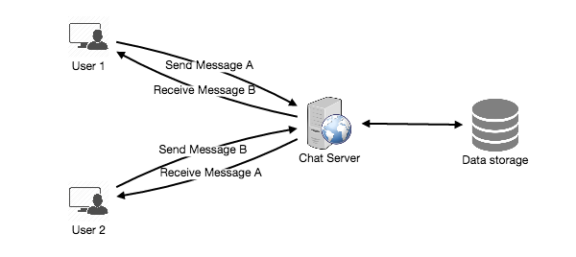**

The detailed workflow would look like this:

1. User-A sends a message to User-B through the chat server.
2. The server receives the message and sends an acknowledgment to User-A.
3. The server stores the message in its database and sends the message to User-B.
4. User-B receives the message and sends the acknowledgment to the server.
5. The server notifies User-A that the message has been delivered successfully to User-B.

Request flow for sending a message

**1** of 8

### 5. Detailed Component Design

Let’s try to build a simple solution first where everything runs on one server. At the high level our system needs to handle the following use cases:

1. Receive incoming messages and deliver outgoing messages.
2. Store and retrieve messages from the database.
3. Keep a record of which user is online or has gone offline, and notify all the relevant users about these status changes.

Let’s talk about these scenarios one by one:

### a. Messages Handling

**How would we efficiently send/receive messages?** To send messages, a user needs to connect to the server and post messages for the other users. To get a message from the server, the user has two options:

1. **Pull model:** Users can periodically ask the server if there are any new messages for them.
2. **Push model:** Users can keep a connection open with the server and can depend upon the server to notify them whenever there are new messages.

If we go with our first approach, then the server needs to keep track of messages that are still waiting to be delivered, and as soon as the receiving user connects to the server to ask for any new message, the server can return all the pending messages. To minimize latency for the user, they have to check the server quite frequently, and most of the time they will be getting an empty response if there are no pending message. This will waste a lot of resources and does not look like an efficient solution.

If we go with our second approach, where all the active users keep a connection open with the server, then as soon as the server receives a message it can immediately pass the message to the intended user. This way, the server does not need to keep track of the pending messages, and we will have minimum latency, as the messages are delivered instantly on the opened connection.

**How will clients maintain an open connection with the server?** We can use HTTP [Long Polling](https://www.educative.io/courses/system-design-basics/long-polling.html) or [WebSockets](https://www.educative.io/courses/system-design-basics/long-polling.html" \t "_blank). In long polling, clients can request information from the server with the expectation that the server may not respond immediately. If the server has no new data for the client when the poll is received, instead of sending an empty response, the server holds the request open and waits for response information to become available. Once it does have new information, the server immediately sends the response to the client, completing the open request. Upon receipt of the server response, the client can immediately issue another server request for future updates. This gives a lot of improvements in latencies, throughputs, and performance. The long polling request can timeout or can receive a disconnect from the server, in that case, the client has to open a new request.

**How can the server keep track of all the opened connection to redirect messages to the users efficiently?** The server can maintain a hash table, where “key” would be the UserID and “value” would be the connection object. So whenever the server receives a message for a user, it looks up that user in the hash table to find the connection object and sends the message on the open request.

**What will happen when the server receives a message for a user who has gone offline?** If the receiver has disconnected, the server can notify the sender about the delivery failure. If it is a temporary disconnect, e.g., the receiver’s long-poll request just timed out, then we should expect a reconnect from the user. In that case, we can ask the sender to retry sending the message. This retry could be embedded in the client’s logic so that users don’t have to retype the message. The server can also store the message for a while and retry sending it once the receiver reconnects.

**How many chat servers we need?** Let’s plan for 500 million connections at any time. Assuming a modern server can handle 50K concurrent connections at any time, we would need 10K such servers.

**How do we know which server holds the connection to which user?** We can introduce a software load balancer in front of our chat servers; that can map each UserID to a server to redirect the request.

**How should the server process a ‘deliver message’ request?** The server needs to do the following things upon receiving a new message: 1) Store the message in the database 2) Send the message to the receiver and 3) Send an acknowledgment to the sender.

The chat server will first find the server that holds the connection for the receiver and pass the message to that server to send it to the receiver. The chat server can then send the acknowledgment to the sender; we don’t need to wait for storing the message in the database (this can happen in the background). Storing the message is discussed in the next section.

**How does the messenger maintain the sequencing of the messages?** We can store a timestamp with each message, which is the time the message is received by the server. This will still not ensure correct ordering of messages for clients. The scenario where the server timestamp cannot determine the exact order of messages would look like this:

1. User-1 sends a message M1 to the server for User-2.
2. The server receives M1 at T1.
3. Meanwhile, User-2 sends a message M2 to the server for User-1.
4. The server receives the message M2 at T2, such that T2 > T1.
5. The server sends message M1 to User-2 and M2 to User-1.

So User-1 will see M1 first and then M2, whereas User-2 will see M2 first and then M1.

To resolve this, we need to keep a sequence number with every message for each client. This sequence number will determine the exact ordering of messages for EACH user. With this solution, both clients will see a different view of the message sequence, but this view will be consistent for them on all devices.

### b. Storing and retrieving the messages from the database

Whenever the chat server receives a new message, it needs to store it in the database. To do so, we have two options:

1. Start a separate thread, which will work with the database to store the message.
2. Send an asynchronous request to the database to store the message.

We have to keep certain things in mind while designing our database:

1. How to efficiently work with the database connection pool.
2. How to retry failed requests.
3. Where to log those requests that failed even after some retries.
4. How to retry these logged requests (that failed after the retry) when all the issues have resolved.

**Which storage system we should use?** We need to have a database that can support a very high rate of small updates and also fetch a range of records quickly. This is required because we have a huge number of small messages that need to be inserted in the database and, while querying, a user is mostly interested in sequentially accessing the messages.

We cannot use RDBMS like MySQL or NoSQL like MongoDB because we cannot afford to read/write a row from the database every time a user receives/sends a message. This will not only make the basic operations of our service run with high latency but also create a huge load on databases.

Both of our requirements can be easily met with a wide-column database solution like [HBase](https://en.wikipedia.org/wiki/Apache_HBase). HBase is a column-oriented key-value NoSQL database that can store multiple values against one key into multiple columns. HBase is modeled after Google’s [BigTable](https://en.wikipedia.org/wiki/Bigtable" \t "_blank) and runs on top of Hadoop Distributed File System ([HDFS](https://en.wikipedia.org/wiki/Apache_Hadoop)). HBase groups data together to store new data in a memory buffer and, once the buffer is full, it dumps the data to the disk. This way of storage not only helps to store a lot of small data quickly but also fetching rows by the key or scanning ranges of rows. HBase is also an efficient database to store variable sized data, which is also required by our service.

**How should clients efficiently fetch data from the server?** Clients should paginate while fetching data from the server. Page size could be different for different clients, e.g., cell phones have smaller screens, so we need a fewer number of message/conversations in the viewport.

### c. Managing user’s status

We need to keep track of user’s online/offline status and notify all the relevant users whenever a status change happens. Since we are maintaining a connection object on the server for all active users, we can easily figure out the user’s current status from this. With 500M active users at any time, if we have to broadcast each status change to all the relevant active users, it will consume a lot of resources. We can do the following optimization around this:

1. Whenever a client starts the app, it can pull the current status of all users in their friends’ list.
2. Whenever a user sends a message to another user that has gone offline, we can send a failure to the sender and update the status on the client.
3. Whenever a user comes online, the server can always broadcast that status with a delay of a few seconds to see if the user does not go offline immediately.
4. Clients can pull the status from the server about those users that are being shown on the user’s viewport. This should not be a frequent operation, as the server is broadcasting the online status of users and we can live with the stale offline status of users for a while.
5. Whenever the client starts a new chat with another user, we can pull the status at that time.

**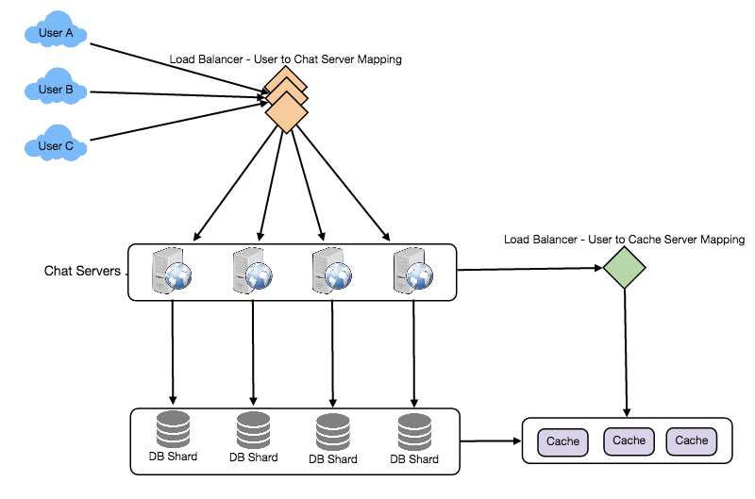**

Detailed component design for Facebook messenger

**Design Summary:** Clients will open a connection to the chat server to send a message; the server will then pass it to the requested user. All the active users will keep a connection open with the server to receive messages. Whenever a new message arrives, the chat server will push it to the receiving user on the long poll request. Messages can be stored in HBase, which supports quick small updates, and range based searches. The servers can broadcast the online status of a user to other relevant users. Clients can pull status updates for users who are visible in the client’s viewport on a less frequent basis.

### 6. Data partitioning

Since we will be storing a lot of data (3.6PB for five years), we need to distribute it onto multiple database servers. What will be our partitioning scheme?

**Partitioning based on UserID:** Let’s assume we partition based on the hash of the UserID so that we can keep all messages of a user on the same database. If one DB shard is 4TB, we will have “3.6PB/4TB ~= 900” shards for five years. For simplicity, let’s assume we keep 1K shards. So we will find the shard number by “hash(UserID) % 1000” and then store/retrieve the data from there. This partitioning scheme will also be very quick to fetch chat history for any user.

In the beginning, we can start with fewer database servers with multiple shards residing on one physical server. Since we can have multiple database instances on a server, we can easily store multiple partitions on a single server. Our hash function needs to understand this logical partitioning scheme so that it can map multiple logical partitions on one physical server.

Since we will store an unlimited history of messages, we can start with a big number of logical partitions, which will be mapped to fewer physical servers, and as our storage demand increases, we can add more physical servers to distribute our logical partitions.

**Partitioning based on MessageID:** If we store different messages of a user on separate database shards, fetching a range of messages of a chat would be very slow, so we should not adopt this scheme.

### 7. Cache

We can cache a few recent messages (say last 15) in a few recent conversations that are visible in a user’s viewport (say last 5). Since we decided to store all of the user’s messages on one shard, the cache for a user should entirely reside on one machine too.

### 8. Load balancing

We will need a load balancer in front of our chat servers; that can map each UserID to a server that holds the connection for the user and then direct the request to that server. Similarly, we would need a load balancer for our cache servers.

### 9. Fault tolerance and Replication

**What will happen when a chat server fails?** Our chat servers are holding connections with the users. If a server goes down, should we devise a mechanism to transfer those connections to some other server? It’s extremely hard to failover TCP connections to other servers; an easier approach can be to have clients automatically reconnect if the connection is lost.

**Should we store multiple copies of user messages?** We cannot have only one copy of the user’s data, because if the server holding the data crashes or is down permanently, we don’t have any mechanism to recover that data. For this, either we have to store multiple copies of the data on different servers or use techniques like Reed-Solomon encoding to distribute and replicate it.

### 10. Extended Requirements

### a. Group chat

We can have separate group-chat objects in our system that can be stored on the chat servers. A group-chat object is identified by GroupChatID and will also maintain a list of people who are part of that chat. Our load balancer can direct each group chat message based on GroupChatID and the server handling that group chat can iterate through all the users of the chat to find the server handling the connection of each user to deliver the message.

In databases, we can store all the group chats in a separate table partitioned based on GroupChatID.

### b. Push notifications

In our current design, users can only send messages to active users and if the receiving user is offline, we send a failure to the sending user. Push notifications will enable our system to send messages to offline users.

For Push notifications, each user can opt-in from their device (or a web browser) to get notifications whenever there is a new message or event. Each manufacturer maintains a set of servers that handles pushing these notifications to the user.

To have push notifications in our system, we would need to set up a Notification server, which will take the messages for offline users and send them to the manufacture’s push notification server, which will then send them to the user’s device.

# Dropbox System Design

28 APR 2020 on System Design

Dropbox is a cloud storage service which allows users to store their data on remote servers. The remote servers store files durably and securely, and these files are accessible anywhere with an Internet connection.

In this design, we will focus mainly on availability, reliability and scalability. So let’s dive right in!

* [Requirements](https://systemdesignprimer.com/dropbox-system-design/#requirements)
  + [Functional Requirements](https://systemdesignprimer.com/dropbox-system-design/#functional-requirements)
  + [Non-functional requirements](https://systemdesignprimer.com/dropbox-system-design/#non-functional-requirements)
  + [Out of scope](https://systemdesignprimer.com/dropbox-system-design/#out-of-scope)
* [Capacity Estimation](https://systemdesignprimer.com/dropbox-system-design/#capacity-estimation)
  + [Assumptions](https://systemdesignprimer.com/dropbox-system-design/#assumptions)
  + [Storage Estimations](https://systemdesignprimer.com/dropbox-system-design/#storage-estimations)
* [Detailed Component Design](https://systemdesignprimer.com/dropbox-system-design/#detailed-component-design)
  + [Client](https://systemdesignprimer.com/dropbox-system-design/#client)
  + [Meta Service](https://systemdesignprimer.com/dropbox-system-design/#meta-service)
  + [Block Service](https://systemdesignprimer.com/dropbox-system-design/#block-service)
  + [Notification Service](https://systemdesignprimer.com/dropbox-system-design/#notification-service)
* [Database Schema](https://systemdesignprimer.com/dropbox-system-design/#database-schema)
* [APIs](https://systemdesignprimer.com/dropbox-system-design/#apis)
  + [Download Chunk](https://systemdesignprimer.com/dropbox-system-design/#download-chunk)
  + [Upload Chunk](https://systemdesignprimer.com/dropbox-system-design/#upload-chunk)
  + [Get Objects](https://systemdesignprimer.com/dropbox-system-design/#get-objects)
* [Performance](https://systemdesignprimer.com/dropbox-system-design/#performance)
  + [Chunking Files](https://systemdesignprimer.com/dropbox-system-design/#chunking-files)
  + [Data Deduplication](https://systemdesignprimer.com/dropbox-system-design/#data-deduplication)
  + [Caching](https://systemdesignprimer.com/dropbox-system-design/#caching)
* [Scalability](https://systemdesignprimer.com/dropbox-system-design/#scalability)
  + [Horizontal Scaling](https://systemdesignprimer.com/dropbox-system-design/#horizontal-scaling)
  + [Database Sharding](https://systemdesignprimer.com/dropbox-system-design/#database-sharding)
  + [Cache Sharding](https://systemdesignprimer.com/dropbox-system-design/#cache-sharding)
* [Security](https://systemdesignprimer.com/dropbox-system-design/#security)
  + [HTTPS](https://systemdesignprimer.com/dropbox-system-design/#https)
  + [Authentication](https://systemdesignprimer.com/dropbox-system-design/#authentication)
* [Resiliency](https://systemdesignprimer.com/dropbox-system-design/#resiliency)
  + [Distributed Block Storage](https://systemdesignprimer.com/dropbox-system-design/#distributed-block-storage)
  + [Queuing](https://systemdesignprimer.com/dropbox-system-design/#queuing)
  + [Load Balancing](https://systemdesignprimer.com/dropbox-system-design/#load-balancing)
  + [Geo-redundancy](https://systemdesignprimer.com/dropbox-system-design/#geo-redundancy)
* [References](https://systemdesignprimer.com/dropbox-system-design/#references)

### Requirements

Let’s look in to some of the functional and non-functional requirements before we start to design the system.

#### Functional Requirements

1. Users should be able to sign up using their email address and subscribe to a plan. If they don’t subscribe, they will get 1 GB of free storage.
2. Users should be able to upload and download their files from any device.
3. Users should be able to share files and folders with other users.
4. Users should be able to upload files up to 1 GB.
5. System should support automatic synchronization across the devices.
6. System should support offline editing. Users should be able to add/delete/modify files offline and once they come online, changes should be synchronized to remote server and other online devices.

#### Non-functional requirements

1. System should be highly reliable. Any file uploaded should not be lost.
2. System should be highly available.

#### Out of scope

1. Real-time collaboration on a file.
2. Versioning of the file.

### Capacity Estimation

Let’s do some back-of-the-envelope calculations to estimate the bandwidth and storage required.

#### Assumptions

1. Total number of users = 500 million
2. Total number of daily active users = 100 million
3. Average number of files stored by each user = 200
4. Average size of each file = 100 KB
5. Total number of active connections per minute = 1 million

#### Storage Estimations

Total number of files = 500 million \* 200 = 100 billion  
Total storage required = 100 billion \* 100 KB = 10 PB

### Detailed Component Design

The system needs to deal with huge volume of read and write data and their ratio will remain almost same. Hence while designing the system, we should focus on optimizing the data exchange between client and server.

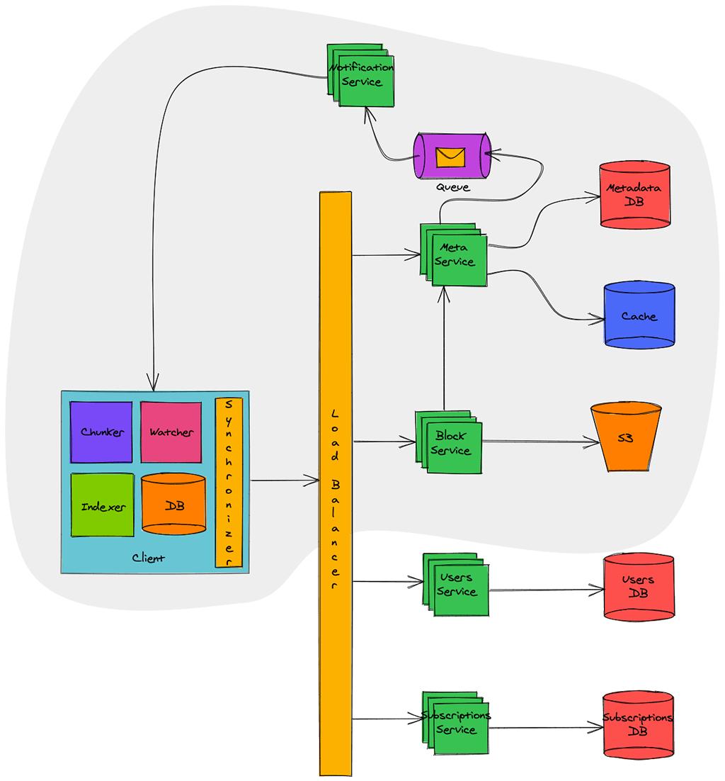

Our focus is on building the components which are in grey area in diagram above. Other components, which are outside, like [Users Service](https://systemdesignprimer.com/netflix-system-design/#users-service) and [Subscriptions Service](https://systemdesignprimer.com/netflix-system-design/#subscriptions-service) have been discussed in detail previously. Hence let’s look in to remaining components in detail.

#### Client

Client here means desktop or mobile application which keeps a watch on user’s workspace and synchronizes the files with remote server. Below are some main responsibilities of client:

* Watch workspace for changes
* Upload or download changes to file from remote server
* Handle the conflicts due to offline or concurrent updates
* Update file metadata on remote server if they change

Let’s naively assume that we build a client which synchronizes the file on each modification to remote server.

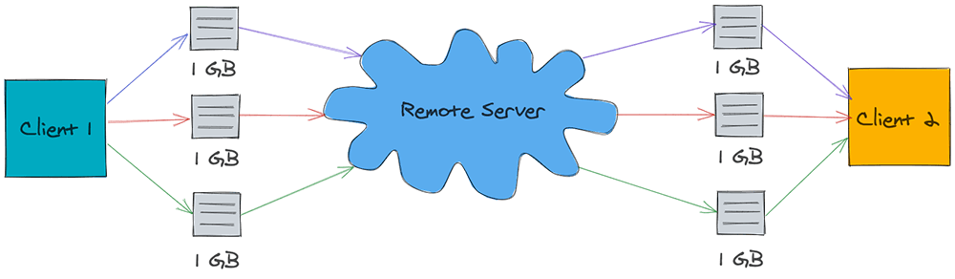

As shown in image above, let’s assume that there is a file of 1 GB and three successive small changes were made to this file. Due to this, the file is sent three time to remote server and same is downloaded three times on another client. In this whole process, 3 GB of bandwidth was used for upload and 3 GB of bandwidth was used for download. Further, the download bandwidth increases in proportion of clients watching the file.

Did you observe that a total of 6 GB of bandwidth was used for just a small change? Also if there is a loss in connectivity, client has to upload/download entire file again. This is a huge waste of bandwidth and hence let’s try to optimize it.

Now let’s assume we build a client which breaks the file in to smaller chunks of say 4 MB and uploads them to remote server as shown below:

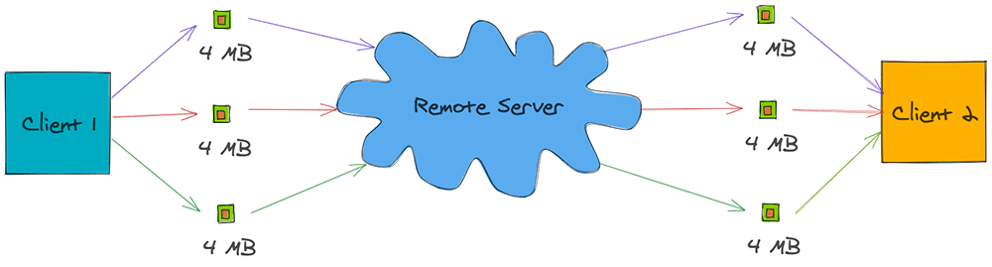

If there is any change in file, client determines which chunk has changed and just uploads that chunk to remote server. Similarly on other side, other client gets notified about the chunk that has changed and downloads just that chunk. This way just 24 MB of bandwidth was used, in contrast to 6 GB earlier, for synchronizing three small changes to the file.

Keeping this in mind, let’s look in to the different components of this optimized client:

**Client Metadata Database:** Client Metadata Database stores the information about different files in workspace, file chunks, chunk version and file location in the file system. This can be implemented using a lightweight database like [SQLite](https://en.wikipedia.org/wiki/SQLite).

**Chunker:** Chunker splits the big files in to chunks of 4 MB. This also reconstructs the original file from chunks.

**Watcher:** Watcher monitors for file changes in workspace like update, create, delete of files and folders. Watcher notifies Indexer about the changes.

**Indexer:** Indexer listens for the events from watcher and updates the Client Metadata Database with information about the chunks of modified file. It also notifies Synchronizer after committing changes to Client Metadata Database.

**Synchronizer:** Synchronizer listens for events from Indexer and communicates with Meta Service and Block service for updating meta data and modified chunk of file on remote server respectively. It also listens for changes broadcasted by Notification Service and downloads the modified chunks from remote server.

#### Meta Service

Meta Service is responsible for synchronizing the file metadata from client to server. It’s also responsible to figure out the change set for different clients and broadcast it to them using Notification Service.

When a client comes online, it pings Meta Service for an update. Meta Service determines the change set for that client by querying the Metadata DB and returns the change set.

If a client updates a file, Meta Service again determines the change set for other clients watching that file and broadcasts the change set via Notification Service.

Meta Service is backed by Metadata DB. This database contains the metadata of file like name, type (file or folder), sharing permissions, chunks information etc. This database should have strong [ACID](https://en.wikipedia.org/wiki/ACID) (atomicity, consistency, isolation, durability) properties. Hence a relational database, like MySQL or PostgreSQL, would be a good choice.

Since querying the database for every synchronization request is a costly operation, a in-memory cache is put in front of Metadata DB. Frequently queries data is cached in this cache thereby eliminating the need of database query. This cache can be implemented using Redis or Memcached and [write-around cache](https://systemdesignprimer.com/netflix-system-design/#caching) strategy can be applied for optimal performance.

*Dropbox uses a claver algorithm for efficiently synchronizing files across multiple clients. You can read more details about the same*[*here*](https://dropbox.tech/infrastructure/streaming-file-synchronization)*.*

#### Block Service

Block Service interacts with block storage for uploading and downloading of files. Clients connect with Block Service to upload or download file chunks.

When a client finishes downloading file, Block Service notifies Meta Service to update the metadata. When a client uploads a file, Block Service on finishing the upload to block storage, notifies the Meta Service to update the metadata corresponding to this client and broadcast messages for other clients.

Block Storage can be implemented using a distributed file system like [Glusterfs](https://en.wikipedia.org/wiki/Gluster" \l "GlusterFS" \t "\\_blank) or Amazon S3. Distributed file system provides high reliability and durability making sure the files uploaded are never lost.

*When Dropbox started, they used S3 as block storage. However as they grew, they developed an in-house multi-exabyte storage system known as*[*Magic Pocket*](https://dropbox.tech/infrastructure/inside-the-magic-pocket)*. In magic Pocket, files are split up into blocks, replicated for durability, and distributed across data centers in multiple geographic regions.*

#### Notification Service

Notification Service broadcasts the file changes to connected clients making sure any change to file is reflected all watching clients instantly.

Notification Service can be implemented using HTTP Long Polling, Websockets or Server Sent Events. Websockets establish a persistent duplex connection between client and server. It is not a good choice in this scenario as there is no need of two way communication. We only need to broadcast the message from service to client and hence it’s an overkill.

HTTP Long Polling is a better choice as server keeps the connection hanging till a data is available for client. Once data is available, server sends the data closing the connection. Once the connection is closed, client has to again establish a new connection. Generally, for each long poll request, there is a timeout associated with it and client must establish a new connection post timeout.

In Server Sent Events, client establishes a long term persistent connection with server. This connection is used to send events from server to client. There is no timeout and contain remains alive till the client remains on network. This fits our use case perfectly and would be a good choice for designing Notification Service. Though the Server Sent Events are not supported in all browsers, it’s not a concern for us as we have our custom built desktop and mobile clients where we can utilize it.

Notification Service before sending the data to clients, reads the message from a message queue. This queue can be implemented using RabbitMQ, Apache ActiveMQ or Kafka. Message queue provides a asynchronous medium of communication between Meta Service and Notification Service and thus Meta Service need not to wait till notification is sent to clients. Notification service can keep on consuming the messages at it’s own pace without affecting the performance Meta Service. This decoupling also allows us to scale both services independently.

### Database Schema

The database schema containing most important tables is illustrated below:

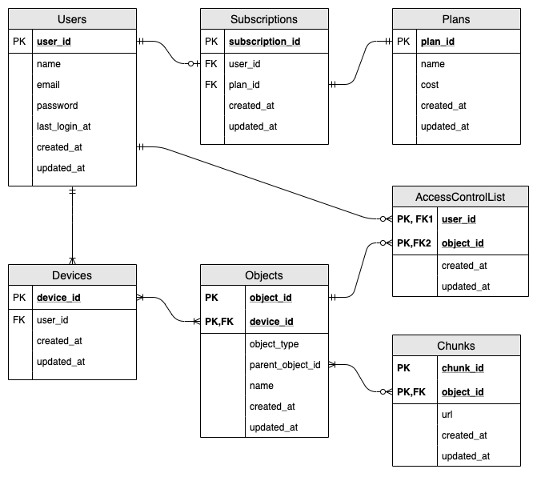

Let’s quickly sum up above database schema:

* A user may subscribe for paid service.
* Each subscription must have one plan.
* Each use must have at-least one device.
* Each device will have at-least one object (file or folder). Once user registers, we create a root folder for him/her making sure he/she has at-least one object.
* Each object may have chunks. Only files can have chunk, folders can’t have chunks.
* Each object may be shared with one or multiple users. This mapping is maintained in AccessControlList.

### APIs

The service will expose API for uploading file and downloading file. Other API like user sign-up, sign-in, sign-out, subscribing, unsubscribing etc. have already been discussed in [this](https://systemdesignprimer.com/netflix-system-design/#apis) article.

#### Download Chunk

This API would be used to download the chunk of a file.

Request:

GET /api/v1/chunks/:chunk\_id

X-API-Key: api\_key

Authorization: auth\_token

Response:

200 OK

Content-Disposition: attachment; filename="<chunk\_id>"

Content-Length: 4096000

The response will contain Content-Disposition header as attachment which will instruct the client to download the chunk. Note that Content-Length is set as 4096000 as each chunk is of 4 MB.

#### Upload Chunk

This API would be used to upload the chunk of a file.

Request:

POST /api/v1/chunks/:chunk\_id

X-API-Key: api\_key

Authorization: auth\_token

Content-Type: application/octet-stream

/path/to/chunk

Content-Type header is set as application/octet-stream to tell server that a binary date is being sent.

Response:

200 OK

On successful upload, the server will return HTTP response code 200. Below are some possible failure response codes:

401 Unauthorized

400 Bad request

500 Internal server error

#### Get Objects

This API would be used by clients to query Meta Service for new files/folders when they come online.

Request:

GET /api/v1/objects?local\_object\_id=<Max object\_id present locally>&device\_id=<Unique Device Id>

X-API-Key: api\_key

Authorization: auth\_token

Client will pass the maximum object id present locally and the unique device id.

Response:

200 OK

{

new\_objects: [

{

object\_id:

object\_type:

name:

chunk\_ids: [

chunk1,

chunk2,

chunk3

]

}

]

}

Meta Service will check the database and return an array of objects containing name of object, object id, object type and an array of chunk\_ids. Client calls the Download Chunk API with these chunk\_ids to download the chunks and reconstruct the file.

### Performance

Chunking of files and data deduplication while uploading files boosts the performance a lot. Let’s look in to both of these in detail.

#### Chunking Files

Instead of uploading entire file in one go, we are chunking files in blocks of 4 MB and then uploading each chunk. This helps in improving performance in following ways:

* Multiple chunks can be uploaded in parallel thereby reducing the time for upload.
* If there is a small change in file, only the affected chunk is uploaded and downloaded by other clients, saving us bandwidth and time.
* If file upload is interrupted due to network connectivity loss, instead of uploading/downloading entire file again, we can just resume after the last chunk already uploaded/downloaded. This again saves our bandwidth and time.

#### Data Deduplication

The files are getting chunked in to blocks of 4 MB and each chunk is assigned a chunk\_id which is SHA-256 hash of that chunk.

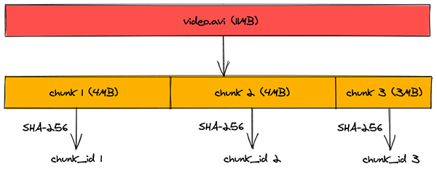

When a client tries to upload a chunk whose chunk\_id is already present in Metadata DB, Meta Service just adds a row in Chunks table containing the new object\_id and chunk\_id. This eliminates the need to re-uploading the data thereby saving bandwidth and time. This also helps us in saving the space of block storage as there won’t be multiple copies of one chunk in same data center.

#### Caching

We are using an in-memory caching to reduce the number of hits to Metadata DB. In-memory caches like Redis and Memcached cache the data from database in key-value pair.

From Meta Service servers, before hitting the Metadata DB, we are checking if data exists in cache or not. If it exists then we return the value from there itself bypassing a database trip. However if data is not present in cache, we hit the database, getting the data and populating the same in cache too. Hence subsequent requests won’t hit the database and get the data from cache itself. This caching strategy is known as write-around caching.

Least Recently Used (LRU) eviction policy is used for caching data as it allows us to discard the keys which are least recently fetched.

### Scalability

Our architecture is highly scalable owing to following facts:

#### Horizontal Scaling

We can add more servers behind the load balancer to increase the capacity of each service. This is known as Horizontal Scaling and each service can be independently scaled horizontally in our design.

#### Database Sharding

Metadata DB is sharded based on object\_id. Our hash function will map each object\_id to a random server where we can store the file/folder metadata. To query for a particular object\_id, service can determine the database server using same hash function and query for data. This approach will distribute our database load to multiple servers making it scalable.

#### Cache Sharding

Similar to Metadata DB Sharding, we are distributing the cache to multiple servers. In-fact Redis has out of box support for [partitioning](https://redis.io/topics/partitioning) the data across multiple Redis instances. Usage of [Consistent Hashing](https://en.wikipedia.org/wiki/Consistent_hashing) for distributing data across instances ensures that load is equally distributed if one instance goes away.

### Security

Our system is highly secure due to following:

#### HTTPS

The traffic between client and server is encrypted over HTTPS. This ensures that no one in the middle is able to see the data, especially the file contents.

#### Authentication

For each API request post log-in, we are doing authentication by checking the validity of auth\_token in Authorization HTTP header. This makes sure that requests which originate from clients are legitimate.

### Resiliency

Our system highly resilient owing to following:

#### Distributed Block Storage

Files are split up in to chunks and these chunks are replicated within data center for durability. Also these chunks are distributed across data centers in multiple geographic regions for redundancy. This makes sure that enough copies of chunks are available within data center is one machine goes down. Also if entire data center goes down, chunks can be served from a data center in other geographical location.

#### Queuing

We are using queuing in our system for sending out the notification to clients. Hence if any worker dies, message in a queue isn’t acknowledged and other worker picks up the task again.

#### Load Balancing

Since we are putting multiple servers behind the load balancer, there is redundancy. Load Balancer is continuously doing health check on servers behind it. If any server dies, load balancer stops forwarding the traffic to it and removes it from cluster. This makes sure that requests don’t fail due to a unresponsive server.

#### Geo-redundancy

We are deploying exact replica of our services in data-centers across multiple geographical locations. This ensures that if one data-center goes down due to some reason, the traffic could still be served from remaining data-centers.